Dominique Anguiano

CPE301 – SPRING 2016

Design Assignment 3

**DO NOT REMOVE THIS PAGE DURING SUBMISSION:**

The student understands that all required components should be submitted in complete for grading of this assignment.

|  |  |  |  |
| --- | --- | --- | --- |
| **NO** | **SUBMISSION ITEM** | **COMPLETED (Y/N)** | **MARKS**  **(/MAX)** |
| 0. | COMPONENTS LIST |  |  |
| 1. | INITIAL CODE OF TASK 1 |  |  |
| 2. | FLOW CHART OF THE CODE |  |  |
| 3. | SCHEMATICS |  |  |
| 4. | SCREENSHOTS OF EACH TASK OUTPUT |  |  |
| 5. | SCREENSHOT OF EACH DEMO |  |  |
| 6. | GOOGLECODE LINK OF THE DA |  |  |
|  |  |  |  |
|  |  |  |  |

|  |  |  |  |
| --- | --- | --- | --- |
| 0. | COMPONENTS LIST |  |  |

* Atmega328P
* Breadboard
* LM35
* FTDI Chip

|  |  |  |  |
| --- | --- | --- | --- |
| 1. | INITIAL CODE OF TASK 1 |  |  |

/*

* Da 3 Task 1.c

*

* Created: 3/17/2016 2:04:27 PM

* Author : Dominique

*/

#include <avr/io.h>

#include <stdint.h> // needed for uint8_t

#include <avr/interrupt.h>

#define *F_CPU* 8000000UL // Clock Speed

#include <util/delay.h>/*

* Da 3 Task 1.c

*

* Created: 3/17/2016 2:04:27 PM

* Author : Dominique

*/

#include <avr/io.h>

#include <stdint.h> // needed for uint8_t

#include <avr/interrupt.h>

#define *F_CPU* 8000000UL // Clock Speed

#include <util/delay.h>

#define BAUD 9600

#define MYUBRR *F_CPU*/16/BAUD -1

volatile *uint32_t* mathy;

volatile *uint16_t* ADCvalue; // Global variable, set to volatile if used with ISR

volatile char ones, tens; // Global variable for the characters to be transmit.

void USART0SendByte(char); // Declaration of the Method to transmit char

void delay1s();

int main(void)

{

/*Set baud rate */

UBRR0L = MYUBRR;

UCSR0B |= (1 << TXEN0); // Enable transmitter

UCSR0C |= (1 << UCSZ01) | (1 << UCSZ00); // Set frame: 8-bit data

ADMUX = 0; // use ADC0

ADMUX |= (1 << REFS0); // use AVcc as the reference

ADCSRA |= (1 << ADPS2) | (1 << ADPS1); // 64 prescaler for 8Mhz

ADCSRA |= (1 << ADATE); // Set ADC Auto Trigger Enable

ADCSRB = 0; // 0 for free running mode

ADCSRA |= (1 << ADEN); // Enable the ADC

ADCSRA |= (1 << ADIE); // Enable Interrupts

ADCSRA |= (1 << ADSC); // Start the ADC conversion

sei();

while (1)

{

}

}

ISR(ADC_vect)

{

ADCvalue = ADCH; // only need to read the high value for 8 bit

mathy = ADCvalue; // Value to perform the conversion between ADC and temperature

mathy = mathy * 5; // Math to convert from the given ADC value to a temperature value

mathy = mathy * 100;

mathy = mathy / 1024;

ones = mathy % 10; // Obtaining the ones digit for the temperature value

tens = mathy / 10; // Obtaining the tens digit for the temperature value

USART0SendByte(tens + '0'); // Output the digits

USART0SendByte(ones + '0');

USART0SendByte('\n');

USART0SendByte('\r');

delay1s(); // Delay for 1 second before converting the next value

}

void USART0SendByte(char u8Data)

{

//wait while previous byte is completed

while(!(UCSR0A&(1<<UDRE0))){};

// Transmit data

UDR0 = u8Data;

}

void delay1s(){

for(int i = 500; i > 0; i--)

*_delay_ms*(2);

}

|  |  |  |  |
| --- | --- | --- | --- |
| 2. | FLOW CHART OF CODE |  |  |

Initialize the ADC to be used and enable serial communication

Check if ADC Interrupt Flag is set

Wait

Not Set

Yes, it is set

Head to Interrupt and convert ADC value to temperature.

Wait 1 second and exit interrupt

|  |  |  |  |
| --- | --- | --- | --- |
| 3. | SCHEMATICS |  |  |

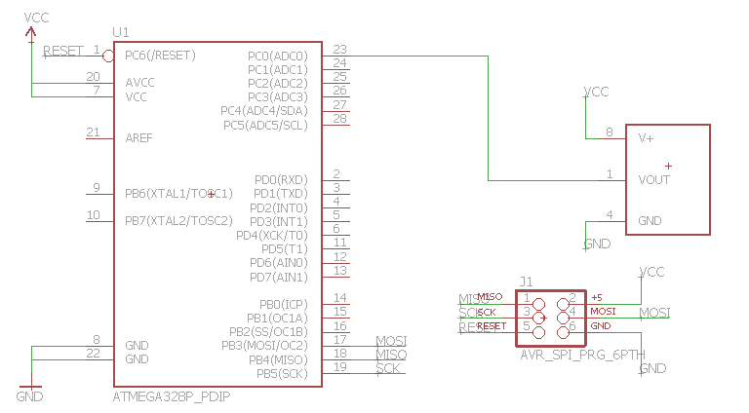

|  |  |  |  |
| --- | --- | --- | --- |
| 4. | SCREENSHOTS OF EACH TASK OUTPUT |  |  |

TASK 1:

Display the Temperature in F on a serial terminal

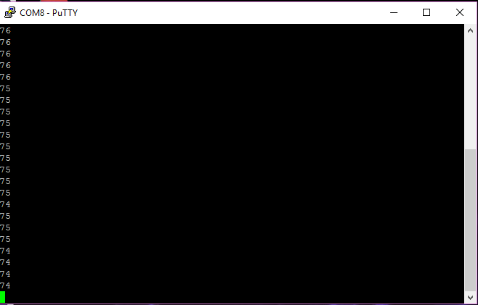

ADC Interrupt Flag Being set

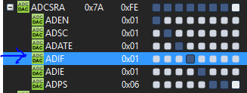

Values being output to the terminal

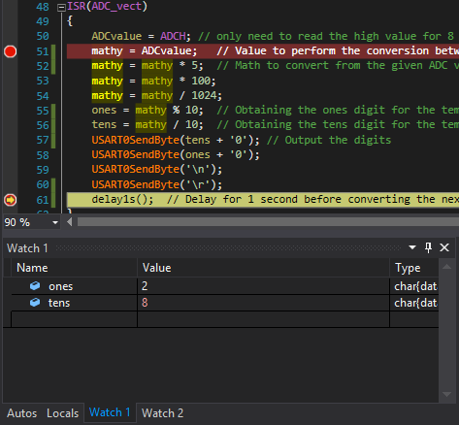

Before and after of 1 second delay

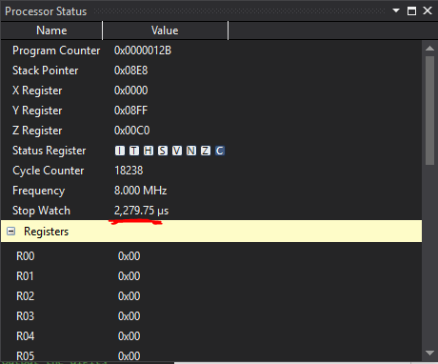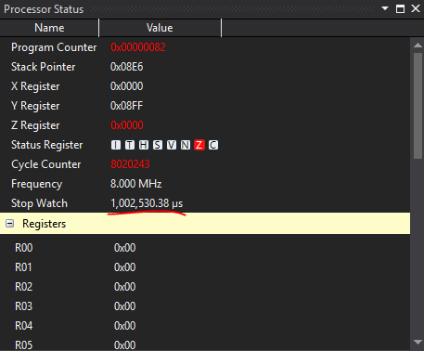

|  |  |  |  |
| --- | --- | --- | --- |
| 5. | SCREENSHOT OF THE BREADBOARD |  |  |

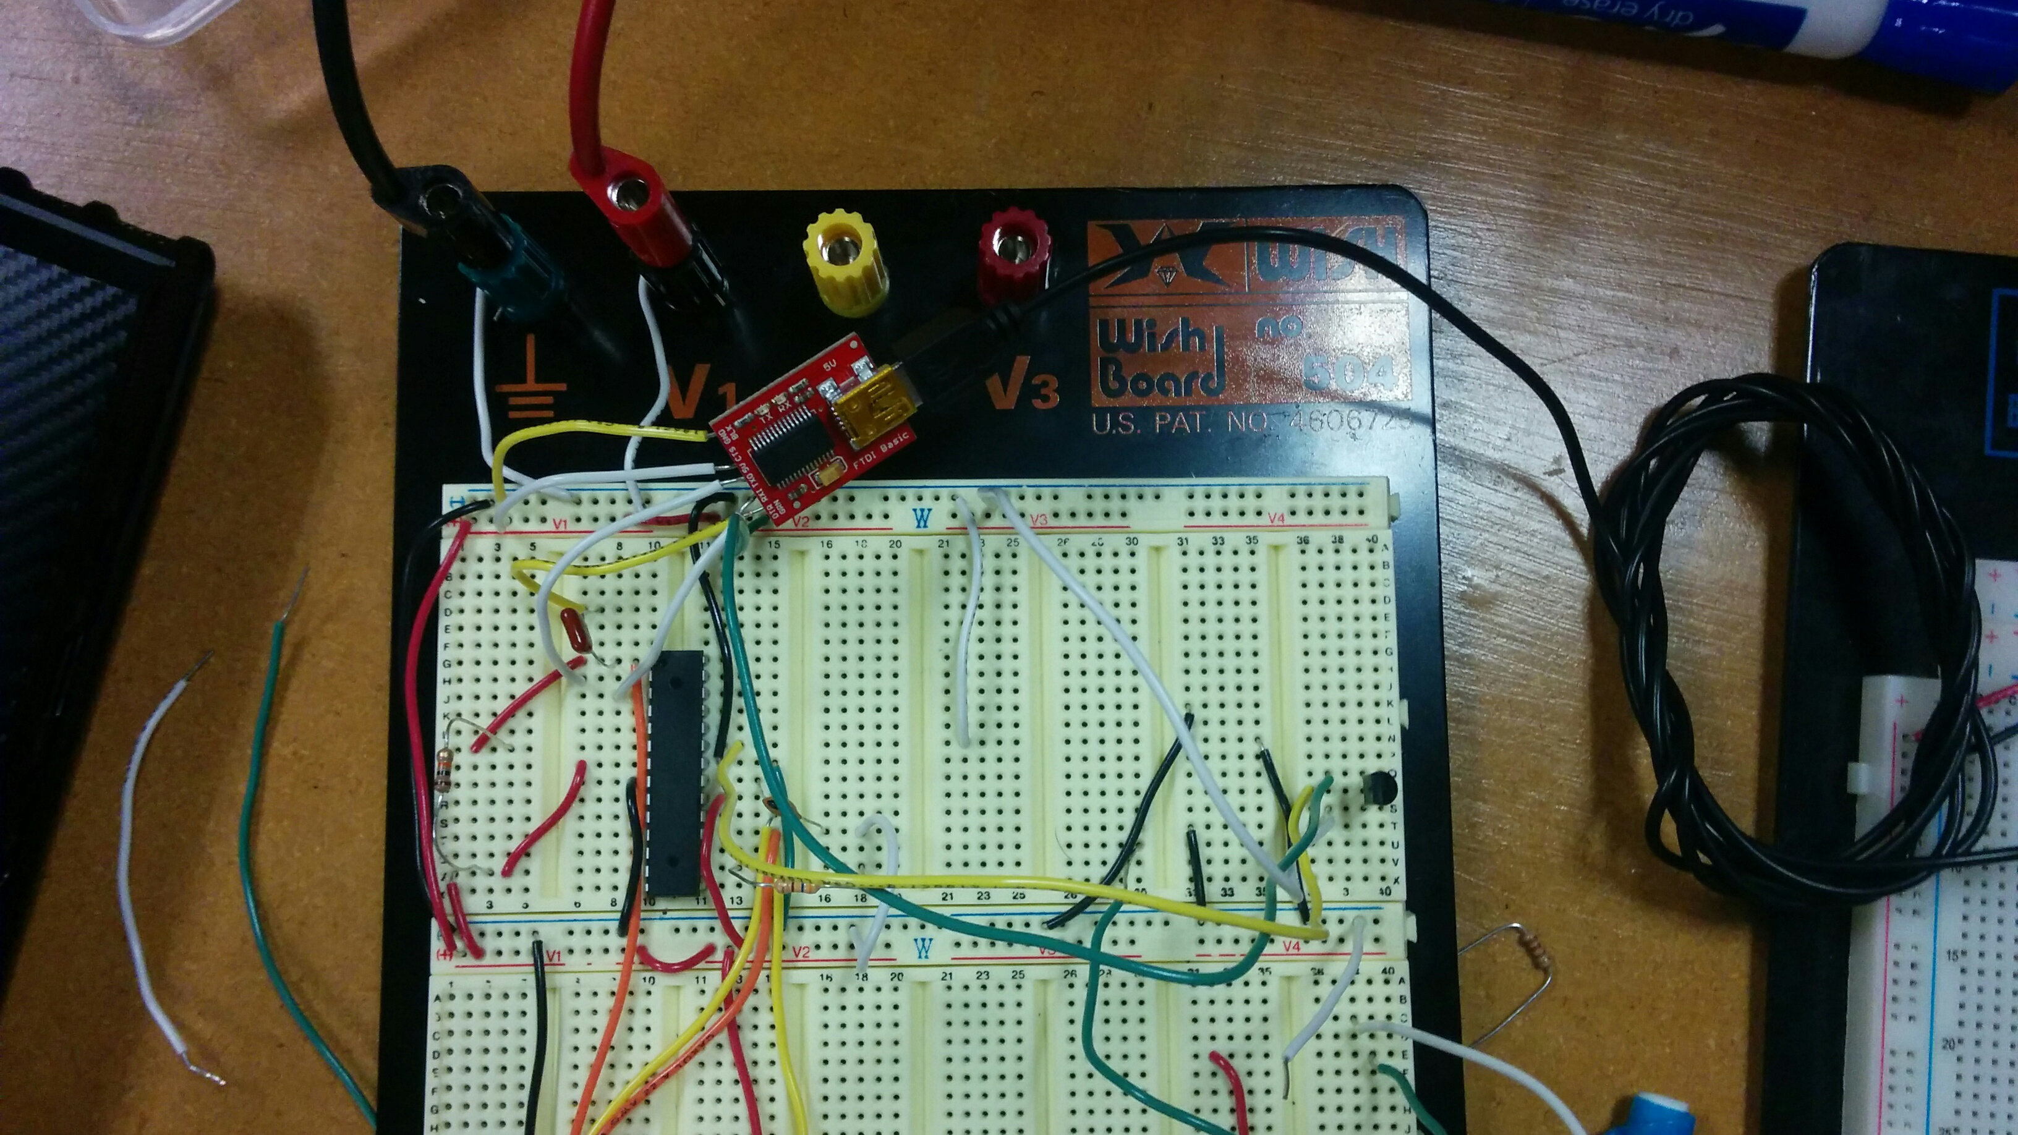

|  |  |  |  |
| --- | --- | --- | --- |
| 6. | GOOGLECODE LINK OF THE DA |  |  |
| https://github.com/Anguian3/anguian3-submissions | | | |

**Student Academic Misconduct Policy**

<http://studentconduct.unlv.edu/misconduct/policy.html>

“This assignment submission is my own, original work”.

Dominique Anguiano