Dominique Anguiano

CPE301 – SPRING 2016

Design Assignment 4

**DO NOT REMOVE THIS PAGE DURING SUBMISSION:**

The student understands that all required components should be submitted in complete for grading of this assignment.

|  |  |  |  |
| --- | --- | --- | --- |
| **NO** | **SUBMISSION ITEM** | **COMPLETED (Y/N)** | **MARKS**  **(/MAX)** |
| 0. | COMPONENTS LIST |  |  |
| 1. | INITIAL CODE OF TASK 1 |  |  |
| 2. | SCHEMATICS |  |  |
| 3. | FLOW CHART |  |  |
| 4. | BREADBOARD SNAPSHOT |  |  |
| 5. | VIDEO LINKS OF EACH DEMO |  |  |
| 6. | GOOGLECODE LINK OF THE DA |  |  |
|  |  |  |  |
|  |  |  |  |

|  |  |  |  |
| --- | --- | --- | --- |
| 0. | COMPONENTS LIST |  |  |

* Atmega328p
* RGB LED

|  |  |  |  |
| --- | --- | --- | --- |
| 1. | INITIAL CODE OF TASK 1/A |  |  |

/*

* Da 4 Task 1.c

*

* Created: 3/31/2016 3:22:08 PM

* Author : Dominique

*/

#define F_CPU 8000000UL // XTAL = 8 MHz

#include <avr/io.h>

#include <util/delay.h> // Library for Delay

void delay**();**

// Red = PB1, OCR1

// Green = PB3, OCR2

// Blue = PD6, OCR0

int main**(**void**)**

**{**

unsigned char i**,** j**,** k**;** // Char Max value is 255

DDRD **=** 0xFF**;** // Set PD6 as an output for OC0A

DDRB **=** 0xFF**;** // Set PB1 as an output for OC1A and PB3 as an output for OC2A

i **=** 230**;** // Values for 10% duty cycle in inverted mode

j **=** 230**;**

k **=** 230**;**

OCR0A **=** i**;** // Duty cycle = 50%

OCR1A **=** j**;**

OCR2A **=** k**;**

TCCR0A **=** 0xC1**;** // Phase Correct PWM, inverted

TCCR0B **=** 0x03**;** // Prescalar = 64

TCCR1A **=** 0xC1**;**

TCCR1B **=** 0x03**;**

TCCR2A **=** 0xC1**;**

TCCR2B **=** 0x04**;**

**while(**1**)**

**{**

**while** **(**k **>=** 30**)**

**{**

**while(**j **>=** 30**)**

**{**

**while(**i **>=** 30**)**

**{**

OCR2A **=** i**;**

i **=** i **-** 25**;**

delay**();**

**}**

i **=** 230**;**

OCR2A **=** i**;**

j **=** j **-** 25**;**

OCR1A **=** j**;**

delay**();**

**}**

j **=** 230**;**

OCR1A **=** j**;**

k **=** k **-** 230**;**

OCR0A **=** k**;**

delay**();**

**}**

k **=** 230**;**

**}**

**while** **(**1**);** // Wait here forever after lighting is done

**return** 0**;**

**}**

// Delay Subroutine that delays for 100 milliseconds.

void delay**(){**

**for(**int i **=** 50**;** i **>=** 0**;** i**--)**

_delay_ms**(**2**);**

**}**

|  |  |  |  |
| --- | --- | --- | --- |
| 2. | SCHEMATIC |  |  |

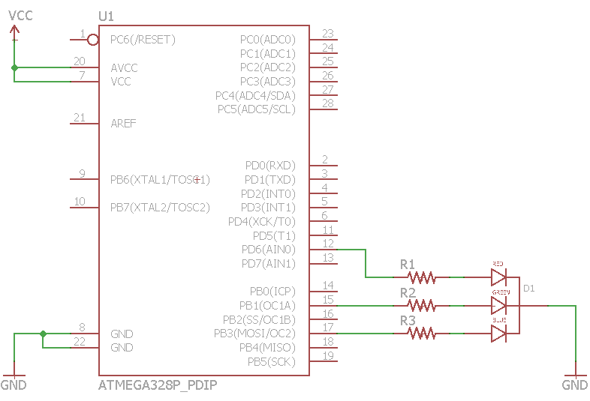

|  |  |  |  |
| --- | --- | --- | --- |
| 3. | FLOW CHART |  |  |

Initialize Timers

Increment Duty Cycle of Timer 2

Timer 2 Duty Cycle 90%?

Timer 0 Duty Cycle 90%?

Timer 1 Duty Cycle 90%?

Increment Duty Cycle of Timer 0

Increment Duty Cycle of Timer 1

Reset Duty Cycle of Timer 2

Reset Duty Cycle of Timer 0

Reset Duty Cycle of Timer 1

Begin Looping

Yes

Yes

Yes

No

No

No

|  |  |  |  |
| --- | --- | --- | --- |
| 4. | BREADBOARD SNAPSHOT |  |  |

TASK 1: RBG LED changes colors based on three PWM signals

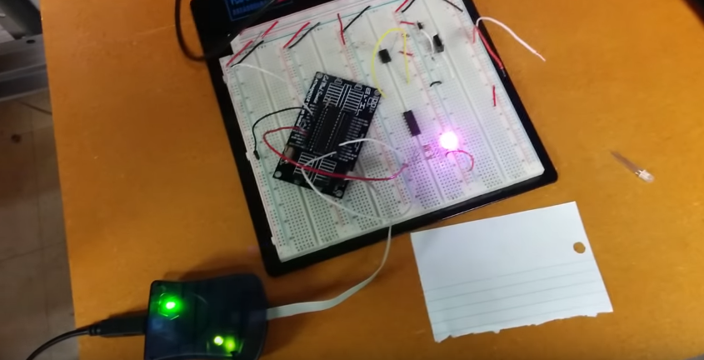

|  |  |  |  |
| --- | --- | --- | --- |
| 5. | VIDEO LINKS OF EACH DEMO |  |  |
| <https://youtu.be/88H3cXeR4Tw> | | | |
| 6. | GOOGLECODE LINK OF THE DA |  |  |
| <https://github.com/Anguian3/anguian3-submissions> | | | |

**Student Academic Misconduct Policy**

<http://studentconduct.unlv.edu/misconduct/policy.html>

“This assignment submission is my own, original work”.

Dominique Anguiano