“Advanced” guide for Jets Of Time – Strategy guide

So first, a quick, rough explanation of what the flowchart below shows, and how to read it, since not everybody is familiar with flowcharts.

The flowchart below starts at the top circle, and each box, triangle/diamond, circle, or other shape, should be read, because they are either questions to help you figure out which step to go to next, or are themselves a step you should perform in the game. The first thing is the circle that says to go to Guardia Forest and beat 1 encounter, etc. etc.. Do what’s said in that step, then follow the arrow to the next step.

Some steps are actually questions. Diamond-shapes are questions, and have two arrows leading to different steps depending on your answer to the question. For instance, “Got the Pendant?” is one of the diamonds below, and if the answer is “yes,” you follow the arrow labeled “yes.” If you don’t have the pendant however, follow the arrow labeled “No.”

The flowchart is primarily a sort of switch diagram, where you have a long list of yes/no questions based on your progress in the randomizer, which are ordered by their importance for doing immediately when they’re available, for the most part. This guide is NOT a 100% optimized, “no need to think for yourself,” guide. It is *a* basis for good routing, and learning the routing and checks you can make in the randomizer. You might answer “no” to many of the questions at first, and keep progressing further down the list, until you get to one that you actually answer “yes” to. That’s fine. That’s why the list is long. It should encompass every possible path you can take, so that if you DO follow this guide without deviating, it will definitely guide you to winning, even if it’s not necessarily 100% fastest (a randomizer does sometimes result in unexpected or interesting situations after all).

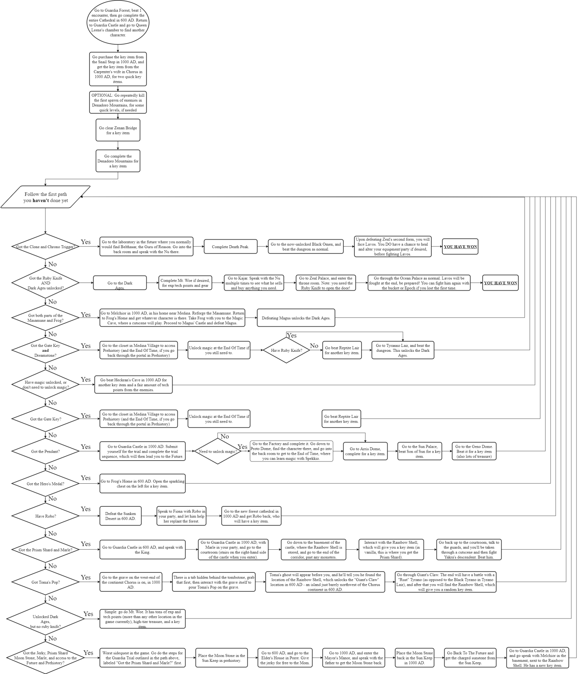

To explain some ofthe decisions here:

* Going through Death Peak and the Black Omen, if you haven’t yet done either Tyrano Lair or Magus’ Castle (especially Magus’ Castle), is faster. Some of the bosses have been removed from Death Peak and the Black Omen generally goes pretty fast if you don’t die a bunch in the process, and it skips the first Lavos battle, going straight to Inner Lavos. It’s also a fairly rare occasion when you have both the Clone/Chrono Trigger, and either Dreamstone/Gate Key or the completed Masamune*and* the Ruby Knife, so you usually don’t need to make a decision between going through Ocean Palace or Black Omen’s path – you usually only have one option or the other.
* Zenan Bridge is pretty fastand easy, though it might be worth your while to grind a few repetitions of the Denadoro Mountains first spawn if you want/need to. Zenan Bridge and Denadoro Mountains afterwards (so that you’re slightly higher level) are both good early key items.
* The Sunken Desert honestly can be done before anything else, if you have Robo after Cathedral, but it will be tough at low levels, so proceed with caution if you try going there super early. This is why it’s further down the chain of checks.
* Toma’s Pop is a fairly long and uninteresting quest, with only one key item, so it is pretty low on the chain of checks.
* Pendant/Gate Key checks are pretty much at the top of the list after the Dark Ages unlocking quests, because you usually want to unlock magic for some characters, and it’s better done soon rather than later.
* You can perform the Hero’s Medal check basically any time. It might move up the chain in the future. It’s easily the fastest check.
* Mt. Woe is low on the list not because it’s bad, but because it’s a bit long, and it’s quite difficult. Don’t go there before level 20. Level 25 is better.