**MODULE: MANAGER**

**Introduction**

The Manager module in the Complaint Management System is designed to efficiently manage and monitor complaints raised by faculty members within the college. This module facilitates tracking, assigning, and resolving issues while maintaining transparency and accountability. The Manager dashboard acts as the central hub for managing complaints and coordinating with workers and other stakeholders, including the principal.

**Manager Dashboard**

The **Manager Dashboard** provides an overview of the manager's responsibilities and the status of complaints.

1. **Manager Details:** The dashboard prominently displays the manager's profile and details.
2. **Complaint Status Counters:** Below the manager's details, key metrics are displayed:
   * **New Issues:** Newly posted issues by the faculty.
   * **Pending Issues:** Issues assigned to the worker team but not yet resolved.
   * **Completed Issues:** Issues successfully resolved by the worker team.
   * **Reassigned Issues:** Tasks reassigned to the worker team due to unsatisfactory resolutions by the faculty or manager.

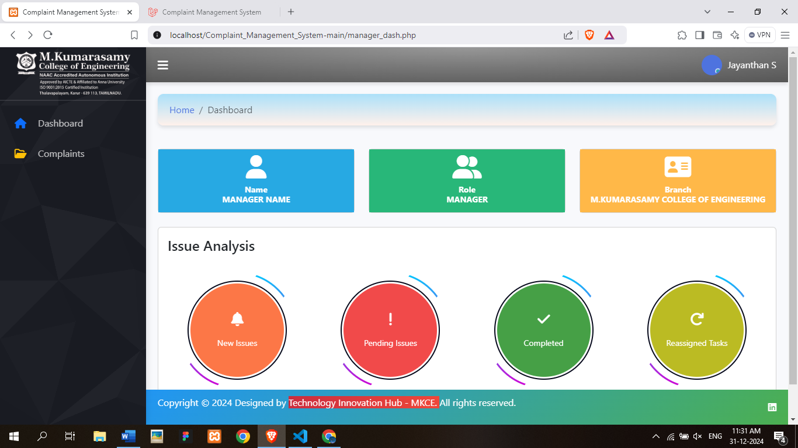

**Complaints Page**

The Complaints page features **eight navigational tabs**, each representing a distinct table for organizing and managing complaints.

**Add Workers**

At the top of the page, there is an option to add workers to the team, ensuring seamless workforce management.

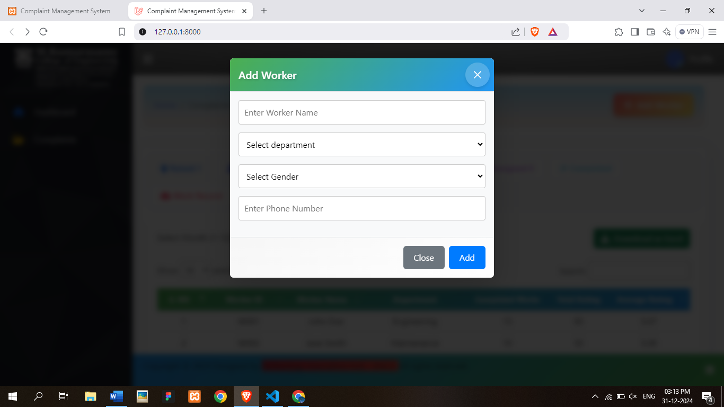

**1. Raised Table**

* Displays the list of issues raised by faculty members.
* Reassigned requests from faculty also appear here.
* Manager Actions:
  + **Accept/Reject Issues:** Manager can accept or reject issues.
  + **Forward Issues to Principal:** If necessary, issues can be forwarded for principal approval.
  + **Reassign Issues:** For reassigned work, the manager can reassign tasks to the worker team.

**2. Principal Table**

* Lists issues forwarded to the principal for approval.
* Once approved by the principal, these issues are moved to the Assigned Table.

**3. Assigned Table**

* Contains issues approved by both the manager and the principal.
* These issues are ready for assignment to the worker team.

**4. Response Table**

* Displays feedback provided by faculty members on resolved issues.

**5. Reassigned Table**

* Lists work reassigned due to unsatisfactory resolutions.
* Faculty requests for reassignment and subsequent reassigned tasks are tracked here.

**6. Completed Table**

* Contains issues marked as completed by the worker team.
* Displays **before and after images** to verify the work completion.

**7. Work Record Table**

* Maintains a record of successfully completed works.
* Includes:
  + Faculty Feedback
  + Manager Feedback
  + Date of Completion
* Provides a comprehensive report for reference and analysis.
* This table can be downloaded as an Excel file.

**8. Workers Record Table**

* Stores details of the worker team, including:
  + Worker Name and Department
  + Total Completed Works
  + Rating and Average Rating
* This table can also be downloaded as an Excel file for documentation purposes.

**Conclusion**

The Manager Module in the Complaint Management System streamlines the entire complaint-handling process by providing a structured workflow. It ensures that issues are addressed effectively, feedback is recorded, and records are maintained for future reference. By integrating detailed tracking and navigation features, the module enhances operational efficiency and fosters accountability, creating a well-coordinated environment for managing complaints within the college.