# Steps to get Maria db database running

## Step-1

Open cmd command prompt application and change directory to Maria DB bin folder

My computer example: cd D:\UniImportant\OneDrive - Queensland University of Technology\CAB302\gitMajorProject\mainProject\database\mariadb-10.5.3-winx64\bin

My computer Cmd input example: cd D:\UniImportant\OneDrive - Queensland University of Technology\CAB302\gitMajorProject\mainProject\database\mariadb-10.5.3-winx64\bin

Note: if stored in different drive to your main drive, you can change drive with

cmd input: directory:

example: d:

This would change your cmd to your D drive

## Step-2

Configure the Maria DB to your computer using the input

cmd input: mysql_install_db

## Step-3

Now run the database on your computer using the input

cmd input: mysqld –console

# Accessing the database

## Step-1

Open a different cmd window then the one running the database and change directory to Maria DB bin folder again

## Step-2

Connect to the Maria DB command line interface using the input

cmd input: mysql -uroot

## Step-3

Access the database we are using for this project with the input

cmd input: use mpdb;

Note: you must have this database installed prior to running this input, this can be done in java by running the createDB method

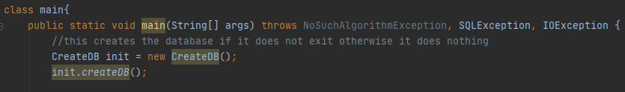

# Exiting the database and disconnect from Maria DB interface

## Step-1

To exit from the Maria DB interface simple input

cmd input: exit;

## Step-2

To stop the database from running, go to the cmd window where it is running and just **Ctrl C** it