* 12/17:
  + Ignore the training first:

|  |  |
| --- | --- |
|  |  |
|  |  |
|  |  |

* + Data generation process:

* + - When t = 1: or ?
  + Generate decision rules:

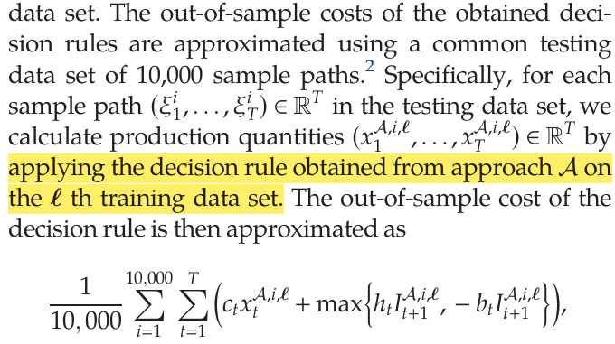

* + - Use and from th training data set, and use known demand to replace uncertain demand ?
* 12/11:
  + Paper p.66: the norm of the uncertainty set is -norm, the partition and the uncertainty set are hyperrectangles.

* + Based on my understanding, the uncertainty set represents the demand in stage 2, so I think the partition process only deals with the demand in stage 1. This means the upper and lower bounds are only used for demand in stage 1 (Since demand in stage 2 should be unknown).

* + The upper and lower bounds from the partition restrict the value of demand in stage 1, there is no limitation for stage 2 (lower bound 0 and upper bound infinity). 🡺 This is still a hyperrectangle.
  + I think the problem with the partition is not because of the range of the upper and lower bound.
    - If stage 1 demand is lower, stage 2 demand will be higher.
      * The upper bound will be lower since the stage 1 demand is lower.
    - If stage 1 demand is higher, stage 2 demand will be lower.
      * The lower bound will be higher since the stage 1 demand is higher.

* + I think my testing result (out-of-sample) might be correct, but I’m not sure about the training result (in-sample).
    - N = 50:

|  |
| --- |
|  |
|  |

* + - N = 200:

|  |
| --- |
|  |
|  |

* + - N = 800:

|  |
| --- |
|  |
|  |