VSCP

Getting started with AVR

Specification - 1.0

2012-06-27

**Abstract**

It will help AVR users to get a brief idea about VSCP PROTOCOL & easily startup with AVR AT90CAN based controllers.

INDEX

1. Brief about VSCP

* What is Open Source?
* What is Home Automation?
* What is VSCP?
* What all VSCP License options are available?
* What does VSCP toolset contains?
* What does VSCP Transport Medium at Physical Level?
* Where to get VSCP start-up Specification?
* What does VSCP Software Architecture contains?
* What is VSCP at protocol level?
* What minimum Hardware you have to invest to start as a VSCP developer?

1. How to start with VSCP using AVR

* What minimum skills you require to start with VSCP?
* Software & Hardware tools required for VSCP development?
* How much software you have to develop to have working VSCP Node?
* What does AVR VSCP Transport Medium at Physical Level?
* What is architecture of AT90CAN based Atmel controller?
* How to compile AVR code out of Trunk folder of SVN?
* What is flow of control of AVR VSCP node code?
* How to program decision matrix for AVR VSCP node?
* What is need of AVR VSCP bootloader?
* What is AVR VSCP bootloader capable of?
* How does AVR VSCP bootloader work?
* What is architecture of AVR VSCP bootloader?
* Example project’s of VSCP under different Scenarios.

1. How to start with CAN Bus

* What is CAN bus?
* What advantages are of CAN bus protocol?
* Can protocol in Brief.
* Can protocol useful application notes & Link to various online documents.
* How to use CAN bus calculator from Atmel for AVR?
* How to provide protection for CAN bus?
* How to preparing CAN hardware Node?
* Cables & connectors used for CAN bus?
* How to prepare CAN network?
* How to troubleshoot & find fault in CAN bus network?

VSCP – Very Simple Control Protocol

1. Brief about VSCP
2. What is Open Source?

Open-source software (OSS) is computer software that is available in source code form: the source code and certain other rights normally reserved for copyright holders are provided under an open-source license that permits users to study, change, improve and at times also to distribute the software.

Open source software is very often developed in a public, collaborative manner.

1. What is Home Automation?

Home automation is the residential extension of "building automation". It is automation of the home, housework or household activity.

Home automation may include centralized control of lighting, HVAC (heating, ventilation and air conditioning), appliances, and other systems, to provide improved convenience, comfort, energy efficiency and security.

Home automation for the elderly and disabled can provide increased quality of life for persons who might otherwise require caregivers or institutional care.

A home automation system integrates electrical devices in a house with each other. Devices may be connected through a computer network to allow control by a personal computer, and may allow remote access from the internet.

Through the integration of information technologies with the home environment, systems and appliances are able to communicate in an integrated manner which results in convenience, energy efficiency, and safety benefits.

The elements of a demotic’s system are:

* hardware controllers or software controllers
* sensors
* actuators

A centralized controller can be used, or multiple intelligent devices can be distributed around the home.

1. What is VSCP?

The **Very Simple Control Protocol** (VSCP) is a free automation protocol suitable for all sorts of automation task where building- or home-automation is in the main focus.

More information can be checked from Wiki, if I mention it here it will be the same as rewriting already existing specs.

Link:--

<http://en.wikipedia.org/wiki/Very_Simple_Control_Protocol>

1. What all VSCP License options are available?

* This program is free software; you can redistribute it and/or modify it under the terms of the GNU General Public License as published by the Free Software Foundation; either version 2 of the License, or (at your option) any later version.
* VSCP & Friends is licensed under three different licenses:--

1. Commercial users can buy a license from eurosource.
2. Non commercial users can use the GPL version.
3. Both commercial and non-commercial users can use the LGPL code such as libraries and firmware code.

* More details are available at following link: ----

<http://www.vscp.org/wiki/doku.php/vscp/05_vscp_license>

1. What does VSCP toolset contains?

* VSCP Protocol & Friends package consist of software tools for m2m (machine to machine communication) and Internet of Things.
* The programs here works on Windows and Linux and are based around VSCP, The Very Simple Control Protocol.
* VSCP really consist of three parts :----

1. **VSCP** - The Very Simple Control Protocol and related specification, software and firmware.
2. **OHAS** - Open Home Automation Server which is web related tools for home automation on top of VSCP.
3. **CANAL** - CAN abstraction layer the low level driver interface used by VSCP.

* The protocol is so easy that everyone can grasp the idea behind it in a few minutes but still complex enough to handle serious tasks.
* It is very easy to construct and use VSCP aware modules and components.
* A lot of Firmware examples are available on this site for most of the Micro-controller architecture like AVR, PIC etc that will get you started fast.
* VSCPWorks :

VSCPworks is the PC (Linux & Windows) based tool to configure & manage the nodes. VSCPWorks allows reading/setting registers presenting those registers in a human-readable format by parsing the MDF file automatically. VSCPWorks also provides wizards to set the decision matrix.

1. What does VSCP Transport Medium at Physical Level?

* VSCP is independent from the physical layer (e.g. CAN bus, Ethernet, RS-485, RS-232, MiWi) connecting the individual nodes to form the automation network bus.
* **Protocol (Level I)** that is very much tailored to the CAN bus and resource restricted microcontrollers.
* **Protocol (Level II)** is designed for Ethernet (UDP, TCP and own Ethernet-type Raw-Ethernet) and wireless physical layers. All share the same common message fields & framework and can be connected through gateways.

1. Where to get VSCP start-up Specification?

As an VSCP start-up you should refer following documents:--

1. VSCP Wikipedia link which is a brief extract of what VSCP is all about. <http://en.wikipedia.org/wiki/Very_Simple_Control_Protocol>
2. VSCP Primer it a very simple to understand document it will help you to understand VSCP easily. <http://www.vscp.org/downloads/VSCP_primer.pdf>
3. Once you are through with it you can start with the latest Specification for VSC P. <http://sourceforge.net/projects/m2m/files/VSCP%20Specification/>
4. What does VSCP Software Architecture contains?
5. The VSCP & Friends subsystem looks like this :----

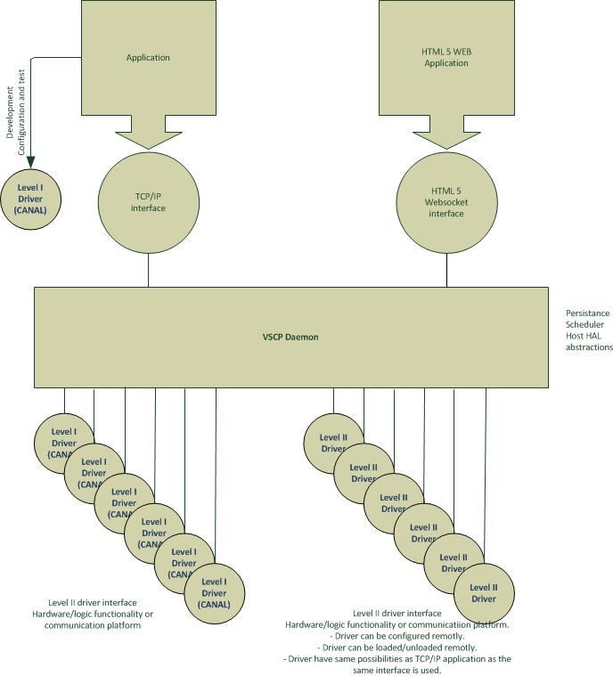

1. From VSCP Node point of view :---

--------------------------------------------

Application Specific Software

--------------------------------------------

^

|

|

V

--------------------------------------------

VSCP Protocol specific Software

--------------------------------------------

^

|

|

V

--------------------------------------------

Physical Layer Driver Software

--------------------------------------------

^

|

|

V

--------------------------------------------

Physical Layer

--------------------------------------------

Physical Layer: ---

VSCP is independent from the physical layer (e.g. CAN bus, Ethernet, RS-485, RS-232, MiWi) connecting the individual nodes to form the automation network bus.

1. What is VSCP at protocol level?

VSCP is based on the concept of Event, Decision & Action process.

**Level-I Protocol**:--

There is a subset of the protocol (Level I) that is very much tailored to the CAN bus and resource restricted microcontrollers.

**Level-II Protocol**:--

Protocol Level II is designed for Ethernet (UDP, TCP and own Ethernet-type Raw-Ethernet) and wireless physical layers. All share the same common message fields & framework and can be connected through gateways.

**VSCP event datagram structure**:--

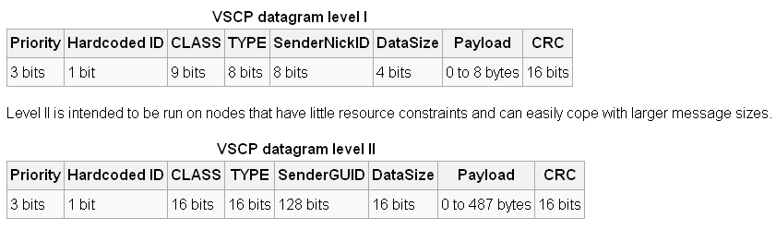

You can refer following link to get a brief idea about:--

1. VSCP Event
2. VSCP Event Class & Type
3. VSCP event datagram structure
4. VSCP Decision Matrix
5. VSCP DataPayload
6. VSCP Zone/Subzone

<http://en.wikipedia.org/wiki/Very_Simple_Control_Protocol>

1. What minimum Hardware you have to invest to start as a VSCP developer?