電通二乙微處理器實驗 實驗結報

實驗名稱 | Lab04-四合一七段顯示器檔案
組別 | 0 | 組員 | 06050615;陸致翰

- 實驗目的
了解七段顯示器的原理

- 實驗步驟
接好七段顯示器的電路
七段顯示器每隔0.3秒跳一個數字0000->0001->2359

- 程式碼
Check 1
#include"SevSeg.h"
SevSeg sevseg;
int Hour=0;
int Min=0;
void setup() {
// put your setup code here, to run once:
byte numDigits = 4;
byte digitPins[] = {2, 3, 4, 5};
byte segmentPins[] = {8, 9, 10, 11, 12, 13, 14, 15};
sevseg.begin(COMMON_CATHODE, numDigits, digitPins, segmentPins);
}
void loop() {
// put your main code here, to run repeatedly:
sevseg.setNumber(Hour * 100 + Min, 4);
Min = Min + 1;
if (Min == 60) {
Min = 0;
if (Hour == 23)
Hour = 0;
else
Hour++;
}
for(int i=0;i<=878787;i++)
sevseg.refreshDisplay();

}
Check2
#include"SevSeg.h"
SevSeg sevseg;
int Hour = 0;
int Min = 0;
int h=23;
void setup() {
// put your setup code here, to run once:
byte numDigits = 4;
byte digitPins[] = {2, 3, 4, 5};
byte segmentPins[] = {8, 9, 10, 11, 12, 13, 14, 15};
sevseg.begin(COMMON_CATHODE, numDigits, digitPins, segmentPins);
pinMode(6, INPUT);
pinMode(17, INPUT);
}
void loop() {
// put your main code here, to run repeatedly:
boolean Pin6 = digitalRead(6);
boolean Pin17 = digitalRead(17);
sevseg.setNumber(Hour * 100 + Min, 4);
if (Pin6 == HIGH)
{
Min = 0;
Hour = 0;
}
if (Pin17 == HIGH) {
Min = Min - 1;
if (Min == 0) {
Min = 59;
if (Hour == 0)
Hour = 23;
}
}
else {
Min = Min + 1;
if (Min == 60) {
Min = 0;
if (Hour == 23)
Hour = 0;
else
Hour++;
}
}
for (int i = 0; i <= 878787; i++)
sevseg.refreshDisplay();
}

- 實驗結果及分析
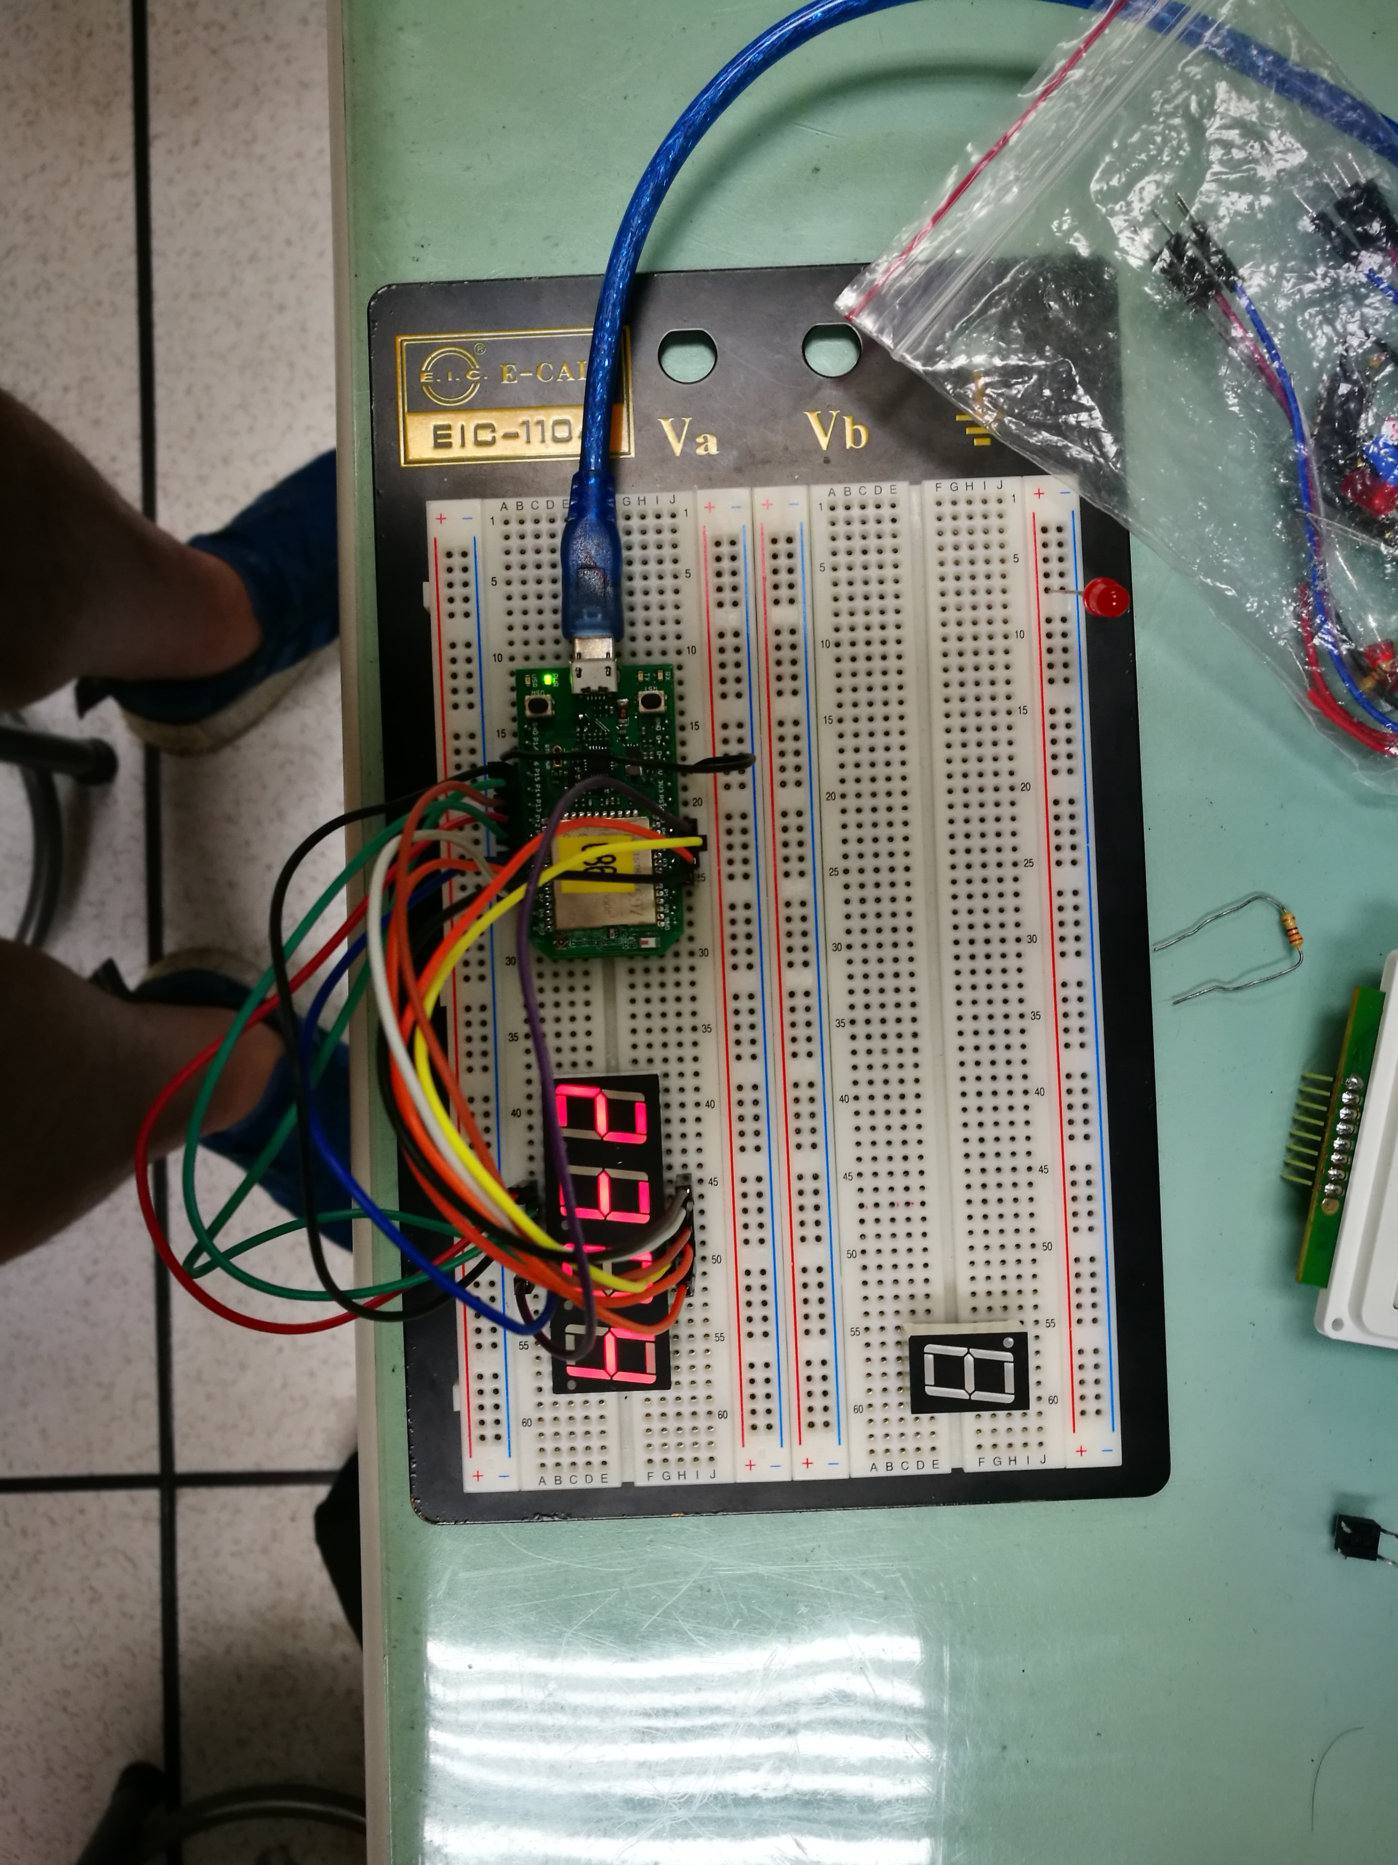
- 心得討論
七段顯示器的電路需多加熟悉，共陰或共陽也要分清楚~
有學到新東西
- 修正電路圖
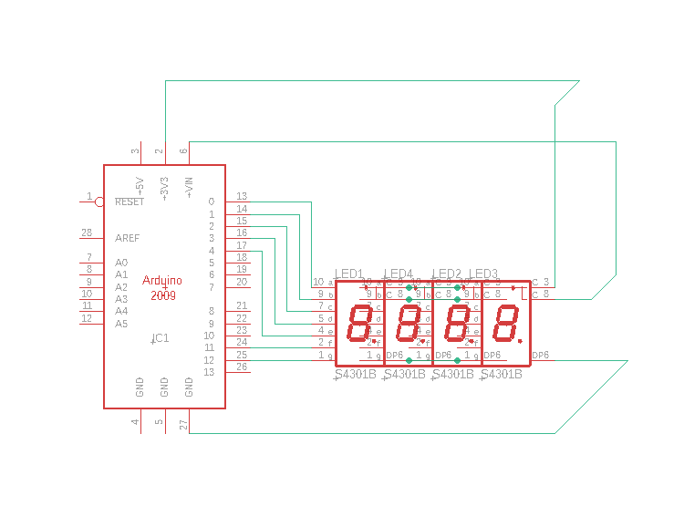
- 修正程式碼

