電通二乙微處理器實驗 實驗結報

實驗名稱 | 期中考
組別 | 0 | 組員 | 06050615;陸致翰

- 實驗目的
學習利用7697做計算機
- 實驗步驟
接好電路，利用上次4*4鍵盤做基礎再加以修改
- 程式碼
#include<Keypad.h>
const byte ROWS = 4;
const byte COLS = 4;
char keys[ROWS][COLS] = {
{'F', 'E', 'D', 'C'}, {'B', '3', '6', '9'},
{'A', '2', '5', '8'}, {'0', '1', '4', '7'}
};
byte rowPins[ROWS] = {11, 10, 9, 8};
byte colPins[COLS] = {15, 14, 13, 12};
int Z;
int count1 = 0;
int count2 = 0;
int a;
int b;
Keypad keypad = Keypad(makeKeymap(keys), rowPins, colPins, ROWS, COLS);
void setup() {
// put your setup code here, to run once:
Serial.begin(9600);
}
void loop() {
// put your main code here, to run repeatedly:
for (int i = 0;; i++) {
char X = keypad.getKey();
if (X != NO_KEY) {
if (X != 'A' && X != 'B' && X != 'C' && X != 'D' && X != 'E' && X != 'F') {
Serial.print("The first number is ");
delay(300);
Serial.println(X);
a = X;
delay(300);
count1++;
break ;
}
}
}
for (int i = 0;; i++) {
char Y = keypad.getKey();
if (Y != NO_KEY) {
if (Y != 'A' && Y != 'B' && Y != 'C' && Y != 'D' && Y != 'E' && Y != 'F') {
Serial.print("The secound number is ");
delay(300);
Serial.println(Y);
b = Y;
delay(300);
count2++;
break ;
}
}
}
for (int i = 0;; i++) {
char P = keypad.getKey();
if (P != NO_KEY) {
if (P == 'A') {
Serial.println("The operation is +");
Serial.print("The result is:");
Z = (a-'0') + (b-'0');
Serial.println(Z);
break ;
}
if (P == 'B') {
Serial.println("The operation is -");
Serial.print("The result is:");
Z = (a-'0') - (b-'0');
Serial.println(Z);
break ;
}
if (P == 'C') {
Serial.println("The operation is *");
Serial.print("The result is:");
Z = (a-'0') * (b-'0');
Serial.println(Z);
break ;
}
if (P == 'D') {
Serial.println("The operation is /");
Serial.print("The result is:");
Z = (a-'0') /(b-'0');
Serial.println(Z);
break ;
}
}
}
}

- 實驗結果及分析
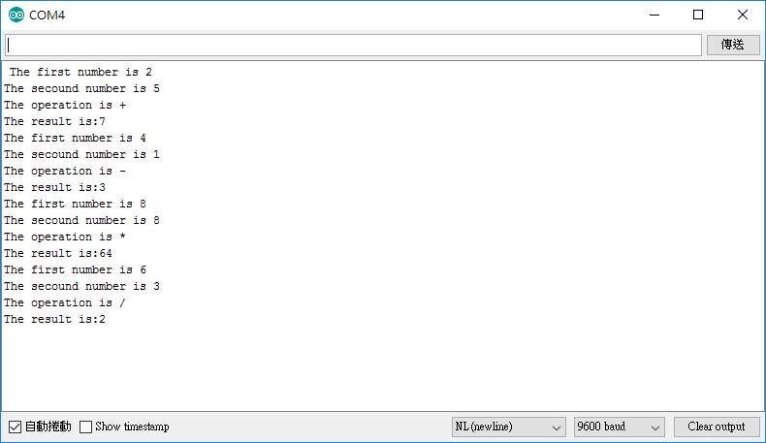
- 心得討論
後面需要思考，因為LOOP會一直重複執行需要多寫一個迴圈讓她不會一直來回跳，作後要減掉0字元因為讀入的數值是ASCII CODE!
6.修正電路圖