電通二乙微處理器實驗 實驗結報

實驗名稱 | Lab-6
組別 | 0 | 組員 | 06050615;陸致翰

- 實驗目的
利用案件顯示在arduino序列阜
- 實驗步驟
4x4 鍵盤之按鍵值經由串列傳輸，顯示在 PC 上
4x4 鍵盤之按鍵值顯示在七段顯示器上程式碼
Check1
#include<Keypad.h>
const byte ROWS = 4;
const byte COLS = 4;
char keys[ROWS][COLS] = {
{'F', 'E', 'D', 'C'}, {'B', '3', '6', '9'},
{'A', '2', '5', '8'}, {'0', '1', '4', '7'}
};
byte rowPins[ROWS] = {11, 10, 9, 8};
byte colPins[COLS] = {15, 14, 13, 12};
Keypad keypad = Keypad(makeKeymap(keys), rowPins, colPins, ROWS, COLS);
void setup() {
// put your setup code here, to run once:
Serial.begin(9600);
}
void loop() {
// put your main code here, to run repeatedly:
char key = keypad.getKey();
if (key != NO_KEY) {
Serial.println(key);
}
}Check2
#include"SevSeg.h"
#include<Keypad.h>
SevSeg sevseg;
const byte ROWS = 4;
const byte COLS = 4;
char keys[ROWS][COLS] = {
{'F', 'E', 'D', 'C'}, {'B', '3', '6', '9'},
{'A', '2', '5', '8'}, {'0', '1', '4', '7'}
};
byte rowPins[ROWS] = {11, 10, 9, 8};
byte colPins[COLS] = {15, 14, 13, 12};
Keypad keypad =
Keypad( makeKeymap(keys), rowPins, colPins, ROWS, COLS );
void setup() {
Serial.begin(9600);
byte numDigits = 1;
byte digitPins[] = {17};
byte segmentPins[] = {2, 3, 4, 5, 6, 7, 16};
sevseg.begin(COMMON_CATHODE, numDigits, digitPins, segmentPins);
}
void loop() {
char key = keypad.getKey();
if (key != NO_KEY) {
Serial.println(key);

if (key >= '0' && key <= '9')
sevseg.setNumber(key - '0', 0);
}
sevseg.refreshDisplay();

}
- 實驗結果及分析

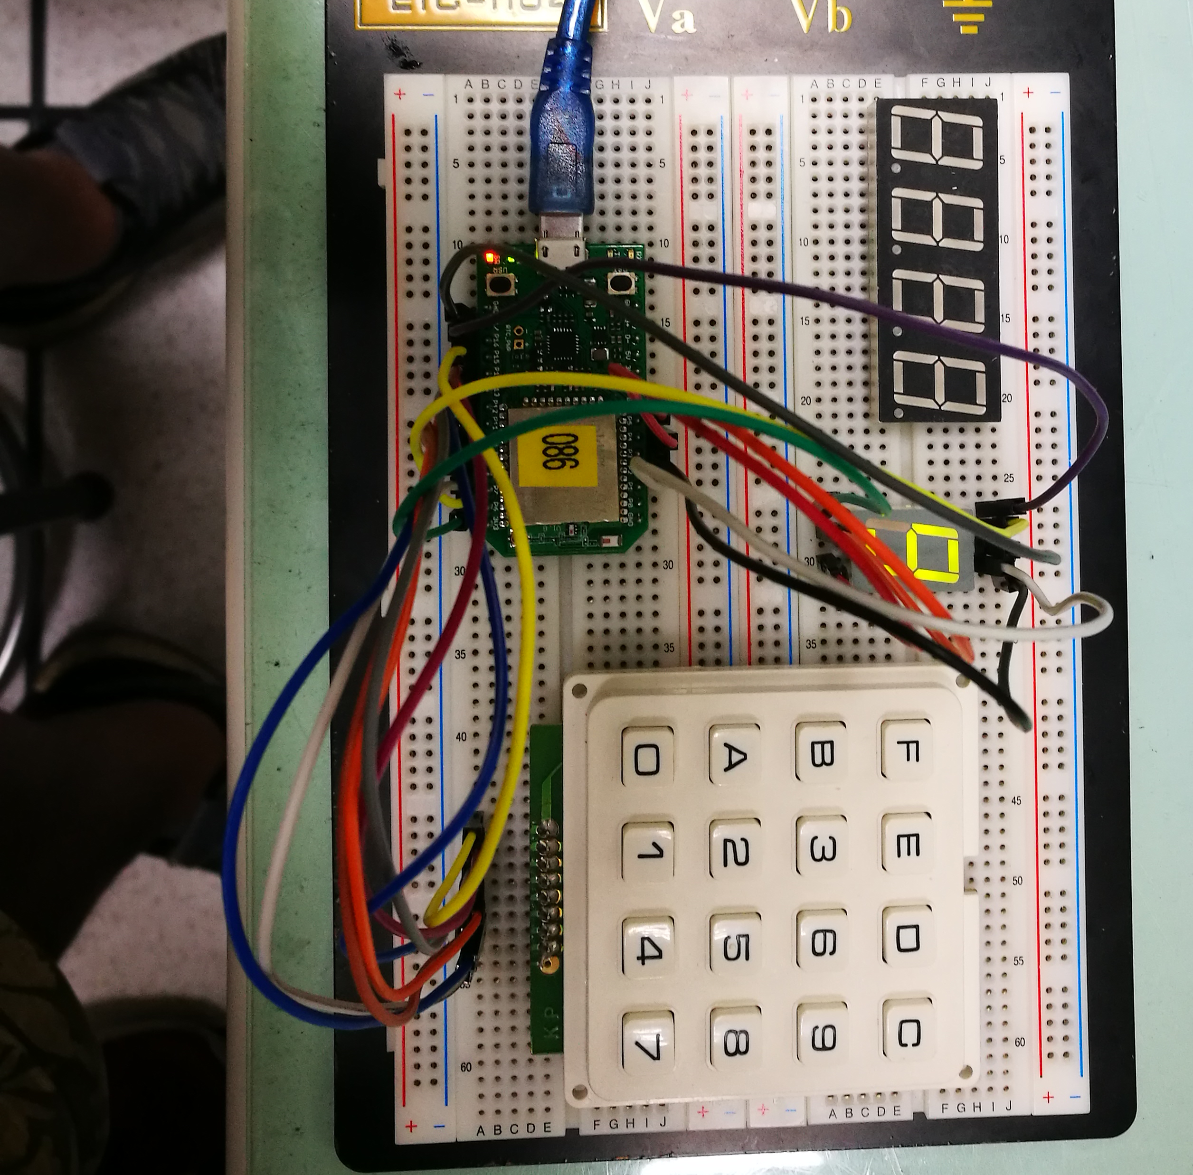

- 心得討論
有時會搞混，因為直排橫列有些順序會搞混，但只要搞清楚還蠻簡單的
- 修正電路圖
- 修正程式碼

