電通二乙微處理器實驗 實驗結報

實驗名稱 | Lab-6
組別 | 0 | 組員 | 06050615;陸致翰

- 實驗目的
利用arduino放音樂
- 實驗步驟
Arduino 演奏一段特定的音樂, 旋律不得是小蜜蜂
使用 4x4 鍵盤演奏音樂
發報摩斯電碼
- 程式碼
Check1
#define C41 262 //1 Do
#define D41 294 //2 Re
#define E41 330 //3 Mi
#define F41 349 //4 Fa
#define G41 392 //5 Sol
#define G42 415 //#5 #Sol
#define A41 440 //6 La
#define B41 494 //7 Si
#define C51 523 //1 Do_h
#define D51 587 //2 Re_h
#define D52 622 //#2 #Re_h
#define E51 659 //3 Mi_h
#define F51 698 //4 Fa_h
#define G51 784 //5 Sol_h
#define A51 880 //6 La_h
#define B51 988 //7 Si_h
#define O1 000 //休止符

int p = 10;
int scale[] = {E51, D52, E51, D52, E51, B41, D51, C51, A41, O1, E41, A41, B41, E41, G42, B41, C51, E41, E51, D52, E51, D52, E51, B41, D51, C51, A41, O1, E41, A41, B41, E41, C51, B41, A41};
int time[] = {1, 1, 1, 1, 1, 1, 1, 1, 3, 0, 1, 1, 3, 1, 1, 1, 3, 1, 1, 1, 1, 1, 1, 1, 1, 1, 3, 0, 1, 1, 3, 1, 1, 1, 3};
int length;

void setup() {
pinMode(p, OUTPUT);
length = sizeof(scale) / sizeof(scale[0]);
}

void loop() {
for (int i = 0; i < length; i++) {
tone(p, scale[i]);

if (time[i] > 0)
delay(time[i] * 250);
else {
noTone(p);
delay(250);
}
noTone(p);
delay(0);
}
delay(1000);
}
Check2
#include<Keypad.h>
const byte ROWS = 4;
const byte COLS = 4;
char keys[ROWS][COLS] = {
{'F', 'E', 'D', 'C'}, {'B', '3', '6', '9'},
{'A', '2', '5', '8'}, {'0', '1', '4', '7'}
};
byte rowPins[ROWS] = {11, 10, 9, 8};
byte colPins[COLS] = {15, 14, 13, 12};
int tune;
Keypad keypad = Keypad(makeKeymap(keys), rowPins, colPins, ROWS, COLS);
void setup() {
// put your setup code here, to run once:
Serial.begin(9600);
}
void loop() {
// put your main code here, to run repeatedly:
char key = keypad.getKey();
if (key == '0')
tune = 131;
if (key == '1')
tune = 139;
if (key == '2')
tune = 147;
if (key == '3')
tune = 156;
if (key == '4')
tune = 175;
if (key == '5')
tune = 185;
if (key == '6')
tune = 196;
if (key == '7')
tune = 208;
if (key == '8')
tune = 220;
if (key == '9')
tune = 233;
if (key == 'A')
tune = 262;
if (key == 'B')
tune = 277;
if (key == 'C')
tune = 294;
if (key == 'D')
tune = 311;
if (key == 'E')
tune = 330;
if (key == 'F')
tune = 349;
if (key != NO_KEY) {
tone(5,tune);
delay(1500);
noTone(5);

}
}
Check3
#define Do 440
const byte audio11 = 5;
int dotLen = 150;
int dashLen = 700;
int incomingByte = 0;

void setup() {
Serial.begin(9600);
}

void loop() {

if (Serial.available() > 0) {

incomingByte = Serial.read();

Serial.println(incomingByte, DEC);
GetChar(incomingByte);
delay(800);
}
}

void MorseDot() {
tone(audio11, Do, dotLen); // start playing a tone
delay(500); // hold in this position
}

// DASH
void MorseDash() {
tone(audio11, Do, dashLen); // start playing a tone
delay(800); // hold in this position
}

void GetChar(char tmpChar) {
switch (tmpChar) {
case 'a':
MorseDot();
MorseDash();
break;
case 'b':
MorseDash();
MorseDot();
MorseDot();
MorseDot();
break;
case 'c':
MorseDash();
MorseDot();
MorseDash();
MorseDot();
break;
case 'd':
MorseDash();
MorseDash();
MorseDot();
break;
case 'e':
MorseDot();

break;
case 'f':
MorseDot();

MorseDot();

MorseDash();

MorseDot();

break;
case 'g':
MorseDash();

MorseDash();

MorseDot();

break;
case 'h':
MorseDot();

MorseDot();

MorseDot();

MorseDot();

break;
case 'i':
MorseDot();

MorseDot();

break;
case 'j':
MorseDot();

MorseDash();

MorseDash();

MorseDash();

break;
case 'k':
MorseDash();

MorseDot();

MorseDash();

break;
case 'l':
MorseDot();

MorseDash();

MorseDot();

MorseDot();

break;
case 'm':
MorseDash();
MorseDash();

break;
case 'n':
MorseDash();

MorseDot();

break;
case 'o':
MorseDash();

MorseDash();

MorseDash();

break;
case 'p':
MorseDot();

MorseDash();

MorseDash();

MorseDot();

break;
case 'q':
MorseDash();

MorseDash();

MorseDot();

MorseDash();

break;
case 'r':
MorseDot();

MorseDash();

MorseDot();

break;
case 's':
MorseDot();

MorseDot();

MorseDot();

break;
case 't':
MorseDash();

break;
case 'u':
MorseDot();

MorseDot();

MorseDash();

break;
case 'v':
MorseDot();

MorseDot();

MorseDot();

MorseDash();

break;
case 'w':
MorseDot();

MorseDash();

MorseDash();

break;
case 'x':
MorseDash();

MorseDot();

MorseDot();

MorseDash();

break;
case 'y':
MorseDash();
MorseDot();
MorseDash();
MorseDash();
break;
case 'z':
MorseDash();
MorseDash();
MorseDot();
MorseDot();
break;
case '0':
MorseDash();
MorseDash();
MorseDash();
MorseDash();
MorseDash();
break;
case '1':
MorseDot();
MorseDash();
MorseDash();
MorseDash();
MorseDash();
break;
case '2':
MorseDot();
MorseDot();
MorseDash();
MorseDash();
MorseDash();
break;
case '3':
MorseDot();
MorseDot();
MorseDot();
MorseDash();
MorseDash();
break;
case '4':
MorseDot();
MorseDot();
MorseDot();
MorseDot();
MorseDash();
break;
case '5':
MorseDot();
MorseDot();
MorseDot();
MorseDot();
MorseDot();
break;
case '6':
MorseDash();
MorseDot();
MorseDot();
MorseDot();
MorseDot();
break;
case '7':
MorseDash();
MorseDash();
MorseDot();
MorseDot();
MorseDot();
break;
case '8':
MorseDash();
MorseDash();
MorseDash();
MorseDot();
MorseDot();
break;
case '9':
MorseDash();
MorseDash();
MorseDash();
MorseDash();
MorseDot();
break;

default:
break;
}
}
- 實驗結果及分析
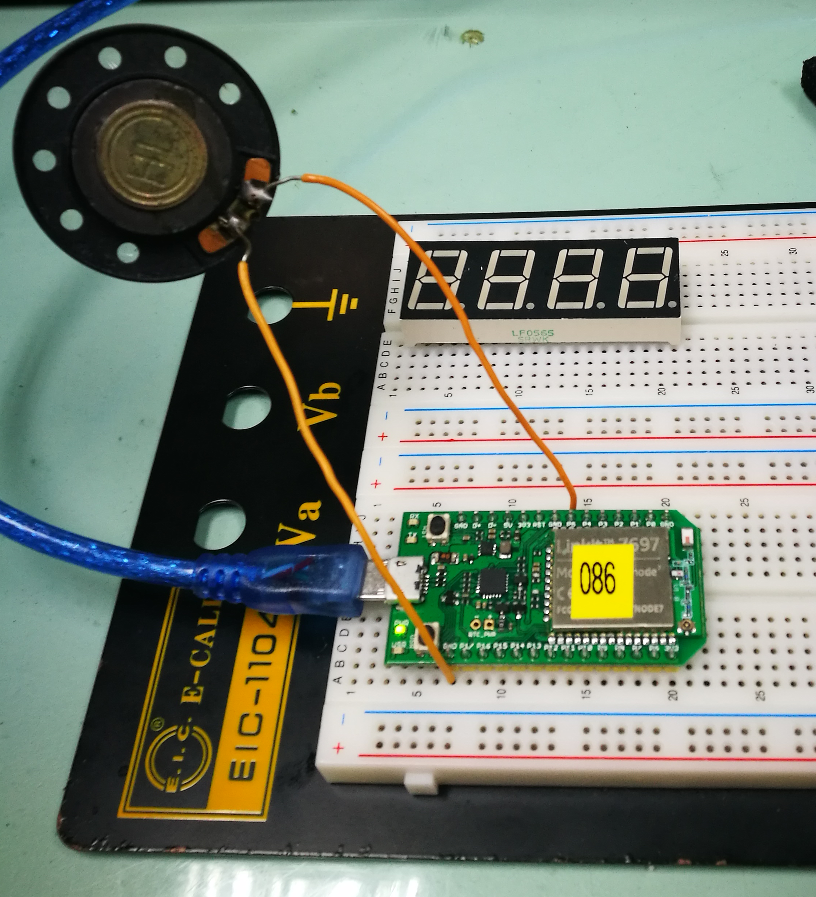
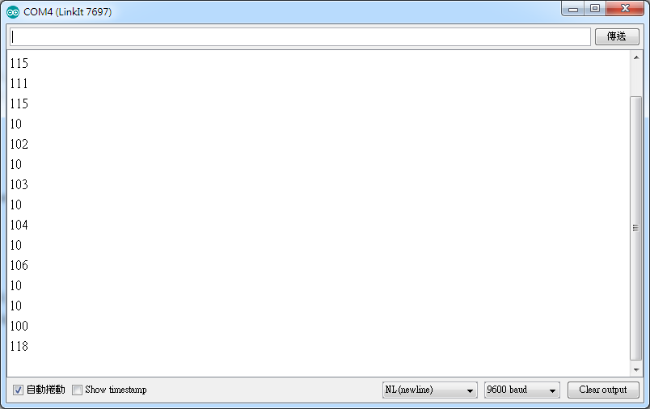
- 心得討論
歌不要找太複雜的，因為音符複雜寫的也很多，總歸來說挺好玩的!
- 修正電路圖
- 修正程式碼

