電通二乙微處理器實驗 實驗結報

實驗名稱 | Lab2走馬燈
組別 | 0 | 組員 | 06050615:陸致翰

- 實驗目的
學會使用arduino的程式及7697板子
- 實驗步驟
Led向左及向右執行花色展示
(花色展示:所有led閃滅兩次->左移8次->所有led閃滅兩次->右移8次)
Linklt7697接上開關
開關off->led向左及向右執行花色展示
開關on->執行自訂花色表示。
- 程式碼
CHECK-1
// Lab02_1
const byte LEDs[] = {2, 3, 4, 5, 8, 9, 10, 11};
int j = 1;
int k;
void setup() {
for (int i = 0; i < 8; i++) {
pinMode(LEDs[i], OUTPUT);
}
pinMode(6, INPUT);
}
void loop() {

for (k = 0; k < 8; k++) {
digitalWrite(LEDs[k], LOW);
}
delay(500);

for ( j = 0; j < 8; j++)
{
digitalWrite(LEDs[j], HIGH);
delay(500);
digitalWrite(LEDs[j], LOW);
}
delay(1000);
for (k = 0; k < 8; k++) {
digitalWrite(LEDs[k], LOW);
}
delay(500);

for ( j = 8; j >= 0; j--)
{
digitalWrite(LEDs[j], HIGH);
delay(500);
digitalWrite(LEDs[j], LOW);
}
delay(1000);
}
CHECK-2
// Lab02_2
const byte LEDs[] = {2, 3, 4, 5, 8, 9, 10, 11};
int j = 1;
int k;
void setup() {
for (int i = 0; i < 8; i++) {
pinMode(LEDs[i], OUTPUT);
}
pinMode(6, INPUT);
}
void loop() {
for(int a=1;a<=2;a++){
for(int i=0;i<=8;i++){
digitalWrite(LEDs[i], HIGH);
}
delay(1000);
for (k = 0; k < 8; k++) {
digitalWrite(LEDs[k], LOW);
}
delay(500);
}
for ( j = 0; j < 8; j++)
{
digitalWrite(LEDs[j], HIGH);
delay(500);
digitalWrite(LEDs[j], LOW);
}
delay(1000);
for(int a=1;a<=2;a++){
for(int i=0;i<=8;i++){
digitalWrite(LEDs[i], HIGH);
}
delay(1000);
for (k = 0; k < 8; k++) {
digitalWrite(LEDs[k], LOW);
}
delay(500);
}
for ( j = 8; j >= 0; j--)
{
digitalWrite(LEDs[j], HIGH);
delay(500);
digitalWrite(LEDs[j], LOW);
}
delay(1000);
}
CHECK-3
// Lab02_3
const byte LEDs[] = {2, 3, 4, 5, 8, 9, 10, 11};
int j = 1;
int k;
void setup() {
for (int i = 0; i < 8; i++) {
pinMode(LEDs[i], OUTPUT);
}
pinMode(6, INPUT);
}
void loop() {
if (digitalRead(6)==true) {
for (k = 0; k < 8; k++) {
digitalWrite(LEDs[k], LOW);
}
delay(500);

for ( j = 0; j < 8; j++)
{
digitalWrite(LEDs[j], HIGH);
delay(500);
digitalWrite(LEDs[j], LOW);
}
delay(1000);
for (k = 0; k < 8; k++) {
digitalWrite(LEDs[k], LOW);
}
delay(500);

for ( j = 8; j >= 0; j--)
{
digitalWrite(LEDs[j], HIGH);
delay(500);
digitalWrite(LEDs[j], LOW);
}
delay(1000);
}

else {
for (int a = 1; a <= 2; a++) {
for (int i = 0; i <= 8; i++) {
digitalWrite(LEDs[i], HIGH);
}
delay(1000);
for (k = 0; k < 8; k++) {
digitalWrite(LEDs[k], LOW);
}
delay(500);
}
for ( j = 0; j < 8; j++)
{
digitalWrite(LEDs[j], HIGH);
delay(500);
digitalWrite(LEDs[j], LOW);
}
delay(1000);
for (int a = 1; a <= 2; a++) {
for (int i = 0; i <= 8; i++) {
digitalWrite(LEDs[i], HIGH);
}
delay(1000);
for (k = 0; k < 8; k++) {
digitalWrite(LEDs[k], LOW);
}
delay(500);
}
for ( j = 8; j >= 0; j--)
{
digitalWrite(LEDs[j], HIGH);
delay(500);
digitalWrite(LEDs[j], LOW);
}
delay(1000);
}
}
- 實驗結果及分析
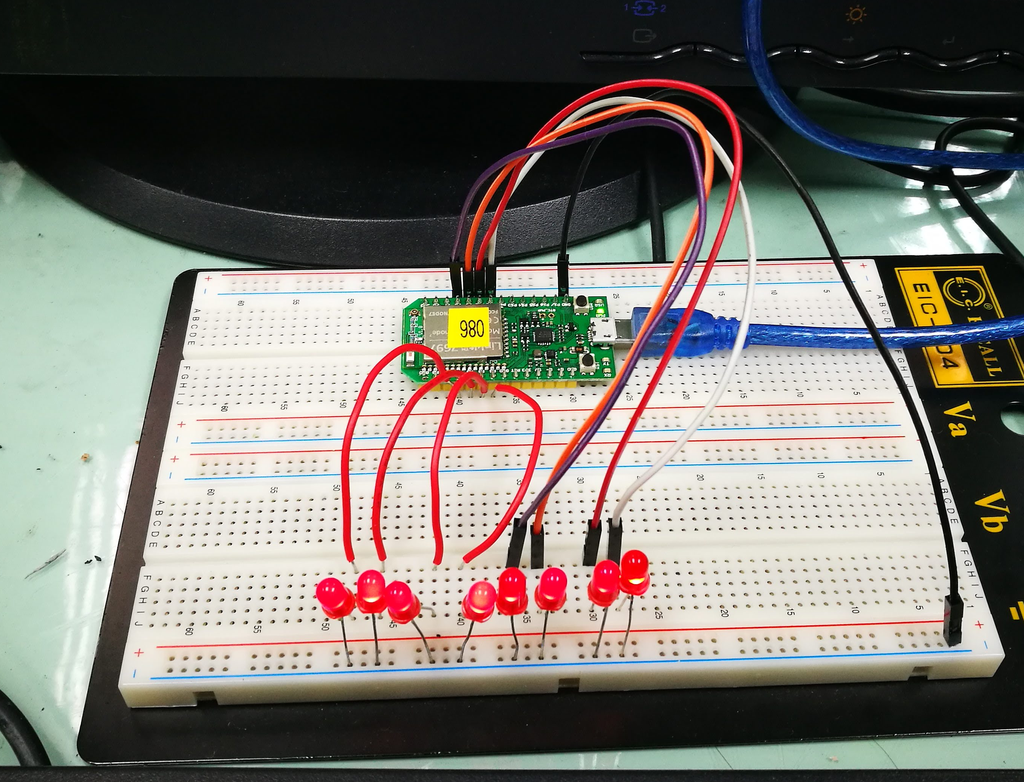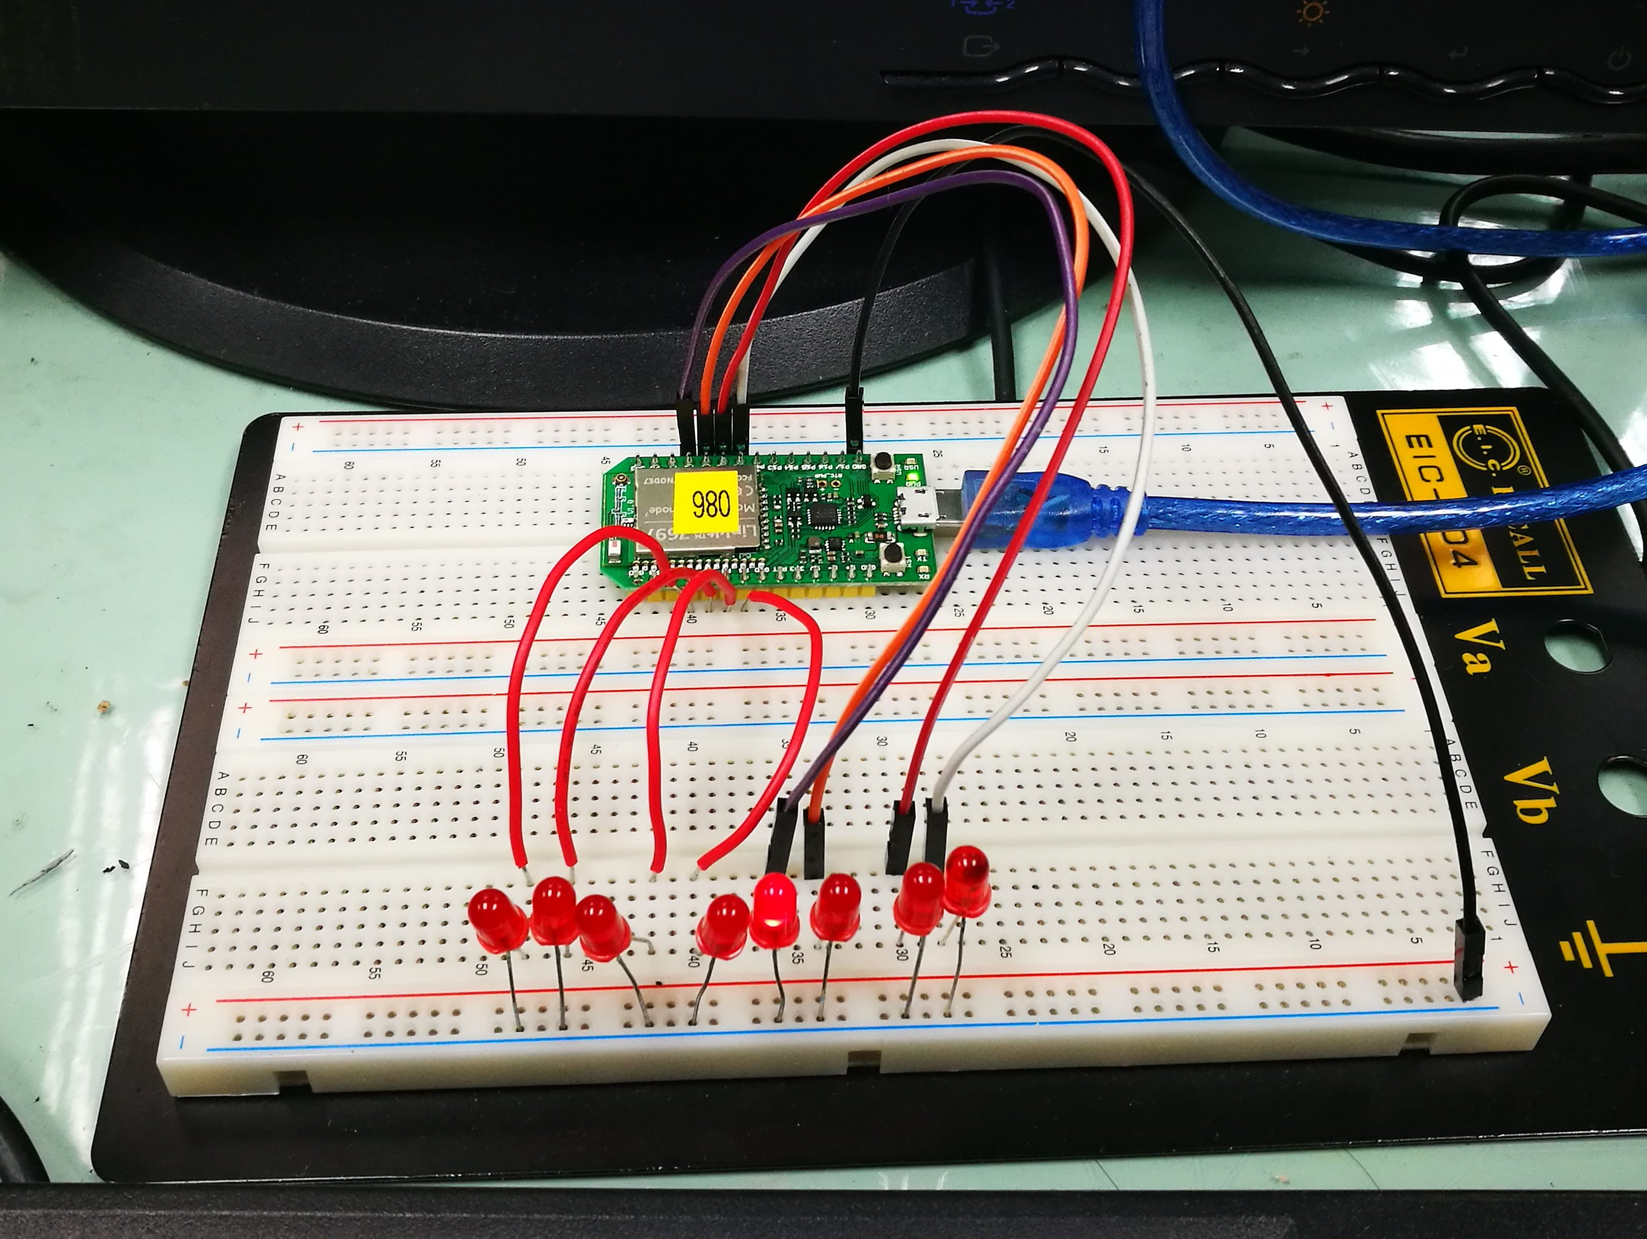
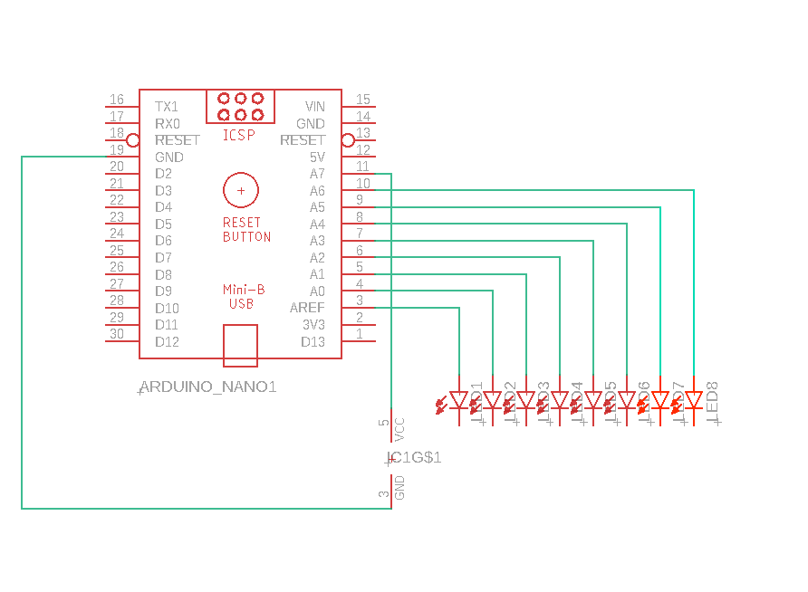
- 心得討論
這次使用ARDUINO的程式尚有許多不熟悉的地方，需要多加熟悉，這次走馬燈的程式，有助於我們學習ARDUINO因為不難，但有些地方需要多加小心才能完成這次的作業!
- 修正電路圖
- 修正程式碼

