電通二乙微處理器實驗 實驗結報

實驗名稱 | Lab03-類比輸入
組別 | 0 | 組員 | 06050615:陸致翰

- 實驗目的
了解類比輸入
- 實驗步驟
把程式打好，測值!
- 程式碼
Check 1
int val;
void setup() {
// put your setup code here, to run once:
Serial.begin(9600);
pinMode(7, OUTPUT);
Serial.print("HELLO WORLD");
}
void loop() {
// put your main code here, to run repeatedly:
if (Serial.available()) {
val = Serial.read();
if (val == '1') {
digitalWrite(7, HIGH);
Serial.print("7 ON");
}
else if (val == '0') {
digitalWrite(7, LOW);
Serial.print("7 OFF");
}
}
}
Check2
double Analogin;
double Vin;
void setup() {
// put your setup code here, to run once:
Serial.begin(9600);
pinMode(14, INPUT);
}
void loop() {
// put your main code here, to run repeatedly:
for(int i=0;i<=5;i++)
Analogin=0.7*Analogin+0.3*analogRead(14);
Vin=Analogin*2.5/4095;
Serial.print(Vin);
delay(500);
}
Check3
int val;
int Vin;
double sensorValue;
double sensorVoltage;
int R1;
int R2;
void setup() {
// put your setup code here, to run once:
Serial.begin(9600);
}

void loop() {
// put your main code here, to run repeatedly:
val = analogRead(15);
Serial.println(val);
delay(500);
for (int i = 0; i <= 5; i++) {
sensorValue = 0.7 * sensorValue + 0.3 * analogRead(15);
}
sensorVoltage = sensorValue * 2.5 / 4095;
R1 = sensorVoltage * 1035500 / 2.5;
Serial.print("R1=");
Serial.print(R1);
Serial.println();
Serial.print("sensorVoltage=");
Serial.print(sensorVoltage);
Serial.println();
delay(500);
}

Check4
int val;
int Vin;
double sensorValue;
double sensorVoltage;
int R1;
int R2;
void setup() {
// put your setup code here, to run once:
Serial.begin(9600);
}

void loop() {
// put your main code here, to run repeatedly:
val = analogRead(15);
Serial.println(val);
delay(500);
for (int i = 0; i <= 5; i++) {
sensorValue = 0.7 * sensorValue + 0.3 * analogRead(15);
}
sensorVoltage = sensorValue * 2.5 / 4095;
R1 = sensorVoltage * 1035500 / 2.5;
Serial.print("R1=");
Serial.print(R1);
Serial.println();
Serial.print("sensorVoltage=");
Serial.print(sensorVoltage);
Serial.println();
delay(500);
}
- 實驗結果及分析
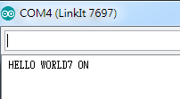
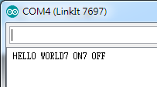
實際電壓 | AnalogRead讀值 | 推測電壓(V)
0 | 11 | 0
0.5 | 831 | 0.51
1 | 1644 | 1.01
1.5 | 2447 | 1.51
2 | 3313 | 2.02
2.5 | 4095 | 2.49

可變電阻測量值(Ω) | AnalogRead讀值 | 推測電壓(V) | 推測電阻值(Ω) | SerialMonitor輸出
356 | 1 | 0 | 328 | 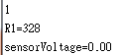
38677 | 158 | 0.09 | 38684 | 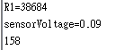
159972 | 612 | 0.38 | 159393 | 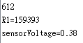
177842 | 769 | 0.43 | 176947 | 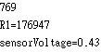
917321 | 3592 | 2.19 | 906445 | 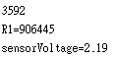
103577 | 4059 | 2.5 | 1035495 | 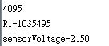

AnalogRead讀值 | 推測電壓(V) | 推測電阻值(Ω) | SerialMonitor輸出
37 | 0.03 | 10917 | 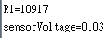
741 | 0.38 | 158432 | 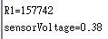
636 | 0.48 | 197273 | 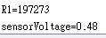
853 | 0.55 | 228171 | 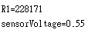
710 | 0.72 | 297681 | 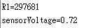
2199 | 1.35 | 560565 | 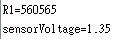

- 心得討論
前兩題還蠻簡單，後兩題需要想一想!
- 修正電路圖
- 修正程式碼

