**Household & Family Unit**

Algorithm:

1. calculate total smoothed population by age (population by age group);

2. male/female population by age group in each mesh block available?

YES: assign gender according to male/female by age group;

NO: estimate male/female by age group according to mesh block population and sex

ratio by age group;

3. matching couples by minimizing age difference to build family units according to marital status by age;

4. allocate children into family units according to number of children ever born by age of mother & live birth by age of mother and live-birth order;

5. allocate family units into household according to zero-truncated Poisson distribution;

**Labor Force Participation**

Based on urban labor force participation rate of Samoa 2012.

using (W) Samoa seems to make sense. There would be some differences in American Samoa because of the military influence and the reliance on US welfare and social security (retirement) system. American Samoa has strong policy on ancestral land rights and not much on agriculture, whereas I imagine more people in Samoa are subsistence farmers/fishers? In Samoa there seems to be more availability of private land purchase or lease, support for business development, and the tourist industry is huge. But in general, there are still probably more similarities than differences.

On the question of gender difference in infection, workforce participation may be contributing, but you see higher prevalence in males in many countries where most people of both genders are subsistence farmers without formal jobs (e.g. PNG). Apart from exposure, some people think there is a hormonal component or other reason for difference in gender susceptibility.

In 2010, 411 of 807 respondents reported a job, of which 289 respondents reported a job village different from residential village. The overall commuting ratio is 289/411 = 70.3%.

**Job dynamics**

For any individual with age , let and be the labour force participation rate at age and , then:

* if : (i) is employed at age given is employed at age ; (ii) is employed with probability at age given is unemployed at age ;
* if : (i) is unemployed at age given is unemployed at age ; (ii) is unemployed with probability at age given is employed at age ;

**Schooling Enrolment**

Individual aged 6-13 are assumed to enrol at the nearest elementary school. Individual aged 14-17 who are not in the labour force are assumed to enrol at the nearest high school. Individuals aged 18-19 who are not in the labour force are assumed to enrol at the AS Community College.

**Natural History** [1, 2]

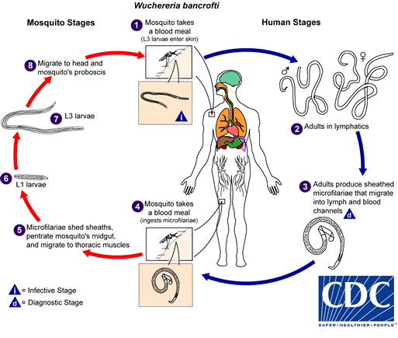

1. Stage 5 - 8

10 to 14 days, L3 can remain alive and active for about 46–50 days [3].

1. Stage 1 - 2

Approximately 9 - 10 days after entry, L3 moults to become the fourth stage larva (L4) [3]. Pre-patent period is believed to be several months. In our research, an average pre-patent period of 5 months is used [3, 4].

1. Stage 2 - 3 [3]

Estimation based on deterministic model showed that the life span of W. bancrofti adult female is 10.2 years. The rate of production of mf by the adult female was found to be stable at least for a period of 5 years.

Adult life span, mean 10 years, maximum 14 years

**Risk Parameters**

1. risk range: r = 150m [5]
2. effective transmission rate: [6]
3. relative mosquito exposure: c = 0.25 (aged 0-4) and 0.75 (aged 5-15) [7]
4. proportion of positive mosquitos: 0.28%, 95% CI (0.20%, 0.39%) [8], similar to Ref [9]
5. mated female worms: (i) pre-patent rate, (average pre-patent 150 days); (i) death rate

**References:**

1. Taylor, M.J., A. Hoerauf, and M. Bockarie, *Lymphatic filariasis and onchocerciasis.* The Lancet, 2010. **376**(9747): p. 1175-1185.

2. Morris, C.P., et al., *A Comprehensive, Model-Based Review of Vaccine and Repeat Infection Trials for Filariasis.* Clinical Microbiology Reviews, 2013. **26**(3): p. 381-421.

3. Paily, K.P., S.L. Hoti, and P.K. Das, *A review of the complexity of biology of lymphatic filarial parasites.* Journal of Parasitic Diseases, 2009. **33**(1): p. 3-12.

4. Ash, L.R. and J.F. Schacher, *Early Life Cycle and Larval Morphogenesis of Wuchereria bancrofti in the Jird, Meriones unguiculatus.* The Journal of Parasitology, 1971. **57**(5): p. 1043-1051.

5. Hapairai, L.K., et al., *Population studies of the filarial vector Aedes polynesiensis (Diptera: Culicidae) in two island settings of French Polynesia.* J Med Entomol, 2013. **50**(5): p. 965-76.

6. Norman, R.A., et al., *EPIFIL: the development of an age-structured model for describing the transmission dynamics and control of lymphatic filariasis.* Epidemiol Infect, 2000. **124**(3): p. 529-41.

7. Stone, W., et al., *Assessing the infectious reservoir of falciparum malaria: past and future.* Trends in Parasitology, 2015. **31**(7): p. 287-296.

8. Schmaedick, M.A., et al., *Molecular Xenomonitoring Using Mosquitoes to Map Lymphatic Filariasis after Mass Drug Administration in American Samoa.* PLoS Negl Trop Dis, 2014. **8**(8): p. e3087.

9. Hairston, N.G. and B. de Meillon, *On the inefficiency of transmission of Wuchereria bancrofti from mosquito to human host.* Bulletin of the World Health Organization, 1968. **38**(6): p. 935.