Innovation Case Lecture Notes
Audiences and Users
- How might your research help others?
- Does it make something less painful or costly? Does it make something easier or more rewarding? Is it better than current options?
- Do you have a solution looking for a problem to solve?
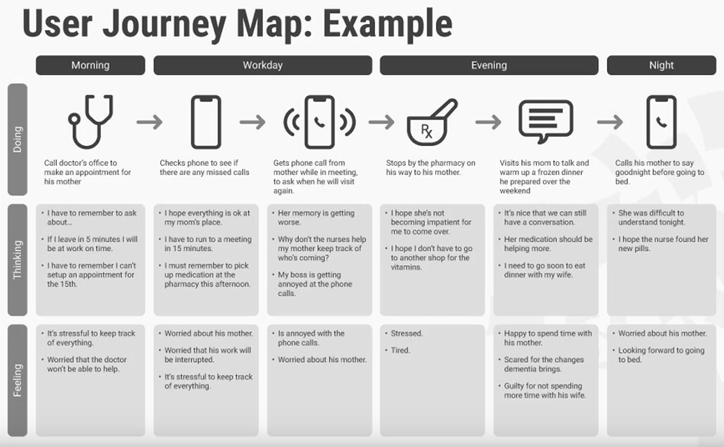
- Who cares?

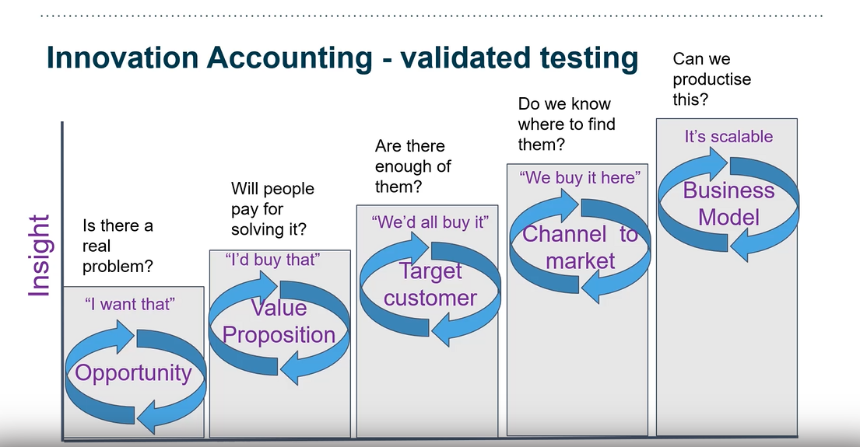
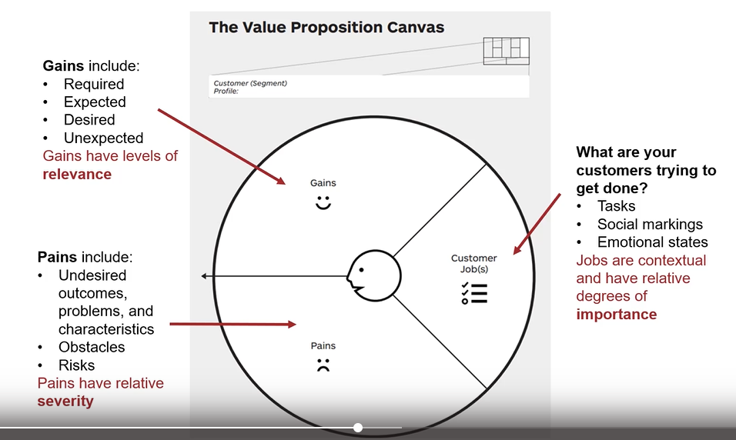
Value Proposition
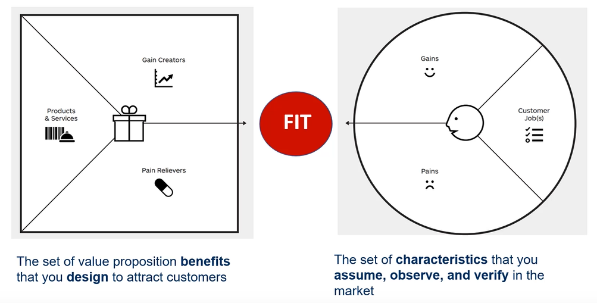
- A description of the benefits users can expect from your products and services.
- Tool/plugin for trading firms, algorithmic trading tool using ML
- Automates more of the process: saves time and costs
- More/better trades
- More profit for clients
- Costs of tools
- Accuracy and credibility of tools is very important, would they buy something from a graduate student?
- Does it work with existing tools
- Tool for private investors
- Simple to use, pocket money + fun, takes time + effort
- Passive income, requires little time and effort – automated

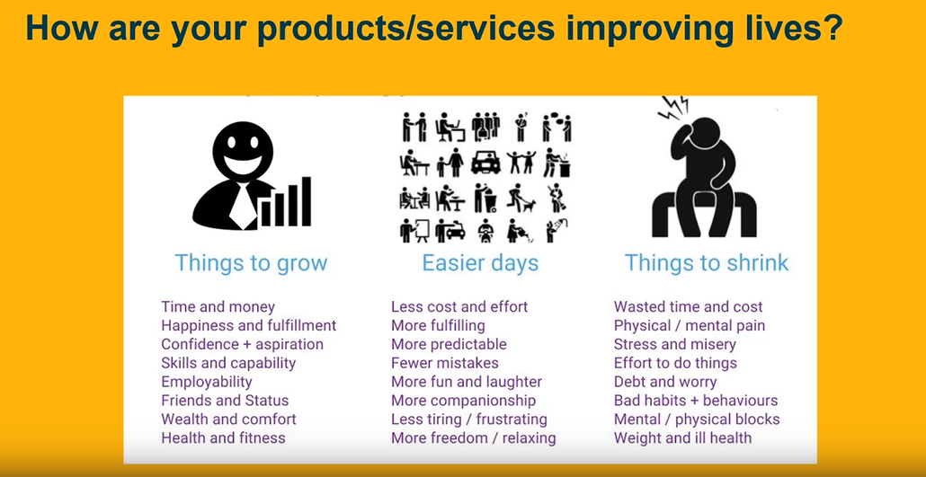
- Desirability
- Feasibility
- Viability

