Learning Long-Term Dependencies in Irregularly-Sampled Time Series
Introduction:
- RNNs with continuous-time hidden states are natural fit for modeling irregularly-sampled time series.
- Face difficulties when input data possesses long-term dependencies.
- Vanishing and/or exploding gradient.
- Expressed by the ordinary differential equation (ODE) representation of hidden state.
- This paper discusses a solution by designing a new algorithm based on the LSTM network that separates memory from its time-continuous state.
- This encodes continuous-time dynamical flow within the RNN, allowing it to respond to inputs arriving at arbitrary time-lags while ensuring a constant error propagation through memory path.
- Models named ODE-LSTMs.
- Outperform RNN-based counterparts on non-uniformly sampled data with long-term dependencies.
- LSTMs demonstrate great performance on learning equidistant streams of data, however similar to other discrete-state RNNs, are puzzled with the events arriving in-between observations.
Architecture:
- RNN state of standard LSTM is represented by a pair (c_{t,} h_{t}) where c_{t} is the memory cell and h_{t} the output state.
- Memory ensures constant error propagation and output state enables the LSTM to learn non-linear dynamics.
- ODE-LSTMs leave RNN’s memory mechanism untouched and assert the continuous dynamics into output function that processes the state.
LSTMs:
- Understanding LSTM Networks -- colah's blog
- Hidden state of an RNN is a variable passed through the RNN (not the same as hidden layer in a feedforward network), each RNN layer will take two inputs; one for our input and a previous hidden value, and two outputs; one for output and the next hidden value. F(x,h) -> (y, h_{t+1}).
- The hidden values are able to encode some information about the sequence which will help in predicting the next character.
- LSTM units are just another way of calculating a hidden state.
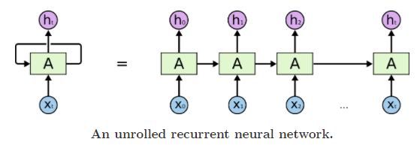
- LSTMs aim to solve the issue of forgetting long-term dependencies in RNNs due to vanishing gradient (hidden state from h₀ doesn’t have much effect on x₁₀).
- Think about predicting the last word of the following sentence “I grew up in France… I speak fluent French.” (recent information suggests the word is a language, long-term information suggests that language would be French).
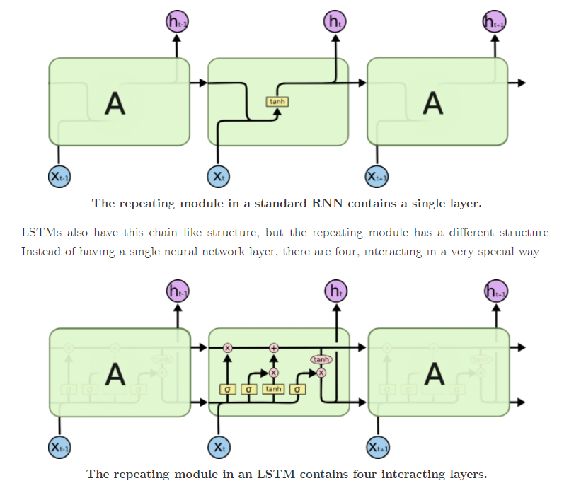
- Fixing the input gate all 1’s and the forget gate to all 0’s (always forget the previous memory) and the output gate to all 1’s (you expose the whole memory) you almost get a standard RNN.
- Some LSTMs even have a peephole to connections that allow the gates to not only depend on the previous hidden state s_{t-1}, but also on the precious internal state c_{t-1}, adding an additional term in the gate equations.
Neural ODE notes:
- https://jontysinai.github.io/jekyll/update/2019/01/18/understanding-neural-odes.html
- Ordinary differential equations are equations relating a function f of one variable to its derivatives. Ordinary refers to the differential equations involving one variable as opposed to equations involving several variables (partial differential equations).
- ODE’s are used to solve data modelling problems.
- They model rates of change as an alternative to regression (which attempts to model data directly).
- Seem to be promising for continuous time settings.
- They offer memory efficiency, adaptive computation, scalable and invertible normalizing flows and continuous time-series (unlike recurrent neural networks, which require discretising observation and emission intervals, continuously-defined dynamics can naturally incorporate data which arrives at arbitrary times.
- Machine learning can be thought of as approach to iteratively find a function that best describes some set of data e.g. X -> (black box function) -> Y, the neural net can help us get from X to Y.
- Neural networks can be viewed as an algorithmic approximation which bypasses the generative process of data, trained over many iteration of an optimization loop.
- Neural networks are highly flexible; they are high-dimensional, have millions of parameters over which we can compress patterns found in data, are highly nonlinear and can be implemented using highly optimised computing frameworks.
- To understand where ODEs fit in, it is useful to abstract away from neural networks and return to the original function X -> f -> Y. We want to find a robust mapping from X to Y. f: X -> Y.
- Given a dataset D, there are two basic approaches to solving this problem, regression and ordinary differential equations.
- Regression can be thought of as curve fitting, finding a line which best fits the data and maps X to Y, e.g. if the data points are in R², then the mapping could be a straight line f*(x) = a*x + b*.
- This is usually done by optimizing some loss function like MSE (distances from data points to the predicted line).
- In order to optimize a loss function we require the function we’re approximating to be differentiable (huge care is usually taken in network architectures to ensure they are differentiable).
- Every differentiable function f has a derivative f’ which is the continuous limit of the rate of change of f df/dx = f’. If the function satisfies certain continuity properties then we can go the other way round (integration), F(x) = ∫ f(x) dx.
- With regression we assumed there was a continuous and differentiable relationship between x and y described by the function f: y = f(x).
- In regression we try to find f directly.
- If f is differentiable, what if we tried to find its derivative instead, this amounts to searching for f indirectly by differentiating the regression relationship: dy/dx = f’(x).
- This is the basic form of an ODE, solving the ODE is equivalent to solving the integral f(x) = ∫ f’(x) dx.
- It can therefore be viewed as a function approximation, only here we are approximating the derivative instead.
Basic form of ODE:
- In the basic form of ODE, we allow the derivative to depend not only on x, but also on y – allowing for greater modelling flexibility.
- In calculus you need a pair of points, x₀ and y₀ to determine the one unknown constant value. In ML we have an entire dataset D of N points.
- Functional form of integral will depend on the approximating function we choose for the derivative, precise form of integral will depend on data.
- Using f to denote the function describing the derivative in the ODE, the setup is:
y’(x) = f(x,y), y(x₀) = y₀
- Where y(x) is interpreted as the value of y at x.
- We now have a function describing the rate of change (how y changes as x changes) as opposed to the direct relationship.
- Approximating derivatives reduces the number of parameters and also the number of function evaluations (computational costs) required to find the optimal parameters.
Parametric efficiency:
- In R² problem with regression we were trying to approximate linear relationship ax + b, with two free parameters, a and b:
y≈f(x)=ax+b.
- Free means the parameters are allowed to vary as we try to minimize loss, they are the parameters we are trying to optimize.
- If we use the ODE approach, we know the parametric form of the derivative, which can be written as dy/dx = a.
- Now we are trying to approximate the function:
dy/dx≈f(x,y)=a.
- Only one free parameter a.
- Solving this problem analytically would still mean solving for b. However most ODE problems can’t be solved anylitcally and require numerical methods.
- These numerical methods are implicit in that they don’t analytically give you the integral but rather a set of function evaluations at future points.
- So we don’t care about the parameter b, all we need is an initial point (x₀,y₀) to get stated and a number of additional points from the data to fine tune the fit.
- This is more computationally efficient than ODE.
Numerical methods for ODEs:
- Analytical is exact whereas numerical is approximate (some differential equations cannot be solved exactly – analytic or closed form solution, so we must rely on numerical techniques to solve them).
- With ODEs, we often can’t solve analytically so we need to resort to numerical methods which approximate a solution at discrete evaluation points.
- How do we find solution for ODE numerically?
- The gradient of the integral is available to us – in our setup it is f(x,y) – and we know that the gradient traces the curvature of the function we are trying to solve for (gradients at each point on a parabola for example).
- We can precisely use this method to compute integrals numerically. We start at an initial point and move in the direction of the gradient evaluated at the initial point to get a new evaluation point.
- Starting at the second evaluation point we repeat for a third evaluation point and so on.
- This is the basic idea behind Euler’s method.
- Euler’s method is a starting point for advanced numerical methods.
- Euler’s method falls in to two larger classes of methods: Runge-Kutte methods
and Adams-Bashford methods.
Euler’s method:
- To describe Euler’s method, we replace the symbol for the input domain by t. By convention we’ll interpret t as being a time element in the evolution of y as we iteratively use the method.
- Euler’s method is derived from the basic definition of the tangential approximation of the gradient at a point.
dy/dt≈y(t+δ)−y(t)δ,
- Where δ, is a fixed step-size, we can rearrange this expression to get:
y(t+δ)=y(t)+δdy/dt.
- This is an explicit algebraic description of the stepwise procedure described above. We can then plug in the functional formula for the derivative to get:
y(t+δ)=y(t)+δf(t,y).
- Finally to compute approximations for y using Euler’s method, we need to discretise the domains. Starting from an initial point (t₀,y₀), we define a computation trajectory recursively as follows:
tn+1=tn+δ(n+1), n=0,1,2,…
yn+1=yn+δf(tn,yn), n=0,1,2,…

- At each time point we use the current value of y to calculate the next value, the gradient tells us which direction to move in and by how much.
Optimising the ODE:
- At this point we have a modelling assumption dy/dx = f(x,y) = a, and we have a numerical method for evaluating y at different values of x, however for Euler’s method we need to explicitly define f(x,y), which requires that we have a value for a. (ML will treat a as a free parameter that we need to optimize).
- We can make an initial guess for a and use Euler’s method to compute the forward pass on our data. Each numerical method is different but for Euler’s method we compute the forward pass as follows:

- Choose an initial value for a and a fixed stepsize δ
- Choose some (x0,y0) to be the initial value. Choose k data points to evaluate at, and order your choices. Choosing k<N points can reduce the scaling complexity of ordering.
- Add additional points from X so that you can use Euler’s method at regular intervals. This is your computation trajectory.
- Compute Euler’s method along your computation trajectory, also evaluating at your chosen points from your data.

- You can calculate the loss by comparing Euler’s method evaluated at the k chosen datapoints with their actual values.
- In the backward pass you can calculate the derivative of your loss function with respect to a, for each evaluation point, and adjust it as you would in gradient descent.
- So using Euler’s method in the context of a ML optimization problem, we have a as a free parameter. It is the only free parameter for describing a linear relationship where we would usually require two.
Neural ODEs:
- Neural networks are universal function approximators, so we can use a neural network to approximate f.
- In theory if we can approximate the derivative of any differentiable function using a neural network, then we have a powerful modelling tool at hand with more flexibility in the modelling process.
- Consider a neural network where the hidden states all have the same dimension. Each state depends on a neural layer, f, which itself depends on (free) parameters θ_{t}, where t is the layer depth,
ht+1=f(ht,θt).
- If we have a residual neural network then,
ht+1=ht+f(ht,θt).
- Similar form to Euler’s method. Euler’s method is a discretization of the continuous relationship between the input and output domains of the data. Neural networks are also discretisations of this continuous relationship, only the discretization is through hidden states in a latent space.
- Residual networks create a pathway through the latent space by allowing states to depend directly on each other (like updates in Euler’s method).
- Latent space is simple a representation of compressed data in which similar data points are closer together in space.
- We consider the continuous limit of each discrete layer in the network.
- Idea proposed by ODEs: instead of a discrete number of layers between input and output domains, we allow the progression of the hidden states to become continuous:
dh(t)/dt=f(t,h(t),θt),
- Where h(t) is the value of the hidden state evaluated for some t, which we understand as a continuous parameterization of layer depth.
- f(t,h(t),θ_{t}) is a neural network layer parameterised by θ_{t} at layer t.
- An RNN has a looping mechanism that acts as a highway to allow information to flow from one step to the next. Passing Hidden State to next time step. This information is the hidden state, which is a representation of previous inputs.
- We can evaluate the value of the hidden state at any depth by solving the integral
h(t)=∫f(t,h(t),θt)dt.
- We solve this integral using numerical ODE.
- We take the input as h(t₀) = x I.e. the initial value of the ODE and to let the output be evaluated at some time t₁ sot that h(t₁) = y.
- The function approximation problem now takes place over a continuous hidden state dynamic.
- We put everything together into a numerical ODE solver of our choice:
yˆ = h(t1) = ODESolve(h(t0),t0,t1,θ,f),
- Where f is a neural network.
Backpropagation through depth:
- We backpropagate (reverse-mode differentiation) through the continuous hidden state dynamics.
- In the neural ODE our parameters are not just θ_{t}, but also the evaluation times t₀ and t₁.
- As usual we define any differentiable loss function of our choice on these free parameters:
L(t0,t1,θt) = L(ODESolve(h(t0),t0,t1,θ,f)).
- To optimize using backpropagation, we compute the gradient of the loss with respect to the hidden states.
- The hidden state is dependent on the time (depth), so we can take a derivative with respect to time.
- This is where the adjoint method comes in, a numerical technique for efficiently computing gradients.
- The adjoint state represents how the loss depends on the hidden state (continuous along a trajectory) at any time t:
a(t) = −∂L/∂h(t).
Summary of neural ODE approach:
- We have a set of N pairs of data points, {(x1,y1),…,(xN,yN)}. Given a new data point, x∗, we would like to make a prediction about it’s value y∗. We seek a functional approximation to the relationship between the input and output domains.
- Instead of modelling this relationship directly, we model the derivative:
dy/dx = f(x,y).
- We paramatrise this approximation by a neural network with hidden states h(t), depending continuously on layer depth t, with h(t0)=x and h(t1)=y. The function approximation problem is now
dh(t)/dt = f(t,h(t),θ),
where f is a neural network.
- This is an ODE describing continuous hidden state dynamics. We can solve the data modelling problem by solving this ODE. This reduces to solving the integral
h(t) = ∫f(t,h(t),θ)dt.
yˆ=h(t1)=∫t1t0f(t,h(t),θ)dt.
The analytical solution of this integral is not available to us. Instead we can use a numerical method (available to us using modern numerical computation software) to solve the integral at the required evaluation points:
yˆ=h(t1)=ODESolve(h(t0),t0,t1,θ,f).
- The free parameters of this problem are t₀, t₁ and θ. We optimise our choice of these free parameters by backpropagating through the ODE solver using the method of adjoints.
Additional ODE Notes:
- https://www.youtube.com/watch?v=AD3K8j12EIE
- Considers neural networks as a continuous function (rather than having discrete layers as in normal neural networks) hence the expression “ODEs learn their depth”.
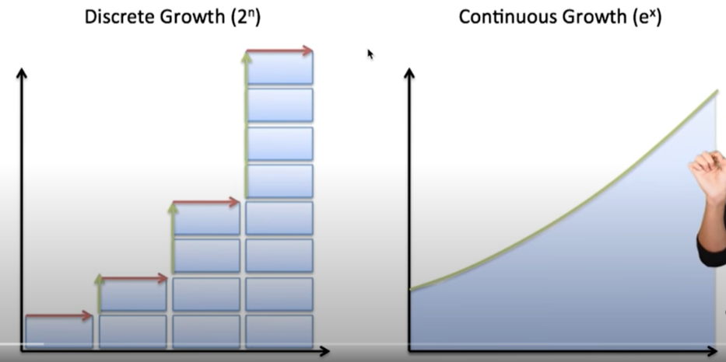
- No specifying the number of layers beforehand, we just specify the desired accuracy and it will learn how to train itself within that margin of error.
- Faster testing time than recurrent neural networks.
- More accurate results for time-series predictions (stock prices changing over time, biometric data etc.). Recurrent neural networks expect discretised timesteps.
- Opens up a whole new realm of mathematics for optimising neural networks.
- Compute gradients with constant memory costs.
- Residual networks feed in the output of the previous layer and the input of the previous layer.
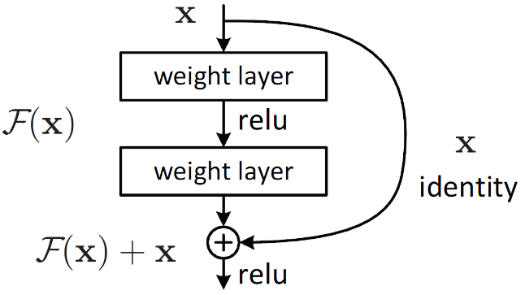
- X_{k+1} = x_{k} + F(x_{k}), helps avoid vanishing gradient problem for very deep networks.
- Adding a constant in front of F(x) is the formula for eulers method for solving differential equations, X_{k+1} = x_{k} + hF(x_{k}).
- ODE solvers find/approximate the original function from the ordinary differential equation (Euler’s method is an example of an ODE solver).
- New neural network layers can be created through different numerical approaches to solving ODEs.
- The possibility of arbitrarily deep neural networks.

