((: By GOD :))

Software name: **GameJudge2**  Version: **2 [March 3, 2017]**

Developer: **Michael B.Khany** Default language: **Persian**

Notes:

Also available in English and German language.

Two themes supporting added

Fonts are variative now

**How it works?**

**Loading teams list…**

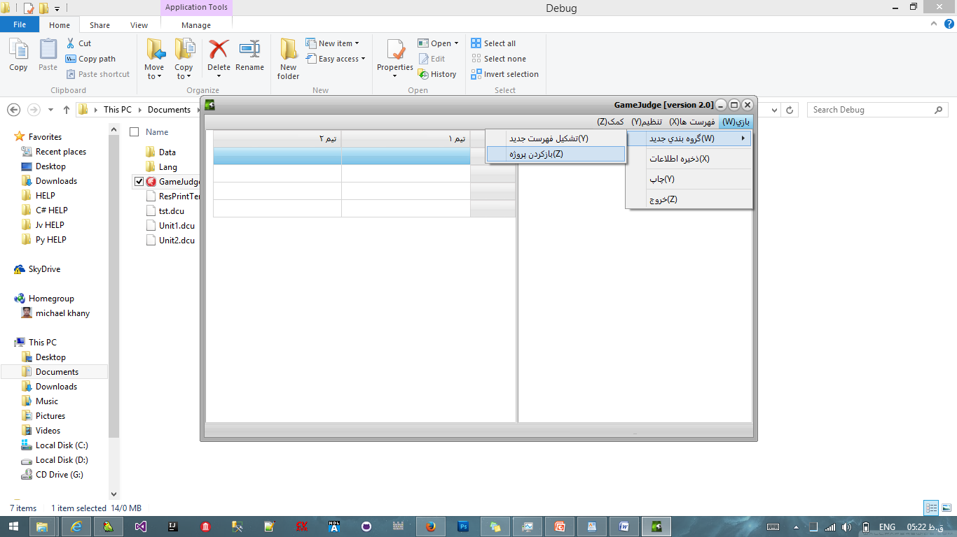

**Teams list instance:**

Head Name-Soccer team

e.g.:

محمدجواد فرجودی-بایرن

محسن موسوی

محمد خوشوقت-رئال

کوروش قربانی-بایرن

**Changing language:**

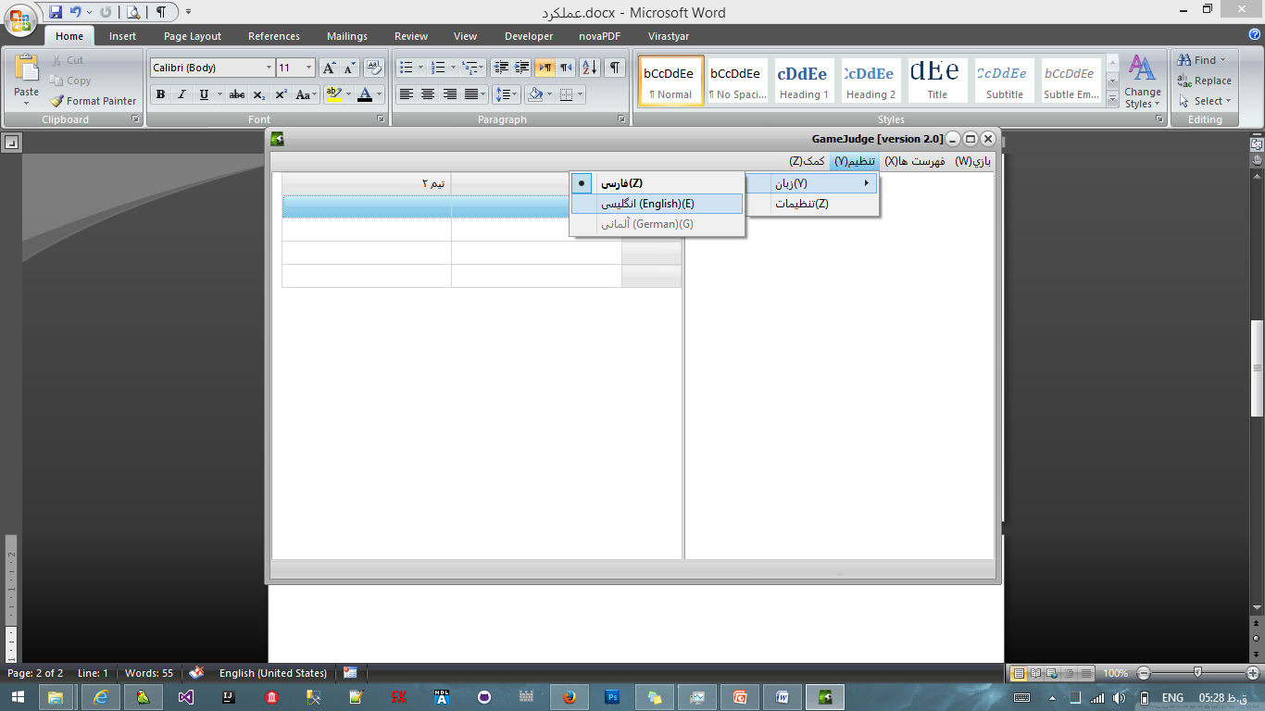

**How to setup?**

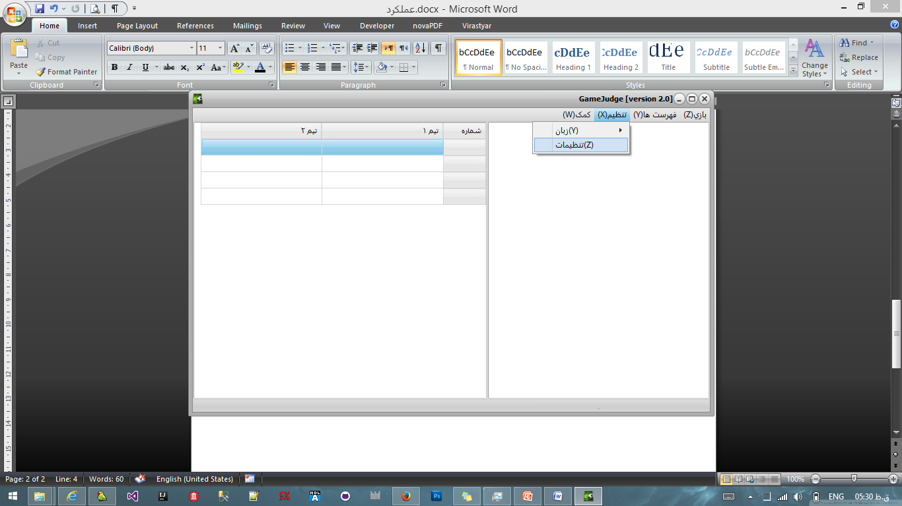

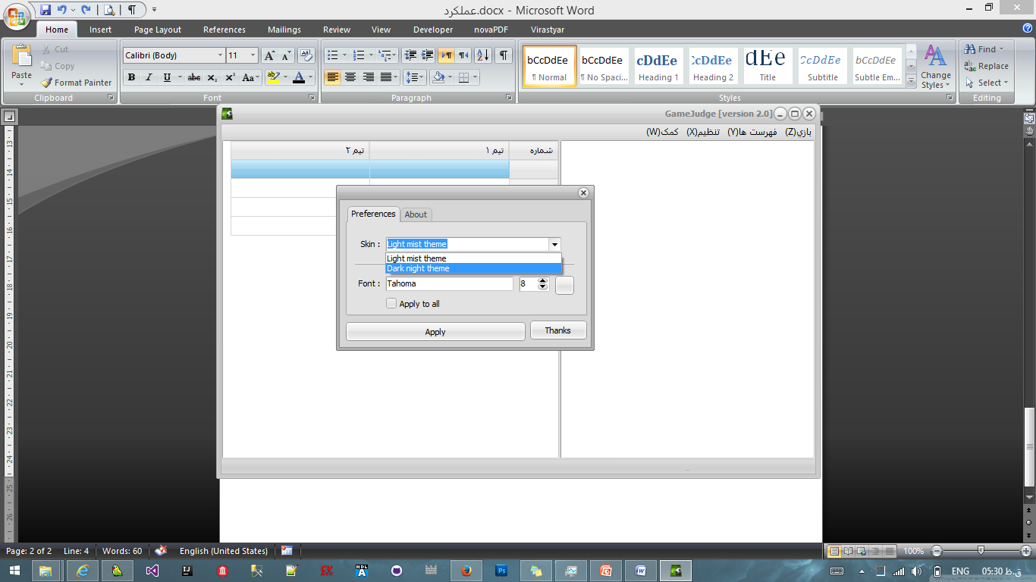

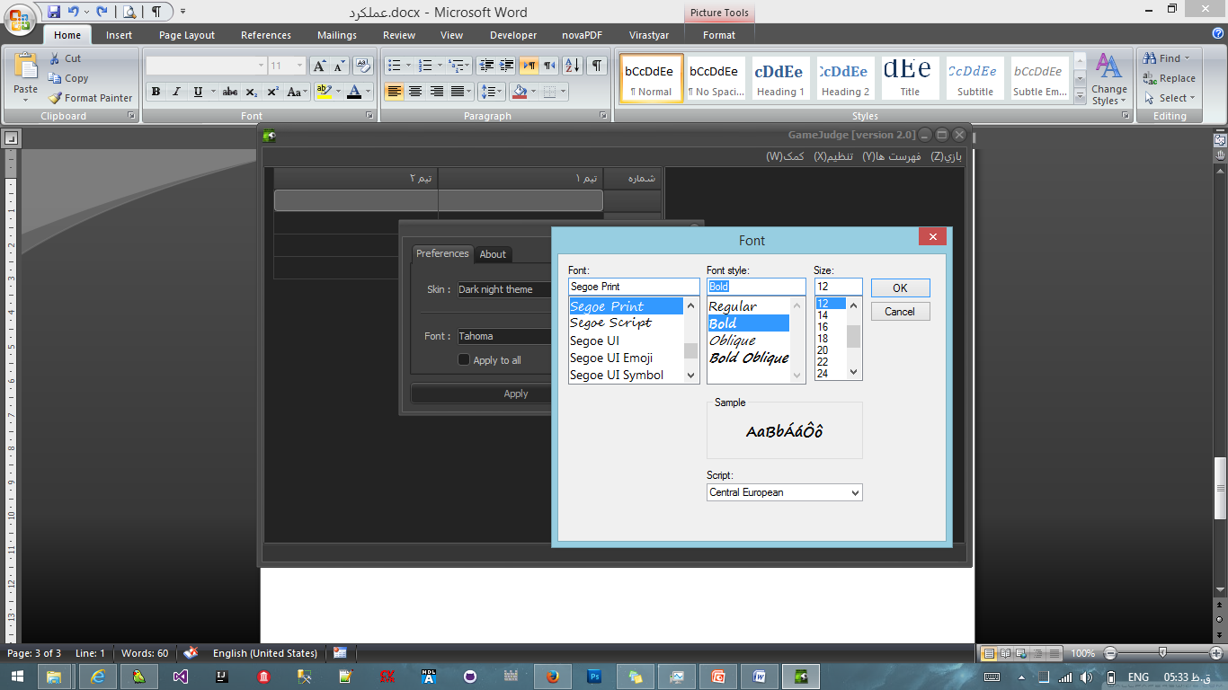

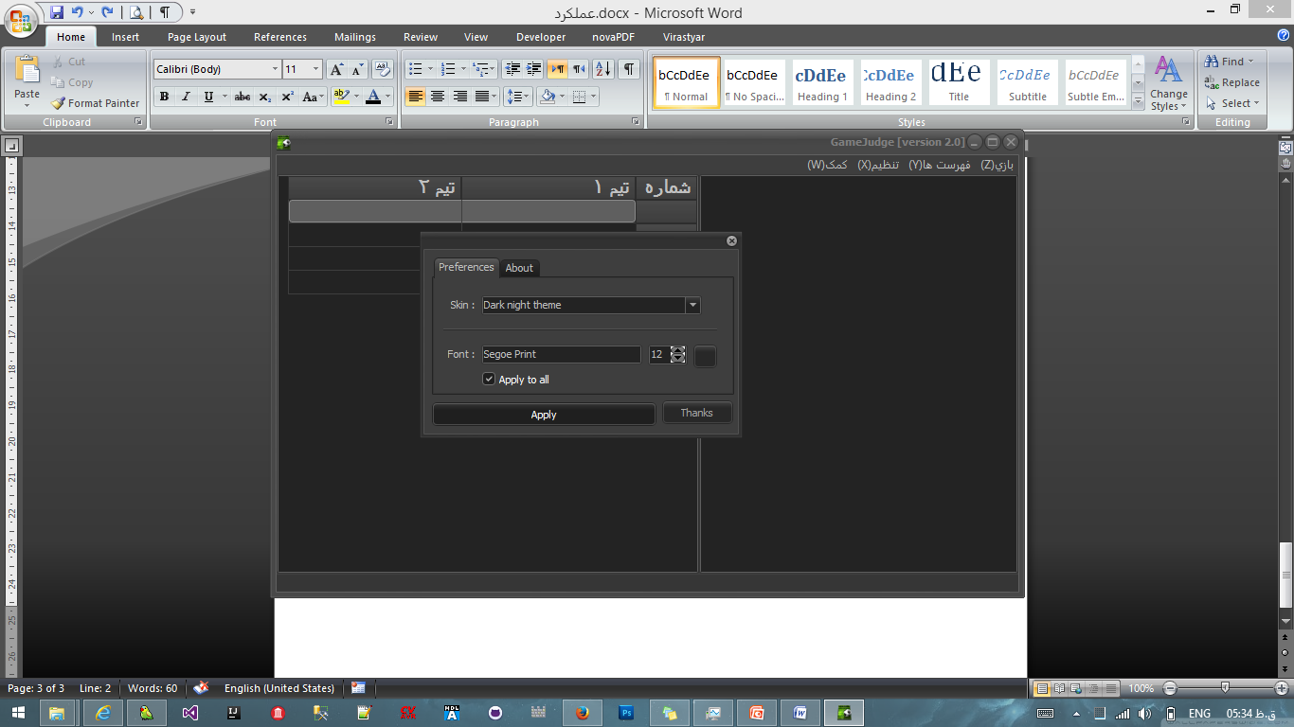

**The END**