Hi Leo,

I wrote python code for problem 1 to 4, and built docker image.

You can see my work and result via github link.

I am using local airflow, which is unable to install some packages, but I am confident my code could work well if the libraries are installed.

P2 bonus, I wrote a function to manually test mean value.

P3 bonus, I have proposed a linear SVM model, which usually have higher accuracy.

Airflow diagram

Airflow log

P4

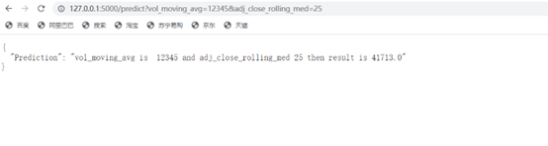

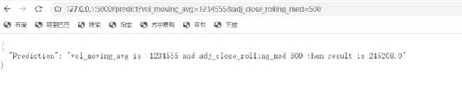

I deployed the model on my virtual environment, it works well, but when I deployed on [Heroku](https://www.heroku.com/), it didn’t work.

The github link for python code is at <https://github.com/Angyu-Wu/work>

The github link for API service code is at <https://github.com/Angyu-Wu/P4>