

**CAPSTONE PROJECT 1**

**WORKLOAD MANAGEMENT SYSTEM FOR INTERNATIONAL SCHOOL**

PROPOSAL DOCUMENT

Version: 1.2

**Mentor: Trinh, Tran Thi Thuy**

**Group:**

* **Hieu, Ngo Quoc**
* **Huyen, To Thi Ngoc**
* **Khanh, Le Anh**
* **My, Nguyen Van**
* **Nhan, Huynh Ba**

Proposal Review Panel Representative:

Name Signature Date

Capstone Project 1- Mentor:

Name Signature Date

**Trinh, Tran Thi Thuy** 

International School – Duy Tan University

**PROJECT INFORMATION**

| **Project** **Acronym** | Proposal Document | | | | |
| --- | --- | --- | --- | --- | --- |
| **Project Title** | Workload Management System for International School | | | | |
| **Start Date** | 17/08/2022 | **End date** | | 10/12/2022 | |
| **Lead Institution** | International School, Duy Tan University | | | | |
| **Project Mentor** | Tran Thi Thuy Trinh | | | | |
| **Project Mentor & Contact Details** | Name: Tran Thi Thuy Trinh  Email: trantthuytrinh@duytan.edu.vn  Phone: 0795898823 | | | | |
| **Partner Organization** | Duy Tan University | | | | |
| **Team Members** | Name | | Email | | Phone |
| Hieu, Ngo Quoc | | quochieutb12@gmail.com | | 0777748073 |
| Huyen, To Thi Ngoc | | ngochuyen26301@gmail.com | | 0388306492 |
| Khanh, Le Anh | | leanhkhanh6540@gmail.com | | 0702355627 |
| My, Nguyen Van | | alexmid147@gmail.com | | 0905411130 |
| Nhan, Huynh Ba | | huynhbanhan1491999@gmail.com | | 0935430785 |

**DOCUMENT NAME**

| **Document Title** | Proposal Document | | |
| --- | --- | --- | --- |
| **Author(s)** | All team members | | |
| **Role** |  | | |
| **Date** | 29 - August - 2022 | **File Name** | [WMS]  Proposal_v1.2.docx |

| **Document History** | | |
| --- | --- | --- |
| **Version** | **Date** | **Comments** |
| V1.0 | 17/08/2022 | Meeting |
| V1.1 | 22/08/2022 | II Meeting, Update |
| V1.2 | 29/08/2022 | Document approved |

**Approve Document:** Sign in to approve document

| Mentor | Tran Thi Thuy Trinh | Date |  |
| --- | --- | --- | --- |
| Sign |  |
| Scrum Master | Huyen, To Thi Ngoc | Date |  |
| Sign |  |
| Scrum Member | Nhan, Huynh Ba | Date |  |
| Sign |  |
| Scrum Member | Hieu, Ngo Quoc | Date |  |
| Sign |  |
| Scrum Member | Khanh, Le Anh | Date |  |
| Sign |  |
| Scrum Member | My, Nguyen Van | Date |  |
| Sign |  |

**Contents**

**1.** **Introduction** 6

1.1. Purpose 6

1.2. Scope 7

**2.** **Problem Definition** 7

2.1. Business problem 7

2.2. Business Need 7

2.3. Technical constraints 7

**3.** **Current Status of Art** 8

3.1. Advantages 8

3.2. Disadvantages 9

**4.** **Engineering Approach** 9

4.1. System Context Overview 9

4.2. System Context Description 10

4.3. Technical Proposal 10

4.3.1. Technical to develop the system: 10

4.3.2. Supported Environment: 11

**5.** **Tasks and deliverables** 11

5.1. Tasks and Scope of your expected work: 11

5.2. Deliverables: 11

**6.** **Project Management** 12

6.1. Scrum definition: 12

6.1.1. Scrum description 12

6.1.2. The artifacts: 13

6.1.3. Process 13

6.2. Cost/Budget for Project 14

6.3. Masterplan 15

**7.** **Project constraint** 15

**8.** **Conclusion** 17

**9.** **References** 18

**10.** **Attachment** 18

# **Introduction**

In the current field of education and training, the school has thousands of students each year, with many different types of training such as undergraduate and postgraduate training; college training; centralized training at schools, training at affiliated schools. In addition, with many Faculties/Institutes, the school also has many different training majors, with different curriculum frameworks, and the number of subjects that need to be managed is up to hundreds.

With such a large volume of teaching and management, currently most of the stages and management operations are still done manually. This situation is leading to a lot of problems in teaching workload management in particular such as slow processing, overlapping work, or errors, etc. This adversely affects the quality of training and the speed of development of the school, so the need to change the management method in the management of teaching volume is very urgent. Therefore, our group would like to do the topic "Building a system to manage the workload of lecturers".

## Purpose

With the goal of building a software system to help automate the stages and operations of workload management, in order to overcome the limitations and weaknesses of the current management system.

* Quick and effective:
* Automate operations and calculations that previously had to be done manually.
* Perform tasks quickly and accurately.
* Ability to store data for a long time.
* Do not overlap data:
* The new system needs to review and adjust the business cycle of the old system, so as to completely eliminate the overlap as happened before.
* Quick handling:
* Provide statistics - report quickly and accurately.
* Easy search:
* Searching, finding information related to teaching volume, timetable, etc. should be easy.
* Reliable and safe:
* There are high reliability and measures to ensure the risk of data loss and corruption is minimal.
* High security, ensuring measures to prevent and detect illegal access.

## Scope

The amount of teaching that needs to be managed is huge. Therefore, within the framework of this topic, my team focuses on building and developing a workload management system in the International School of Duy Tan University.

The expansion to management throughout the school will be the target for future projects.

# **Problem Definition**

* 1. **Business problem**

Up to now, the management of the workload of the lecturers in the school is done manually, leading to the head of the department and the dean of the department having a hard time managing their lecturers.

The current workload management cycle is complex and time consuming.

The current workload management system shows quite clearly a number of limitations such as slowness, difficulty in searching, data overlap, and unnecessary error.

* 1. **Business Need**

To solve this problem, we have come up with a workload management system for lecturers.

This system is designed so that department heads and deans can better manage the teaching load of their lecturers. Management will become easier and more accurate, reducing paperwork and distributing information quickly and accurately. The project is developed in the form of a management website, the work is handled automatically, saving effort and time for managers. Automate information storage and processing, provide accurate and timely information at the request of the manager. Synthesize, report statistics, print and get better results.

* 1. **Technical constraints**

The technology for development is Visual Studio Code, which is the tool for Website development and the official IDE for the Website platform.

* **Technical to develop**
* Language: Java Script, PHP
* Operating system: Microsoft Windows
* Develop tool: Visual Studio Code
* Database Management System: MySQL
* **Environment**
* Tool: Visual Studio Code
* Operation systems: Microsoft Windows
* **Other Constraints**
* Resource: 5 people.
* Budget: Limited.
* Time: The project must be completed within 04 months.
* Area: Duy Tan University

# **Current Status of Art**

## Advantages

* The system meets the needs of data processing, ensures high efficiency, and at the same time ensures openness and responds to future developments. The output of the system must be adequate and flexible to meet the reporting and search needs.
* The system has the ability to store and access data quickly, conveniently and accurately, with simple operations, easy maintenance, and adjustment. Can check the correctness of data, detect and handle errors.
* Scientific interface, easy to use and user-friendly system.
* The installation system is feasible, providing all the necessary information, reports and charts for use.
* Automate the storage and processing of information, compile reports periodically or unexpectedly.
* Provide timely and accurate information as required by the faculty/institute.
* Save time, effort and cost for calculation, synthesis, statistics and achieve better results in teaching volume management.

## Disadvantages

* With the aim of being quick, timely, accurate, saving effort and time of lecturers and administrators in order to improve the management efficiency of the Faculty/Institute, a process is required. meticulous and scientific analysis in order to install an application system to be put into practice in the University.
* The data of the teaching volume is very large, so it requires very high requirements in data storage and processing, avoiding errors, data overlap or data loss.

# **Engineering Approach**

## System Context Overview

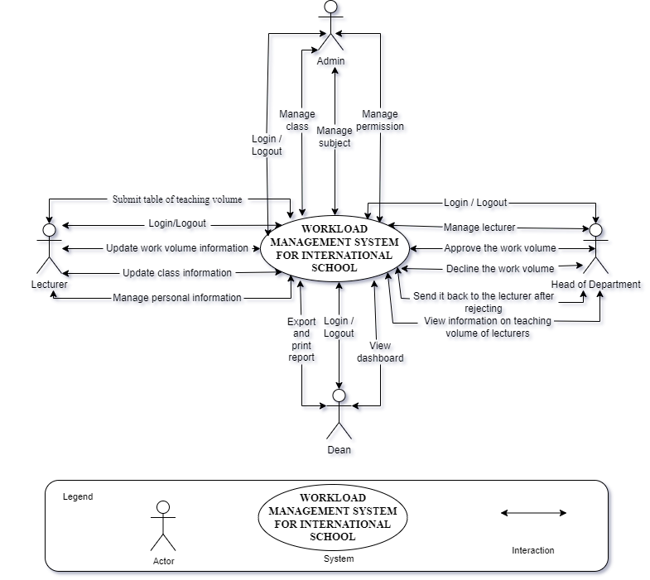

**Figure1.** *System Context Diagram*

## System Context Description

* As a Lecturer, they can:
* Log in to the system and log out of the system.
* Manage their personal information
* Update their class information
* Update their teaching volume
* Submit table of teaching volume
* As Head of Department, they can:
* Log in to the system and log out of the system.
* Manage instructors in their subjects
* Approving the teaching volume of lecturers after they submit
* Reject, send it back to the lecturer if the teaching volume is unsatisfactory
* View instructor's teaching volume information
* As Deans, they can:
* Log in to the system and log out of the system.
* View dashboard about the teaching volume of the faculty
* Export and print the report
* As an Administrator, they can:
* Log in to the system and log out of the system.
* Manage class information
* Manage subject information
* Manage permission: allow any lecturer to use the function of lecturer, department head or dean.

## Technical Proposal

### Technical to develop the system:

* Operating System: Windows 10 Pro
* Development Tools: Visual Studio Code, Git
* Version Control System: GitHub
* Language: HTML5, JavaScript, PHP
* Database: MySQL

### Supported Environment:

* Operating System: Windows
* Web browsers: Chrome, Coc Coc, Microsoft Edge

# **Tasks and deliverables**

## Tasks and Scope of your expected work:

1. Proposal Document
2. Project Plan Document
3. Product Backlog Document
4. User Story Document
5. Architecture Document
6. Database Design Document
7. Interface Design Document
8. Test Plan Document
9. Test Case Document
10. Sprint Backlog
11. Meeting

## Deliverables:

1. Engineering report
2. Proposal
3. Design drawings
4. Design documents
5. Completed product (building, etc.)
6. Technical interpretation
7. Design review
8. Progress report
9. Improved process efficiency
10. Better customer service
11. Faster response time
12. Product prototype
13. User manual

# **Project Management**

## Scrum definition:

Scrum is a subset of Agile and one of the most popular process frameworks for implementing Agile. It is an iterative software development model used to manage complex software and product development. Fixed-length iterations, called sprints lasting one to two weeks long, allow the team to ship software on a regular cadence. At the end of each sprint, stakeholders and team members meet to plan next steps.

### Scrum description

* There are three specific roles in Scrum:
* **Product Owner:** The Product Owner focuses on business and market requirements, prioritizing all the work that needs to be done. He or she builds and manages the backlog, provides guidance on which features to ship next, and interacts with the team and other stakeholders to make sure everyone understands the items in the product backlog. The Product Owner is not a project manager. Instead of managing the status and progress, his or her job is to motivate the team with a goal and vision.
* **Scrum Master:** Often considered the coach for the team, the Scrum Master helps the team do their best possible work. This means organizing meetings, dealing with roadblocks and challenges, and working with the Product Owner to ensure the product backlog is ready for the next sprint. The Scrum Master also makes sure the team follows the Scrum process. He or she doesn’t have authority over the team members, but he or she does have authority over the process. For example, the Scrum Master can’t tell someone what to do, but could propose a new sprint cadence.
* **Teams working at scrum:** The Scrum Team is composed of five to seven members. Everyone on the project works together, helps each other, and shares a deep sense of camaraderie. Unlike traditional development teams, there are not distinct roles like programmer, designer, or tester. Everyone completes the set of work together. The Scrum Team owns the plan for each sprint; they anticipate how much work they can complete in each iteration.

### The artifacts:

* **Product Backlog:** The Product Owner and Scrum Team meet to prioritize the items on the product backlog (the work on the product backlog comes from user stories and requirements). The product backlog is not a list of things to be completed, but rather it is a list of all the desired features for the product. The development team then pulls work from the product backlog to complete during each sprint.
* **Sprint Backlog**: is a list of functions developed for Sprint; it is determined by a Sprint Planning meeting. Sprint Backlog is the functionality selected from the Product Backlog based on priority levels and the ability of the team to develop.
* **Estimation**: In SCRUM, members of the Task Team will be chosen by themselves and estimate the expected development time and be responsible for this estimate. After completing the table will update Sprint Backlog.

### Process

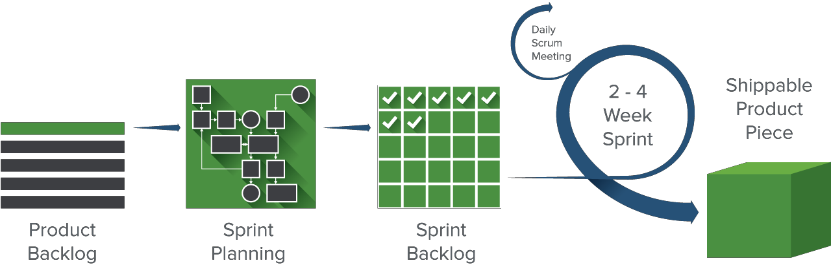

**Figure 2.** *Scrum Process*

* **Sprint Planning meeting (planning meetings for each Sprint):** At the Planning meetings, the Team and Product Owner negotiate which items will be committed to the sprint. The team pulls the top items from the Product Backlog, commits them to the Sprint Backlog, breaks them into smaller tasks typically, and decides whether it’s the right amount of work for them to do and if they’re clear about what they are going to do. They plan one sprint.
* **Daily Scrum Meeting (also called Stand-up Meeting):** Daily Scrum Meeting is meeting the recommended daily and no more than 15 minutes and standing meeting to ensure the meeting time is not extended at the beginning of each day.
* If members are having problems, it should work individually to address and not take long for the members. Scrum Master to ensure this meeting is to comply with regulations.
* **Sprint Review:** A meeting to:
* Evaluate the results of the past Sprint and determine the Release function.
* The function continues to modify or develop. Identify and discuss issues arising plan award decisions, additional Product Backlog.

## Cost/Budget for Project

**Table 1.** *Cost Effort Estimation*

| **Category** | **Detailed** | **Description** |
| --- | --- | --- |
| **Start date** | August 17th, 2022 | The start date of the project. |
| **End date** | December 10th, 2022 | The end date of the project. |
| **Duration (1)** | 102 | Total day of project. |
| **Working time (2)** | 5 hours/day | In one day and for one member. |
| **Total effort (3) = (1) * (2) * 5** | 2550 hrs. | For five team members and the entire project. |
| **Labor cost (4) = (3) * 2** | 5100 | For five team members and the entire project. ($2.0/ member) |

## Masterplan

**Table 2.** *Master Plan*

| **No** | **Task name** | **Duration**  **(day(s))** | **Start** | **Finish** | **Effort work (hrs.)** |
| --- | --- | --- | --- | --- | --- |
| 1 | **Workload management system for International School** | **102** | **17/08/2022** | **10/12/2022** | **2550** |
| 1.1 | Initial | 16 | 17/08/2022 | 01/09/2022 | 400 |
| **1.2** | **Development** | **84** | **05/09/2022** | **08/12/2022** | **2100** |
| 1.2.1 | Sprint 1 | 21 | 05/09/2022 | 28/09/2022 | 525 |
| 1.2.2 | Sprint 2 | 21 | 29/09/2022 | 22/10/2022 | 525 |
| 1.2.3 | Sprint 3 | 21 | 24/10/2022 | 16/11/2022 | 525 |
| 1.2.4 | Sprint 4 | 21 | 17/11/2022 | 08/12/2022 | 525 |
| **1.3** | **Project ‘s meeting** | **1** | **09/12/2022** | **09/12/2022** | **25** |
| **1.4** | **Final Release** | **1** | **10/12/2022** | **10/12/2022** | **25** |

# **Project constraint**

| **Constraint** | **Constraints Description** | **Guidelines for Acceptance** |
| --- | --- | --- |
| **Economic** | 5100$ | Elements for consideration are design costs, production costs, maintenance costs, operating costs, and sales price |
| **Environmental** | N/A | Impact of the design on the environment as well as impact of the environment (e.g. temperature range, humidity, vibration, electromagnetic interference immunity, and shock) on the design should be considered. Design for recycling and design to use recycled materials should also be considered |
| **Ethical** | N/A | Ethical considerations can be broad. Areas that are typically addressed include intellectual property, reverse- engineering, privacy, security, and the conflict between cost and safety |
| **Public health, safety, and welfare** | N/A | Includes safety standards as well as impact of the design on users (for example, electrical or physical hazards) |
| **Social and Global** | User-friendly interface, easy to use, used within the School's Faculty / Institute | Addresses aspects such as benefits, risks, the man-machine interface, the acceptance of products by the intended user or by society at large, global and socially responsible engineering. |
| **Cultural** | N/A | Which cultural characteristics could influence the approach?  How do the design from differents cultures differ? |
| **Sustainability** |  | Refers to sustainability of resources, including material, energy, supplies, manufacturing techniques, personnel, operation, and the need for additional infrastructure, as well as sustainability of the design including reliability, lifetime, durability, reusability, maintainability. |

# **Conclusion**

If in the past, the school's lecturers had to arrange statistics on their workload, then send it to the head of the department for approval, then the head of the department would make statistics in his subject, and then send it to the head of the department. Dean of the department of summaries, such a process makes it very difficult for lecturers and administrators to manage information and spend a lot of time on this. So now it is no longer a matter of process complexity, because designing a professional, flexible and automatic teaching volume management system has become almost a must, helping to short process. In addition to faster and easier processing, the new system will help lecturers and managers have a more intuitive view of the data, and manage it more closely and accurately. Data storage is also more compact.

It can be said that the importance of building a teaching management system is essential for the current situation when the school expands the class size and has thousands of students enrolled in the school. This will help to improve the quality of training and student management, and speed up the development of the school.

* Below is a chart of qualifications and experience on a 5-point scale

| Developers | Skill | Experience |
| --- | --- | --- |
| Huynh Ba Nhan | 3 | 2 |
| Ngo Quoc Hieu | 3 | 1 |
| Le Anh Khanh | 3 | 1 |
| To Thi Ngoc Huyen | 2 | 1 |
| Nguyen Van My | 3 | 1 |

# **References**

[1]. PHP [https://www.php.net/manual/en/](https://www.php.net/manual/en/?fbclid=IwAR3p7lpQqowTgmwsL_fYeqJGw6gKIC5DWMR2Y6Pp8rJHJtSX-9X7lDx-Y0Q) ; <https://www.w3schools.com/>

[2]. Reactjs https://reactjs.org/docs/getting-started.html

[3]. UI, using React.js <https://reactjs.org/docs/getting-started.html>

[4]. Html and CSS <https://www.w3schools.com/>

[5]. MySQL https://dev.mysql.com/doc/

# **Attachment**

