|  |  |
| --- | --- |
|  | **MINISTRY OF EDUCATION AND TRAINING** |

|  |
| --- |
| **FPT UNIVERSITY** |
| Capstone Project Document |
| TripNET |
|  |
| |  |  | | --- | --- | | **<TripNET Group>** | | | **Group Members** | Do Trung Quan – SE02357  Nguyen Hoang Long – SE03685  Nguyen Hoang Long – SE03299  Tran Nhat Linh – SE03795  Dinh Tuan Anh – SE03435 | | **Supervisor** | Mr. Tran Dinh Tri | | **Capstone Project code** | TN | |
|  |

- Hanoi, 09/2017 –

**CHAPTER 2 SOFTWARE PROJECT MANAGEMENT PLAN**

**2.1. Purpose**

The purpose of this chapter is to describe the organization and planning of the project. This chapter describes roles and responsibilities of each member in this project. It also included an overview of this project and team member. This is a document for daily meeting and meeting minute.

**2.2. Problem Organization**

**2.2.1. Software Process Model**

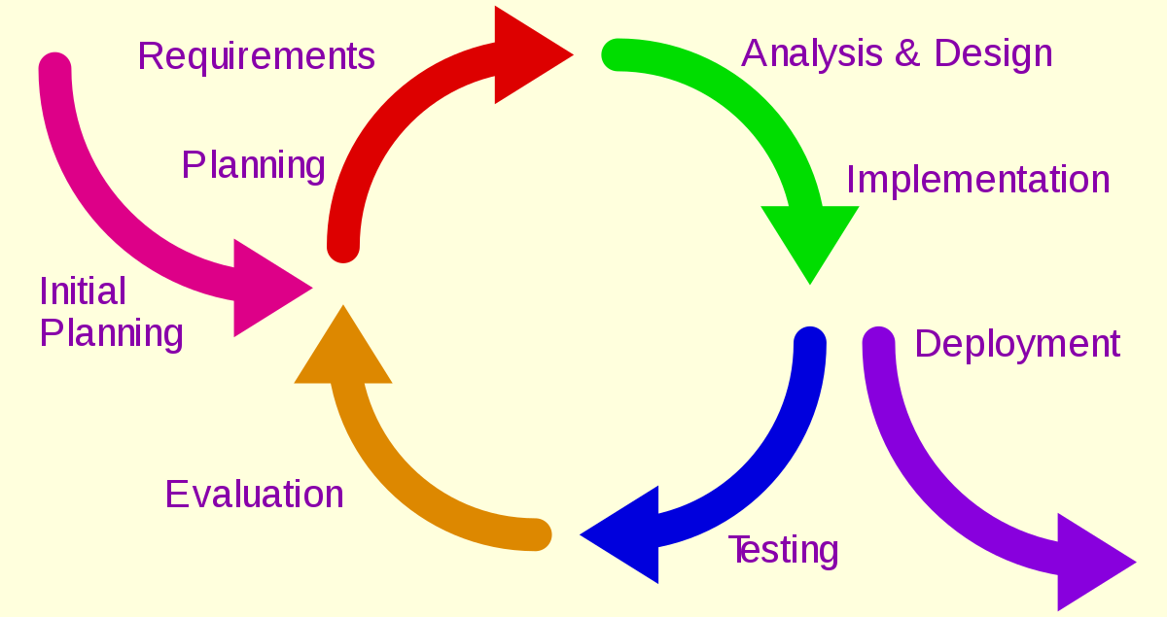

*Figure01. Iterative & Incremental Software Process Model*

The TripNET used “Iterative and Incremental Software Process Model” to develop. This process model is suitable for team and have many advantages:

* We can develop prioritized requirements first.
* Initial product delivery is faster.
* Important functionality can be finish early.
* Requirements changes can be easily accommodated.

**2.2.2. Roles and Responsibilities**

**2.2.2.1. Team Organization Structure**

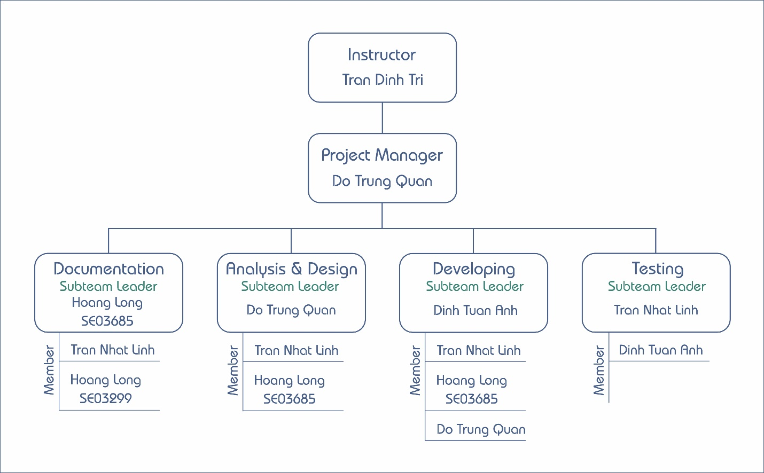

*Figure02. Team Organization Structure*

**2.2.2.2. Roles and Responsibilities**

|  |  |
| --- | --- |
| **Role** | **Quality Responsibility** |
| Project Management | * Determine scope, plan and resources for project. * Leading the team member, solve conflict in team, keep the team focus on project |
| Documentation Team | * Prepare the all document for project(report, images,..). |
| Analyst & Design Team | * Determine and analyzing requirements for project. * Give solution meet requirements. |
| Developing Team | * Coding functions of project. * Design interface. * Fix bugs(if any) and reviews code. |
| Testing Team | * Defining testing plan and test cases. * Report bugs for Developing team. |

**2.2.3. Tools and Techniques**

|  |  |
| --- | --- |
| **Programming Language** | NodeJS, Java, Javascript, HTML, CSS |
| **Framework** | ExpressJS, Spring, Bootstrap v4.0.0-beta, JQuery |
| **Version Control** | Github |
| **IDEs** | Visual Studio Code, Sublime Text 3 |
| **DBMS** | MySQL 5.6 |
| **UML Tools** | Visual Paradigm |
| **Other** | Microsoft Office 2016, Google Drive |

**2.3. Project Management Plan**

**2.3.1. Task**

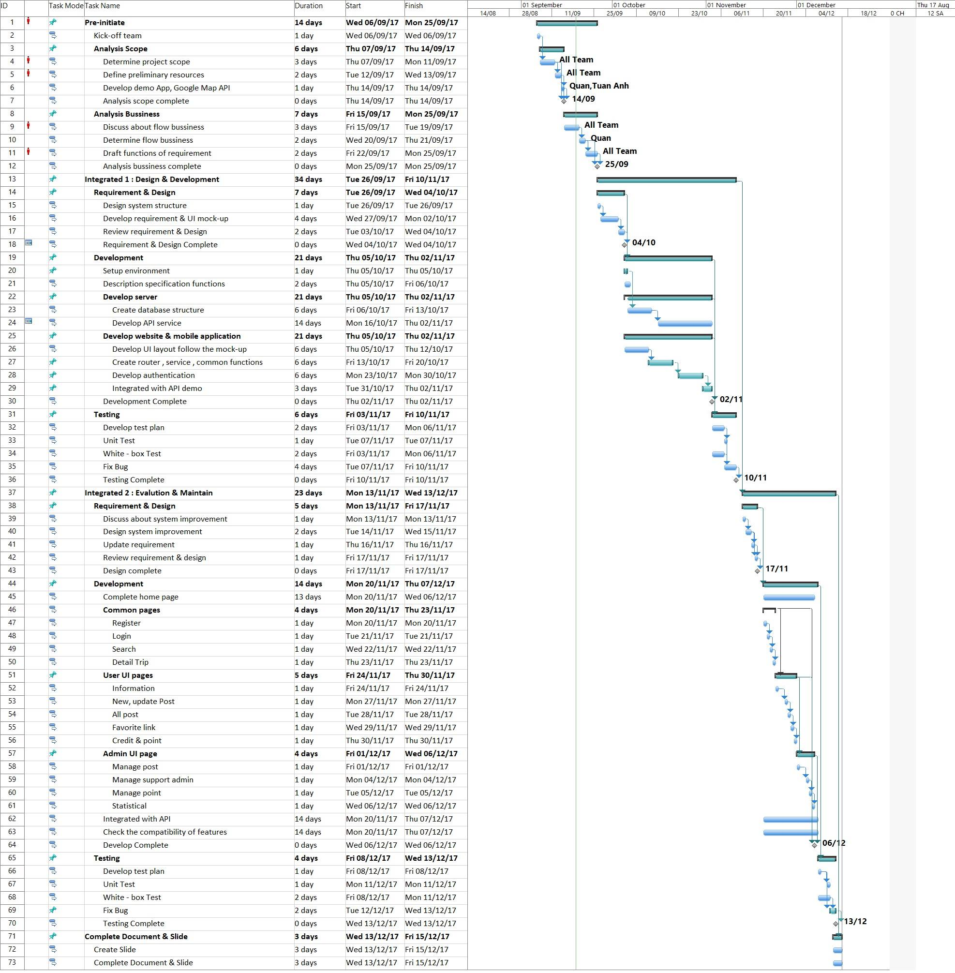

*Figure03. Work Breakdown Structure*

**2.3.2. Meeting Minutes**

Weekly meeting is hold on Tuesday every week from 13h30 to 15h00 at room HB/402L FPT University, Hoa Lac Campus.

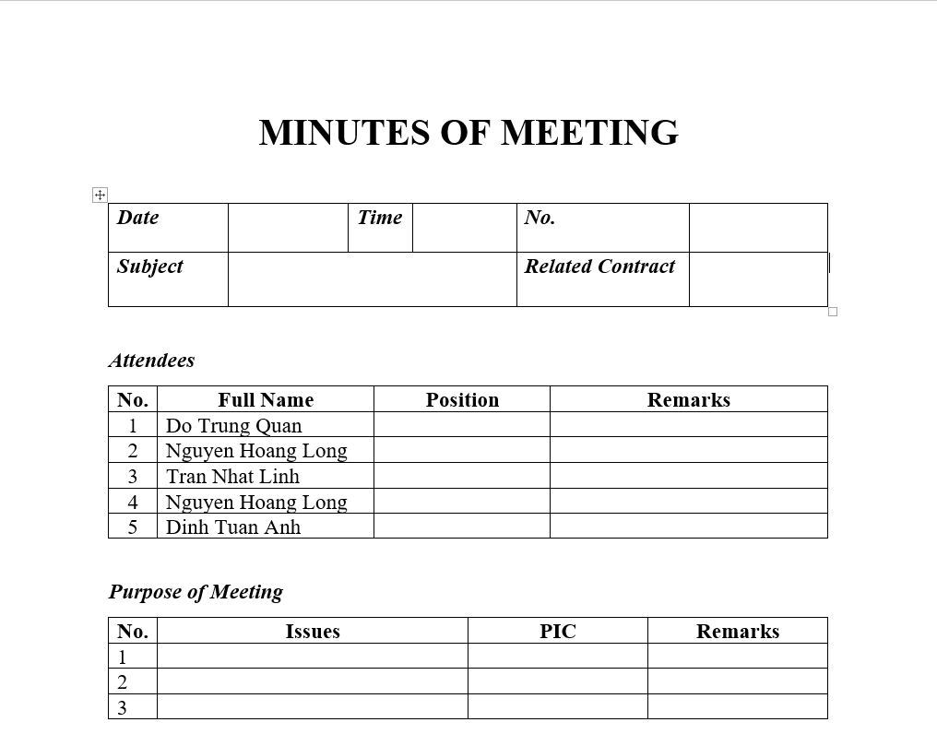

*Figure04. Meeting Minute Template*

**2.3.3. Coding Conventions**

* NodeJS coding convention: <https://github.com/felixge/node-style-guide>.
* JavaScript coding convention: <https://github.com/airbnb/javascript>.
* Java coding convention: <https://google.github.io/styleguide/javaguide.html>.

**2.3.4. Risk Management Plan**

|  |  |  |  |  |
| --- | --- | --- | --- | --- |
| **No.** | **Description** | **Avoidance plan** | **Contingency plan** | **Status** |
| 1 | Conflict between team members | * Holding team building activities to build team to connect team members. * Creating friendly environment. | Talking together to find out problem and solve it as soon as possible. | Close |
| 2 | Absences member | * Providing clearly schedule and place of all meeting to all team members. * Making the rule for team, if member absent many times, PM and other team members should be warning immediately. | Assign tasks to other team members. | Close |
| 3 | Lack technical skills and knowledge | * Training for team members who need know technical skills and knowledge for finish project. * Encourage team members to study for themselves. | Technical leader assists team members personally or in the group to develop required skills and knowledge. | Close |
| 4 | Requirement changes | * Take time to brainstorm features carefully with all team members. * Meticulously design system, take care of all possible situations to avoid changes. | Holding meeting with supervisor to decide which features suitable for implementation. | Close |
| 5 | Losing data | * Backup data daily. * Use tools to management and control source code(Github). | * Restore data from backed up data. * Restore source code from history versions. | Close |
| 6 | Late deadline | Assign suitable tasks for team members depending their abilities, strength and weakness. | * Find the problem and solve it immediately to avoid for the next time. * Assign task to other team member. | Close |

**2.3.5. Communication Plan**

**2.3.5.1. Project Meetings**

|  |  |  |  |
| --- | --- | --- | --- |
| **Meeting** | **Description purpose** | **Frequency** | **Comments/ Participants** |
| Kick-off meeting | * Project introduction. * Supervisor and team member introduction. | Once, before start project . | Supervisor and all team members. |
| Project requirement meeting | Confirms the project’s requirements. | Once, before developing team start. | All team member. |
| Urgent meeting(optional) | When a serious problems occurs and must be solved immediately. |  | Depends on the problem. |
| Weekly meeting | * Report the progress of last week. * Brainstorming to find out solution for current issues. * Determine the work and assign task for team members for next week. | Weekly, on every Tuesday at 13:30 PM. | Supervisor and all team members. |
| Milestone meeting | * Summarize the result of a development stage. * Implementation plan for the next stage. | After the project has passed a milestone. | Supervisor and all team members. |
| Closing meeting | Summarize the result of project. | After the project finish. | Supervisor and all team members. |

**2.3.5.2. Communication Methods**

* Face to face: This is most effective and common communication methods.
* Mobile Phone: Used for emergency situation to contact to team members when they are not same place.
* Instant Messages(Facebook Messenger, Skype): Used for general conversation, Skype is used when video calls are required.