|  |  |
| --- | --- |
|  | **MINISTRY OF EDUCATION AND TRAINING** |

|  |
| --- |
| **FPT UNIVERSITY** |
| Capstone Project Document |
| [Project name] |
|  |
| |  |  | | --- | --- | | **<Group Name>** | | | **Group Members** | Do Trung Quan – SE02357  Nguyen Hoang Long – SE03685  Nguyen Hoang Long – SE03299  Tran Nhat Linh – SE03795  Dinh Tuan Anh – SE03435 | | **Supervisor** | Mr. Tran Dinh Tri | | **Ext Supervisor** |  | | **Capstone Project code** |  | |
|  |

- Hanoi, 09/2017 -

**CHAPTER 1. INTRODUCTION**

* 1. **Purpose**

This report provides an overview of project include background information, literature review of existing system and raising a proposal for ideas of improvement.

* 1. **Project Information**
* Project Name:
* Project Code:
* Project Group Name:
* Product Type: **Website Application**.
  1. **The People**
     1. ***Supervisor***

|  |  |  |  |  |
| --- | --- | --- | --- | --- |
|  | **Full name** | **Phone** | **Email** | **Title** |
| Supervisor | Tran Dinh Tri |  | [tridt@fpt.edu.vn](mailto:trungnt@fpt.edu.vn) | Lecturer |

Table 1‑1 Supervisor’s information

* + 1. ***Team Members***

|  |  |  |  |  |  |
| --- | --- | --- | --- | --- | --- |
| **No** | **Full name** | **Student ID** | **Phone Number** | **Email** | **Role in Group** |
| 1 | Do Trung Quan | SE02357 | 0966057359 | [*quandtse02357@fpt.edu.vn*](mailto:quandtse02357@fpt.edu.vn) | Leader |
| 2 | Nguyen Hoang Long | SE03685 | 01683864646 | [*longnhse03685@fpt.edu.vn*](mailto:longnhse03685@fpt.edu.vn) | Member |
| 3 | Nguyen Hoang Long | SE03299 | 01685516681 | [*longnhse03299@fpt.edu.vn*](mailto:longnhse03299@fpt.edu.vn) | Member |
| 4 | Tran Nhat Linh | SE03795 | 0972694289 | [*linhtnse03795@fpt.edu.vn*](mailto:linhtnse03795@fpt.edu.vn) | Member |
| 5 | Dinh Tuan Anh | SE03435 | 0973876107 | [anhdtse03435*@fpt.edu.vn*](mailto:anhdtse03435@fpt.edu.vn) | Member |

Table 1‑2 Team members’ information

* 1. **Problem**

|  |
| --- |
|  |

Now a day, we have a lot of website, application support people to review famous sightseeing places. But many people like trip by motorbike to go somewhere far away, they need more information about this place but not much what can provide this information. Besides, they do not know how to go to this place or what nice things are wait they to discover. The target customer using our website and application to find out that information.

* 1. **Solution**

We created a website where people can share their experience about trips and some beautiful places and people who want to go can find information they need to their trip in the future.

Beside, we create a application to help people can find the good way to trip and what they can do, how they can stay or some beauty place they can visit.

* 1. **Compare** **other** **system**

In Viet Nam, the website are famous is <https://www.phuot.vn/>. This website is too much topic, the design of website is complicated. It is hard for guest visit website first time. Beside, member post one topic can show detail about their trip., the information is generic.

Also have many group share information about travel on Facebook but it very chaotic and hard to find needed information.

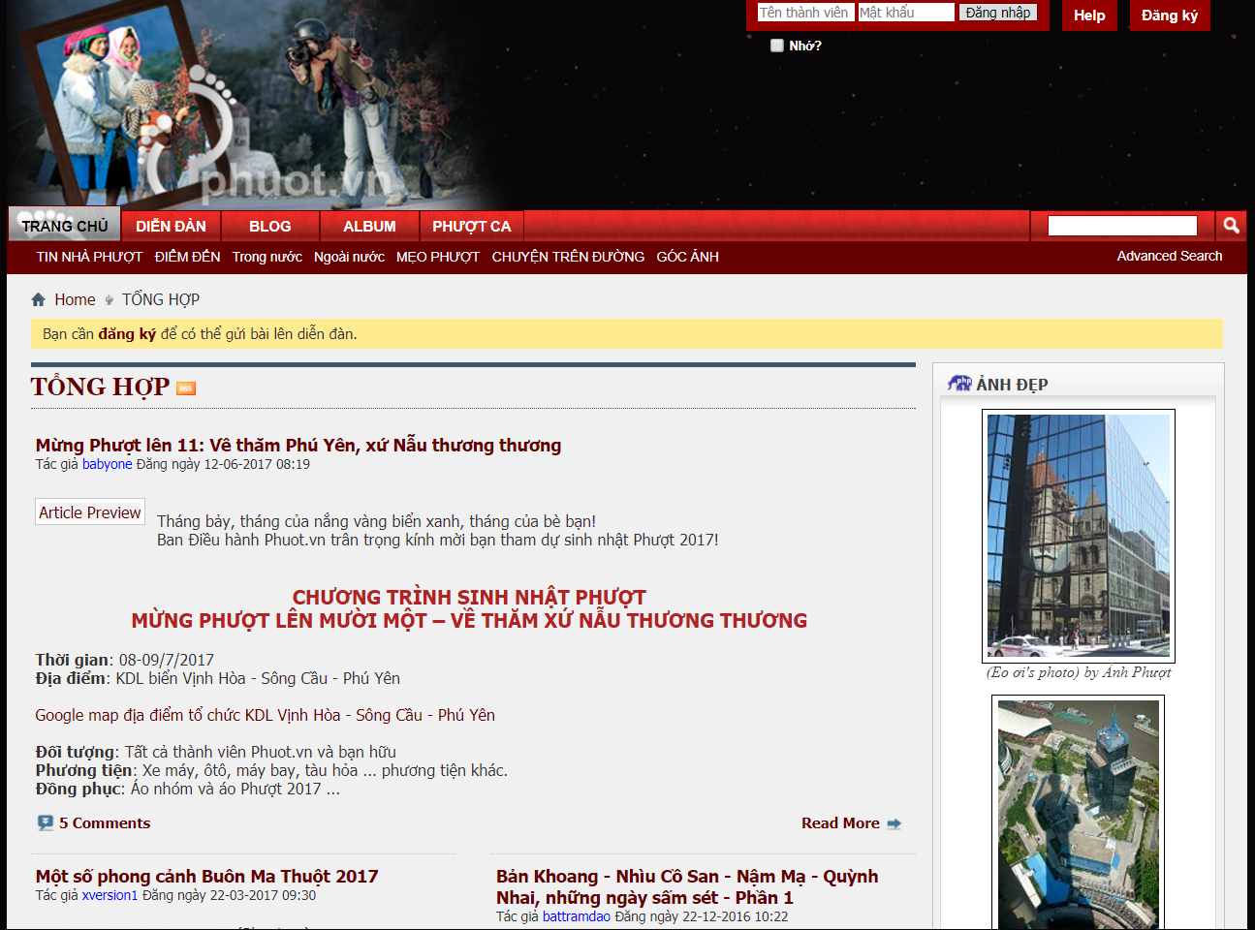

* 1. **Benefit**
* For our group
* Have change and experiment to develop a project, how to manage plan, how to promote effective teamwork.
* Training skill about HTML5, JavaScript, NodeJS, MySQL.
* For guest
* Find the necessary information to prepare their trip in the future.
* Make more friends who are similar interests.
* For member
* Website is a good way to show picture and some special they receive by trip.
* People can express their passion.
* A good member with high rate will receive money from admin from topics what they write.
  1. **Limitation**
* We are not invested.
* We do not have experiment to develop a mobile project.
* Lack of the information.
* Information depends on user provided.
  1. **Proposal of system**

After reviewing and analyzing, we determined the system have 3 roles: Admin, Guest (who do not have account) and Member (who have account to login to system) and functions for each role.

* + 1. ***Admin***
* Add new user.
* Edit information of user.
* Delete user.
* View information of user.
* Add new trip review.
* Edit information of trip review.
* Delete trip review.
* Add new comment.
* Edit comment.
* Delete comment.
  + 1. ***Guest***
* Search information about trip reviews.
* View trip reviews.
  + 1. ***Member***
* Search information about trip reviews.
* View trip reviews.
* Create new trip reviews.
* Edit trip reviews.
* Delete trip reviews.
* Comment on trip reviews.
* Rate on trip reviews.
* Share trip reviews on social network(Facebook, Twitter, Google+).