# CHAPTER 4: SOFTWARE DESIGN DESCRIPTION

**4.1. Purpose**

The purpose of this chapter is to give the developer team a guidance of what the system’s architecture is, and how they should be implemented. This chapter consists of:

* Architecture overview.
* Sequence Diagram.
* Component Diagram.
* Class Diagram.
* Database design.

**4.2. Architecture Overview**

TripNET is developed base on MVC model. MVC model stands for Model-View-Control model is software architectural pattern for implementing user interfaces on computers. It divides a given application into three interconnected parts. This is done to separate internal representations of information from the ways information is presented to, and accepted from, the user. The MVC design pattern decouples these major components allowing for efficient code reuse and parallel development.

* **Model:** Model represents for data. Each model represents a table in database and each object of model represents a record of that table. The main tasks of the model is to manipulate data such as: add, edit, delete, select, validate,…
* **View:** View is user interface. View display data using model to the user and also enables them to modify the data.
* **Control:** Controller handles the user request. Typically, user interact with View, which in-tern raises appropriate URL request, this request will be handled by a controller. The controller renders the appropriate view with the model data as a response.

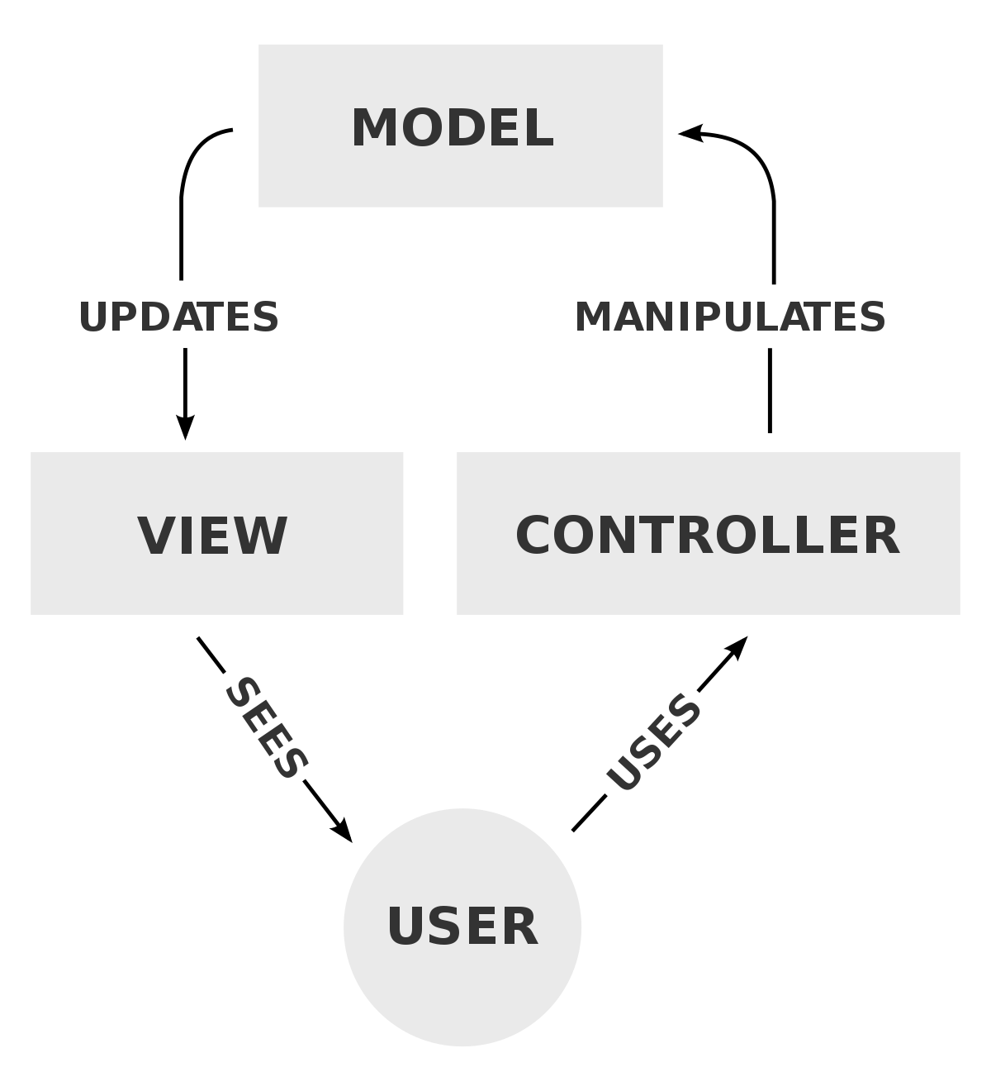

***Figure 4-1 MVC Model***

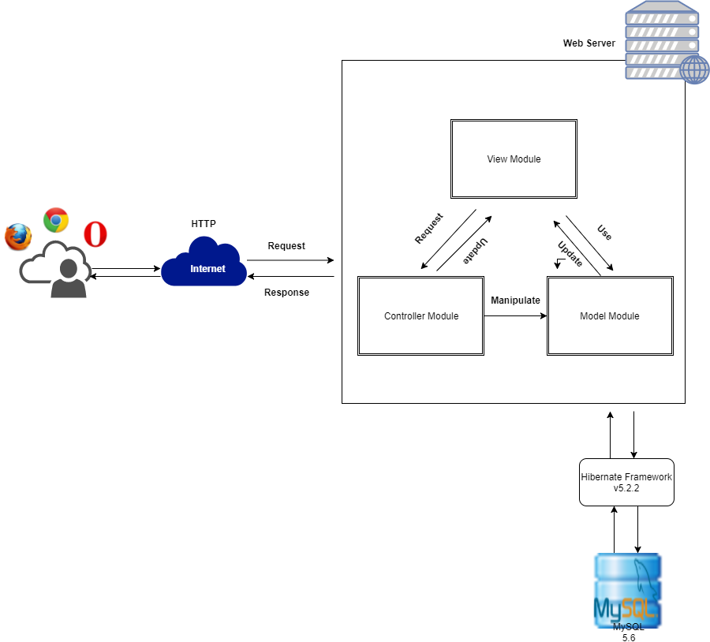

***Figure 4-2 TripNET System Architecture Overview***

**4.3. Component Diagram**

**4.4. Sequence Diagram**

**4.5. CRC Cards**

**4.6. Class Diagram**

**4.7. Database Design**

**4.8. User Interface**