**RESTAURANT MANEGERMENT**

* Team member:
* Giang Luu Anh Dung

Table of content:

1. **Review 1**

* **Problem**

**Definication……………..................................................................**

* **Customer Request**

**Specification……………..................................................................**

1. **Review 2**

* **Use Case Diagram**
* **Class Diagram**
* **Sequence Diagram**
* **ERD**
* **Entity Description**
* **Table Relationship Diagram**

1. **Review 3**

* **Interface**

**Design……………..................................................................**

* **Site**

**Map……………......................................................................**

* **Resport……………..................................................................**
* **Tasksheet……………................................................................**

**Review 1**

Problem Definition

1. **The Object Of The Project**

This project will aim at creation of an efficient and convenient restaurant management system. This will be accessible to users with valid username and passwords. This system provides the following facilities:

* Allows users to order and pay by the table.
* View and update information user.
* Admin can view bills by date.
* Insert, update, delete, search items.
* Insert, update, delete category
* Search, add, delete food table.
* Search, delete user by admin.

**Technology: Window Form, ADO.NET**

Customer Request

Specification

1. **Functional Requirements**

Following is a list of functionalities of the system. More functionalities that you find appropriate can be added to this list.

* User must have a valid username and password to login to the system.
* If user login with a wrong username or password, a message box will show with a notification.
* After the valid user login, the screen will show all table with their status. The right of the screen has categories of item and items of them and bill of the table that user chose. Below the screen is total bill and check out button.
* On selecting the desired item for table that selected, total bill with change by adding price with before total.
* If table call the first item or check out table, the status of table will change.
* User can view their information and update their account (fullname and password).
* User needs enter current password to update.
* Only users with administrator roles can access the management page.
* Administrator must enter a start and end date to view a list of invoices during this period.
* Administrator search item by name (full name is not required). List of items show with 3 columns name, category and price.
* The data of the item the user has selected will be bound in corresponding text fiels.
* If text fiels is null or invalid format or smaller or equal than 0 with numaral fiels, a message box with show with a warning. (for all management of administrator)
* Can not add new item with duplicate name or update name.
* Delete item by name.
* Click button view to view all item. (for all management of administrator)
* After perform the add, update, delete function, message box will show message successful or error. (for all management of administrator)
* Administrator can add, update, delete and view categories.
* The data of the category the user has selected will be bound in corresponding text fiels.
* Can not add new category with duplicate id or update id.
* Delete category by id.
* After perform a change category function, list category in main form also change.
* List of categories show with 2 columns id and name.
* Administrator search food table by name (full name is not required). List of table show with 2 columns name and status.
* Administrator can add, delete and view tables.
* The data of the table the user has selected will be bound in corresponding text fiels.
* Can not add new table with duplicate name.
* Administrator search user by name (full name is not required). List of table show with 3 columns username, fullname and role. Users in list are who have ‘Active’ status and ‘member’ role.
* Administrator can delete and view users.
* Delete function will update status to Inactive. Add function will have status Active ( Except table has status Empty).
* Password fiel is password char.
* When user have done using app, user logout the system.

1. **Hardware/ Software Requirements**

**+ System Requirement**

* For Users
* Hardware
* Intel (R) Core (TM) i5-6200U CPU @ 2.30GHz 2.40GHz
* RAM: 4.00GB or higher
* Software
* OS: Windows 10
* Database Management System: Microsoft SQL Server 2014
* IDE: Microsoft Visual Studio 2019
* For Software developers
* Hardware
* Intel (R) Core (TM) i5-6200U CPU @ 2.30GHz 2.40GHz
* RAM: 4.00GB or higher
* Software
* OS: Windows 10
* Environment: Window Form
* Database Management System: Microsoft SQL Server 2014
* IDE: Microsoft Visual Studio 2019

**Review 2**

**USE CASE DIAGRAM**

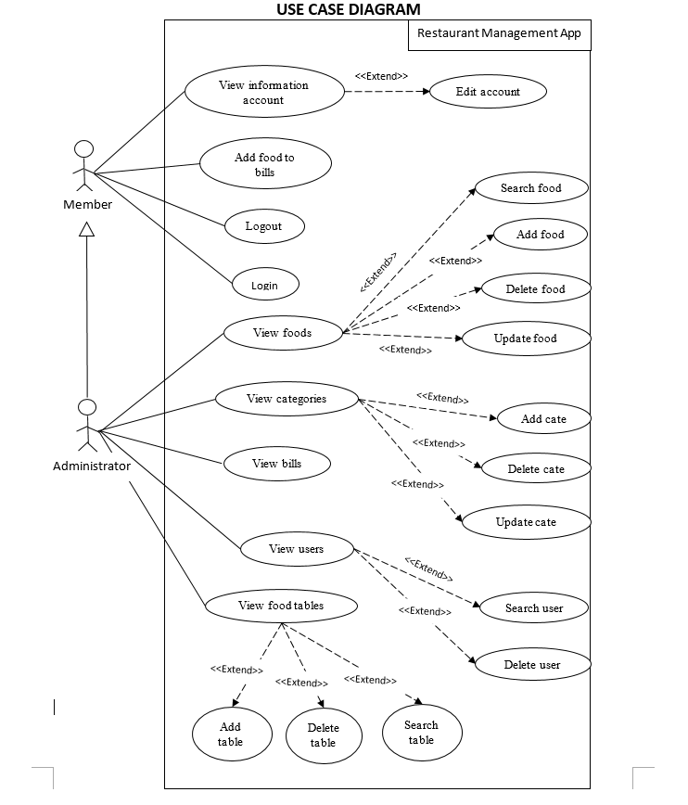

**USE CASE DESCRIPTION**

1. **Actor:**

**+ Member:** is the user of this application for the restaurant's service such as ordering , payment.

**+ Administrator**: is person who can use all functions of this application include ordering, payment, maintain,…

1. **User case:**

|  |  |
| --- | --- |
| **Use case** | Login |
| **Short Description** | Login to use functions for member or admin. |
| **Pre-Conditions** |  |
| **Post-Conditions** |  |
| **Main flow** | - Guest inputs the login information:  * Username  * Password  - Guest clicks on the Login button.  - System checks the username and password:  * If username and password are valid, system will come to restaurant management page.  * If username or password is invalid, a message box will show announcement. |
| **Alternative flow(s)** | - If guest clicks the Exit button, a message box will show confirm exit message.  - If role of user is member, manager window of admin will be disable.  - If app notifies any error, when it’s processing, system must be write report into message box and show. |

|  |  |
| --- | --- |
| **Use case** | Logout |
| **Short Description** | User exits the application. |
| **Pre-Conditions** |  |
| **Post-Conditions** |  |
| **Main flow** | - Guest clicks Logout on the menu bar.  - System will redirect to login page. |
| **Alternative flow(s)** |  |

|  |  |
| --- | --- |
| **Use case** | Edit account |
| **Short Description** | Edit member’s information. |
| **Pre-Conditions** |  |
| **Post-Conditions** |  |
| **Main flow** | - Guest logins to this app.  - Member clicks Account on the menu bar.  - Member edits information and enter current password to save.  - System checks password is valid or no.  - System notify report to member. |
| **Alternative flow(s)** | - If any information edit are invalid, system will notify the error.  - If editting is successfully, system will show successful message.  - If user clicks Exit button, this window will close.  - If app notifies any error, when it’s processing, system must be write report into message box and show. |

|  |  |
| --- | --- |
| **Use case** | Add food into bill |
| **Short Description** | User adds food into bill of table what user chose. |
| **Pre-Conditions** |  |
| **Post-Conditions** |  |
| **Main flow** | - Guest logins to this app.  - User choose a table.  - User selects category, food and quantity that customer called.  - Total bill will add price of this food multiply quantity. |
| **Alternative flow(s)** | - If table hasn’t been chosen yet, system will be show notification.  - If table’s state is “empty”, the state will change to already occupied.  - If this food hasn’t existed yet in bill, the bill will be added this food.  - If this food has been existed in bill, the food will be increased quantity . |

|  |  |
| --- | --- |
| **Use case** | Check out |
| **Short Description** | User check out bill for customer. |
| **Pre-Conditions** |  |
| **Post-Conditions** |  |
| **Main flow** | - Guest logins to this app.  - User clicks Checkout button in screen.  - System send confirm box for user.  - Click OK to checkout. |
| **Alternative flow(s)** | - If table hasn’t been chosen yet, system will be show notification.  - If user don’t choose OK button to confirm, system does nothing. |

|  |  |
| --- | --- |
| **Use case** | View bills |
| **Short Description** | User views bills of restaurant by date check out. |
| **Pre-Conditions** |  |
| **Post-Conditions** |  |
| **Main flow** | - Guest logins to this app.  - User clicks admin manager on menu bar.  - User chooses bill manager part.  - Enter the time period that need to find.  - Click Find button. |
| **Alternative flow(s)** |  |

|  |  |
| --- | --- |
| **Use case** | View Food |
| **Short Description** | User views food detail list. |
| **Pre-Conditions** |  |
| **Post-Conditions** |  |
| **Main flow** | - Guest logins to this app.  - User clicks admin manager on menu bar.  - User chooses food manager part.  - In the first time come to this manager or user click to view button, table will show all food available of restaurant. |
| **Alternative flow(s)** | - Data will be bound into text fiels. |

|  |  |
| --- | --- |
| **Use case** | Add Food |
| **Short Description** | User add food to list. |
| **Pre-Conditions** |  |
| **Post-Conditions** |  |
| **Main flow** | - Guest logins to this app.  - User clicks admin manager on menu bar.  - User chooses food manager part.  - Full fill all text fiels.  - Click Add button.  - System show result.  - Reload table. |
| **Alternative flow(s)** | - If fiels are wrong format such as null, format numeral,… warning will be show.  - If name food has already existed, warning will also be show. |

|  |  |
| --- | --- |
| **Use case** | Delete Food |
| **Short Description** | User delete food by name. |
| **Pre-Conditions** |  |
| **Post-Conditions** |  |
| **Main flow** | - Guest logins to this app.  - User clicks admin manager on menu bar.  - User chooses food manager part.  - Full fill name food text fiel.  - Click Delete button.  - System show result.  - Reload table. |
| **Alternative flow(s)** | - If this fiel is wrong format such as null, format numeral,… warning will be show.  - If name food hasn’t existed, system do nothing. |

|  |  |
| --- | --- |
| **Use case** | Update Food |
| **Short Description** | User update food information. |
| **Pre-Conditions** |  |
| **Post-Conditions** |  |
| **Main flow** | - Guest logins to this app.  - User clicks admin manager on menu bar.  - User chooses food manager part.  - Full fill all text fiels.  - Click Update button.  - System show result.  - Reload table. |
| **Alternative flow(s)** | - If fiels are wrong format such as null, format numeral,… warning will be show.  - If name food was changed, system would show warning. |

|  |  |
| --- | --- |
| **Use case** | Search Food |
| **Short Description** | User search food by name (don’t need entering full name). |
| **Pre-Conditions** |  |
| **Post-Conditions** |  |
| **Main flow** | - Guest logins to this app.  - User clicks admin manager on menu bar.  - User chooses food manager part.  - Enter content into search fiel.  - Click Search button.  - Table show list. |
| **Alternative flow(s)** | - If search fiel is empty, system will show warning. |

|  |  |
| --- | --- |
| **Use case** | View Category |
| **Short Description** | User views category detail list. |
| **Pre-Conditions** |  |
| **Post-Conditions** |  |
| **Main flow** | - Guest logins to this app.  - User clicks admin manager on menu bar.  - User chooses category manager part.  - In the first time come to this manager or user click to view button, table will show all category available of restaurant. |
| **Alternative flow(s)** | - Data will be bound into text fiels. |

|  |  |
| --- | --- |
| **Use case** | Add Category |
| **Short Description** | User add category to list. |
| **Pre-Conditions** |  |
| **Post-Conditions** |  |
| **Main flow** | - Guest logins to this app.  - User clicks admin manager on menu bar.  - User chooses category manager part.  - Full fill all text fiels.  - Click Add button.  - System show result.  - Reload table. |
| **Alternative flow(s)** | - If fiels are wrong format such as null, format numeral,… warning will be show.  - If id category has already existed, warning will also be show. |
| **Use case** | Delete Category |
| **Short Description** | User delete category by id. |
| **Pre-Conditions** |  |
| **Post-Conditions** |  |
| **Main flow** | - Guest logins to this app.  - User clicks admin manager on menu bar.  - User chooses category manager part.  - Full fill id text fiel.  - Click Delete button.  - System show result.  - Reload table. |
| **Alternative flow(s)** | - If this fiel is wrong format such as null, format numeral,… warning will be show.  - If id hasn’t existed, system do nothing. |

|  |  |
| --- | --- |
| **Use case** | Update Category |
| **Short Description** | User update category information. |
| **Pre-Conditions** |  |
| **Post-Conditions** |  |
| **Main flow** | - Guest logins to this app.  - User clicks admin manager on menu bar.  - User chooses category manager part.  - Full fill all text fiels.  - Click Update button.  - System show result.  - Reload table. |
| **Alternative flow(s)** | - If fiels are wrong format such as null, format numeral,… warning will be show.  - If id was changed, system would show warning. |

|  |  |
| --- | --- |
| **Use case** | View Food Table |
| **Short Description** | User views food table detail list. |
| **Pre-Conditions** |  |
| **Post-Conditions** |  |
| **Main flow** | - Guest logins to this app.  - User clicks admin manager on menu bar.  - User chooses food table manager part.  - In the first time come to this manager or user click to view button, table will show all food table available of restaurant. |
| **Alternative flow(s)** | - Data will be bound into text fiels. |

|  |  |
| --- | --- |
| **Use case** | Add Food Table |
| **Short Description** | User add food table to list. |
| **Pre-Conditions** |  |
| **Post-Conditions** |  |
| **Main flow** | - Guest logins to this app.  - User clicks admin manager on menu bar.  - User chooses food table manager part.  - Full fill name text fiel.  - Click Add button.  - System show result.  - Reload table. |
| **Alternative flow(s)** | - If this fiel is null, warning will be show.  - If name food table has already existed, warning will also be show. |

|  |  |
| --- | --- |
| **Use case** | Delete Food Table |
| **Short Description** | User delete food table by name. |
| **Pre-Conditions** |  |
| **Post-Conditions** |  |
| **Main flow** | - Guest logins to this app.  - User clicks admin manager on menu bar.  - User chooses food table manager part.  - Full fill name food table text fiel.  - Click Delete button.  - System show result.  - Reload table. |
| **Alternative flow(s)** | - If this fiel is null, warning will be show.  - If name food table hasn’t existed, system do nothing. |

|  |  |
| --- | --- |
| **Use case** | Search Food Table |
| **Short Description** | User search food table by name (don’t need entering full name). |
| **Pre-Conditions** |  |
| **Post-Conditions** |  |
| **Main flow** | - Guest logins to this app.  - User clicks admin manager on menu bar.  - User chooses food table manager part.  - Enter content into search fiel.  - Click Search button.  - Table show list. |
| **Alternative flow(s)** | - If search fiel is empty, system will show warning. |

|  |  |
| --- | --- |
| **Use case** | View User |
| **Short Description** | Admin views users who have member role. |
| **Pre-Conditions** |  |
| **Post-Conditions** |  |
| **Main flow** | - Guest logins to this app.  - User clicks admin manager on menu bar.  - User chooses user manager part.  - In the first time come to this manager or user click to view button, table will show all user who have member role available of restaurant. |
| **Alternative flow(s)** | - Data will be bound into text fiels. |

|  |  |
| --- | --- |
| **Use case** | Delete User |
| **Short Description** | User delete user by name. |
| **Pre-Conditions** |  |
| **Post-Conditions** |  |
| **Main flow** | - Guest logins to this app.  - User clicks admin manager on menu bar.  - User chooses user manager part.  - User chooses a user in table.  - Data of user bound to text fiels.  - Click Delete button.  - System show result.  - Reload table. |
| **Alternative flow(s)** |  |

|  |  |
| --- | --- |
| **Use case** | Search User |
| **Short Description** | Admin search users by name (don’t need entering full name). |
| **Pre-Conditions** |  |
| **Post-Conditions** |  |
| **Main flow** | - Guest logins to this app.  - User clicks admin manager on menu bar.  - User chooses user manager part.  - Enter content into search fiel.  - Click Search button.  - Table show list. |
| **Alternative flow(s)** | - If search fiel is empty, system will show warning. |

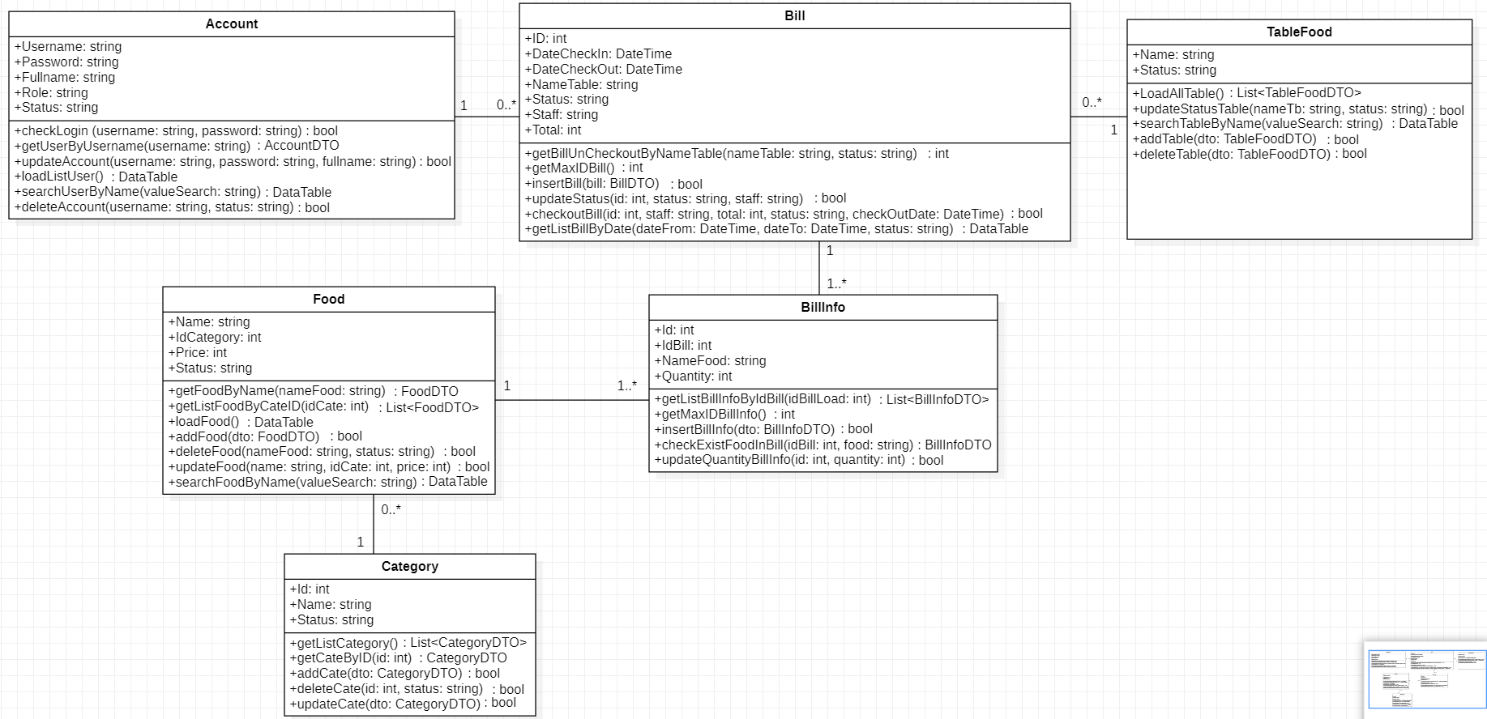**CLASS DIAGRAM**

**SEQUENCE DIAGRAM**

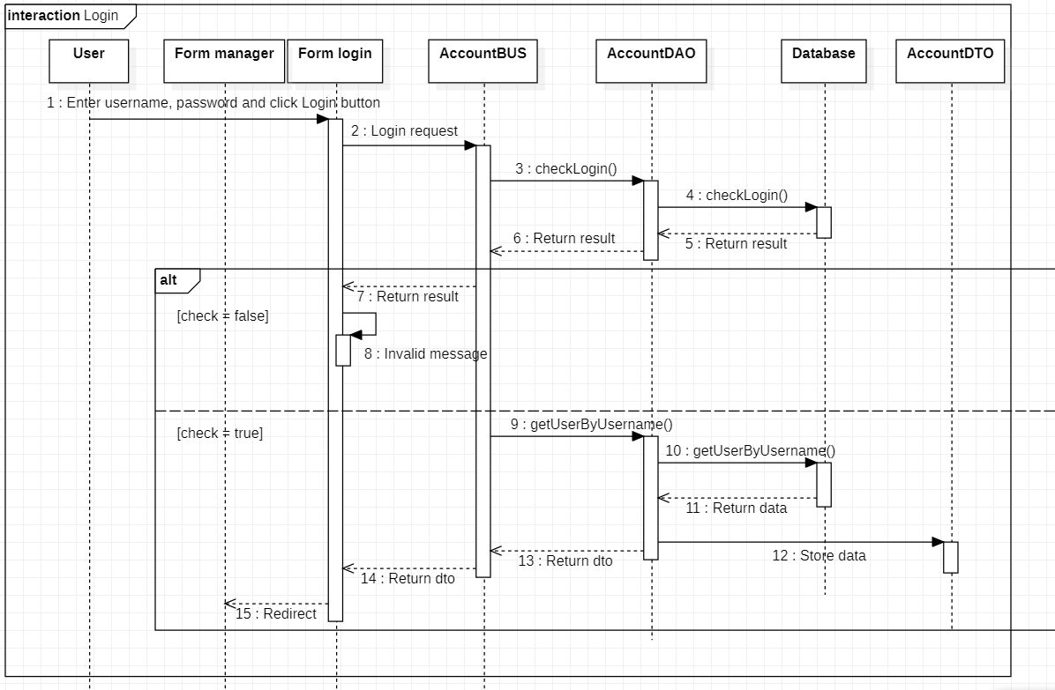

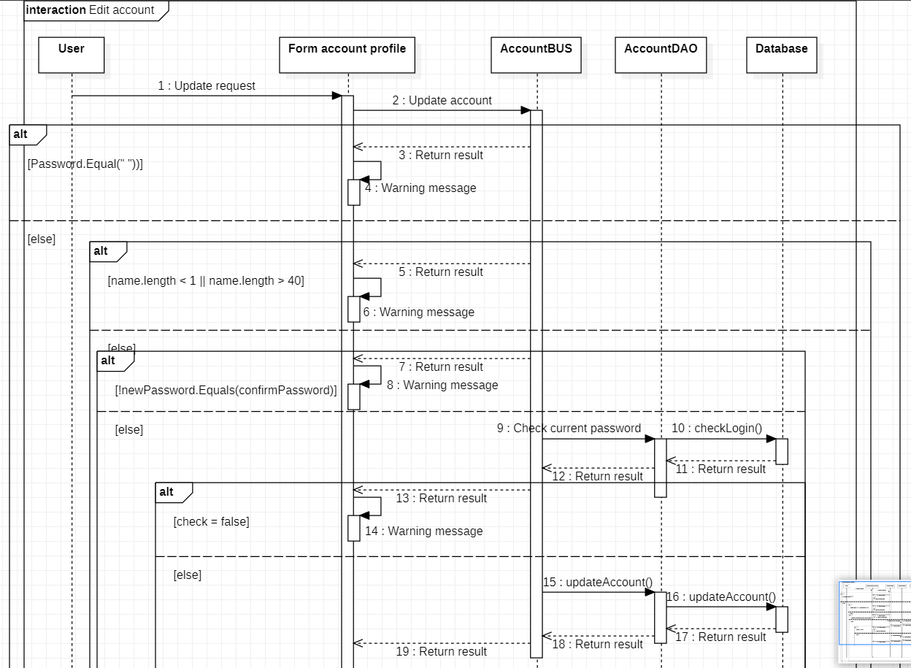

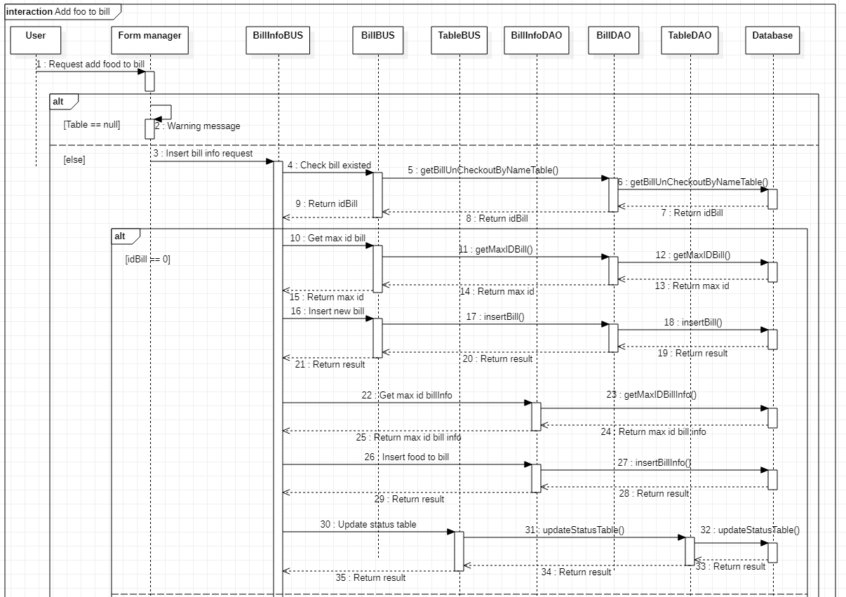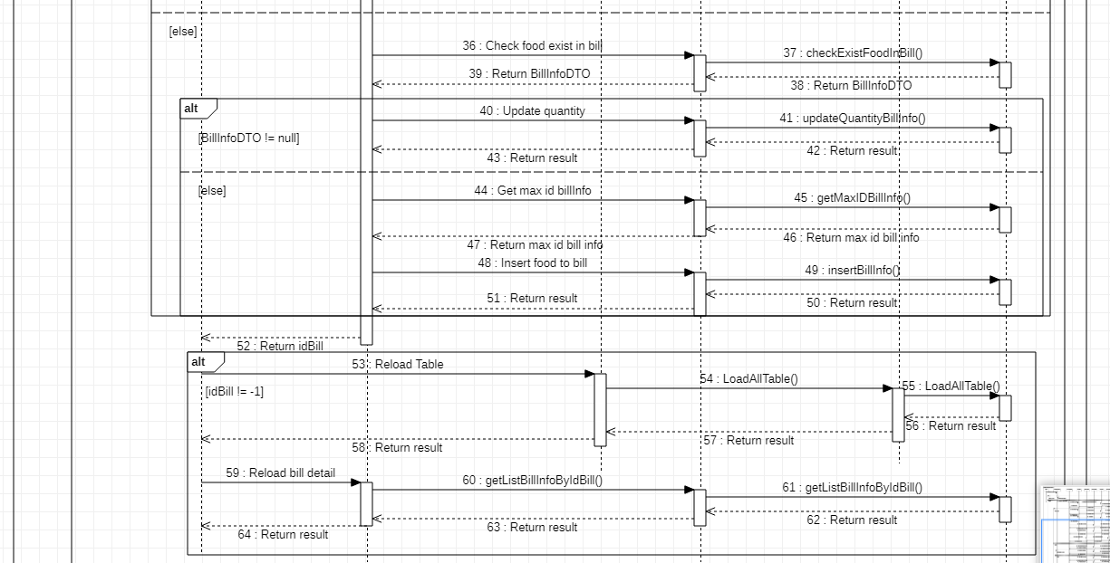

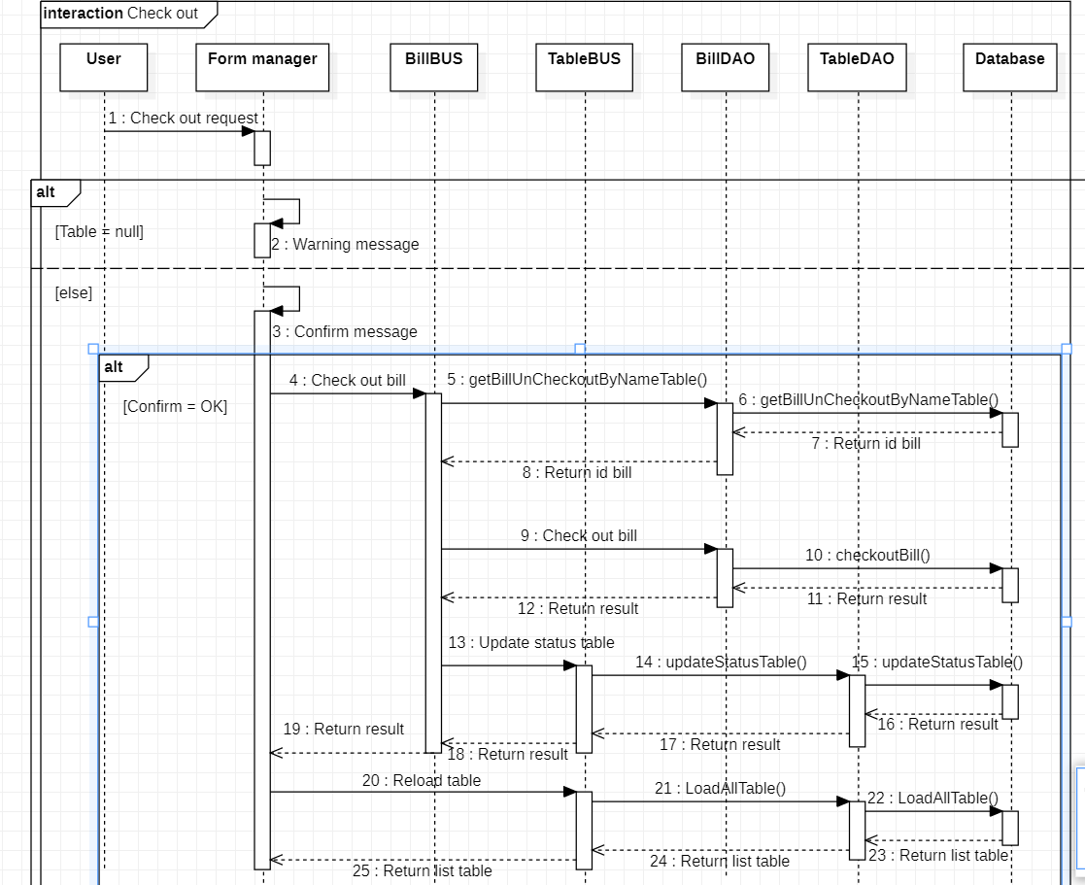

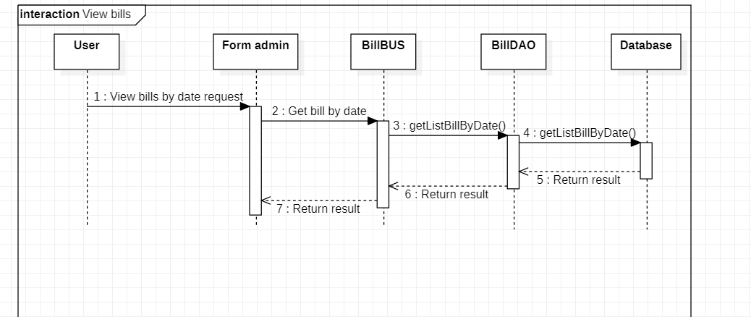

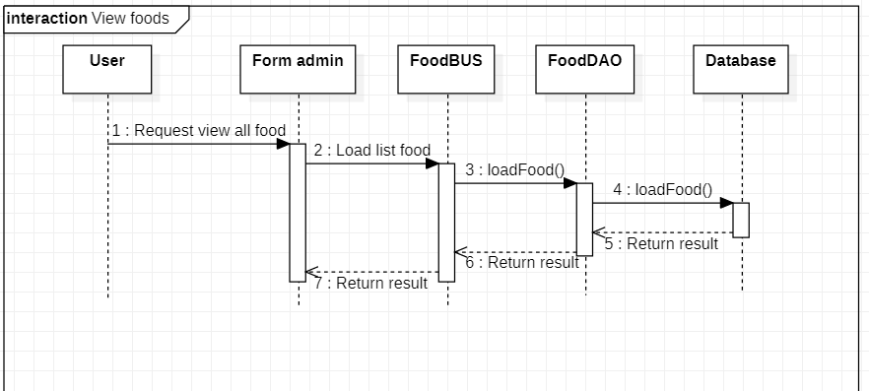

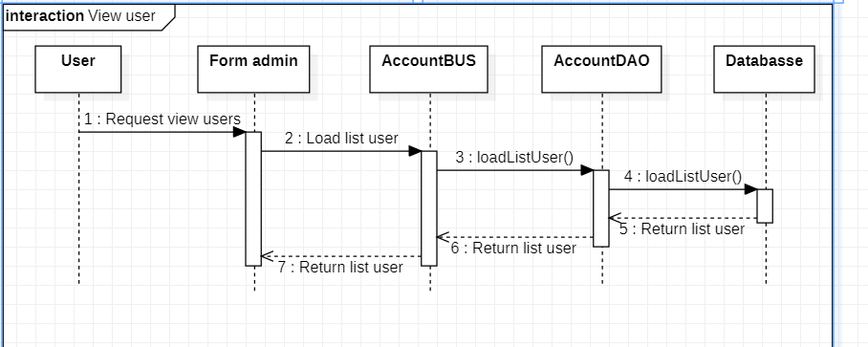

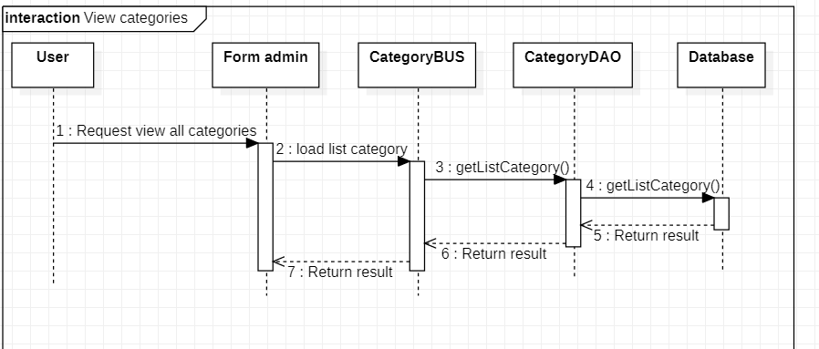

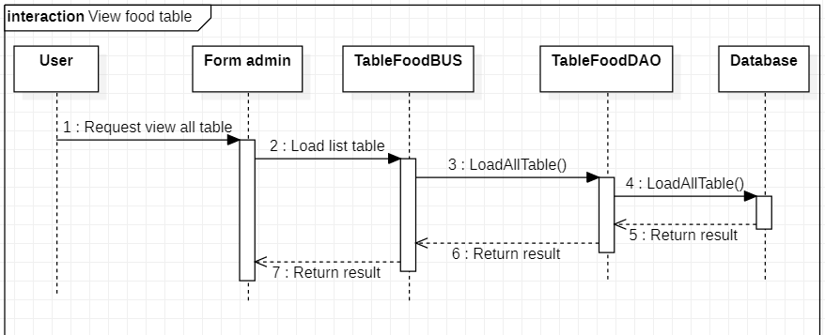

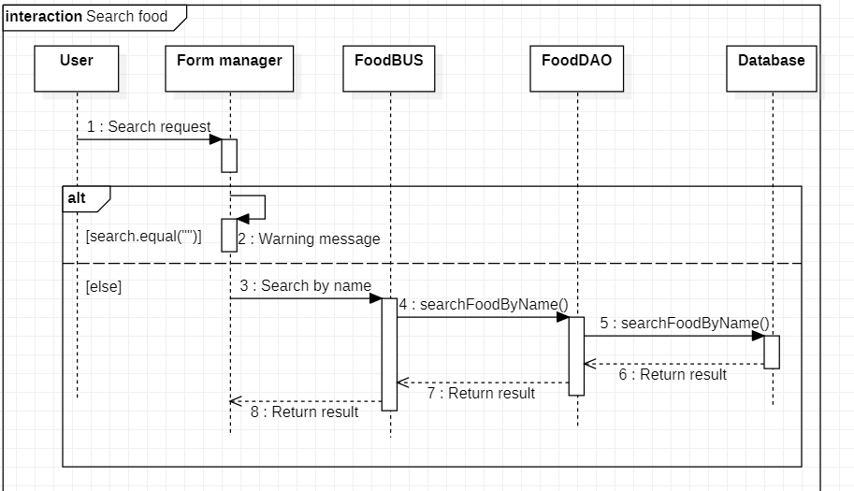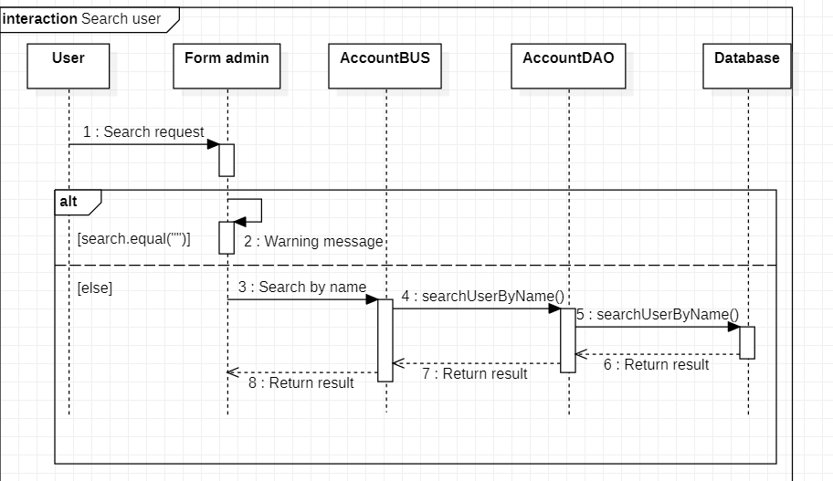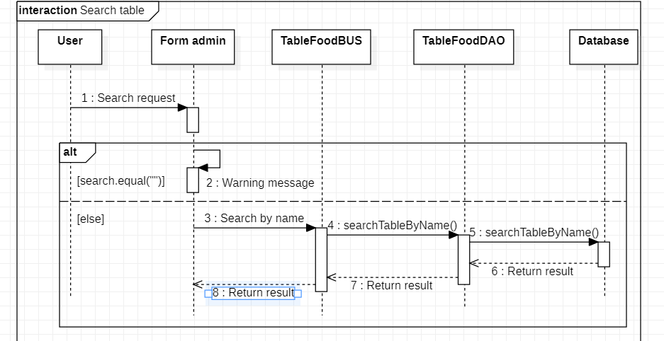

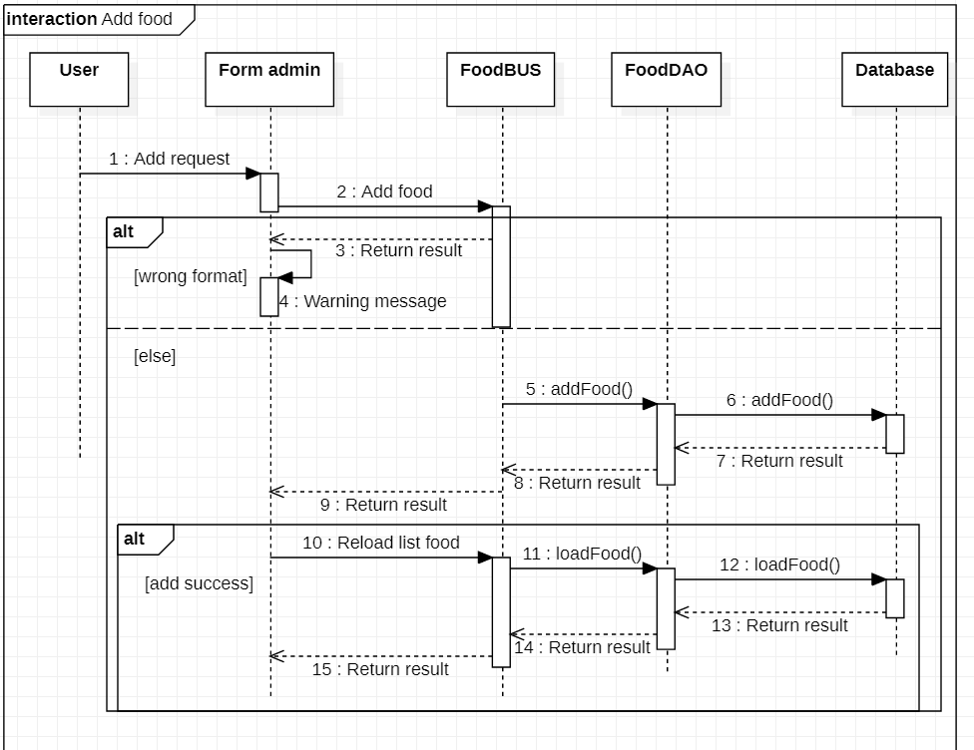

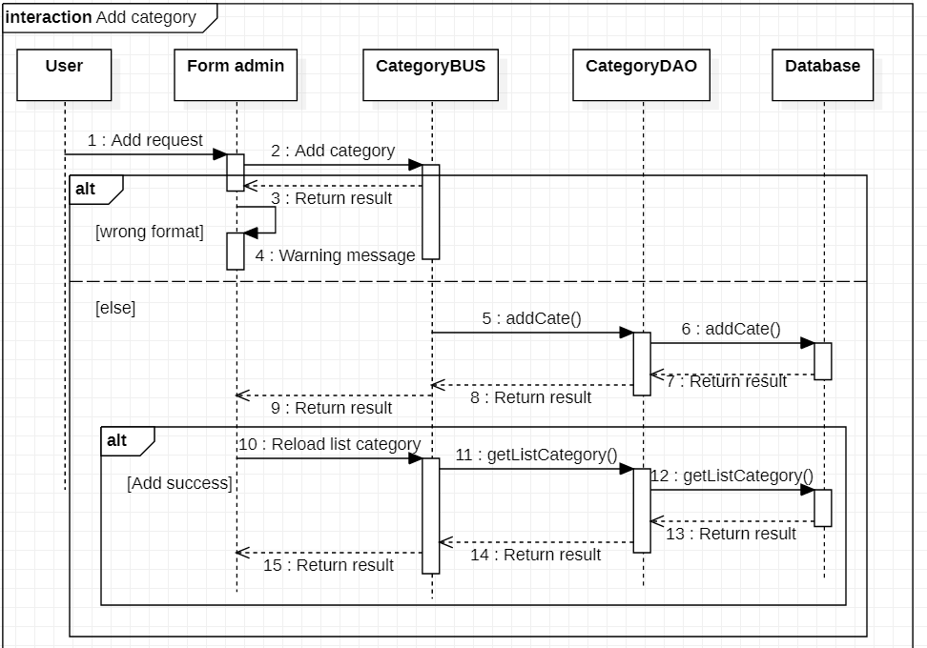

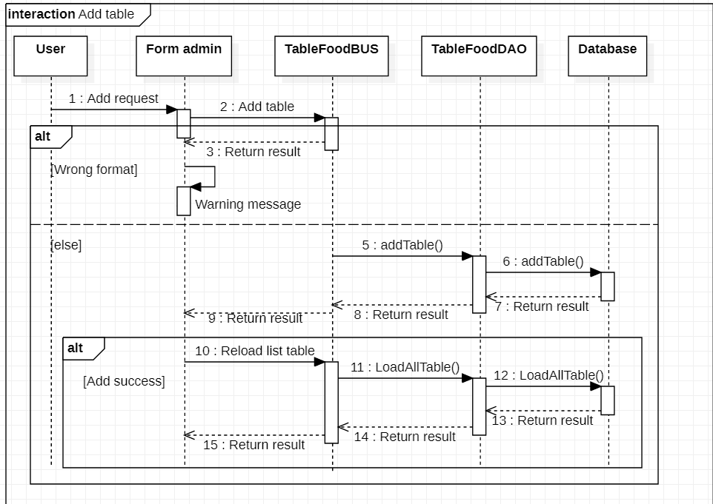

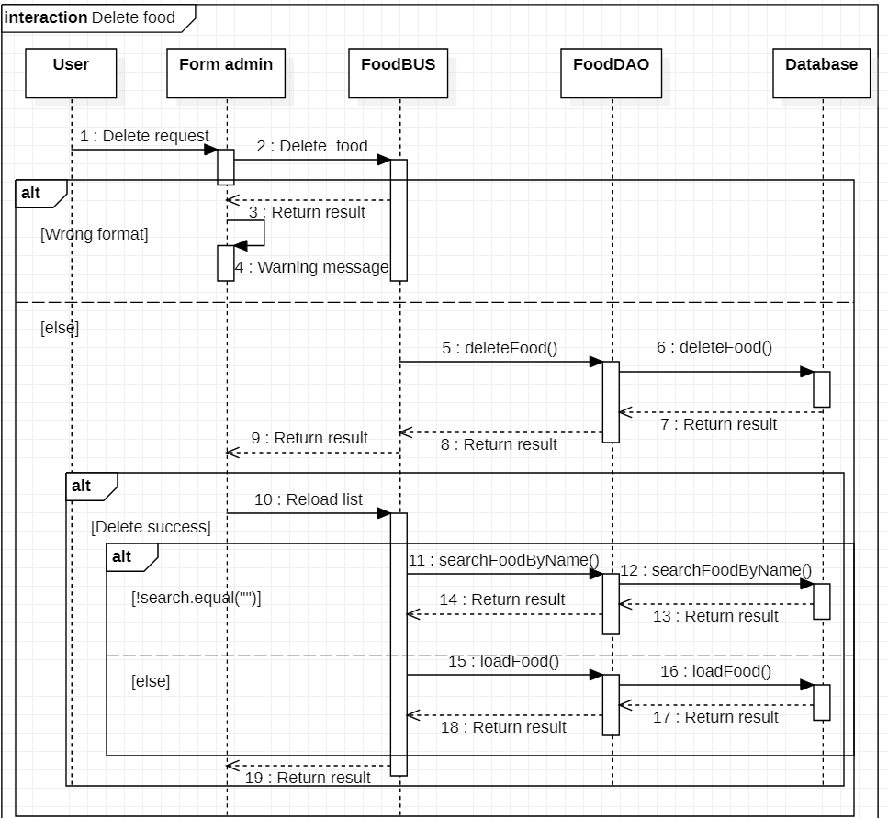

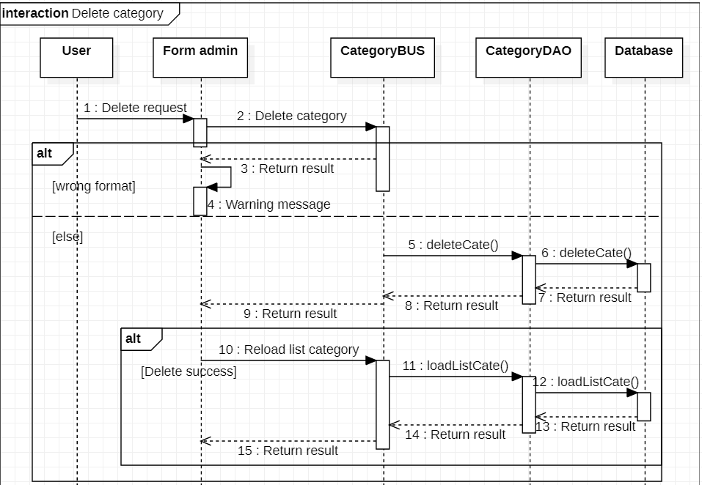

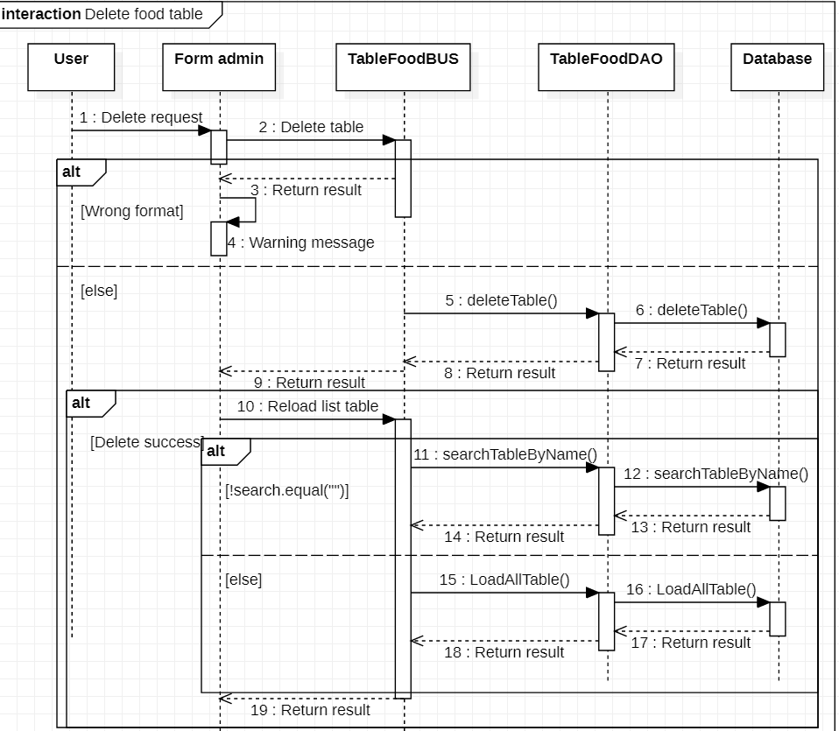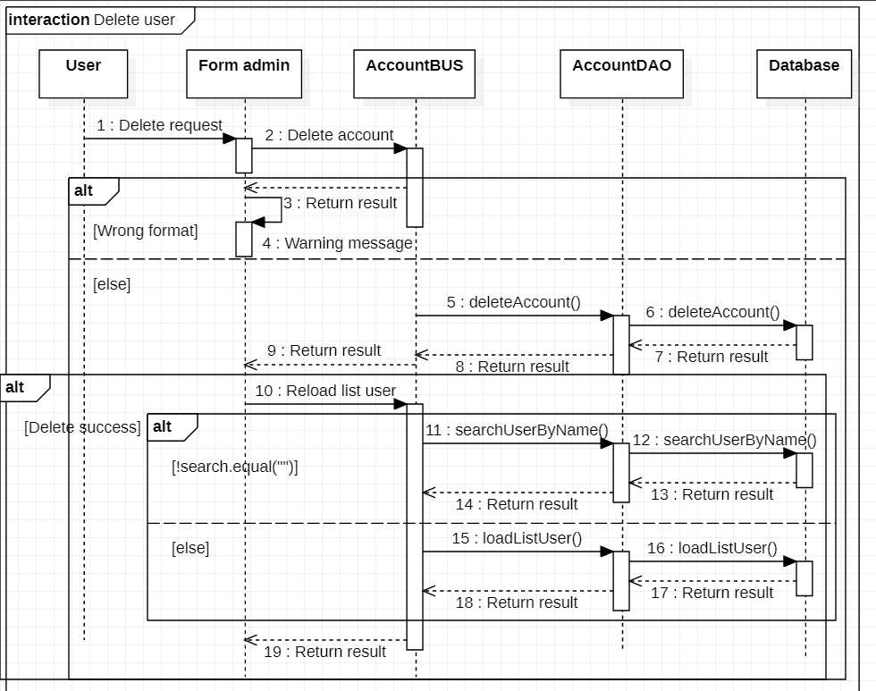

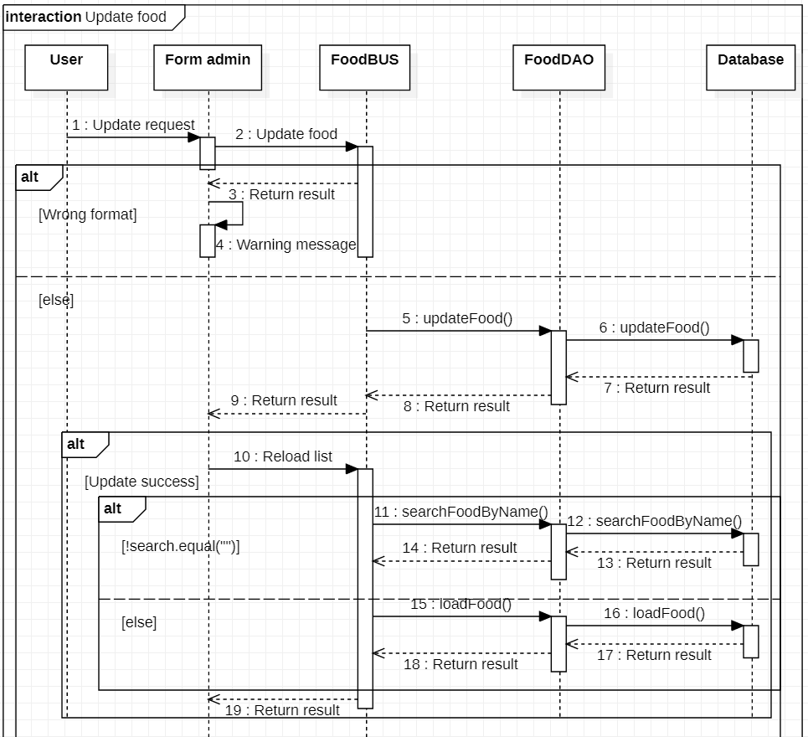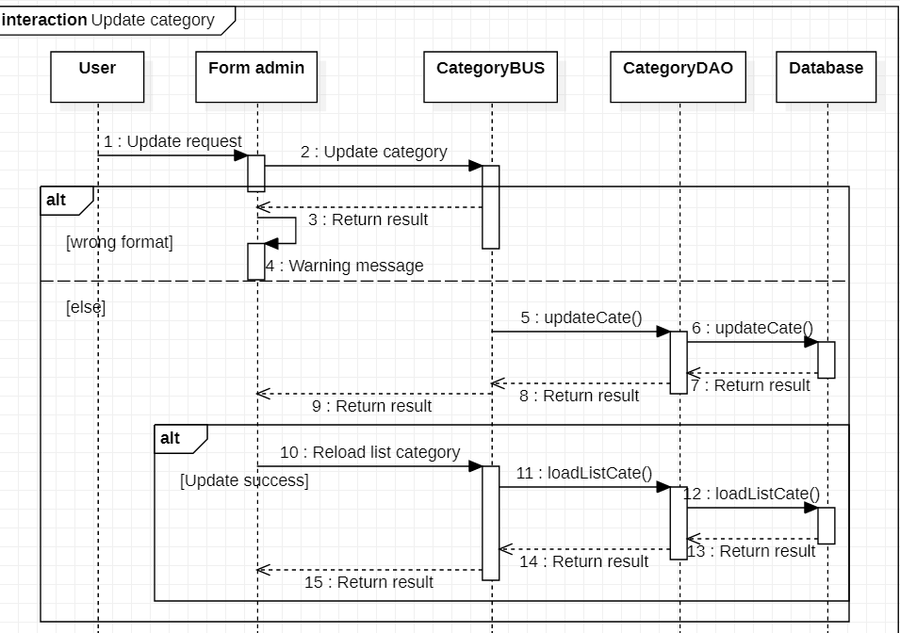

**ENTITY RELATIONSHIP DIAGRAM (ERD)**

Account

Checkout

Bill

Table food

Have

Bill info

Have

Food

Belong

Belong

FoodCategory

**ENTITY DESCRIPTION**

1. **Account**

**Account**

1. **Bill**

**Bill**

1. **Table food**

**TableFood**

1. **BillInfo**

**BillInfo**

1. **Food**

**Food**

1. **FoodCategory**

**FoodCategory**

**TABLE DESIGN**

1. **Account**

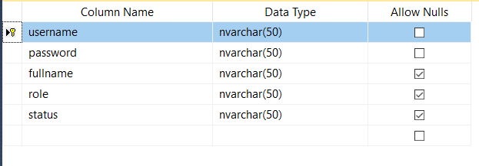

1. **Bill**

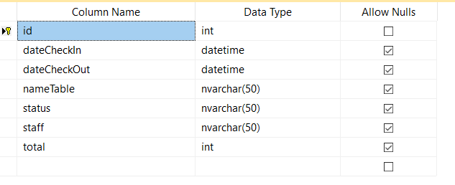

1. **Table food**

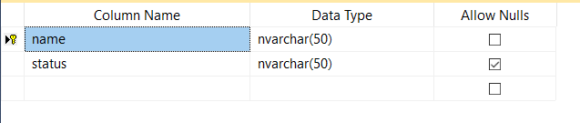

1. **BillInfo**

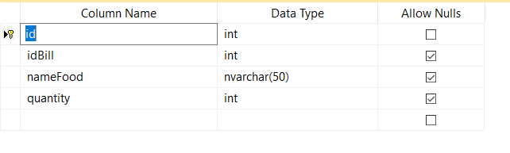

1. **Food**

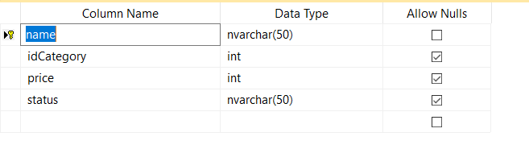

1. **FoodCategory**

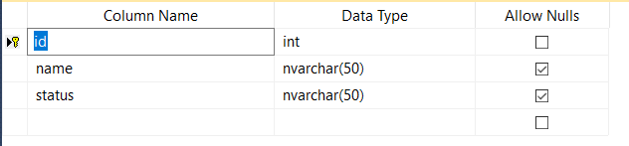

**TABLE RELATIONSHIP DIAGRAM**

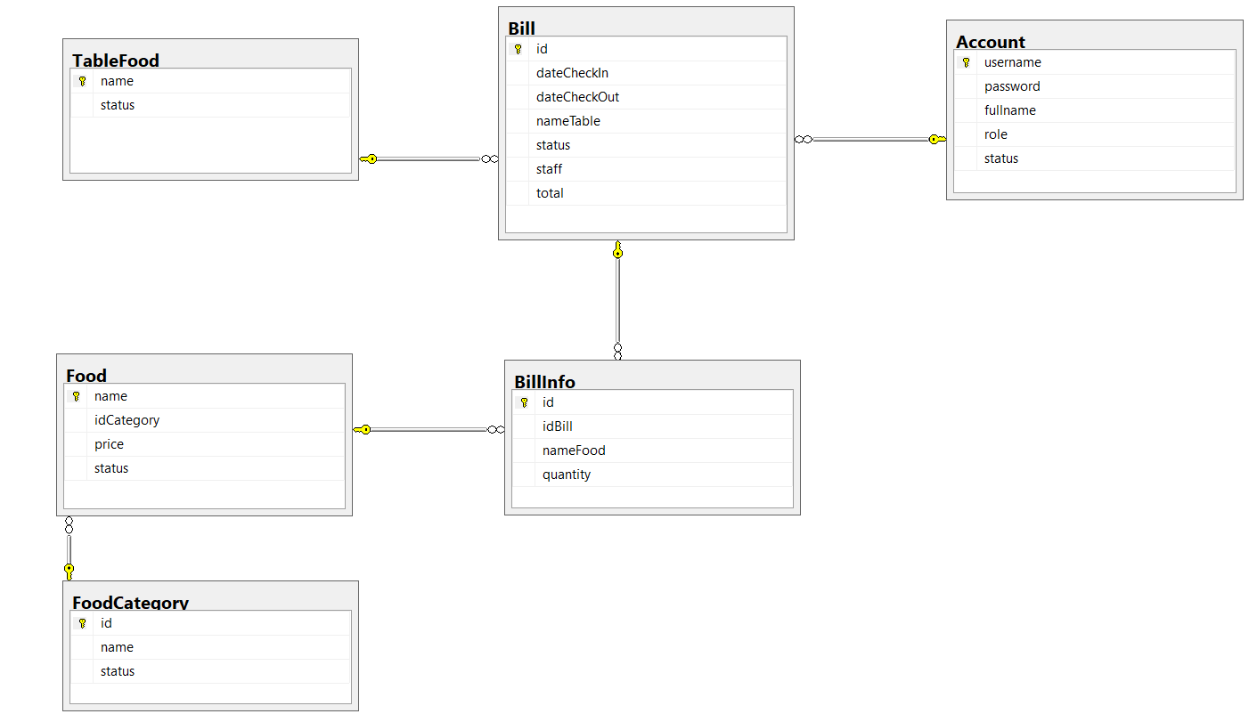

**Architectural model 3 layers**

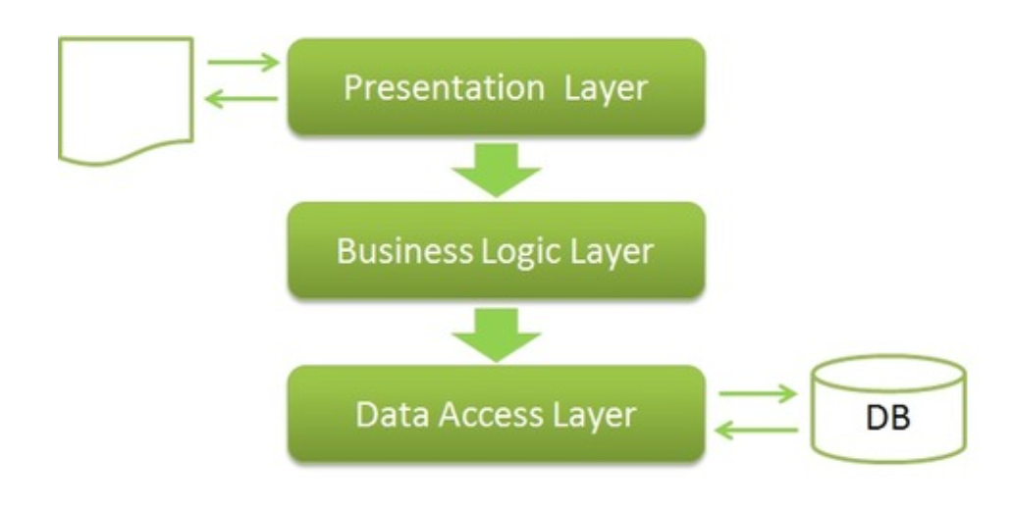

**Review 3**

**INTERFACE DESIGN**

1. **Login page**

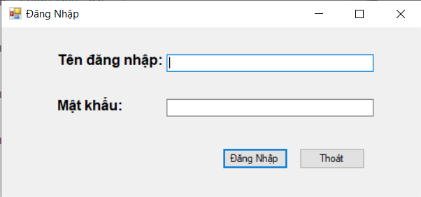

|  |  |  |  |  |  |
| --- | --- | --- | --- | --- | --- |
| **Name** | **Type** | **Event** | **Validation** | **Description** | **Status** |
| txtUsername | Textbox |  |  | Input user’s username |  |
| txtPassword | Textbox |  |  | Input user’s password |  |
| btnLogin | Button | Click |  | Login |  |
| btnExit | Button | Click |  | Exit |  |

1. **Manager page**

|  |  |  |  |  |  |
| --- | --- | --- | --- | --- | --- |
| **Name** | **Type** | **Event** | **Validation** | **Description** | **Status** |
| adminToolStripMenuItem | ToolStripMenuItem | Click |  | Show admin form | Readonly if role is member |
| thôngTinTàiKhoảnToolStripMenuItem | ToolStripMenuItem | Click |  | Show account profile |  |
| flpTable | FlowLayoutPanel |  |  | Show tables |  |
| cbxCategory | Combobox | SelectedIndexChanged |  | Choose category |  |
| cbxFood | Combobox |  |  | Choose food |  |
| btnAddFood | Button | Click |  | Add food to bill |  |
| nudQuantity | NumericUpDown |  |  | Choose quantity food | Readonly |
| lsvBill | ListView |  |  | View bill detail |  |
| txtTotalBill | Textbox |  |  | Total bill | Readonly |
| btnCheckOut | Button | Click |  | Checkout |  |

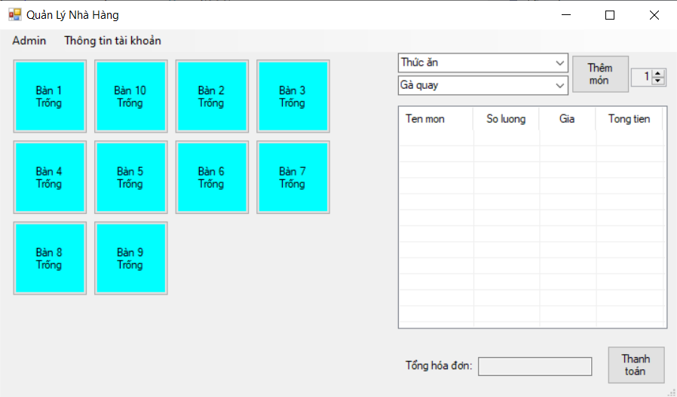

1. **User profile page**

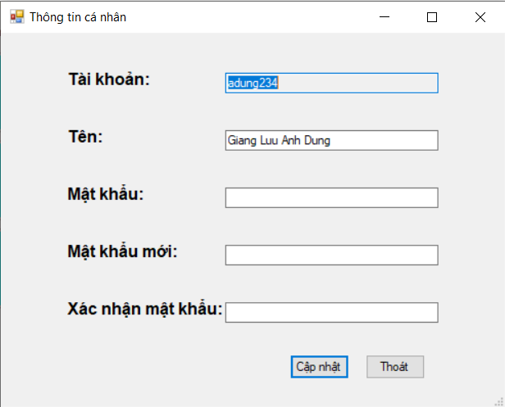

|  |  |  |  |  |  |
| --- | --- | --- | --- | --- | --- |
| **Name** | **Type** | **Event** | **Validation** | **Description** | **Status** |
| txtUsername | Textbox |  |  | Input user’s username | Readonly |
| txtPassword | Textbox |  | Not null | Input user’s password |  |
| txtFullname | Textbox |  | Not null | Input user’s name |  |
| txtNewPassword | Textbox |  |  | Input new password |  |
| txtConfirm | Textbox |  | Same as txtNewPassword | Confirm new password |  |
| btnUpdate | Button | Click |  | Update |  |
| btnExit | Button | Click |  | Exit |  |

1. **View bill page**

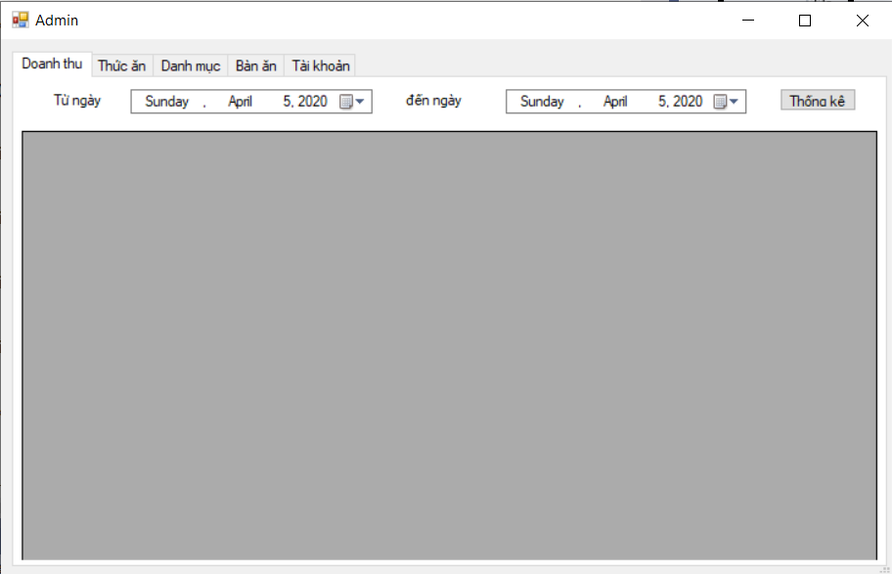

|  |  |  |  |  |  |
| --- | --- | --- | --- | --- | --- |
| **Name** | **Type** | **Event** | **Validation** | **Description** | **Status** |
| dtpkFromDate | DateTimePicker |  |  | Find bill from date |  |
| dtpkToDate | DateTimePicker |  |  | Find bill to date |  |
| btnViewBill | Button | Click |  | View |  |
| dtgvBill | DataGridView |  |  | Show bill |  |

1. **Food manager page**

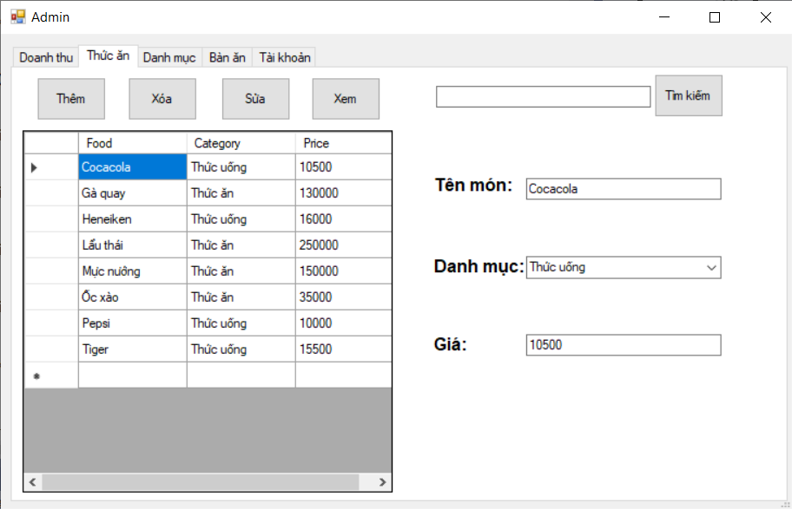

|  |  |  |  |  |  |
| --- | --- | --- | --- | --- | --- |
| **Name** | **Type** | **Event** | **Validation** | **Description** | **Status** |
| btnAddFood | Button | Click |  | Add food |  |
| btnDeleteFood | Button | Click |  | Delete food |  |
| btnUpdateFood | Button | Click |  | Update food |  |
| btnViewFood | Button | Click |  | View all food |  |
| dtgvFood | DataGridView |  |  | Show list food |  |
| txtSearchFood | Textbox |  |  | Input key search |  |
| btnSearchFood | Button | Click |  | Search |  |
| txtFoodName | Textbox |  | Not null, int format | Input (Bind) name of Food |  |
| cbxFoodCategory | ComboBox |  |  | Choose (Bind) category of Food |  |
| txtFoodPrice | Textbox |  | Not null, int format | Input (Bind) name of Food |  |

1. **Category manager page**

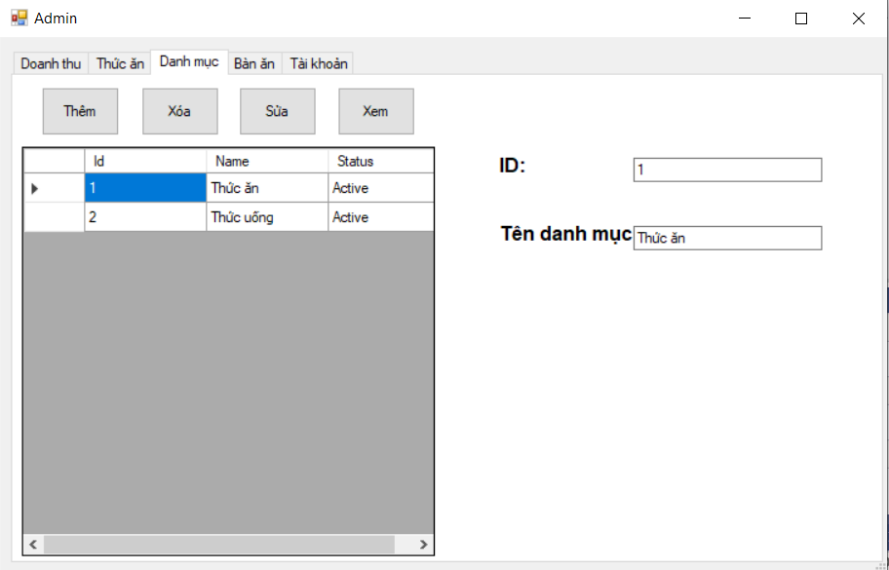

|  |  |  |  |  |  |
| --- | --- | --- | --- | --- | --- |
| **Name** | **Type** | **Event** | **Validation** | **Description** | **Status** |
| btnAddCategory | Button | Click |  | Add category |  |
| btnDeleteCategory | Button | Click |  | Delete category |  |
| btnUpdateCategory | Button | Click |  | Update category |  |
| btnViewCategory | Button | Click |  | View all category |  |
| dtgvCategory | DataGridView |  |  | Show list category |  |
| txtCategoryID | Textbox |  | Not null, int format | Input (Bind) id of category |  |
| txtCategoryName | Textbox |  | Not null | Input (Bind) name of category |  |

1. **Food table manager page**

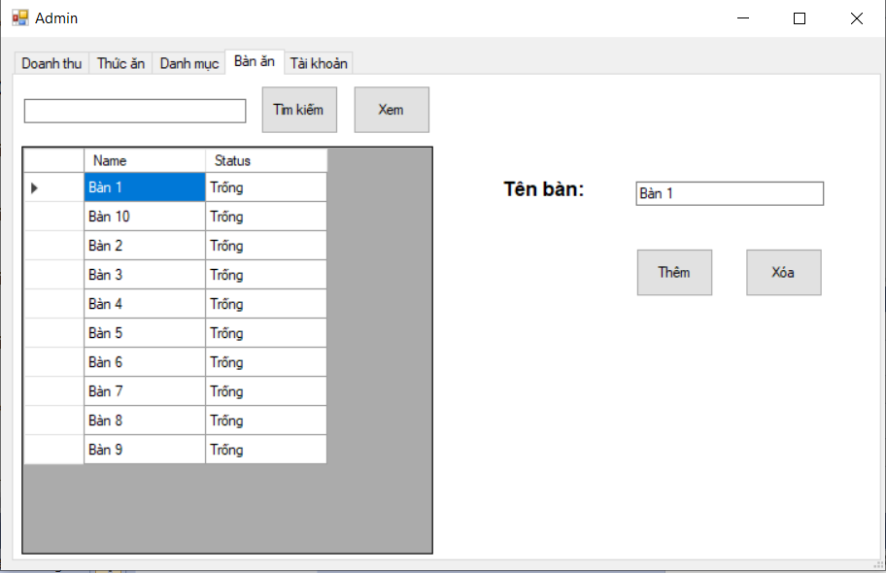

|  |  |  |  |  |  |
| --- | --- | --- | --- | --- | --- |
| **Name** | **Type** | **Event** | **Validation** | **Description** | **Status** |
| txtSearchTable | Textbox |  |  | Input key search |  |
| btnSearchTable | Button | Click |  | Search |  |
| btnViewTable | Button | Click |  | View all table |  |
| dtgvTable | DataGridView |  |  | Show list table |  |
| txtTableName | Textbox |  | Not null | Input (Bind) name of table |  |
| btnAddTable | Button | Click |  | Add table |  |
| btnDeleteTable | Button | Click |  | Delete table |  |

1. **Food table manager page**

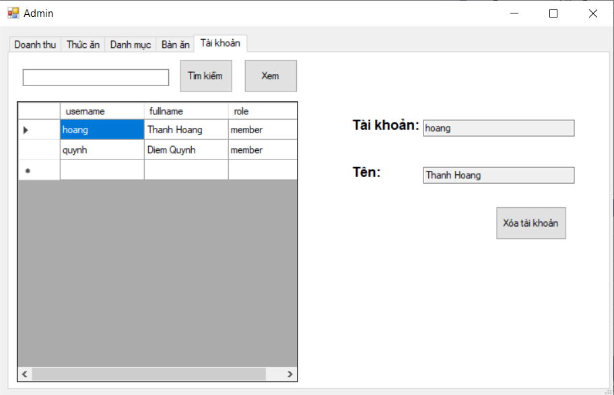

|  |  |  |  |  |  |
| --- | --- | --- | --- | --- | --- |
| **Name** | **Type** | **Event** | **Validation** | **Description** | **Status** |
| txtSearchUser | Textbox |  |  | Input key search |  |
| btnSearchUser | Button | Click |  | Search |  |
| btnViewUser | Button | Click |  | View all table |  |
| dtgvUser | DataGridView |  |  | Show list table |  |
| txtUser | Textbox |  |  | Bind username of user | Readonly |
| txtName | Textbox |  |  | Bind fullname of user | Readonly |
| btnDeleteAccount | Button | Click |  | Delete user |  |