**USER GUIDE FOR RESTAURANT MANAGER APPLICATION**

**1: Introduction**

This app is an efficient and convenient restaurant management system. This will be accessible to users with valid username and passwords. This system provides the following facilities:

* Allows users to order and pay by the table.
* View and update information user.
* Admin can view bills by date.
* Insert, update, delete, search items.
* Insert, update, delete category
* Search, add, delete food table.
* Search, delete user by admin.

**2: Link download**

**Sql server:**

[https://www.microsoft.com/en-us/download/details.aspx?id=42299](https://www.microsoft.com/en-us/download/details.aspx?id=42299&fbclid=IwAR2PCzqwR6auC3T8FFQQWBStrM-IAjTAc6n0UUe6SxY-xfYhcQy7xtYEQ3k)

**App:**

**https://drive.google.com/open?id=1hkAyJyXf4gU9t0fyhjaHfIypkmYq5QVn**

**3: Use app**

**Open the program**

**First, form login will show**

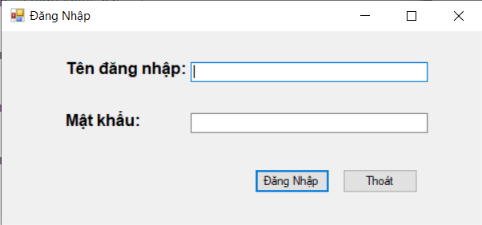

**User input username and password then click login button**

**If invalid:**

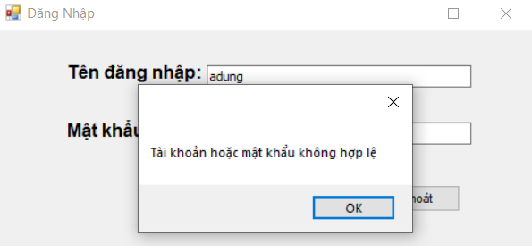

**If valid manager form will show:**

**If you are member, admin window will enable:**

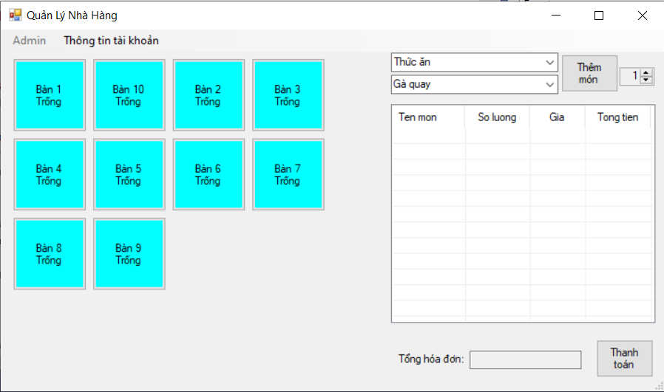

**If you are admin:**

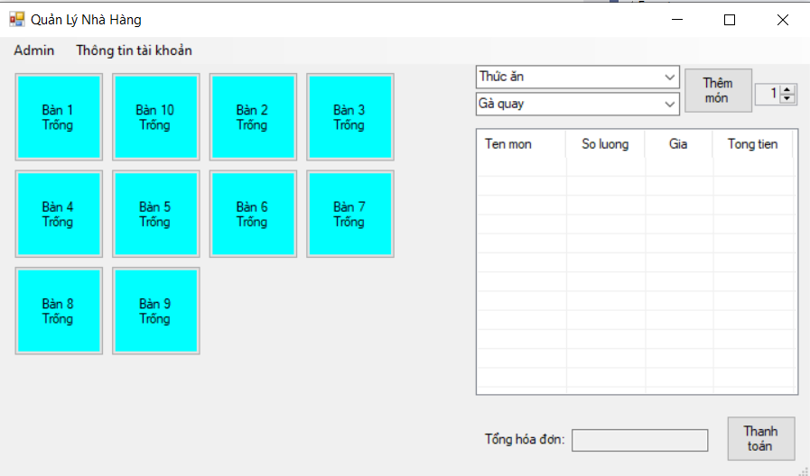

**Click information account in menu bar to show detail account and edit:**

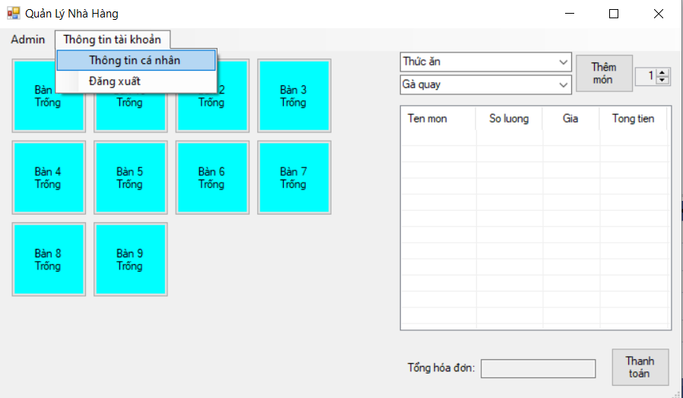

**Then**

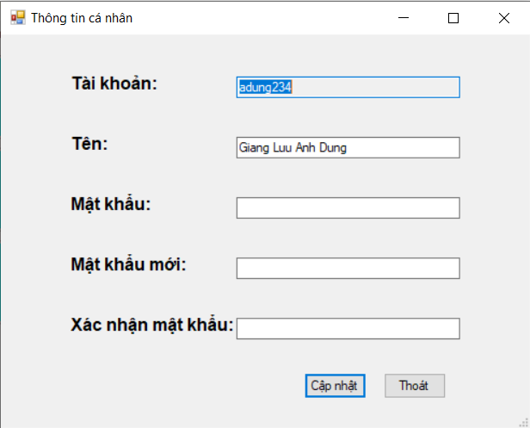

**If you edit, you must enter current password**

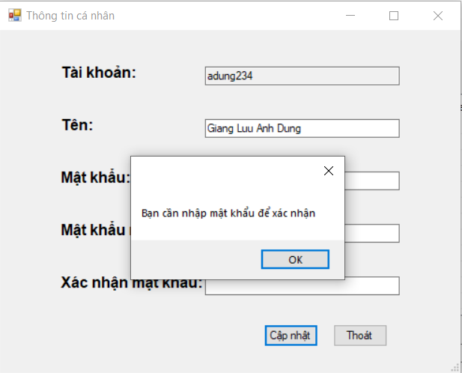

**Edit valid information and click button:**

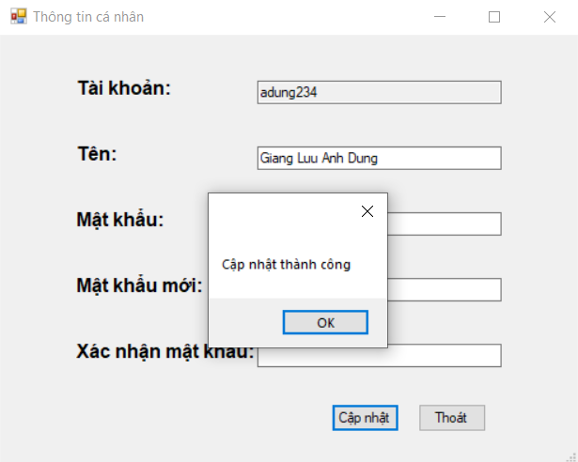

**Add food to bill function:**

**1: choose table**

**2: choose category and food**

**3: choose quantity (default 1)**

**4:click add button**

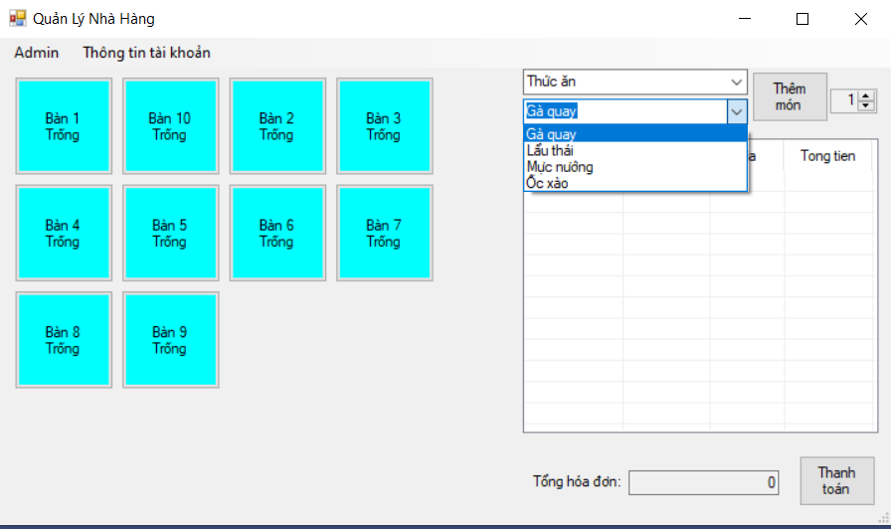

**Affter add, table will chance status and update bill information**

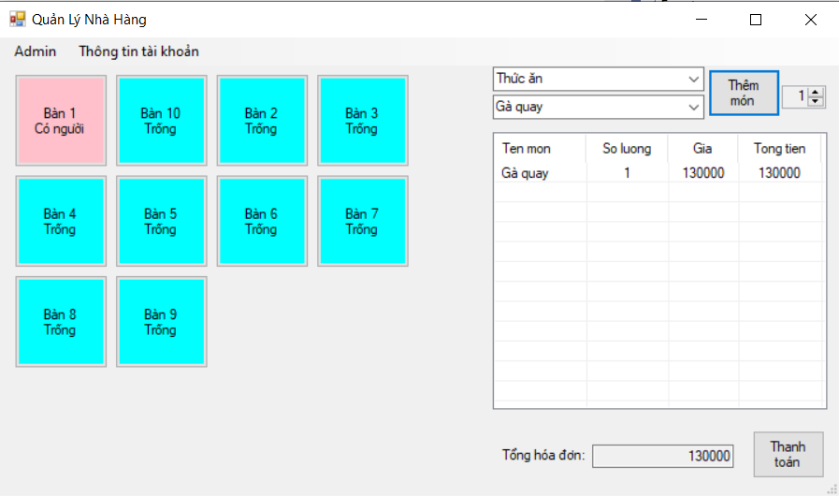

**Checkout function:**

**1: choose table checkout**

**2: click checkout button, confirm message will show**

**3: click ok to continue**

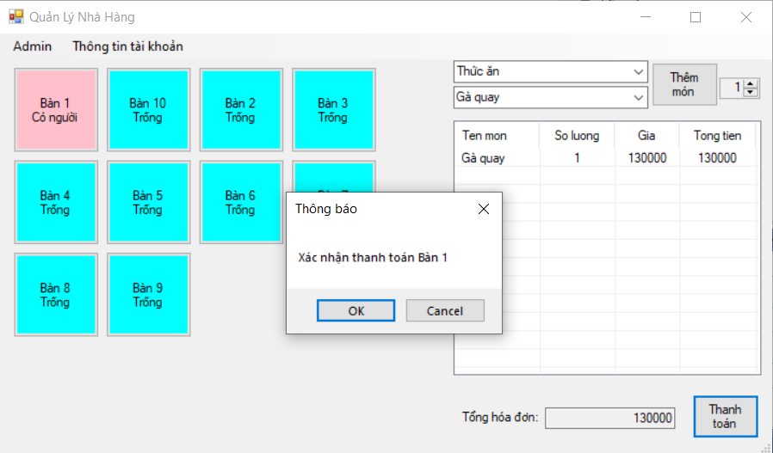

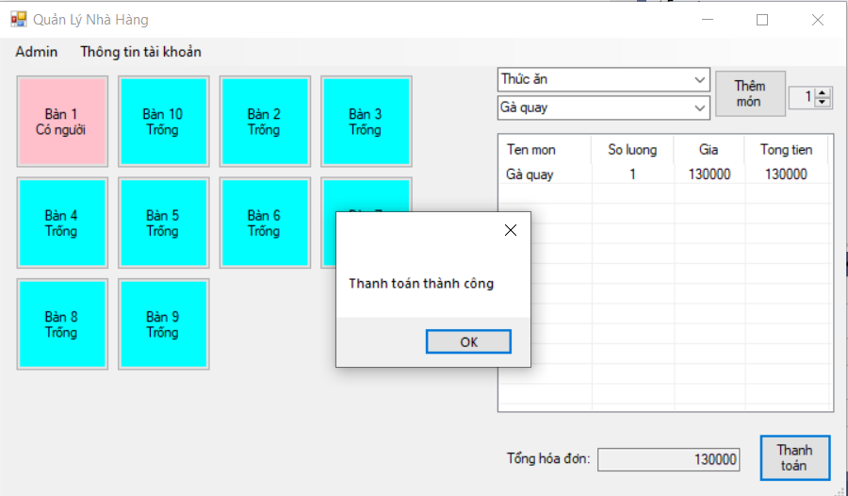

**Admin function:**

**1: Bill manager:**

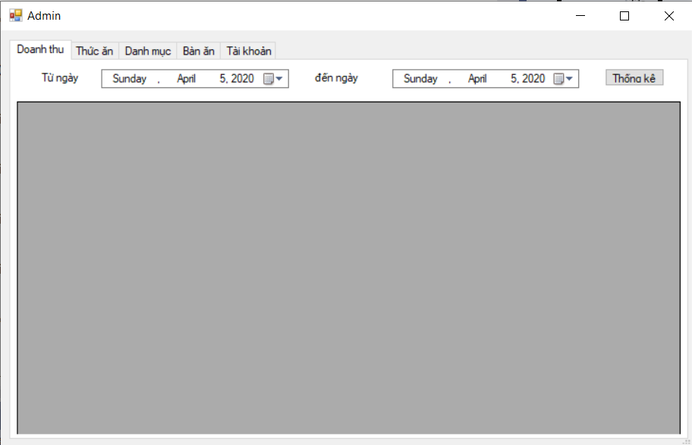

**Choose the time period you want to find**

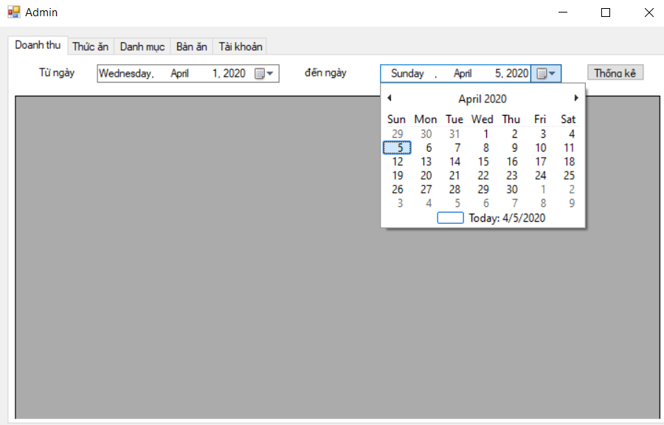

**Then click view button.**

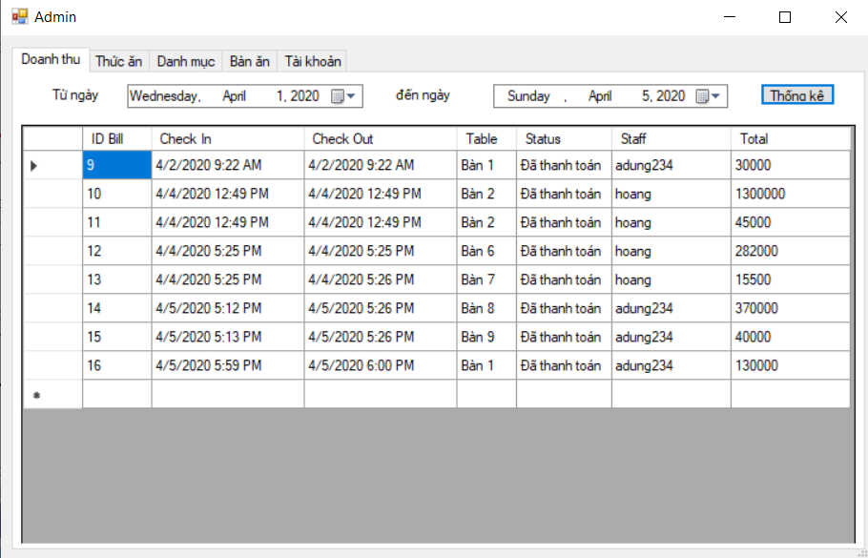

**2: Food manager:**

**Click Food part, system will show foods available: (Click view button is the same)**

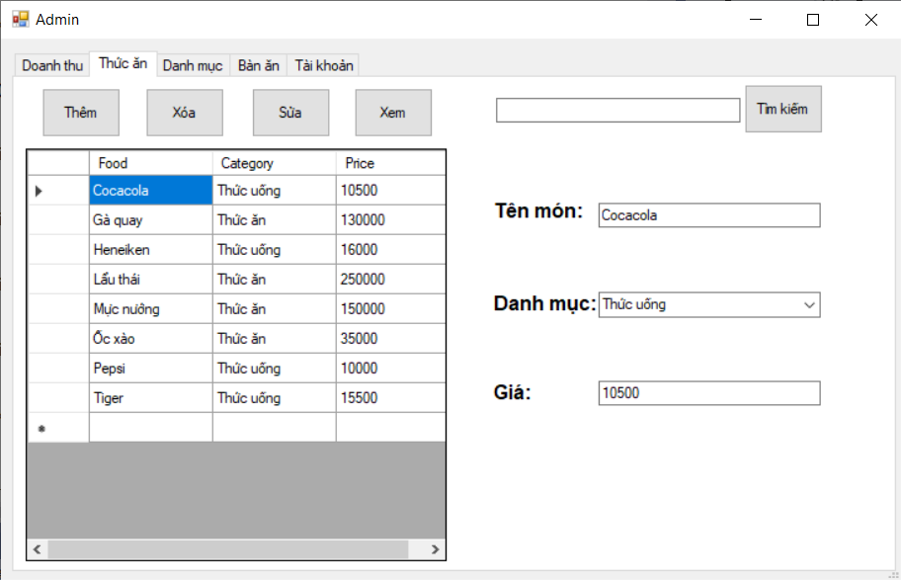

**Enter key search and press Search ( don’t need fullname):**

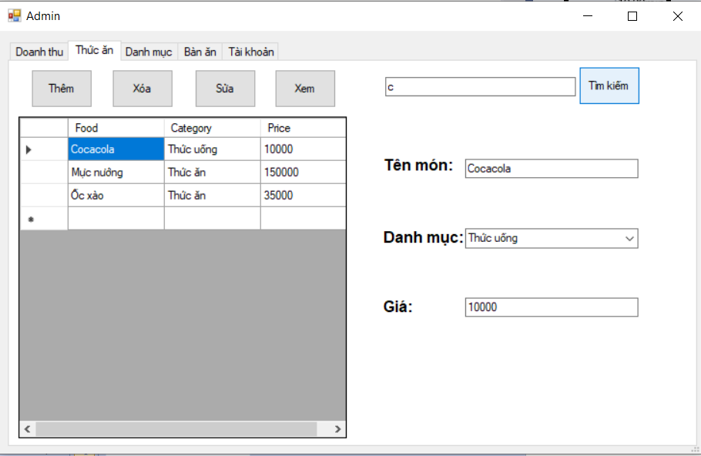

**Add food:**

**1: Input all fiels**

**2: click add button**

**If food is existed or fiels are wrong format, warning will show**

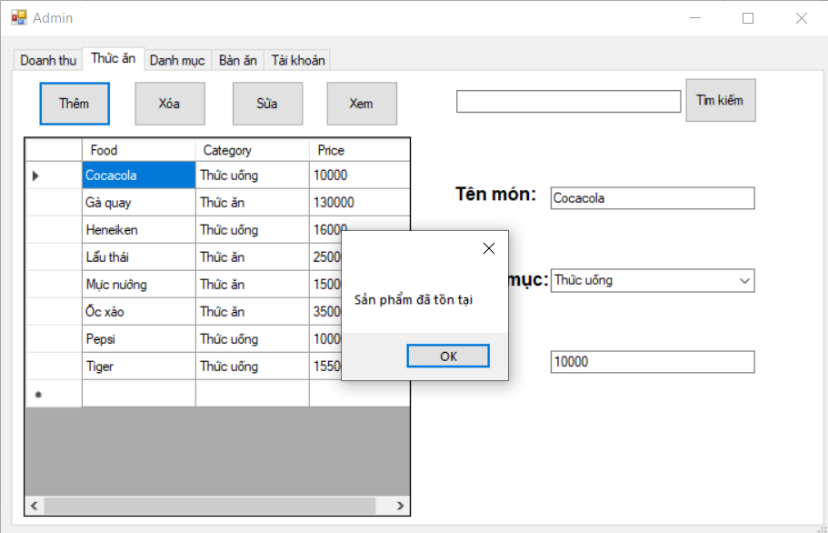

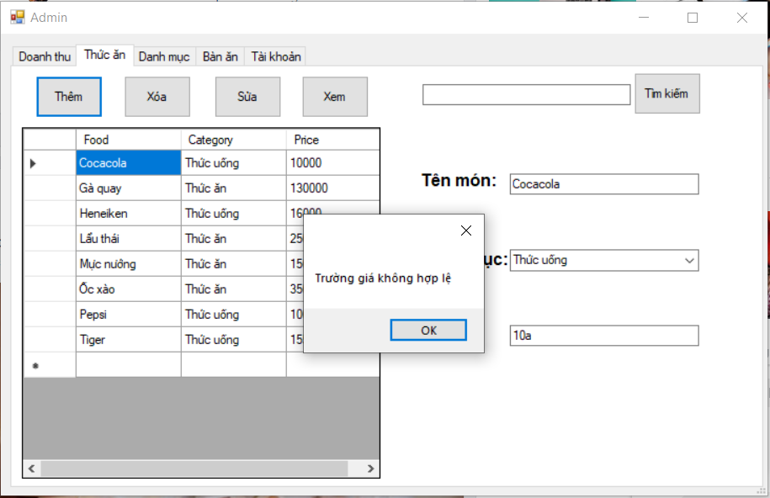

**If fiels are valid, success message will show and update list food**

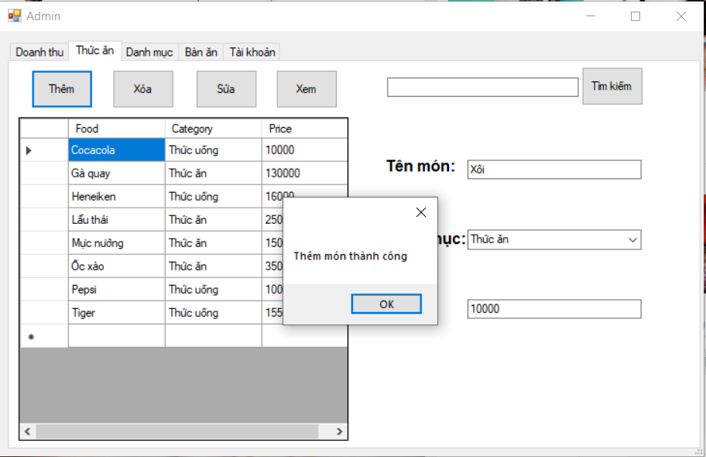

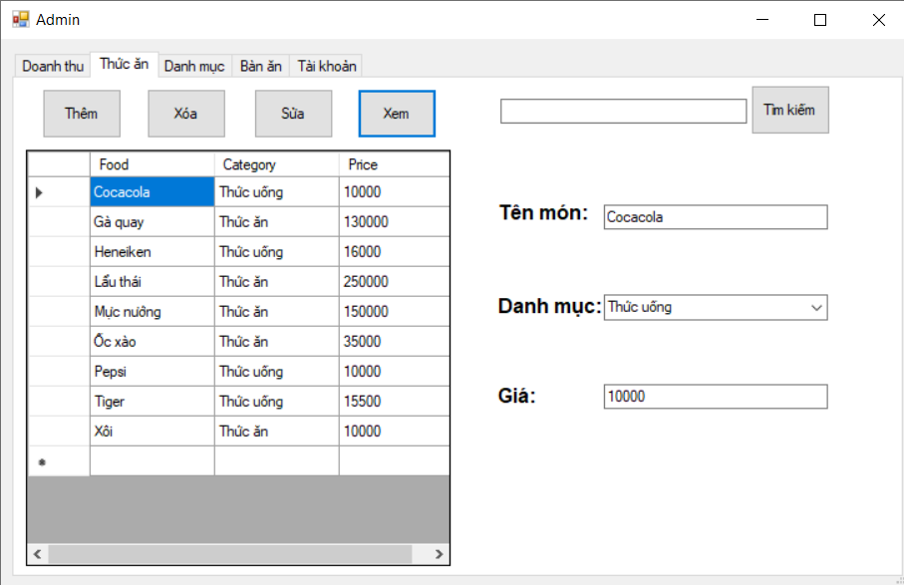

**Delete food function:**

**Choose a food in the table and click delete button to delete.**

**After delete, system will show success message and update list.**

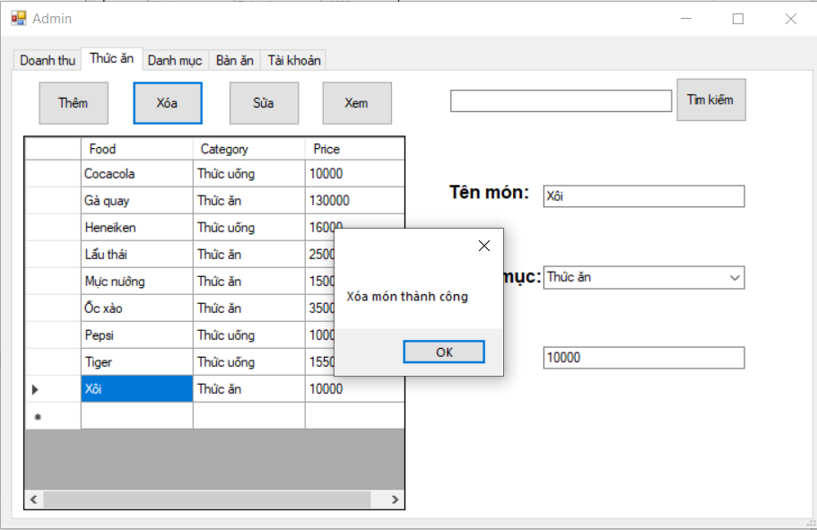

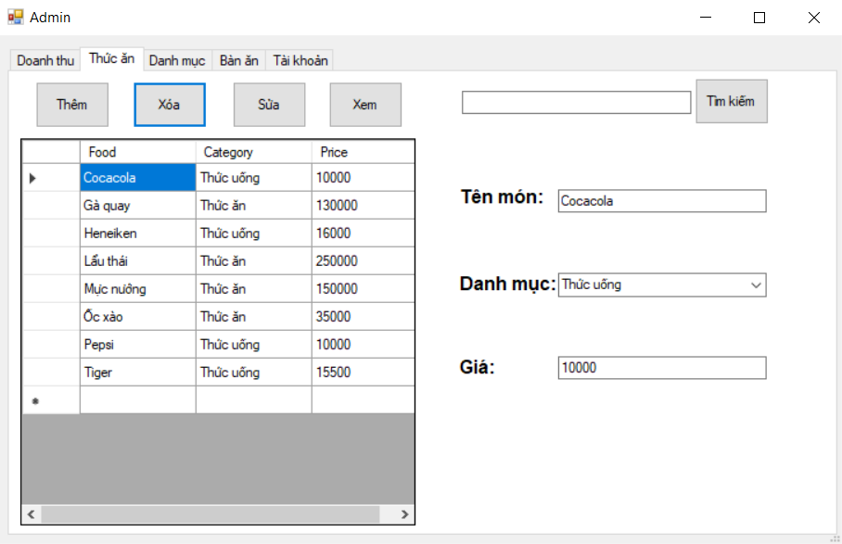

**Update food function:**

**Choose a food in the table, then edit information in text fiels.**

**Cann’t update name food and fiels are valid format.**

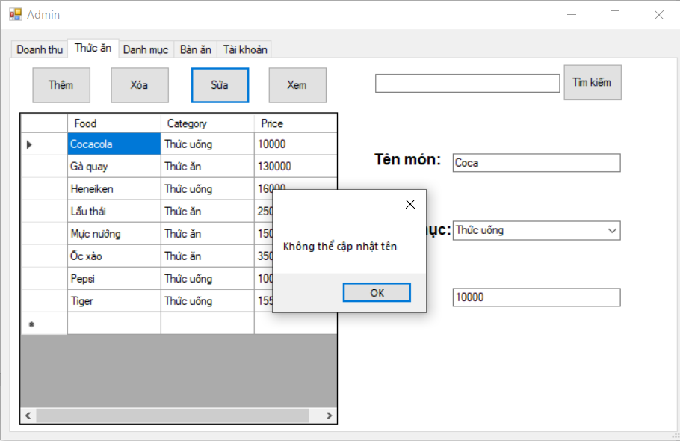

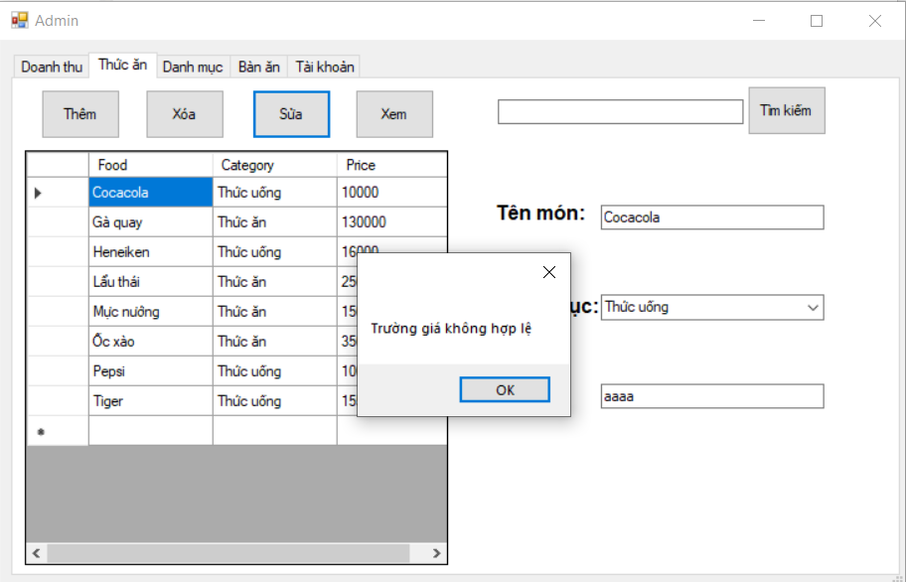

**Update success, system will show notification then update list food in table**

