**DOCUMENT HISTORY AND INFORMATION**

**History of Amendments:**

|  |  |  |  |  |
| --- | --- | --- | --- | --- |
| **Date** | **Version** | **Modified Section** | **Summary of Change** | **Author** |
| 18/10/2024 | 0.1 | ALL | Initial Draft | Hoang Nam |
|  |  |  |  |  |
|  |  |  |  |  |
|  |  |  |  |  |

Distributed for Review

This document has been distributed for the following to review:

|  |  |  |  |
| --- | --- | --- | --- |
| **Name** | **Title & Company** | **Issue Date** | **Revision** |
|  |  |  |  |

Approvals

This document requires the following approvals:

|  |  |  |  |
| --- | --- | --- | --- |
| **Name** | **Signature** | **Title** | **Issue Date** |
|  |  |  |  |
|  |  |  |  |
|  |  |  |  |
|  |  |  |  |
|  |  |  |  |

Associated Documents

This document is associated with the following other documents:

| Name | Title and Originator’s Reference | Source | Issue Date | Version |
| --- | --- | --- | --- | --- |
|  |  |  |  |  |

Table of contents

1 Introduction: 4

2 Purpose: 4

3 Scope: 4

4 Definitions, Acronyms and Abbreviations : 4

5 Overview: 4

5.1 Use case diagram: 4

5.2 Entity relationship diagram: 4

6 Functionality Requirements: 4

6.1 Order Information Display: 4

6.1.1 Order status bar: 4

6.1.2 Order Information Display: 4

6.1.3 Order status tracking: 5

6.1.4 User Interactions 6

6.1.5 Shipping information: 7

7 Non-functional requirements: 7

7.1 Performance: 7

7.2 Scalability: 7

7.3 Security: 7

7.4 Portability: 7

7.5 Audit: 8

7.6 Error handling: 8

7.7 Infrastructure: 8

7.8 Look and feel: 8

7.9 Legal: 8

7.10 Training: 8

7.11 User Documentation & Help Screen Requirements: 8

7.12 Support & Supportability: 8

7.13 Reliability: 8

7.14 Design Constraints: 8

7.15 Purchased Components: 9

7.16 Interfaces: 9

7.17 Test: 9

7.18 Data: 9

# Introduction:

The software requirements specification (SRS) document details the order tracking functionality for the Shopee e-commerce platform. This document outlines the purpose, scope, functional and non-functional requirements, as well as assumptions and limitations of the order tracking functionality..

# Purpose:

This document outlines the functional and non-functional requirements for the Order Tracking feature on the Shopee platform.

# Scope:

This document covers all types of orders on Shopee (domestic, international), including completed, in-transit, canceled, and returned orders.

# Definitions, Acronyms and Abbreviations :

* Bộ lọc: Tiêu chí để thu hẹp kết quả hiển thị (ví dụ: mã đơn hàng, thời gian mua).
* Sắp xếp: Tùy chọn để sắp xếp kết quả theo trạng thái của đơn hàng.

# Overview:

## Use case diagram:

## Entity relationship diagram:

# Functionality Requirements:

## Order Information Display:

### Order status bar:

Description: The order status bar is where users track the status of purchased orders.



Functionalities:

* Users can interact by selecting each tab on the order status bar to display the status of the purchased order..
* The system will display results as the user selects each tab..
* The order status bar will always be displayed at the top of the page, including the order page..

Pre-condition: User must be on the e-commerce platform (purchase page) and have successfully placed an order.

Post-condition: After selection, a list of purchased products will be displayed or a notification will be received if there are no matching results.

### Order Information Display:

Description: Display comprehensive order information, including order ID, product name, quantity, price, seller, shipping address, shipping method, and order status.

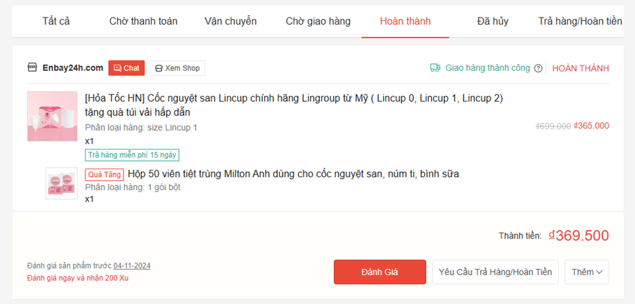

Functionalities:

* The system displays information about orders:
* Product name.
* Order ID.
* Quantity.
* Price.
* Shipping address.
* Payment method.
* Order status.
* Shipping method
* Enable users to search for orders based on various criteria such as order ID, product name, and date range.
* Order information is displayed quickly..

Pre-condition: Must select correct item on order status bar.

Post-condition: Results will be displayed along with matching products..

### Order status tracking:

Description: Provide real-time or near real-time updates on order status.

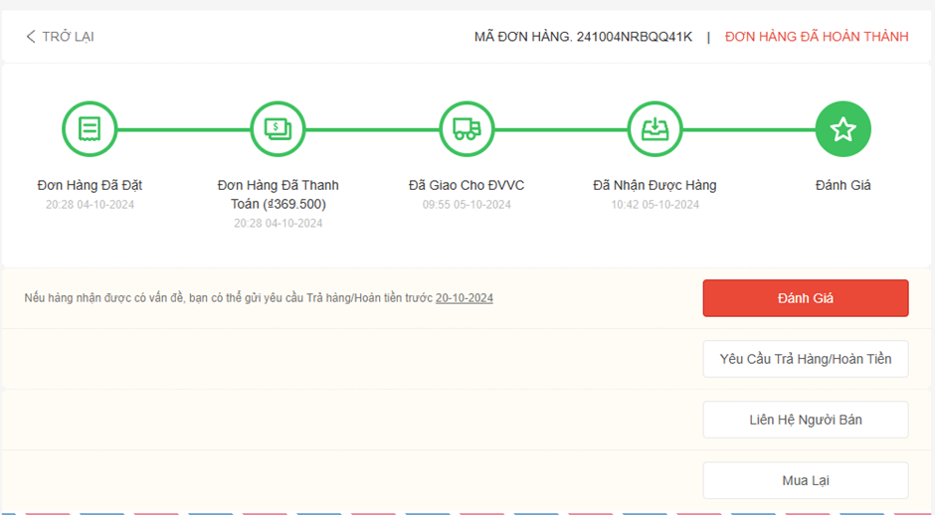 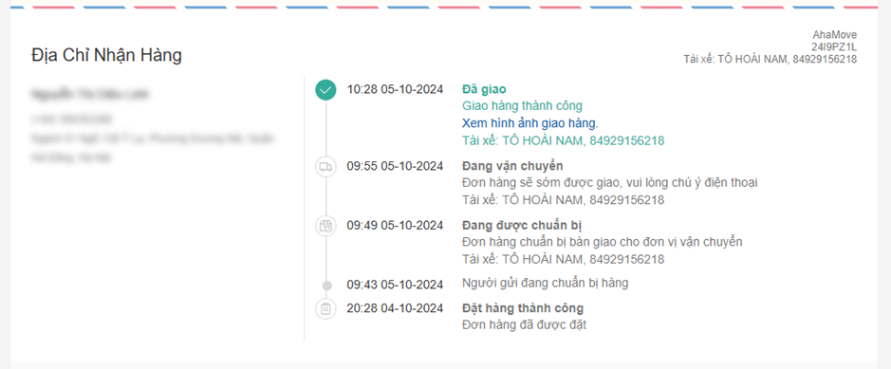

Functionalities:

* Display a complete history of order status changes.
* Send notifications (via email or in-app notifications) for significant status changes (e.g., order shipped, in transit, delivered).

### User Interactions

Description: Allows users to interact with orders according to specified conditions.

Functionalities:

* Allow users to cancel orders under specified conditions.
* Enable users to request refunds if necessary.
* Provide a direct communication channel between users and sellers or customer support from the order tracking page.

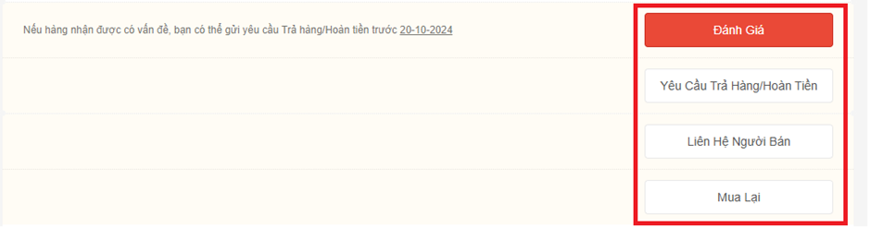

### Shipping information:

Description: Display detailed shipping information.

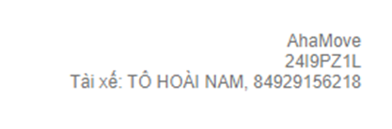

Functionalities:

* Display detailed shipping information, including the shipping carrier and tracking number.
* Provide a link to the shipping carrier's website for more in-depth tracking.

# Non-functional requirements:

## Performance:

* Ensure fast loading times for the order tracking page to maintain a seamless user experience.
* Order status updates should be smooth and responsive.

## Scalability:

* The system should be able to handle increasing numbers of users and orders without compromising performance.

## Security:

* Protect user data, including personal information and transaction details.
* Implement robust security measures to prevent unauthorized access.

## Portability:

* The order tracking system should be available 24/7.

## Audit:

Record user activity: The system needs to record user activity and collate information to analyze customer behavior and improve the experience.

## Error handling:

Invalid Keyword Handling: If the user enters an invalid keyword or has a syntax error, the system will display a specific error message and guide the user.

No Results Found: If there are no matching products, a clear message should be provided.

System Error Handling: A user-friendly error message should be displayed when a system or network connection error occurs.

## Infrastructure:

Scalability: The search system needs to be designed to be scalable, handling high traffic volumes and millions of queries per day.

High performance: Ensure fast searches, with fast response times even during peak hours.

Caching: Use caching to store orders to speed up response times.

## Look and feel:

User-friendly interface: The search interface should be intuitive, easy to use, and consistent with Shopee's overall aesthetic.

User feedback: When users interact, the feature of displaying recently purchased orders should be displayed immediately to improve the experience.

## Legal:

Privacy Policy: Search features should include provisions for personal data protection in accordance with local and international laws.

Advertising regulations: If sponsored products are displayed in search results, they should be clearly stated to users so that they know that this is an advertisement.

## Training:

None required at present.

## User Documentation & Help Screen Requirements:

Search Guide: Provides detailed instructions on how to use the order tracking feature, including using filters and shopping by product category. Frequently Asked Questions (FAQ): Assists users with frequently asked questions related to the order tracking feature.

## Support & Supportability:

User Support: Provide live support or chatbot functionality to help users troubleshoot issues related to displaying purchased orders.

Early Error Detection: The system needs to be able to monitor and notify about unusual search errors so that the support team can intervene quickly.

## Reliability:

High Availability: The command display system needs to operate reliably 24/7 with minimal downtime. Disaster Recovery: Have a backup and recovery plan in place to ensure operations even in the event of a major incident.

## Design Constraints:

Maximum priority for multiple devices: Search must be compatible with both mobile apps and websites, supporting multiple screen sizes.

Response speed: Product loading time should not exceed 2 seconds, especially with large number of products.

## Purchased Components:

None required at present.

## Interfaces:

## Test:

Unit testing to handle order queries, filtering, and sorting.

Integration testing to ensure the system interacts correctly with order information.

Usability testing to assess user satisfaction with the interface and order tracking functionality.

## Data: