**REQUIREMENT  
Secure STM32-Based Home Security System**

**1. The Home Security System Shall Use an STM32 Microcontroller for Secure Operation**

1.1 The system shall use an STM32F103C8T6 microcontroller for handling security operations.

1.2 The system shall interface with input components including a 4×4 Keypad, MFRC522 RFID module with S50 cards or keys, Magnetic Switches, and a push button for user interaction.

1.3 The system shall integrate output components including an LCD 1602 with I2C module for user feedback, LEDs (Red/Green/Yellow), Buzzer, Servo motor for door control, and Magnetic switches for security alerts.

1.4 The system shall use an ST-Link V2 programmer for firmware flashing and debugging.

1.5 The system shall be powered via a breadboard setup with necessary resistors and wiring for stable operation.

**2. The Home Security System Shall Be Secure Against Unauthorized Access and Tampering**

2.1 The microcontroller shall use Readout Protection (RDP Level 1 or 2) to prevent unauthorized firmware extraction.

2.2 The system shall disable unused debugging interfaces (e.g., SWD, JTAG) to prevent hardware attacks.

2.3 The system firmware shall implement Secure Boot to prevent unauthorized firmware from running.

2.4 The system shall support AES-128/256 encryption for securely storing and transmitting authentication data.

2.5 The system shall securely store authentication credentials, such as RFID data, in non-volatile memory.

2.6 The system shall detect and log any tampering attempts, triggering the buzzer and alert LEDs.

**3. The Home Security System Shall Support Secure and Reliable Operation**

3.1 The system shall authenticate users using an RFID card or Keypad input.

3.2 The system shall allow users to unlock and lock the door using the servo motor upon successful authentication.

3.3 The system shall provide visual and audio feedback (LCD display, Green LED, and Buzzer) upon successful authentication.

3.4 If an unauthorized attempt is detected, the system shall activate the Red LED and buzzer to alert the user.

3.5 The system shall monitor door and window status using Magnetic Switches and trigger an alarm if tampering is detected.

3.6 The system shall use a reset button to return to normal state after an alert event.

**4. The Home Security System Shall Operate with Low Power Consumption**

4.1 The STM32 microcontroller shall operate in low-power modes when idle to reduce energy consumption.

4.2 The system shall optimize power usage by only activating the servo motor, buzzer, and LED when necessary.

4.3 The LCD display shall enter a power-saving mode when not in use.

**5. The Home Security System Shall Support Secure Firmware Updates**

5.1 The system shall allow firmware updates through a secure interface.

5.2 The firmware update process shall include a rollback mechanism in case of update failure.

5.3 The system shall validate firmware authenticity before applying updates.

**6. The Home Security System Shall Meet Environmental and Operational Requirements**

6.1 The system shall operate within a temperature range of -20°C to +70°C.

6.2 The system shall be resistant to dust, moisture, and water (minimum IP54 rating).

6.3 The system hardware shall withstand minor physical shocks and vibrations.

**7. The Home Security System Shall Provide Secure Debugging and Testing Features**

7.1 The system shall allow secure debugging via STM32 Secure Debug Authentication.

7.2 The system shall include a self-test mode for checking hardware integrity.

7.3 The system software shall include tools for monitoring authentication attempts and error detection.

7.4 The system shall support logging and debugging over secure UART, SWD, or JTAG with authentication.

**BLOCK DIAGRAM**

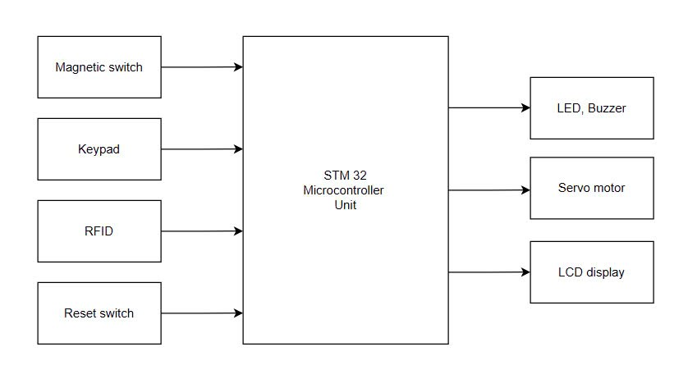

**COMPONENT SELECTION**

* STM32F103C8T6 microcontroller
* ST-Link V2 programmer
* Keypad 4x4
* MFRC522 read/write card IC with additional S50 cards or keys
* Green LCD 1602 with I2C module
* Push button
* Red/Green/Yellow LEDs and Buzzers
* Servo motors
* Magnetic switches
* Breadboard and wires
* Some resistors
* Explanation:

The general block diagram of the microcontroller based home security has been shown in the figure above. It consists of 3 sections: Input, controller and output section. At first the controller section remains in the waiting state for receiving a signal from the input section which includes Magnetic Switches, 4 × 4 Keypad and RFID scanner. In the input section, a magnetic S50 card or key has been used for interfacing with the microcontroller to lock or unlock the door of the system. Consequently, a manual keypad performs the similar function. On the other hand, magnetic switches have been placed both at door and window to detect the current state of the system.

If anyone tries to unlock the system without authority, then those sensors will activate and the controller will receive a suitable pulse. According to the pulse of input devices, the controller section takes decisions and activates the output section which includes LCD display, Servo motor, LED and Buzzer. However, the activation of the output device depends on the activity of the input section that indicates the user unlocked the system either authoritatively or without authoritative way. In an authoritative way, the controller sends a pulse signal to the servo motor and then 90 degree rotation of the servo motor to lock or unlock the system. At the same time, a message is displayed on the LCD and green LED. Conversely, without an authoritative way, magnetic switches send signals to controllers. Then the controller sends a signal to the LED, Buzzer. LED and Buzzer have been placed surrounding the home which indicates some wrong events that have occurred within the system. At last a reset switch is used to regain the whole system at normal condition.