**CHAPTER 1: INTRODUCTION**

**1. Overview**

Currently, the development of Information Technology in our country is entering a new era with the widespread deployment of informatics applications for organizations and society. There is no doubt about the role of Information Technology in life, in science and technology, in business, as well as in all aspects of society, even for an individual.

However, at the present time, Information Technology is only initially being applied in life in general and education in particular. The use of electronic documents in teaching and learning is not really popular, not yet highly effective, books, textbooks ... still play an extremely important role. For large universities, managing a library system with thousands of books and managing the borrowing and returning of thousands of students is extremely complicated. Therefore, we have received the research topic: "Building a library management program"

**2. Important of the project**

To partially solve the limitations of manual library management, we have to technologyize library management tasks. In order to better serve the increasing number of readers and book titles. Therefore, a library management system must perform the main functions of the library such as: searching, entering book data, registering readers, registering to borrow and return books, statistical reports, etc..

**3. Scope of the project**

This program will be used in university libraries. Librarians will use the system to add, edit, delete and search books.

**CHAPTER 2: DESIGNING**

We use a struct to define a struct Book, an array of structs to store listBooks, and the following are the specific steps to create a Library management program in C using struct and File satisfying four functions: add, delete, update, search.

* **Struct Book:**

We will create the book structure as follows: bookID, name, author, and category are declared with data type char, and for quantity use int. In addition, we also declare the global variable listBooks, and the variable numBooks is assigned a value of 0.

* **readFile() function:**

First, we need to declare a pointer of type FILE so that it points to the file "Library.txt" to be read on the computer and use the fopen() function to open the file and the "r" mode to open for reading.

Then use an if statement and declare the variables outside with fscanf .

After opening the file and done, we should close the file using the fclose (fOut) function, where fOut is the pointer of the file being processed.

* **writeFile() function:**

We continue to declare pointers of type File but "w+" mode is open for reading and writing. Declare variable I and use for loop to write all data in the file. And do not forget to close the file after executing the commands.

* **addBook() function:**

Declare the variable book of the struct type Book and use printf , gets to input and output all input from the keyboard. Particularly for the quantity variable, it will pass the reference “&book.quantity”.

* **deleteBookByID() function:**

First, we will declare a one-dimensional array id. Then use a for loop and an if conditional statement to determine the book to delete and perform the deletion algorithm. If the input id is not in the list, output " Can not delete book with id ".

* **updateBookByID() function:**

First, we need to declare new 1-dimensional arrays: tempName, tempAuthor, tempCategory, tempQuantity to serve the editing algorithm. Continue using the for loop and the if conditional to determine the book to edit and perform the editing algorithm.

* **searchBookByID() function:**

Similar to the above two functions, use for and if to search for books by checking the bookID and output to the screen using the printf function. If you enter the wrong bookID, then output “Can not found the book with id”.

* **viewListBooks() function:**

This function is quite simple, just use a for loop to print out all the data from the file.

* **main() function:**

To run the program to meet the functions, we use a combination of the " do - while " conditional statement and the " switch - case " function with 5 cases being the 5 above functions.

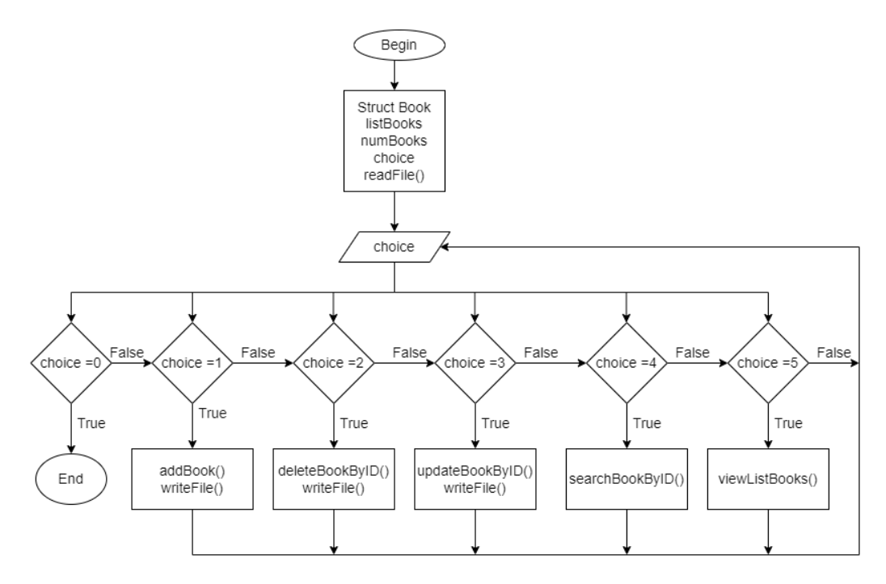

**CHAPTER 3: DISCUSSION**

**1. Limitations of the program**

Besides the results achieved, the program still has some limitations as follows:

- The new program only supports the management of books in the library, and the management of readers, management of borrowing - returning and reporting statistics, the system has not yet supported.

- The program is only for library staff to use, readers do not have the right to use the system to be able to search and view information of books.

**2. Oriented development**

In the future to improve and operate more effectively, the project sets out the following development directions:

- Add login function to the system to easily verify users

- Add internal data handling in the library

- Investigate and improve the functions to suit the profession of library management in schools

**CHAPTER 4: CONCLUSIONS**

After a period of research and installation, the project has achieved certain results and moreover, personally and as a team, I have cultivated and learned a lot of important knowledge before upon completion of the course. The results obtained are as follows:

- Have basic knowledge of programming language C used in the project such as: struct, functions, array, read/write file, ...

- Based on the acquired knowledge to apply and build a system with basic functions and meet some requirements of the library management system.

- The interface of the system is friendly, easy to use.