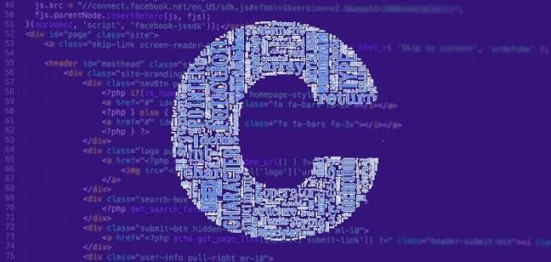

Daily Report C Programming
Author:Lương Đỗ Anh Kha
reporting date: 03/11/2026 (day 2)

I.Basic concepts in C

C Introduction

What is C?
- C is a general-purpose programming language created by Dennis Ritchie at Bell Labs in 1972.
- It is popular because it is fast, widely supported, and helps you understand how programs work "under the hood".
- The main reason for its popularity is because it is a fundamental language in the field of computer science

What is C used for? C is often used to create programs that need to run fast and work closely with the computer.
- Operating systems, such as parts of Windows, Linux, and macOS
- Programs inside devices like cars, TVs, and home electronics
- Software that needs to be fast, including databases and system tools
- Core libraries that other programming languages rely on

Why Learn C?
- It is one of the most widely used programming languages
- If you know C, you will have no problem learning other popular programming languages such as Java, Python, C++, C#, etc, as the syntax is similar
- It helps you understand memory, performance, and how computers handle data
- C is very versatile; it can be used in both applications and technologies
Difference between C and C++
- C++ was developed as an extension of C, and the syntax is often similar
- C is mainly a procedural language (you build programs with functions)
- C++ supports classes and objects (often used for object-oriented programming)
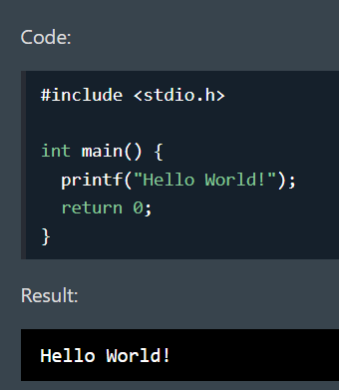
The process of compiling a program:
- Programs written in C require the source code to be compiled into executable code in order to run.
- The process is divided into 4 main stages:
  - Pre-processing stage.
  - The phase of translating NNB C into Assembly.
  - The stage of translating assembly language into machine language.
  - Linking phrase.

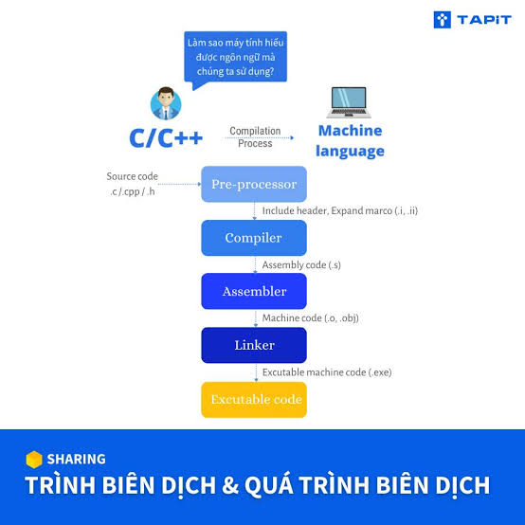

Programming Rules
- Statements must end with a semicolon “ ; ”:
- Code block: Statements enclosed within a pair of curly braces “{ }”
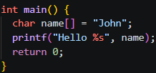
- Comments: single-line “//” or multi-line “/* */”:
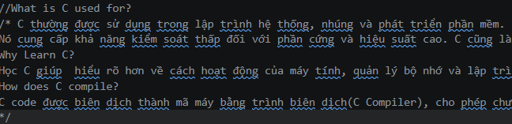
- Thư viện: nằm sau #include trong cặp dấu “< >”:
- A main() function is mandatory; the program begins execution from the main() function.
- Variable names must not contain spaces or special characters, and cannot begin with a number.

Syntax
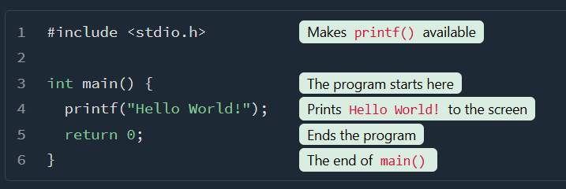
Line 1: #include <stdio.h> tells C to include a header file. This header lets us use input/output functions such as printf() (used in line 4).
Line 2: A blank line. C ignores extra spaces and blank lines, but we use them to make the code easier to read.
Line 3: main() is a special function. Your program starts running here. Any code inside the curly brackets {} will be executed.The word int before main() means that the function gives back a whole number (an integer) when it ends. That number is the 0 in return 0.
Line 4: printf() is a function used to output (print) text to the screen. In our example, it prints Hello World!.
Line 5: return 0 ends the main() function and sends a value back to the operating system.(Returning 0 usually means "everything worked").
Line 6: Do not forget the closing curly bracket } to end the main() function.

Input and output in C programming
- Printf and Scanf functions
Input command:
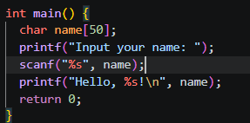
Syntax:
printf("format string");
- Function: displays output on the screen.
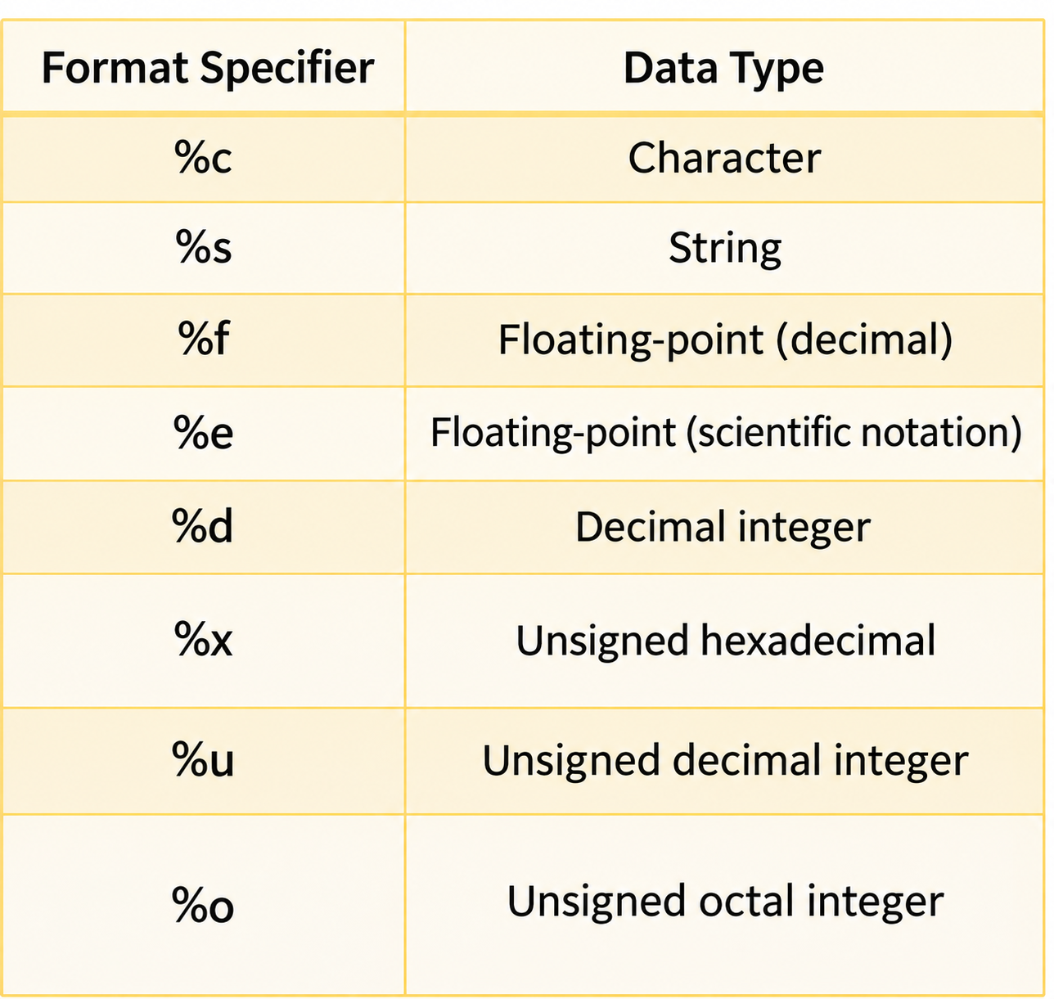
scanf ("format string"[, argument 1, argument 2,…]);
- Function: Read data from the keyboard.
- The format is similar to that of the printf function.

II.OPERATOR AND PROGRAMING STRUCT

1.Variables
- Variables are containers for storing data values, like numbers and characters.
- In C, variables must have a specific type, which tells the program what kind of data the variable can store.
- int - stores whole numbers (integers), such as 123 or -123.
- float - stores numbers with decimals, such as 19.99 or -19.99.
- char - stores a single character, such as 'a' or 'B'. Characters are surrounded by single quotes.
- Declaring (Creating) Variables
type variableName = value;
- type is one of the C data types (such as int)
- variableName is the name you choose (for example x or myNum).
- The equal sign = is used to assign a value to the variable.
- value is the value of the variable
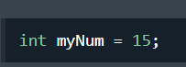

2.Data type in C

Data Type | Size | Description | Example
int | 2 or 4 bytes | Stores whole numbers, without decimals | 1
float | 4 bytes | Stores fractional numbers, containing one or more decimals. Sufficient for storing 6-7 decimal digits | 1.99
double | 8 bytes | Stores fractional numbers, containing one or more decimals. Sufficient for storing 15 decimal digits | 1.99
char | 1 byte | Stores a single character/letter/number, or ASCII values | A

3. Derived Data Type

Derived Data Type | Description | Example
Array | Store a sequence of fixed-size elements with the same type. Multiple targets of the same data under the same name. | 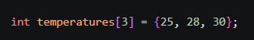
Pointer | Keeps track of another data type's memory address, can change the value of variable.It’s used in task: function pointers, data structures and dynamic memory allocation. | 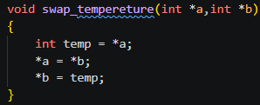
Structure | Group many data types under a single name. A structure's members or fields are used to refer to each variable within it. Any data type, including different structures, can be a member of a structure. A structure's members can be accessed by using the dot (.) operator. | 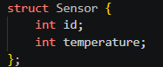
Union | Store various data types in the same memory address, members of a union all share a single memory space. A value can only be held by one member of a union at any given moment. | 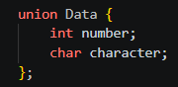
enum | Define named integer constants | 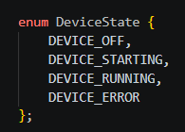

4. Operator

Operator | Name | Description | Example
+ | Addition | Adds together two values | 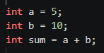
- | Subtraction | Subtracts one value from another | 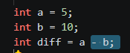
* | Multiplication | Multiplies two values | 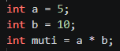
/ | Division | Divides one value by another | 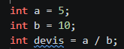
% | Modulus | Returns the division remainder | 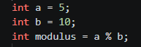
++ | Increment | Increases the value of a variable by 1 | 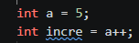
-- | Decrement | Decreases the value of a variable by 1 | 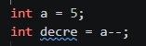

4.1 Comparison Operators

Operator | Name | Description | Example
== | Equal to | Less than or equal to | 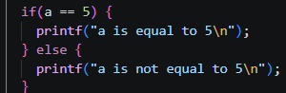
!= | Not equal | Returns 1 if the values are not equal | 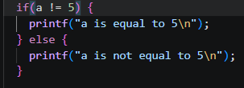
> | Greater than | Returns 1 if the first value is greater than the second value | 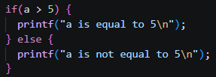
< | Less than | Returns 1 if the first value is less than the second value | 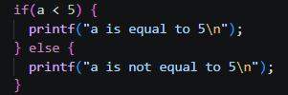
>= | Greater than or equal to | Returns 1 if the first value is greater than, or equal to, the second value | 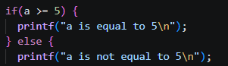
<= | Less than or equal to | Returns 1 if the first value is less than, or equal to, the second value | 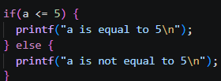

4.2 Shift Operators

Operator | Name | Description | Example
<< | the left | Shifts the bits of an integer to the left by a specified number of positions. | 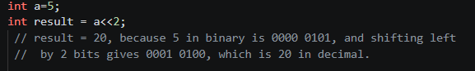
>> | right shift | Shifts the bits of an integer to the right by a specified number of positions. | 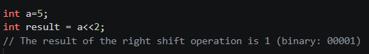

4.3 Bitwise Operators

Operator | Name | Description
& | AND | The bitwise AND operator performs a bitwise AND operation on the corresponding bits of the operands.
| | OR | The bitwise OR  operator performs a bitwise OR operation on  the corresponding bits of the operands.
^ | XOR | The bitwise  XOR operator performs a bitwise  exclusive OR operation on the  corresponding bits of the operands.
~ | NOT | The bitwise NOT  operator flips each bit of  the operand.
(a>b)?a:b | Ternary or Conditional | The ternary or conditional  operator allows you to assign a  value based on a condition.

Example:
- AND
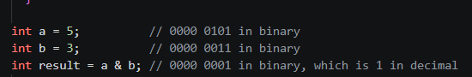
- OR
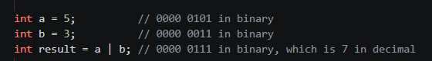

- XOR
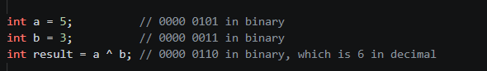
- NOT
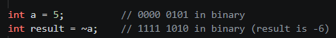
- Ternary or Conditional

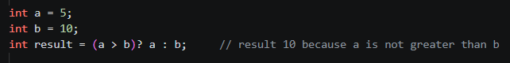

4.4 Type casting in C

Implicit type casting: The compiler automatically converts data from one type to another—this is known as implicit type casting or automatic type conversion.
Exam:
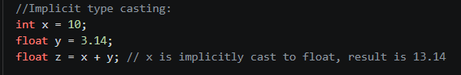
Explicit Casting:(type) expression
Exam:
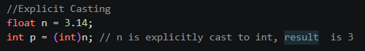
Narrowing Conversion: a value is converted to a data type with a narrower range, which may result in data loss.
Exam:

5. Conditions and Statements

5.1 If else statement
The If statement is used to check specific conditions and perform actions based on whether those conditions are true or not.
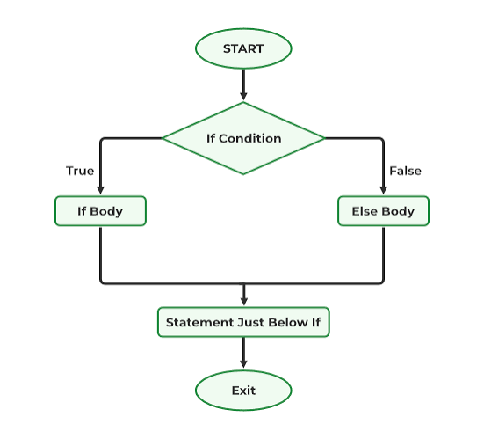
Exam:
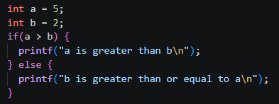

5.2 Switch statement
The switch statement in C: allows to execute multiple operations for the different possible values of a single variable.

Rules for switch statement in C language:
- The switch expression must be of an integer or character type.
- The case value must be an integer or character constant.
- The case value can be used only inside the switch statement.
- The break statement in the switch case is not must.

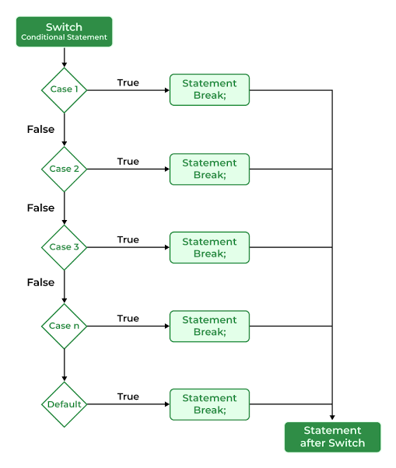
Exam:
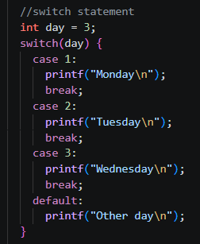

5.3 For loop in C
For Loop: Used to iterate the statements or a part of the program several times. It is traverse the data structures like the array and linked list.

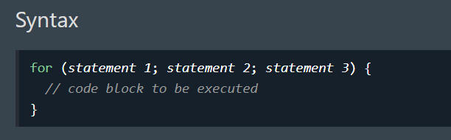
Statement 1: is executed (one time) before the execution of the code block.
Statement 2: defines the condition for executing the code block.
Statement 3: is executed (every time) after the code block has been executed.
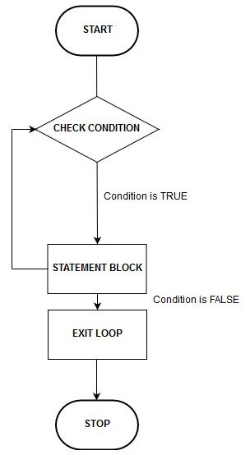

Exam:
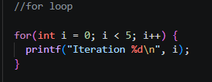

5.4 While loop in C
A while loop allows a part of the code to be executed multiple times depending upon a given boolean condition.
The while loop is mostly used in the case where the number of iterations is not known in advance.
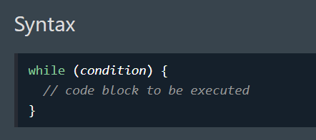

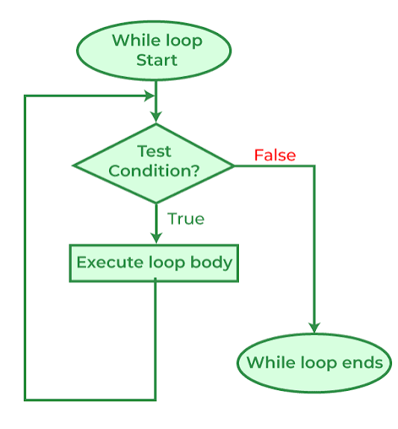
Exam:
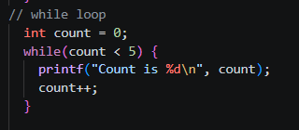

5.5 Do while loop in C
- A "do-while" loop is a form of a loop in C that executes the code block first, followed by
- the condition
- If the condition is true, the loop continues to run; else, it stops.
- The condition is originally true, it ensures that the code block is performed at least once

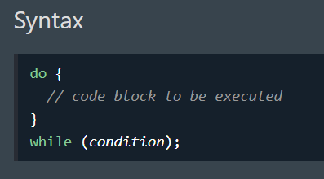
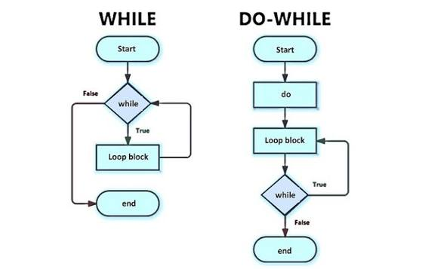
Exam:


