Chu Anh Lợi 20215280

Lesson 5.1

4. Build the layout in XML

Delete the textview and add cost of service text field

Review edittext attributes

Add the service question

5. Add tip options

Add RadioButtons

Add a default selection

6. Complete the rest of the layout

Add a Switch for rounding up the tip

Add the Calculate button

Add tip result

Chạy chương trình hoàn thiện

Lesson 5.2

3.View binding

Sau khi Sync



Initialize the binding object

4.Calculate the tip

Add click listener to the button

Get the cost of service

Get the tip percentage

Calculate the tip and round it up

Format the tip

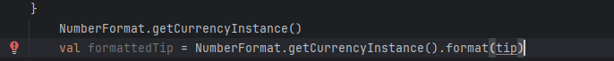

Display the tip



5.Test and Debug

Chạy chương trình:

__HẾT__