1. Retrieve a list of users who have completed more than 3 courses. For each user, display their full name, email, and the total number of completed courses.

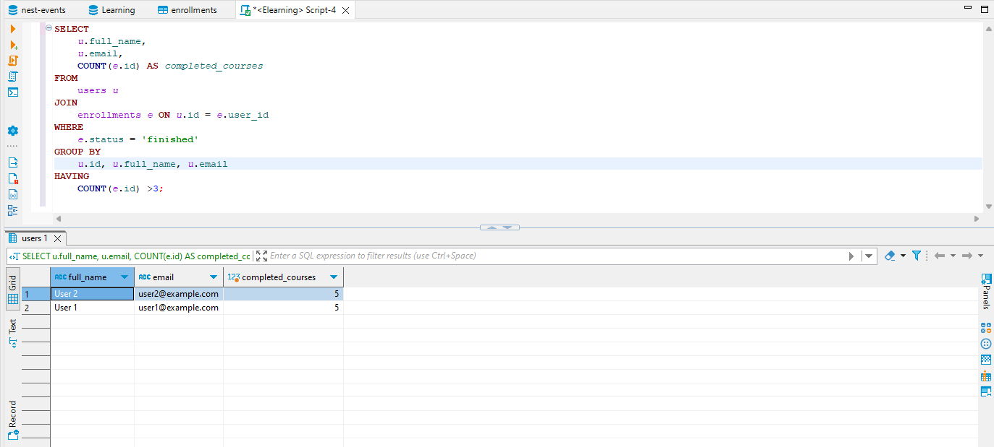

1. Find the top 5 courses with the highest enrollment rates. Display the course name, instructor, price, and the number of enrollments.

**SELECT**

*c*.name **AS** *course_name*,

*u*.full_name **AS** *instructor_name*,

*c*.price,

**COUNT**(*e*.id) **AS** *number_of_enrollments*

**FROM**

courses *c*

**JOIN**

enrollments *e* **ON** *c*.id = *e*.course_id

**JOIN**

users *u* **ON** *c*.instructor_id = *u*.id

**WHERE**

*u*.role = **'instructor'**

**GROUP** **BY**

*c*.id, *c*.name, *u*.full_name, *c*.price

**ORDER** **BY**

***number_of_enrollments*** **DESC**

**LIMIT** 5;

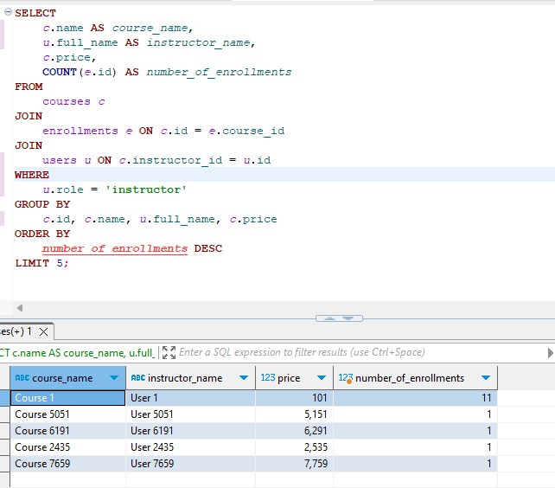

1. List all lessons for a given course, including whether they have a free preview available. Additionally, include the total number of users enrolled in that course, sorted by the course name.

**SELECT**

*c*.name **AS** *course_name*,

*l*.title **AS** *lesson_title*,

*l*.free_preview,

(**select** **count**(*e*.course_id) **from** enrollments *e* **where** *e*.course_id = *c*.id)

**FROM**

courses *c*

**JOIN**

lessons *l* **ON** *c*.id = *l*.course_id

**where** *c*.name= **'Course 1'**

**ORDER** **BY**

*l*.title ;

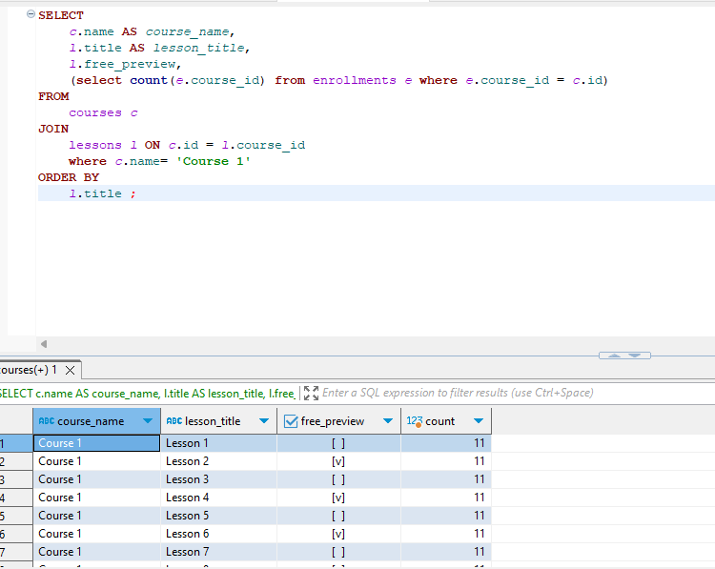

1. Retrieve a list of posts with the total number of comments and reactions (likes/dislikes). Only display posts with more than 5 comments and 10 reactions. Sort the result by the number of reactions in descending order
2. Query the top 3 most popular topics based on the number of courses associated with them. Display the topic name and the total number of associated courses.

**SELECT**

*t*.title **AS** *topic_name*,

**COUNT**(*tc*.courses_id) **AS** *total_courses*

**FROM**

topics *t*

**JOIN**

topic_courses *tc* **ON** *t*.id = *tc*.topic_id

**GROUP** **BY**

*t*.id, *t*.title

**ORDER** **BY**

***total_courses*** **DESC**

**LIMIT** 3;

