Joseph Le – jsl2449

Give your app a title.
TheNewGateReader

List contact email(s).
JoeLe1202@gmail.com

What sort of app are you building? What will be the major subsystems? What will be the major challenges?
A manga/comic reader for the specific manga “The New Gate”. Major subsystems include manga viewing activity, an HttpGet from MangaHere website activity, and a background downloader. The major challenge will be to get a set of images from the website and cache only a small set of images for efficiency.

Sketch the major user interface elements (i.e., actually draw them and include the drawing in your proposal. Focus on elements that are likely to be difficult.
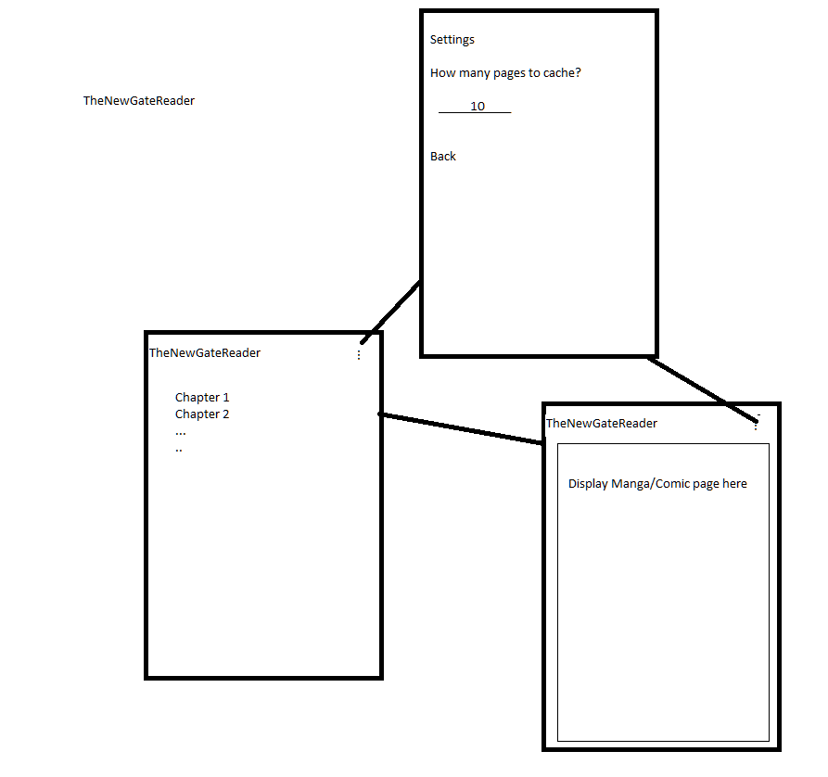

Include a week-by-week schedule.
Week of:
10/11 – Pull chapter list and display
10/18 – Pull download subset of pages of a chapter in background
10/25 – Display each page, incorporate swiping left and right for page changes
11/01 – Bug fixes, week due

List the APIs you will be using.
AsyncTask, HttpGet, Intents

Include a short functional specification for a deliverable that you will demo to the TA. The date your demo is due is listed on the course syllabus as a the project deliverable. The purpose of the deliverable is to help us ensure that you are on the right track.
- Download chapter list
- Download subset of pages from chapter
- Small settings (increase or decrease number of images to cache/store on disk)
- Display manga page one at a time, swipe to change page
- Have background downloading for pages coming up or left behind

Include a short discussion of other apps that have similar features and the sources of inspiration for your design.
Other apps that have similar features are Mango and MangaReader. The reason I want to design this app is because I used the Mango application. Sadly, the creator has expressed his discontinuance of support for the Mango application, so I wanted to create my own.

Remember that we are looking at two things. First is the technical breadth of your app, what APIs does it use, how complex is it, how functional, how well tested. The second is the usability of your app. Can we reinitialize the app without quitting? Can you demo all of the functionality easily? In general, usability is less technically demanding, so it is a good idea to polish it, regardless of the technical scope of your app.
Okay.

