Duc Anh Nguyen Assignment 2
- Data cleaning
Before conducting any analysis, the dataset was examined for missing values, invalid data types in each column, unrealistic values, outliers, and duplicate values. Therefore, several issues were identified, such as missing entries (NaN), nonsensical values, and outliers. To ensure the reliability and accuracy of the results, the data underwent a deep cleaning process.
The dataset was first checked for missing values by Python’s Pandas library. Entries with missing values and invalid data types were removed to prevent further analytical errors and bias. Additionally, logical filters were applied to detect and eliminate unrealistic values, preventing the result from becoming unreliable for the owners. Some of the unrealistic logic that I apply to find to remove the data, such as: The number of bikes, hours can not be less than 0, or the temperature has to be between -35 and 45 degrees. Finally, duplicated values were identified and deleted to ensure data integrity.
Once the cleaning process was finished, the dataset was assigned to a new variable for the following analysis. However, the dataset could go through more advanced cleaning techniques to improve the quality of the analysis result, such as imputing missing entries instead of deleting them, turning all the string or object types to numerical values for analysis, and checking for the reliability of renting bikes with other variables.
- Numerical analysis
 | Mean | Median | Standard Deviation
Rented Bike Count | 691.94 | 504 | 597.1
Temperature (deg C) | 12.26 | 12.2 | 11.43
Humidity (%) | 58.14 | 58 | 18.74

The descriptive statistics show that the average daily bike rental is approximately 692 bikes with a median of 504, indicating the data is slightly right-skewed with a few high-rental days, and most days have below-average bike rentals. Moreover, the high standard deviation of 597 suggests that the number of bikes rented daily varies significantly around the average (692). Additionally, the average temperature of 12 degrees and the humidity of 58% suggest the cool and slightly damp weather in Seoul, which is suitable for cycling. The high standard deviation of these weather aspects indicates their unstable environmental conditions. It might fluctuate throughout the year.
- Simple plot
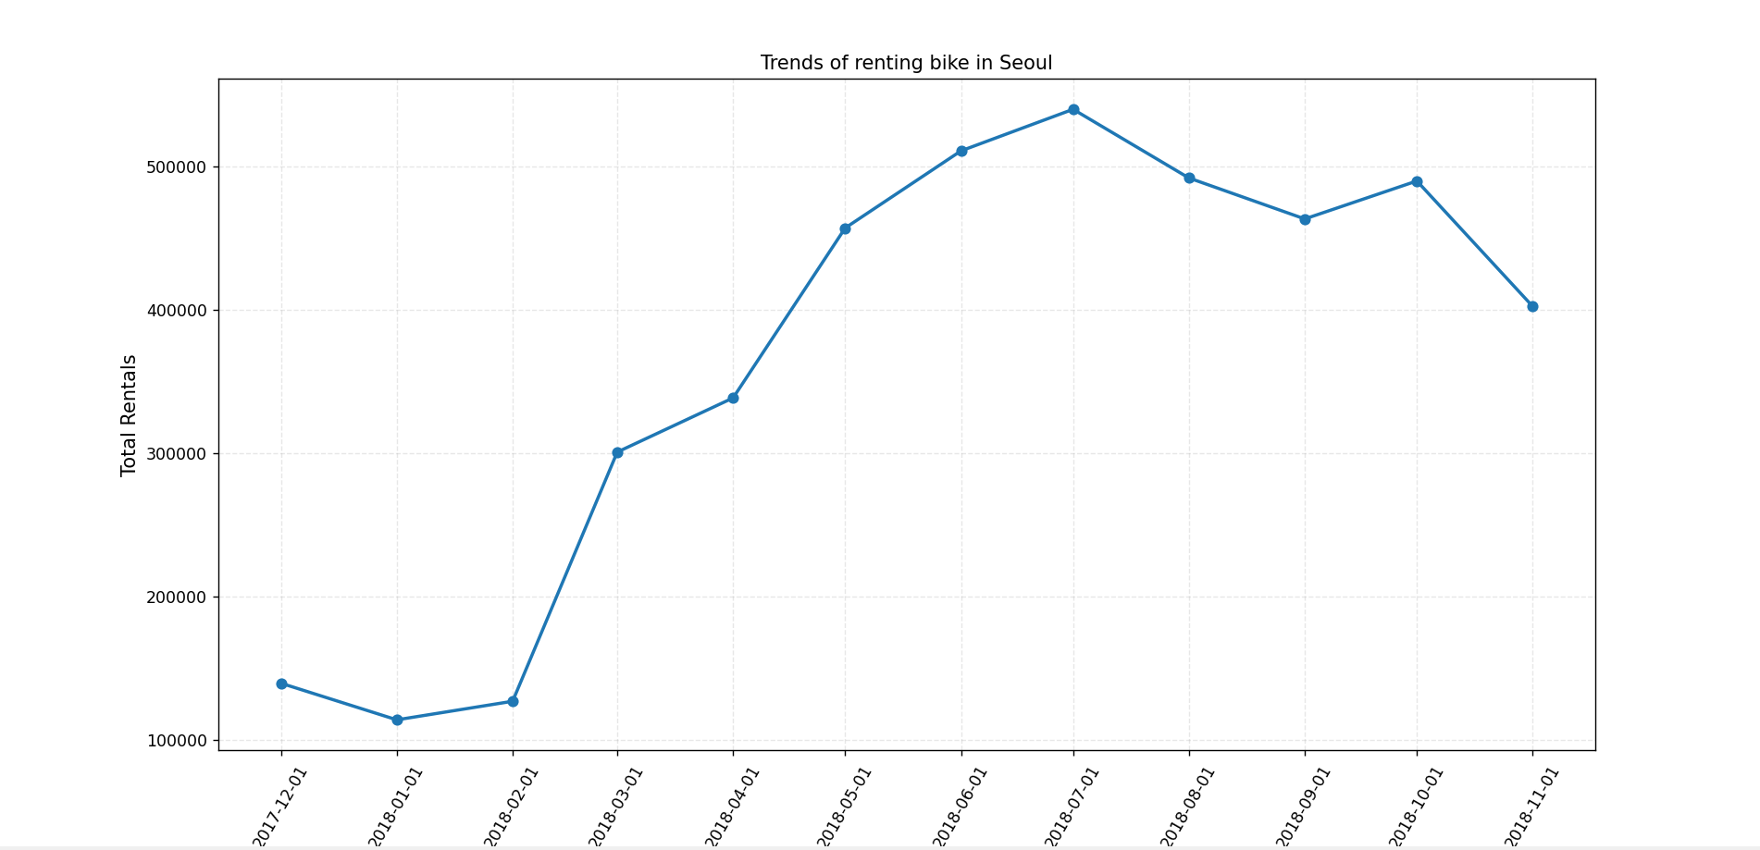
The line chart shows the monthly trend in bike rental across Seoul. In December 2017, the total number of bike rentals was around 150,000, and they grew steadily. However, there was a fluctuation from July 2018 to the end of that year, which led to a drop of around 100000 bikes in total bike rentals, and the shops ended the year with around 400000 rented bikes.
- Multiple–variable plot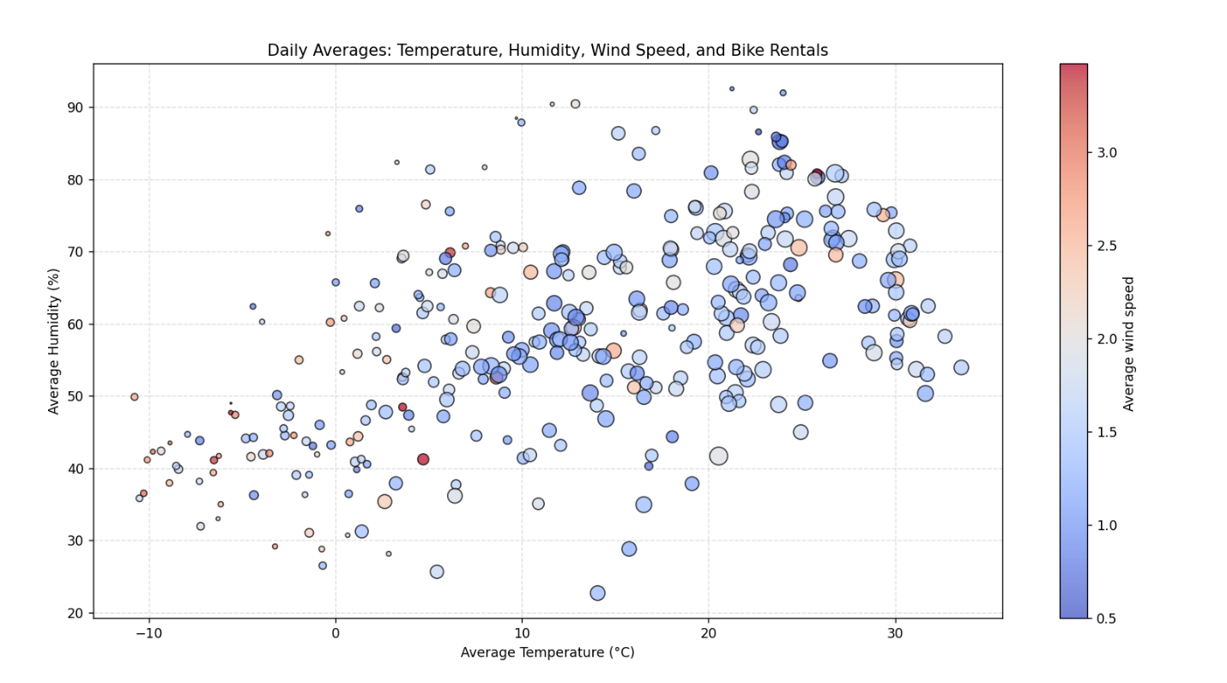
The scatter plot visualises the relationship between the weather conditions and bike rentals daily. I use the smaller ratio of the bubble size to make the scatter plot look clearer. Each of the points’ size represents the number of rented bikes in a single day, while the x-axis shows the average temperature, the y-axis shows the average humidity, and the colour bar shows the average wind speed. From the chart, a clear trend is witnessed: The bike rental tends to increase on warm days with an upper-middle level percentage of humidity and wind speed. However, higher humidity days show a very small bubble, representing a small amount of bike rentals. Though the wind speed does not change too much overall, the days with high wind speed tend to have fewer people going cycling in Seoul. To summarize, this scatter plot suggests that the warm day (20 deg C – 30 deg C) with around 70% of humidity and 1.5m/s of wind speed is the most suitable time for cycling.
- Extension task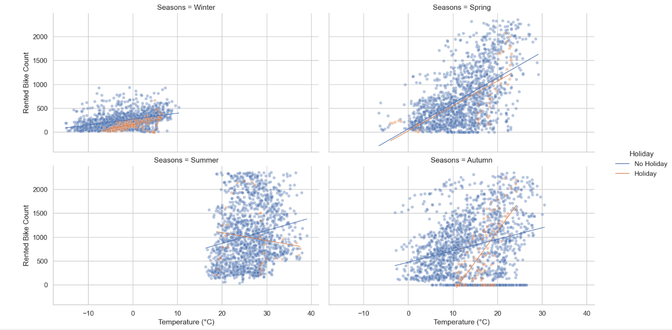
The Facetgrid plots with regression lines provide us with deeper insight into how temperature affects the bike rentals across different seasons. The regression slopes show that the temperature is less correlated with the bike rentals during winter and summer. However, during spring and autumn, the slopes indicate a high correlation between the bike rentals and temperatures. This suggests that moderate temperatures are good for the bike-renting business. Additionally, the holiday data shows minimal deviation from regular days, indicating that the rental doesn’t change much throughout the year. Therefore, Seoul’s citizens tend to have similar reasons to rent the bike for a whole year.

Overall, my code cleaned all of the dataset, so I can focus on seeing how the business goes through all year. I already removed all of the duplicate values and missing values to prevent bias or wrong conclusions. Even though the dataset covers many parts of the weather conditions as well as the time, only the season and temperature affect the bike rental. Other aspects seem affect just a little to the bike rental, or it doesn’t change much throughout the whole year.

