Nguyễn Anh Quân

22DTHG6

Lab01:

Lab02:

Lab03:

Lab04:

aes_rsa_socket( Lab04)

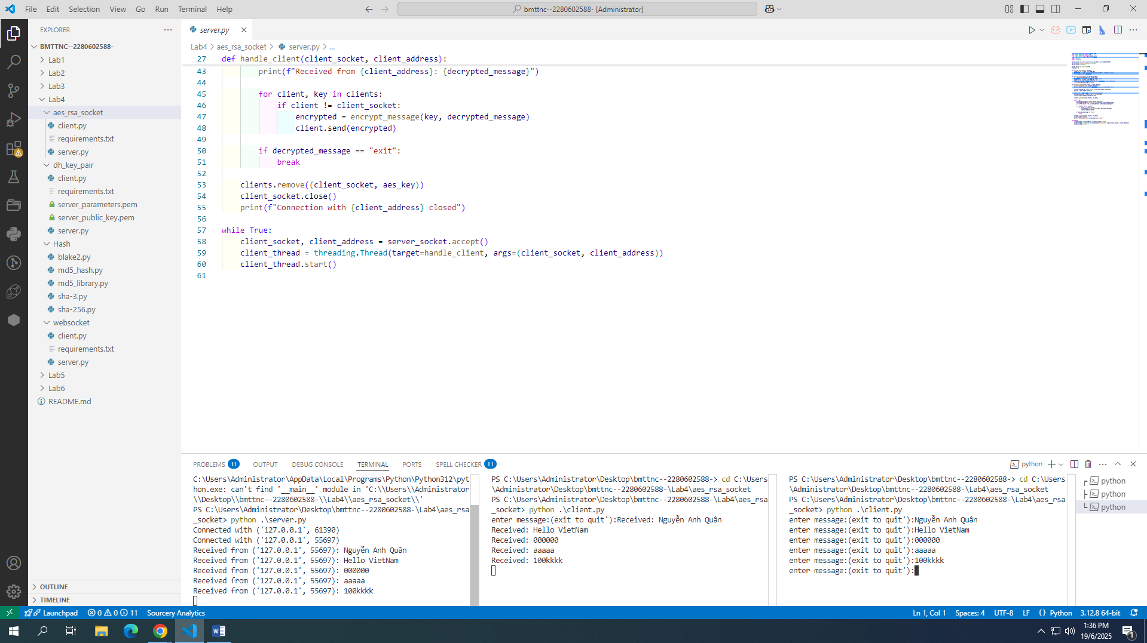

dh_key_pair(Lab04)

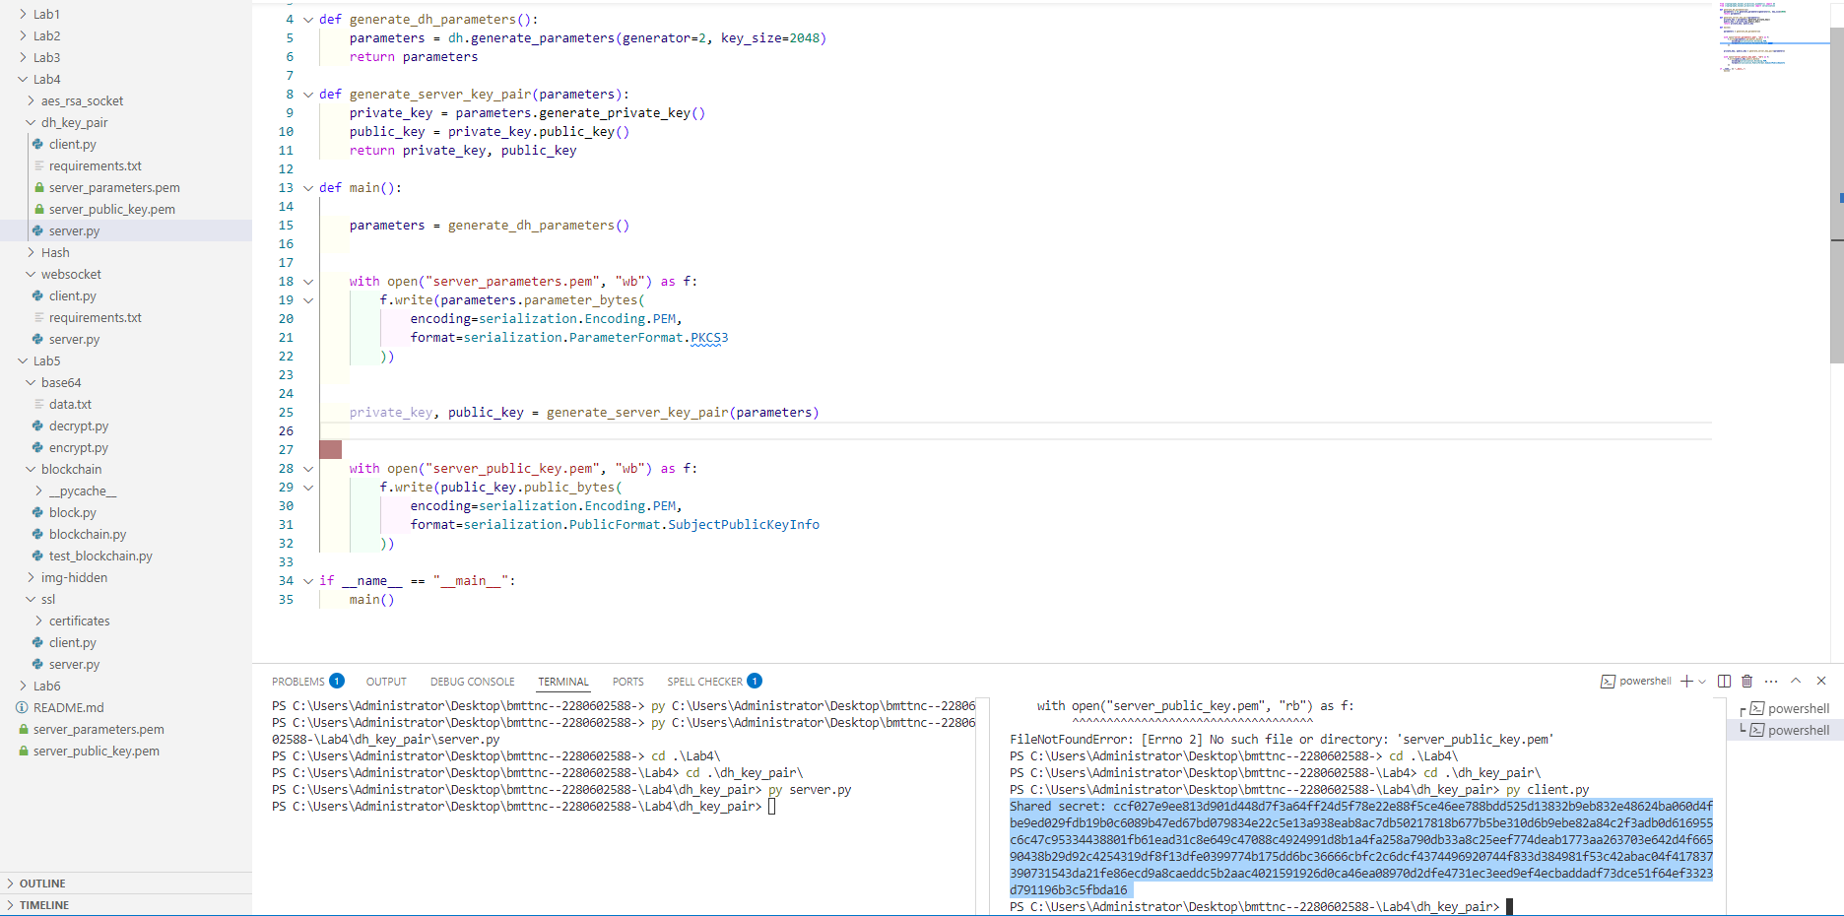

Hash(lap04)

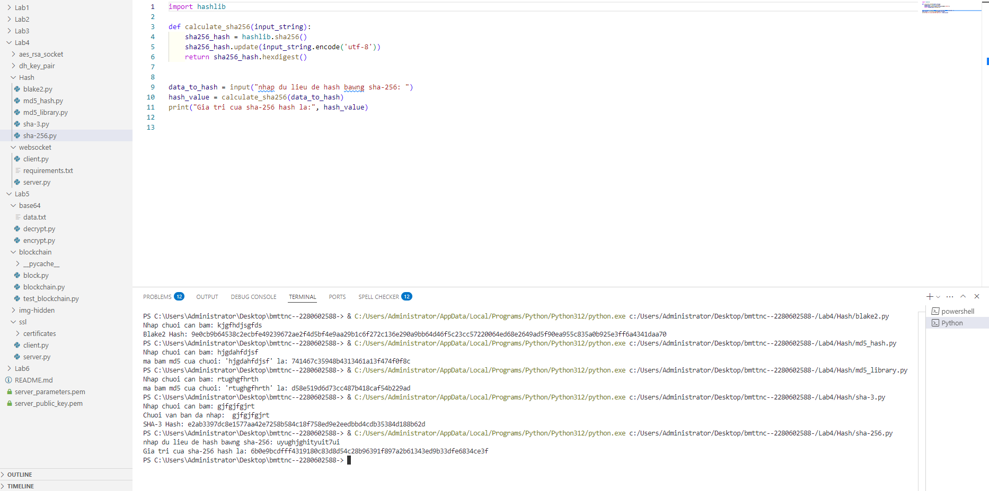

Web socket (Lab04)

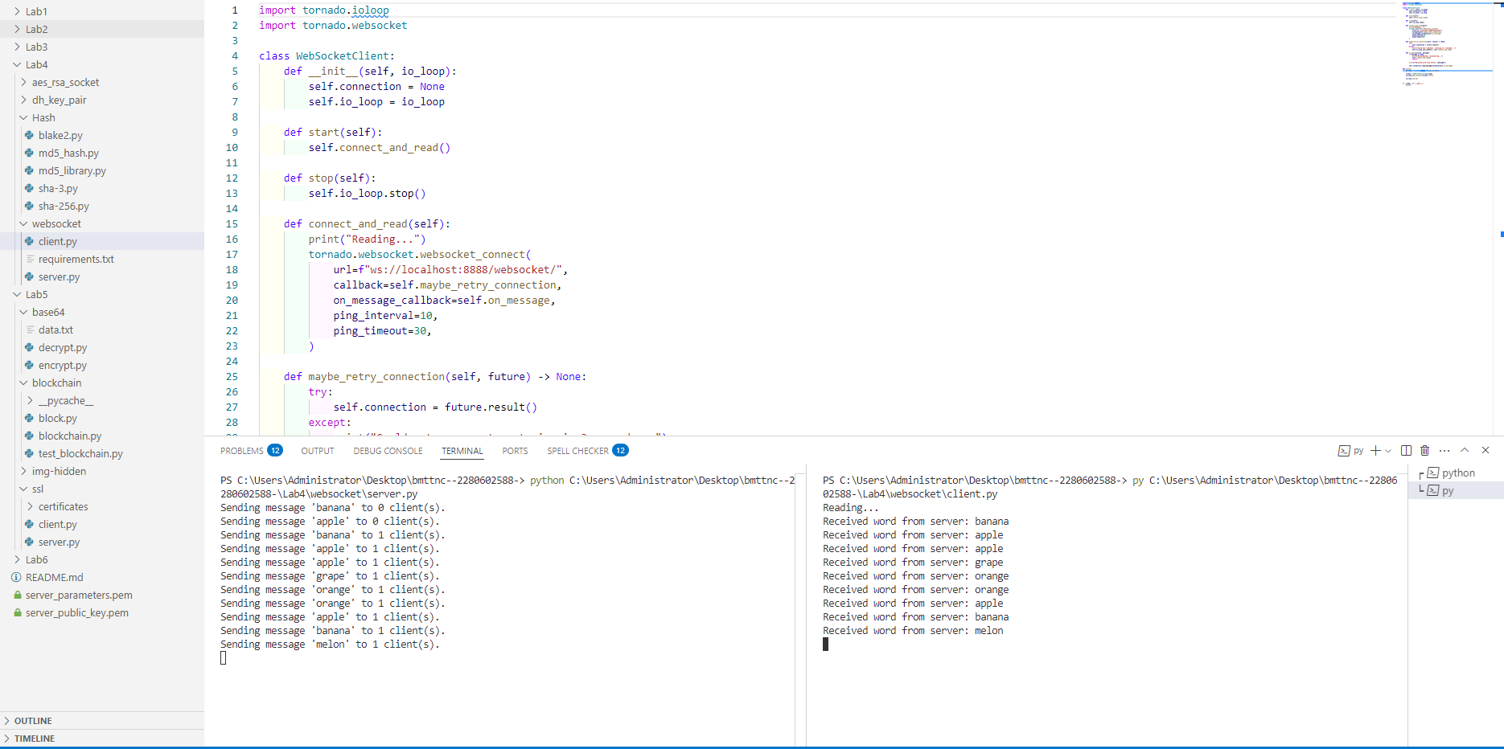

Lab05:

Base 64(Lab05

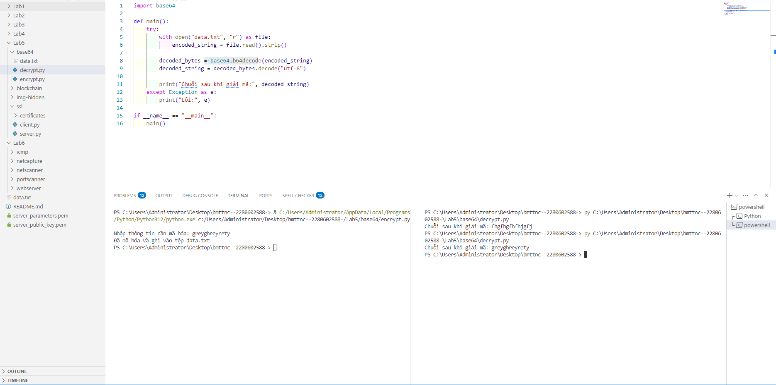

Blockchain( Lab05)

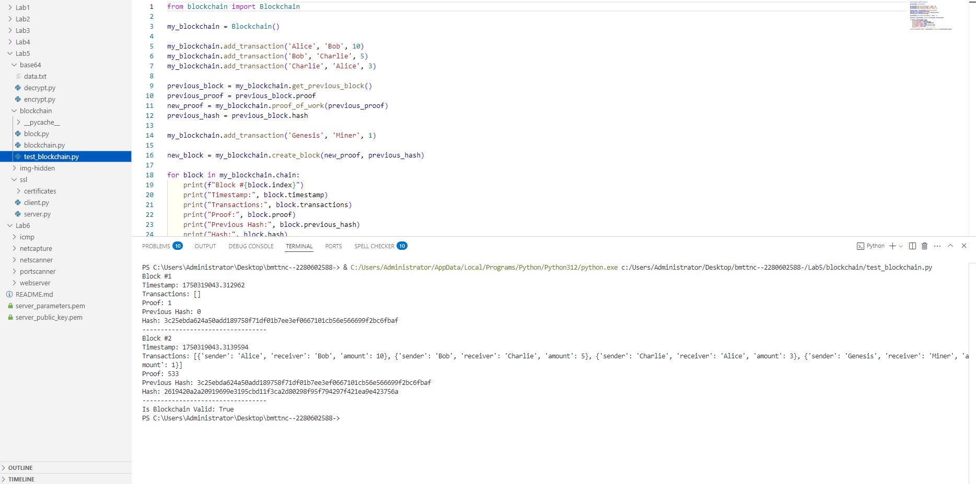

Image-hiden(Lab05)

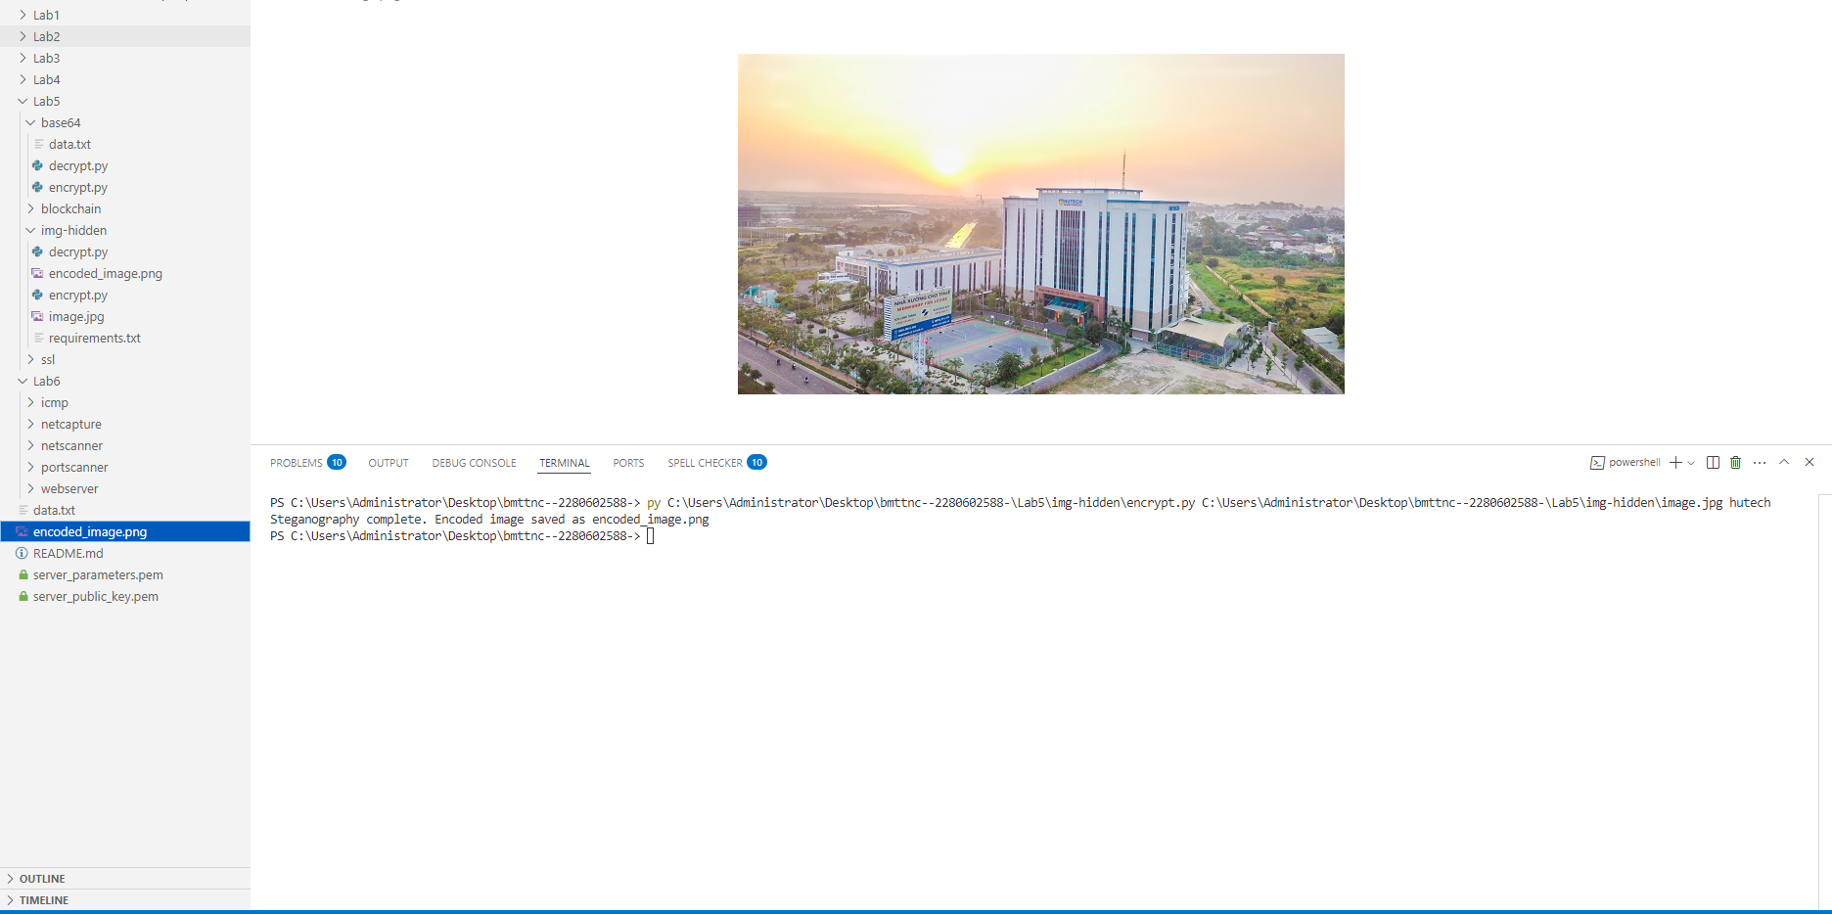

Ssl( Lab05)

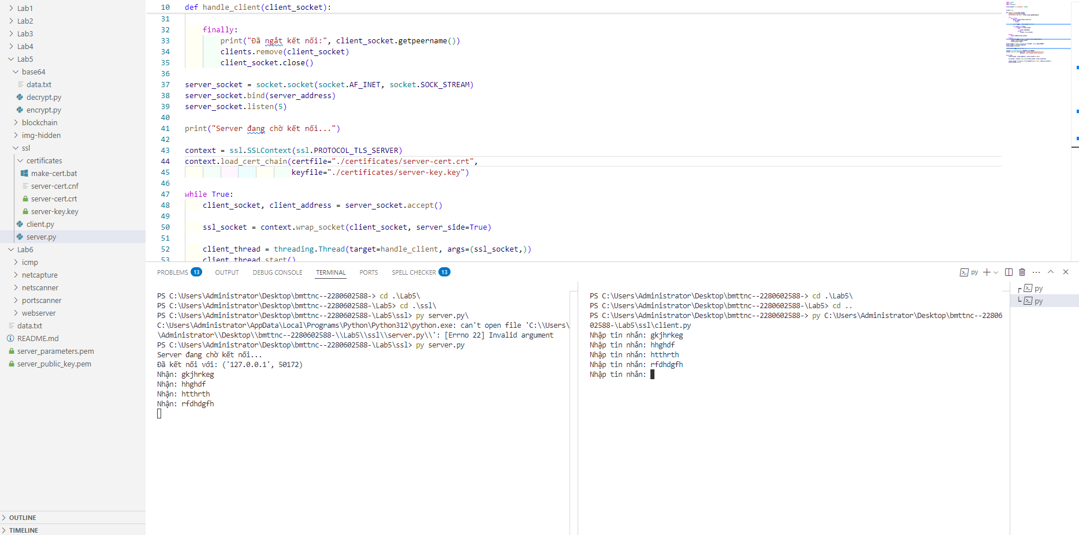

Lab06

Lab_06

Web server

Client

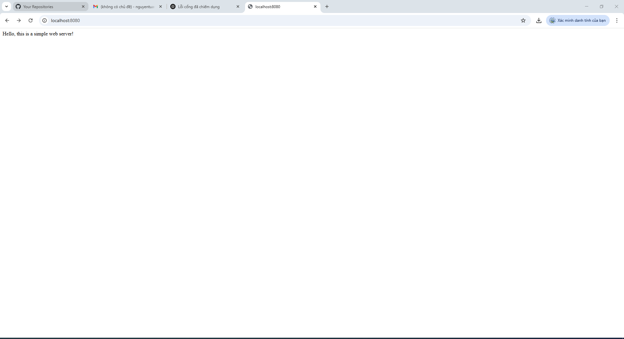

Admin

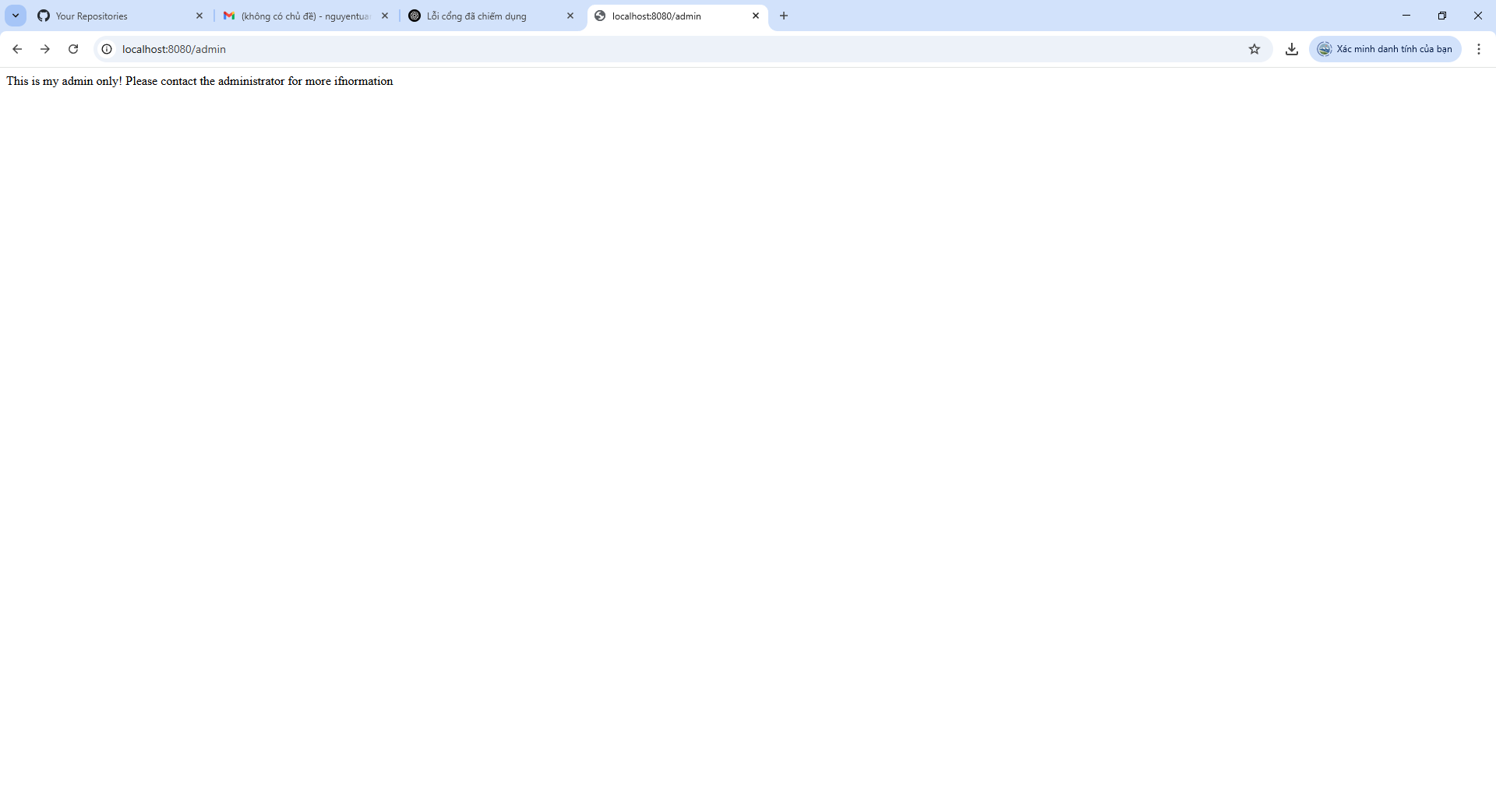

network_capture

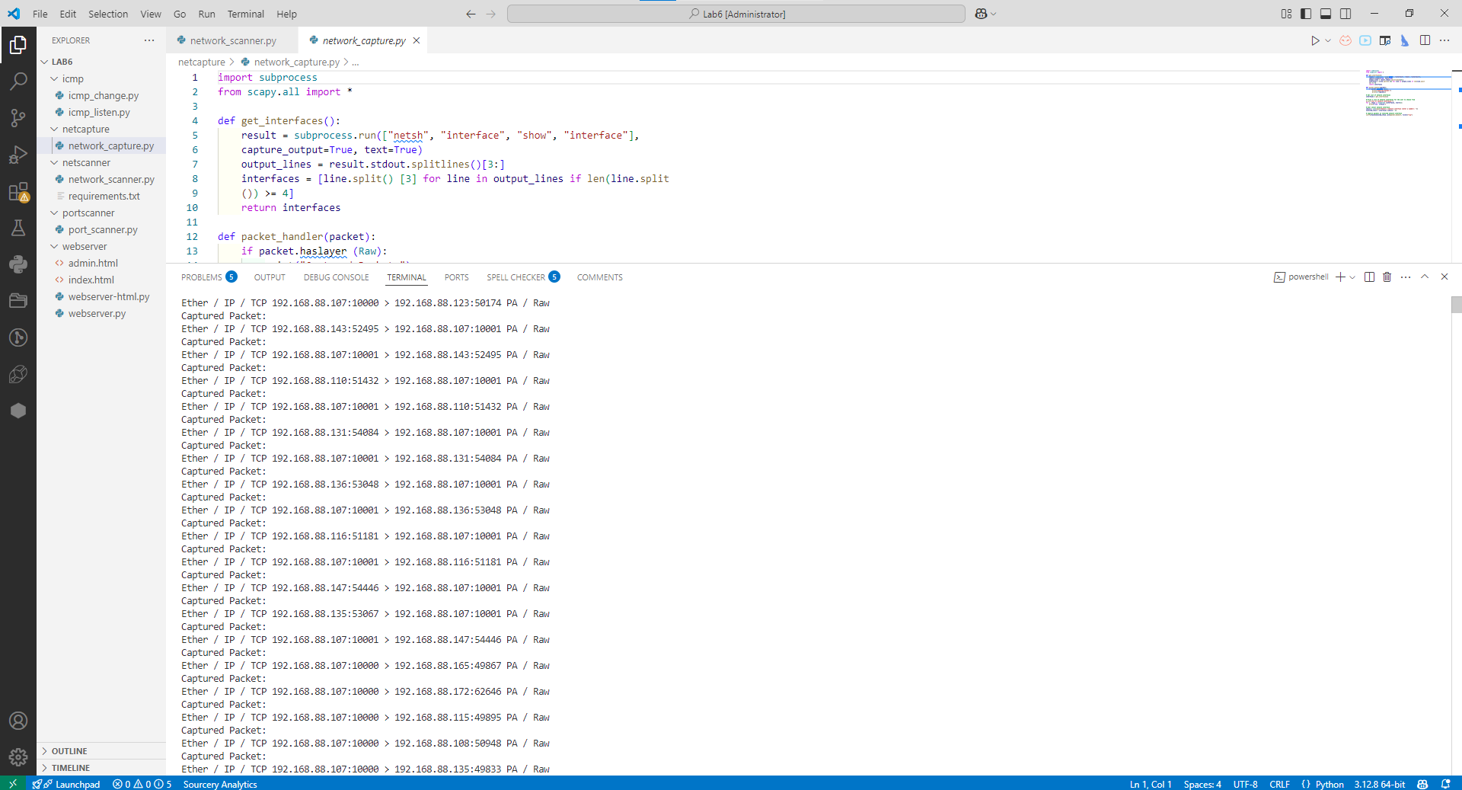

Icmp_listen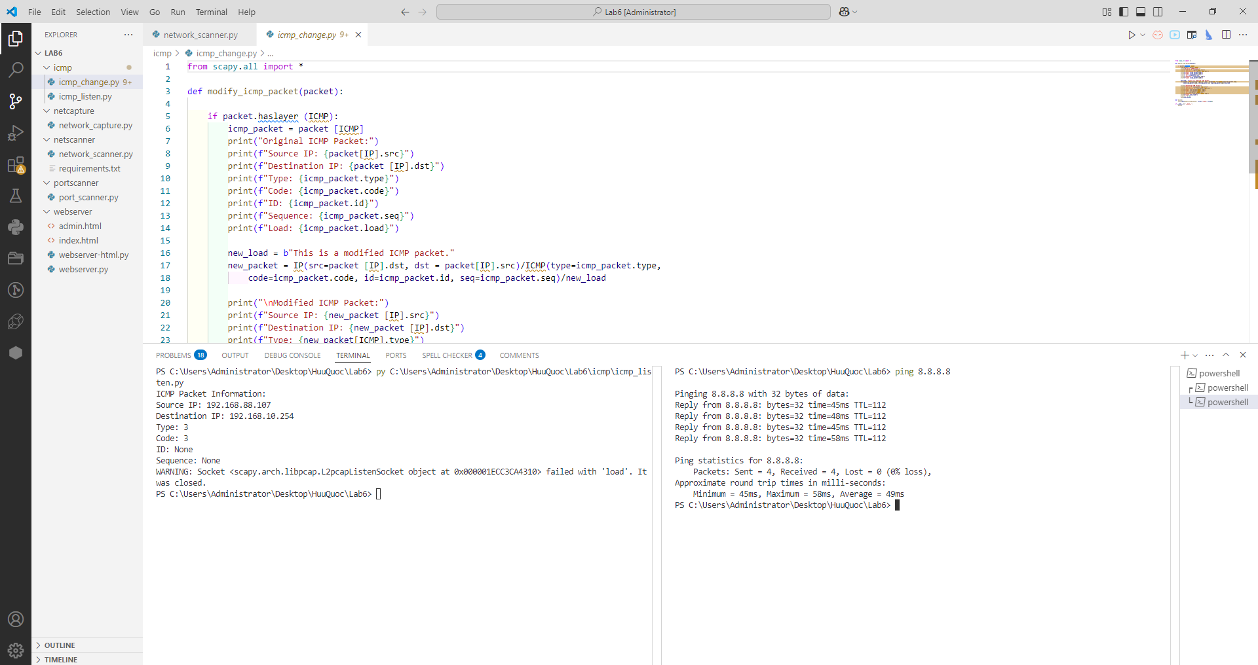

Icmp_change

