BÀI TẬP LÝ THUYẾT 2
- Thiết kế màn hình Login
- Tao file strings.xml
<resources>
<string name="app_name">Lab01_2c</string>
<string name="sign_in">Sign in</string>
<string name="username">Username: </string>
<string name="password">Password: </string>
<string name="signup">Sign up</string>
</resources>

- Tạo file dimems.xml

<resources>
<!-- Default screen margins, per the Android Design guidelines. -->
<dimen name="activity_horizontal_margin">16dp</dimen>
<dimen name="activity_vertical_margin">16dp</dimen>
<dimen name="margin_base">5dp</dimen>
<dimen name="margin_basex2">10dp</dimen>
<dimen name="margin_basex3">15dp</dimen>
<dimen name="margin_basex4">20dp</dimen>
<dimen name="text_small">16sp</dimen>
<dimen name="text_medium">18sp</dimen>
<dimen name="text_large">20sp</dimen>
</resources>
- Nội dung file activity_main.xml
- <?xml version="1.0" encoding="utf-8"?>
<RelativeLayout xmlns:android="http://schemas.android.com/apk/res/android"
xmlns:tools="http://schemas.android.com/tools"
android:id="@+id/main"
android:layout_width="match_parent"
android:layout_height="match_parent"
android:padding="@dimen/margin_basex4">
<TextView
android:id="@+id/tv_sign_in"
android:layout_width="wrap_content"
android:layout_height="wrap_content"
android:text="@string/sign_in"
android:textAllCaps="true"
android:layout_centerHorizontal="true"
android:layout_marginTop="@dimen/margin_basex4"
android:textSize="@dimen/text_large" />
<TextView
android:id="@+id/tv_user_name"
android:layout_width="100dp"
android:layout_height="wrap_content"
android:text="@string/username"
android:layout_below="@id/tv_sign_in"
android:layout_marginTop="@dimen/margin_basex4"
android:layout_alignParentLeft="true"
tools:ignore="RtlHardcoded" />
<EditText
android:id="@+id/et_username"
android:layout_width="match_parent"
android:layout_height="wrap_content"
android:hint="name@gmail.com"
android:layout_alignTop="@id/tv_user_name"
android:layout_toRightOf="@id/tv_user_name"
tools:ignore="HardcodedText,RtlHardcoded" />
<TextView
android:id="@+id/tv_password"
android:layout_width="100dp"
android:layout_height="wrap_content"
android:text="@string/password"
android:layout_below="@id/et_username"
android:layout_marginTop="@dimen/margin_base"
android:layout_alignParentLeft="true"
tools:ignore="RtlHardcoded" />
<EditText
android:id="@+id/et_password"
android:layout_width="match_parent"
android:layout_height="wrap_content"
android:hint="******"
android:inputType="textPassword"
android:layout_alignTop="@id/tv_password"
android:layout_toRightOf="@id/tv_password"
tools:ignore="HardcodedText,RtlHardcoded" />
<Button
android:id="@+id/btn_sign_in"
android:layout_width="wrap_content"
android:layout_height="wrap_content"
android:padding="@dimen/margin_base"
android:text="@string/sign_in"
android:layout_marginTop="@dimen/margin_base"
android:layout_below="@id/et_password"
android:layout_alignParentRight="true"
tools:ignore="RtlHardcoded" />
</RelativeLayout>
- Giao diện đăng nhập
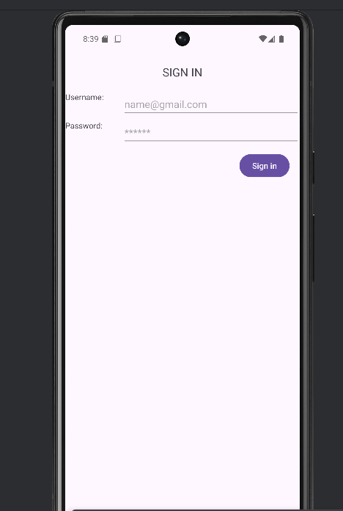

- Thiết kế giao diện Create an account
- Nội dung file activity_main.xml
- <?xml version="1.0" encoding="utf-8"?>
<ScrollView xmlns:android="http://schemas.android.com/apk/res/android"
android:layout_width="match_parent"
android:layout_height="match_parent"
android:padding="20dp">
<LinearLayout
android:layout_width="match_parent"
android:layout_height="wrap_content"
android:orientation="vertical">
<!-- Tiêu đề -->
<TextView
android:id="@+id/tv_create_account"
android:layout_width="wrap_content"
android:layout_height="wrap_content"
android:text="Create an Account"
android:textSize="22sp"
android:textStyle="bold"
android:layout_gravity="center"
android:layout_marginBottom="20dp"/>
<!-- Họ tên -->
<EditText
android:id="@+id/et_fullname"
android:layout_width="match_parent"
android:layout_height="wrap_content"
android:hint="Full Name"
android:inputType="textPersonName"
android:layout_marginBottom="10dp"/>
<!-- Email -->
<EditText
android:id="@+id/et_email"
android:layout_width="match_parent"
android:layout_height="wrap_content"
android:hint="Email"
android:inputType="textEmailAddress"
android:layout_marginBottom="10dp"/>
<!-- Mật khẩu -->
<EditText
android:id="@+id/et_password"
android:layout_width="match_parent"
android:layout_height="wrap_content"
android:hint="Password"
android:inputType="textPassword"
android:layout_marginBottom="10dp"/>
<!-- Nhập lại mật khẩu -->
<EditText
android:id="@+id/et_confirm_password"
android:layout_width="match_parent"
android:layout_height="wrap_content"
android:hint="Confirm Password"
android:inputType="textPassword"
android:layout_marginBottom="20dp"/>
<!-- Nút đăng ký -->
<Button
android:id="@+id/btn_create_account"
android:layout_width="match_parent"
android:layout_height="wrap_content"
android:text="Create Account"
android:layout_marginBottom="15dp"/>
<!-- Đã có tài khoản -->
<TextView
android:id="@+id/tv_already_account"
android:layout_width="wrap_content"
android:layout_height="wrap_content"
android:text="Already have an account? Sign In"
android:textSize="14sp"
android:layout_gravity="center"/>
</LinearLayout>
</ScrollView>
- Giao diện
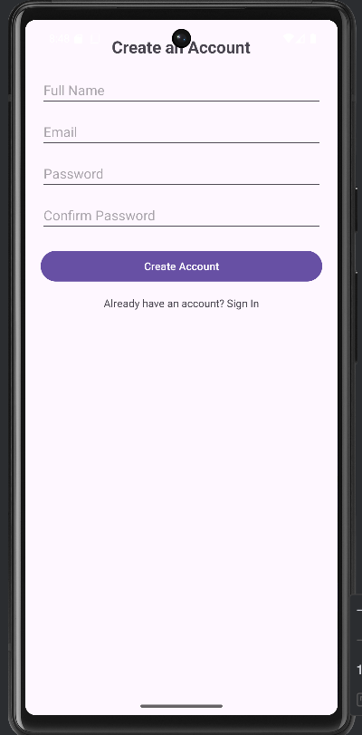
- Thiết kế giao diện máy tính

- Thêm file styles.xml
- <resources>
<style name="CalcButton">
<item name="android:layout_width">0dp</item>
<item name="android:layout_height">80dp</item>
<item name="android:layout_columnWeight">1</item>
<item name="android:layout_rowWeight">1</item>
<item name="android:textSize">20sp</item>
</style>
</resources>

- Nội dung file activity_main.xml

<?xml version="1.0" encoding="utf-8"?>
<LinearLayout xmlns:android="http://schemas.android.com/apk/res/android"
android:id="@+id/main"
android:layout_width="match_parent"
android:layout_height="match_parent"
android:orientation="vertical"
android:padding="16dp">
<!-- Màn hình hiển thị -->
<TextView
android:id="@+id/tv_result"
android:layout_width="match_parent"
android:layout_height="100dp"
android:background="#E0E0E0"
android:gravity="end|center_vertical"
android:padding="16dp"
android:text="0"
android:textSize="32sp"
android:textColor="#000000" />
<!-- Các phím số và phép toán -->
<GridLayout
android:layout_width="match_parent"
android:layout_height="wrap_content"
android:columnCount="4"
android:rowCount="5"
android:layout_marginTop="16dp">
<!-- Hàng 1 -->
<Button android:text="7" style="@style/CalcButton" />
<Button android:text="8" style="@style/CalcButton" />
<Button android:text="9" style="@style/CalcButton" />
<Button android:text="÷" style="@style/CalcButton" />
<!-- Hàng 2 -->
<Button android:text="4" style="@style/CalcButton" />
<Button android:text="5" style="@style/CalcButton" />
<Button android:text="6" style="@style/CalcButton" />
<Button android:text="×" style="@style/CalcButton" />
<!-- Hàng 3 -->
<Button android:text="1" style="@style/CalcButton" />
<Button android:text="2" style="@style/CalcButton" />
<Button android:text="3" style="@style/CalcButton" />
<Button android:text="-" style="@style/CalcButton" />
<!-- Hàng 4 -->
<Button android:text="0" style="@style/CalcButton" />
<Button android:text="." style="@style/CalcButton" />
<Button android:text="=" style="@style/CalcButton" />
<Button android:text="+" style="@style/CalcButton" />
</GridLayout>
</LinearLayout>

- Giao diện KQ
