Data Visualization

**Lecture5**

**MathamaticsVisualization**

Phuc Loi Luu, PhD

p.luu@garvan.org.au

luu.p.loi@googlemail.com

Content

Plot a mathmatics graph • Introduction to Linear Algebra 6: InnerProductSpace

Inner Product Space

❖ An inner product is an operation on vectors in a vector space and it will definegeometricproperties of the vector space.

❖ A vector space paired with an inner product is called an inner product space. ❖ With an inner product we can define the length of a vector and also the distance betweentwovectors.

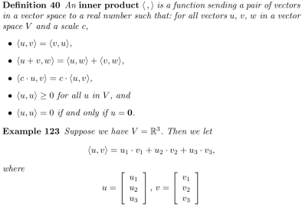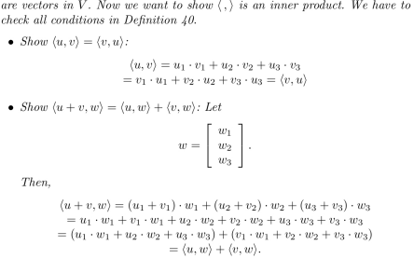

Inner Product Space

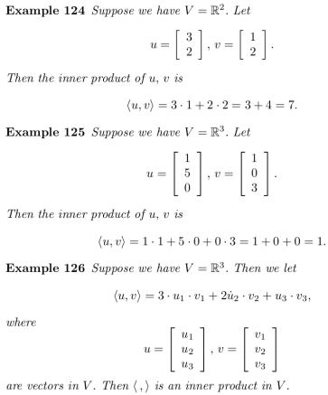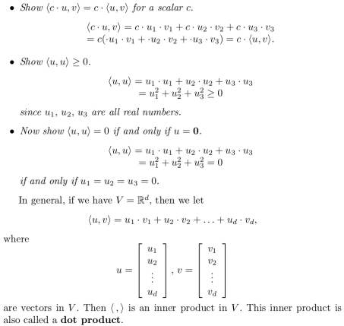

In R: compute Inner Product Space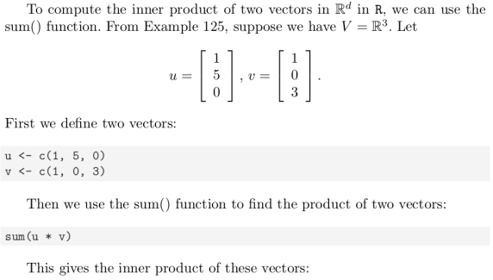



In R: compute Inner Product Space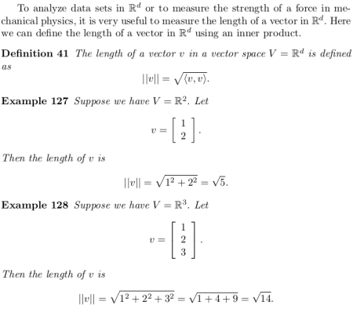

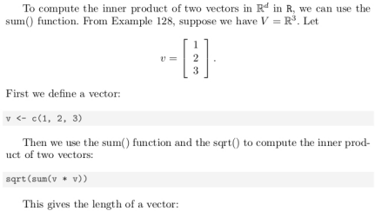

In R: Compute Inner Product Space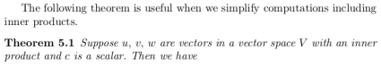

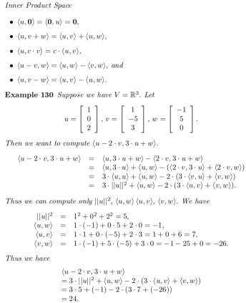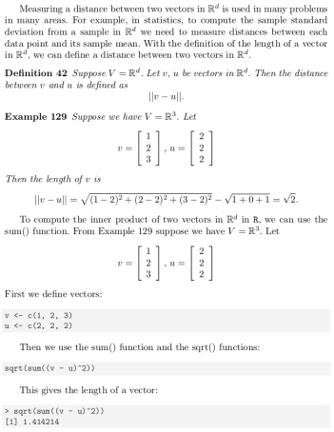

Exercises

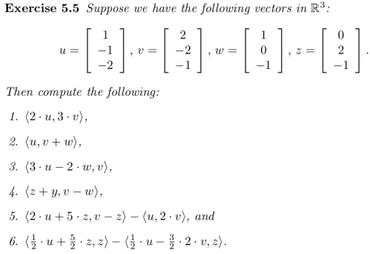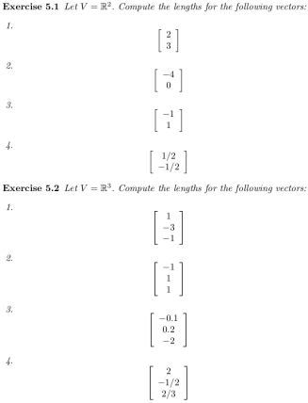

Homework

