.



**Team project plan**

**Android Grocery Management Application**

**PROJECT PLAN**

Version 1.0

Date:Nov 30th,2023

**TEAM NAME :** Group 5

**MENTOR** : Jan Samuelsson

**PROJECT MEMBERS** :

**Tăng Ngọc Tuân**

**Trần Thanh Vũ**

**Huỳnh Anh Tuấn**

**Trần Phúc Nhân**

**INTERNATIONAL SCHOOL**

**Project Information**

|  |  |  |  |
| --- | --- | --- | --- |
| **Project Title** | Android Grocery Management Application | | |
| **Start Date** | Nov 30th,2023 | **End Date** |  |
| **Lead Institution** | International School, Duy Tan University | | |
| **Project Mentor & contact details** | Jan Samuelsson  Email: [jan452@gmail.co](mailto:jan452@gmail.co)m  Tel: 012345678 | | |
| **Team members** | **Name** | **Email** | **Tel** |
|  | Tăng Ngọc Tuân | tuan3110272@gmail.com | 0935403594 |
| Trần Thanh Vũ | vutv579@gmail.com | 0702374029 |
| Trần Phúc Nhân | Phucnhant@gmail.com | 0865003881 |
| Huỳnh Anh Tuấn | anhtuan2003147@gmail.com | 0369705323 |
|  |  |  |

|  |  |  |  |
| --- | --- | --- | --- |
|  | **DOCUMENT NAME** | | |
| **Document Title** | Project plan | | |
| **Author(s)** | Group 5 | | |
| **Date** | 30 November, 2023 | **File name:** | Project Plan v1.0 |

**REVISION HISTORY**

|  |  |  |  |
| --- | --- | --- | --- |
| **Version** | **Person(s)** | **Date** | **Description** |
| **1.0** | Tang Ngoc Tuan | ---- | Create basic data |
| **1.1** | Tang Ngoc Tuan | 30-11-2023 | WBS |
| **1.2** | Tang Ngoc Tuan | 30-11-2023 | Fix WBS && project schedule |
| **1.3** | Tang Ngoc Tuan | 4-12-2023 | Replace new WBS && sprints |
| **1.4** |  |  |  |

Contents

Contents 3

**1.** **Introduction:** 4

1.1. Purpose of document: 4

**2.** **Product overview** 4

2.1. Product definition: 4

2.2. User: 4

2.2.2. User problems: 4

2.3. Prior art: 4

**3.** **Project overview** 4

3.1. Project goal 4

**4.** **Work Breakdown Structure** 4

**5.** **Planning** 5

**5.1.** **Product requirements (Product backlog)** 5

**6.** **Project schedule (overview)** 6

**7.** **Development Process:** 6

**8.** **Team Organization:** 7

8.1. Scrum Team Information: 7

8.2. Role and Responsibility: 7

8.3. Communication Methodology: 7

8.4. Communication and Report: 8

**9.** **Schedule:** 8

9.1. Detailed Schedule: 9

**10.** **Budget:** 11

**11.** **Project Risks** 13

**12.** **Deliverables** 13

**13.** **Individual contribution** 14

1. **Introduction:**
   1. **Purpose of document:**

This document provides a summary of the project's objectives, division of work, the major milestones, required resources, time and overall schedule and budget allocation used and based on the document proposal to build a xyz application on time, according to requirement and plan.

1. **Product overview**
   1. **Product definition:**

Nowaday, its hard for people to keep track of there number/quality of groceries. It’s can lead to lack of groceries when be in need, or wrong kind of groceries required. And can make lots of trouble if these groceries’s in need for special occasion such as Thanksgiving, Christmast, Tet,...

We have designed an Android Grocery Management Appliaction to help people solve those problen. This app’s going to keep track on groceries they need, suggest some groceries from previous months. And in future, we’re going to add some features to help customer use there grocery effeciently.

* 1. **User:**

-Family

-Restaurants

* + 1. **User needs:**
* Get notifications from app when lack ingredients/things
* Edit recommend recipe to fit their taste
  + 1. **User problems:**

Heavy(~5gb)

* 1. **Prior art:**

Suggest recipes

Easy to use, even with elders

1. **Project overview**
   1. **Project goal**

-We will build this project on 10000$ budget and deliver on march 28th,2024.

* 1. **Project Deliverables:**

Main features:

* Save groceries
* Remind user to buy/order groceries when needed.
* Show/recommend some groceries from previous months

Side features:

* Show recipe for cooking from ingredient
* Suggest ingredient for input problem

1. **Work Breakdown Structure**

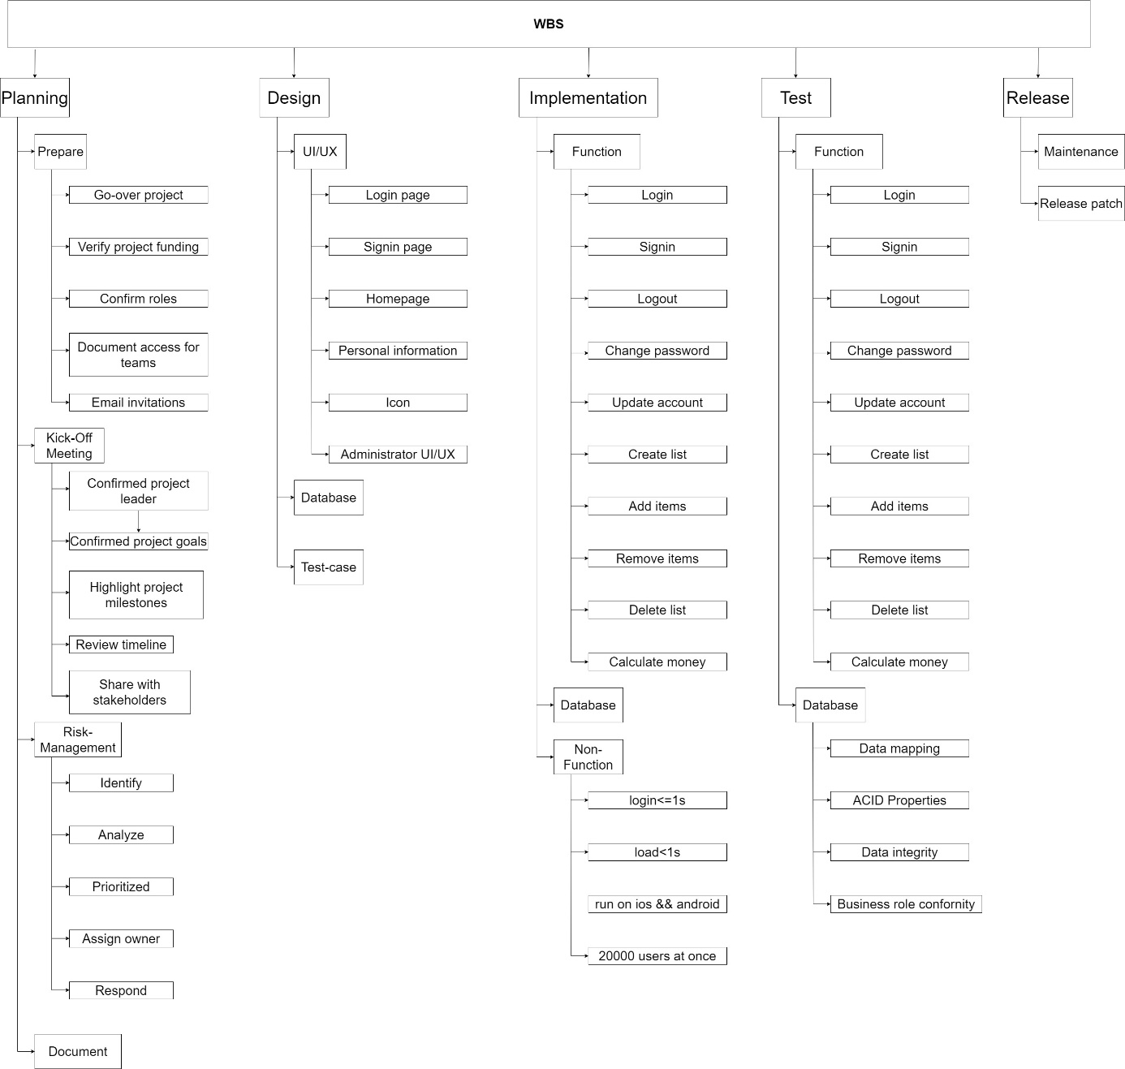

1. **Planning**
   1. **Product requirements (Product backlog)**

***OBS:***

***Put the below information in the Document: “Product and Sprint Backlog and Burn down chart Team project”***

* Provide a short description of the Requirement or Activity Or User Story
* Provide an estimate of the effort in manhours
* Provide a priority
* Document in which Sprint it was done (history)  
  The schedule will show in which Sprint it is planned to be done

Priorities are set from 1 to 3

◦ The highest priority is 1

◦ The lowest priority is 3

◦ Priorities of some user stories can be the same with others

◦ If a user story has dependencies, it must have lower priority than its dependencies

1. **Project schedule (overview)**

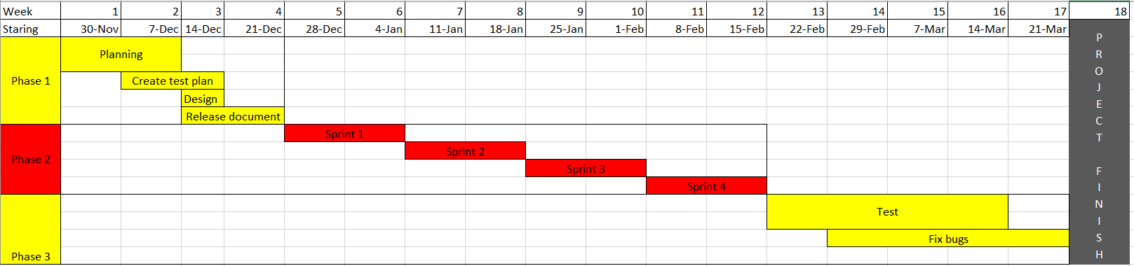

1. **Development Process:**

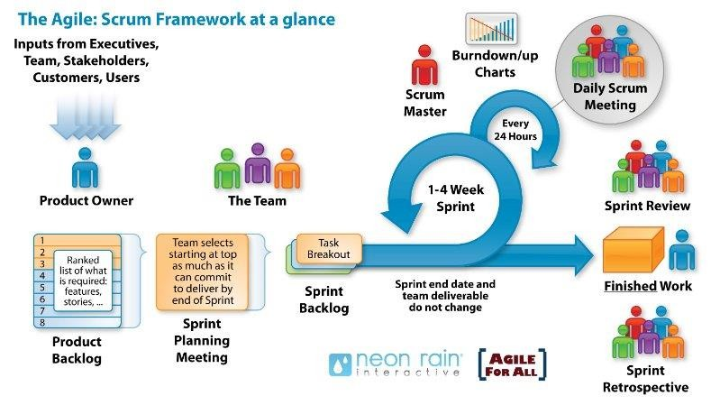**Scrum Process**

* Scrum is an empirical process, which mean decisions are based on:
  + Observation
  + Experience
  + Experimentation
* Include 3 pillars:
  + Transparency
  + Inspection
  + Adaption

Benefit of the methodology:

* Clearly defined sprint goals
* Flexibility to allow quick product change
* Tested, stabled product
* Developer growth

1. **Team Organization:**
   1. **Scrum Team Information:**

***Table 1: Scrum Team Organization.***

|  |  |  |  |
| --- | --- | --- | --- |
| **Full Name** | **Phone** | **Email** | **Position** |
| Tăng Ngọc Tuân | 0935403594 | tuan3110272@gmail.com | Master |
| Huỳnh Anh Tuấn | 0369705323 | anhtuan2003147@gmail.com | Member |
| Trần Thanh Vũ | 0702374029 | anhtuan2003147@gmail.com | Member |
| Trần Phúc Nhân | 0865003881 | Phucnhant@gmail.com | Member |
|  |  |  |  |

* 1. **Role and Responsibility:**

***Table 2: Role and Responsibilities.***

|  |  |  |
| --- | --- | --- |
| **Role** | **Responsibility**  **Describe shortly each role** | **Name/Title** |
| **Product Owner** | * Analyze users/customers responses | Tang Ngoc Tuan |
| **Scrum Master** | * Enhance the process | Huynh Anh Tuan |
| **Developer** | * Coding and unit testing | All Members |
| **Tester** | * Test program | All Members |

* 1. **Communication Methodology:**

***Table 3: Communication Methodology.***

|  |  |  |  |
| --- | --- | --- | --- |
| **Audience/ Attendees** | **Topic/ Deliverable** | **Frequency** | **Method** |
| **Mentor and Team member** | Project Progress Review | Weekly | Meeting, Email,  One Drive |
| **Team Member** | Project Progress Review and Daily Meeting | Daily | Email, Facebook, Zoom |

* 1. **Communication and Report:**

***Table 4: Communication and Report.***

|  |  |  |  |  |
| --- | --- | --- | --- | --- |
| **Type of communication** | **Methods, tools** | **Frequency** | **Information  (Definition of the meeting)** | **People** |
| **Communication among in group** | | | | |
| **Scrum meeting** | Face to face or Zoom | Every two day | Indentify obstacles and how to solve them | Project team |
| **Sprint Planning Meeting** | Meet face to face | Beginning of each sprint | Decides priotizing | Project team |
| **Retrospective meeting** | Meet face to face | After each sprint | Determind what worked, what didn’t worked, and how to improve on next sprint | Project team |
| **Demo** | Zoom | After each sprint | Show what have been done | Project team and Mentor |

1. **Schedule:**  
   1. **Detailed Schedule:**

|  |  |  |  |  |  |
| --- | --- | --- | --- | --- | --- |
| No. | Task Name | Duration(days) | Start | Finish | Effort(h) |
| **1** | **Initial** | **4 months** | **30-Nov** | **28-Dec** | **868** |
| **1.1** | **Gathering Requirement** | **1** | **30-Nov** | **30-Nov** | **10** |
| 1.1.1 | Gather requirement | 1 | 30-Nov | 30-Nov | 10 |
| **2** | Document && test plan | 21 | 1-Dec | 21-Dec | 128 |
| **2.1** | **Create Document** | **4** | **1-Dec** | **4-Dec** | **38** |
| 2.1.1 | Create Project Plan | 2 | 1-Dec | 2-Dec | 8 |
| 2.1.2 | Create User Stories | 2 | 3-Dec | 4 Dec | 15 |
| 2.1.3 | Create Product Backlog | 2 | 3-Dec | 4-Dec | 15 |
| **2.2** | **Test plan** | **14** | **7-Dec** | **21-Dec** | **50** |
| **2.3** | **Design** | **14** | **14-Dec** | **28-Dec** | **40** |
| 2.3.1 | Design User Interface | 7 | 14-Dec | 21-Dec | 20 |
| 2.3.2 | Design User Experiment | 7 | 21-Dec | 28-Dec | 20 |
| **3** | **Development** |  | 28-Dec | 22-Feb |  |
| **3.1** | **Sprint 1** | **14** | **28-Dec** | **11-Jan** | **200** |
| **3.1.1** | **Sprint Planning Meeting** | 1 | 28-Dec | 28-Dec | 5 |
| **3.1.2** | **Create Sprint Backlog** | 1 | 28-Dec | 28-Dec | 5 |
| **3.1.3** | **Design** | 8 | 29-Dec | 2-Jan | **100** |
| 3.1.3.1 | login page | 1 | 29-Dec | 29-Dec | 10 |
| 3.1.3.2 | register page | 1 | 30-Dec | 30-Dec | 10 |
| 3.1.3.3 | homepage | 1 | 31-Dec | 31-Dec | 20 |
| 3.1.3.4 | personal information page | 1 | 2-Jan | 2-Jan | 15 |
| 3.1.3.5 | Icon | 1 | 2-Jan | 2-Jan | 5 |
| 3.1.3.6 | Database | 2 | 3-Jan | 4-Jan | 30 |
| 3.1.3.7 | Admin homepage | 1 | 2-Jan | 2-Jan | 10 |
| **3.1.4** | **Create Database** | 4 | 5-Jan | 9-Jan | 40 |
| **3.1.5** | **Regression test,** | 1 | 10-Jan | 10-Jan | **20** |
| **3.1.6** | **Bug fixing** | 2 | 10-Jan | 11-Jan | **20** |
| **3.1.7** | **Release Sprint 1** | **1** | **11-Jan** | **11-Jan** | **10** |
| 3.1.7.1 | Sprint 1 Review Meeting | 1 | 11-Jan | 11-Jan | 5 |
| 3.1.7.2 | Sprint 1 Retrospective | 1 | 11-Jan | 11-Jan | 5 |
| **3.2** | **Sprint 2** | **14** | **12-Jan** | **25-Jan** | **110 h** |
| **3.2.1** | **Sprint 2 Planning Meeting** | 1 | 12-Jan | 12-Jan | 5 |
| **3.2.2** | **Create Sprint 2 Backlog** | 1 | 12-Jan | 12-Jan | 5 |
| **3.2.3** | **Create/Code** | 8 | 13-Jan | 20-Jan | 60 |
| 3.2.3.1 | Register | 3 | 13-Jan | 15-Jan | 20 |
| 3.2.3.2 | Login | 1 | 16-Jan | 16-Jan | 10 |
| 3.2.3.3 | Logout | 1 | 17-Jan | 17-Jan | 10 |
| 3.2.3.4 | Reset password | 1 | 18-Jan | 18-Jan | 10 |
| 3.2.3.5 | Update account | 2 | 19-Jan | 20-Jan | 10 |
| **3.2.4** | **Regression test** | **1** | **21-Jan** | **21-Jan** | **5** |
| **3.2.5** | **Fix bug** | **3** | **22-Jan** | **24-Jan** | **25 h** |
| **3.2.6** | **Release sprint 2** | **1** | **25-Jan** | **25-Jan** | **10** |
| 3.2.6.1 | Sprint 2 review meeting | 1 | 25-Jan | 25-Jan | 5 |
| 3.2.6.2 | Sprint 2 retrospective | 1 | 25-Jan | 25-Jan | 5 |
| **3.3** | **Sprint 3** | **14** | **26-Jan** | **8-Feb** | **200 h** |
| **3.3.1** | **Sprint 3 Planning Meeting** | **1** | **26-Jan** | **26-Jan** | **5** |
| **3.3.2** | **Create Sprint 3 Backlog** | **1** | **26-Jan** | **26-Jan** | **5** |
| **3.3.3** | **Create/code** | **15** | **27-Jan** | **7-Feb** | **130** |
| 3.3.3.1 | Create list | 2 | 27-Jan | 28-Jan | 20 |
| 3.3.3.2 | Add items to list | 2 | 28-Jan | 29-Jan | 20 |
| 3.3.3.3 | Remove items from list | 2 | 30-Jan | 31-Jan | 20 |
| 3.3.3.4 | Delete list | 2 | 30-Jan | 31-Jan | 20 |
| 3.3.3.5 | Calculate money | 2 | 1-Feb | 2-Feb | 10 |
| **3.3.4** | **Regression test** | 2 | 3-Feb | 4-Feb | **10** |
| **3.3.5** | **Fix bug** | 3 | 5-Feb | 7-Feb | **30** |
| **3.3.7** | **Release Sprint 3** | **2** | **7-Feb** | **8-Feb** | **15** |
| 3.3.7.1 | Sprint 3 Review Meeting | 1 | 7-Feb | 7-Feb | 8 |
| 3.3.7.2 | Sprint 3 Retrospective | 1 | 8-Feb | 8-Feb | 7 |
| **3.4** | **Sprint 4** | **14** | **9-Feb** | **22-Feb** | **200 h** |
| **3.4.1** | **Sprint 4 Planning Meeting** | **1** | **9-Feb** | **9-Feb** | **5** |
| **3.4.2** | **Create Sprint 4 Backlog** | **1** | **9-Feb** | **9-Feb** | **5** |
| **3.4.3** | **Memorize items from previous months** | **2** | **10-Feb** | **11-Feb** | **20** |
| **3.4.4** | **Suggest items from memory** | **1** | **12-Feb** | **12-Feb** | **10** |
| **3.4.5** | **Performance** | **6** | **12-Feb** | **18-Feb** | **100 h** |
| 3.4.5.1 | Login <1s | 2 | 12-Feb | 13-Feb | 20 |
| 3.4.5.2 | Load <=1s | 2 | 12-Feb | 13-Feb | 20 |
| 3.4.5.3 | Run on IOS | 2 | 13-Feb | 14-Feb | 40 |
| 3.4.5.4 | Run on android |  |  |  | - |
| 3.4.5.5 | 20000 users at same time | 2 | 15-Feb | 16-Feb | 20 |
| **3.4.6** | **Regression test** | **2** | **17-Feb** | **18-Feb** | **20** |
| **3.4.7** | **Bug fixing** | **3** | **18-Feb** | **20-Feb** | **25** |
| **3.4.8** | **Release Sprint 4** | **2** | **21-Feb** | **22-Feb** | **15** |
| 3.4.8.1 | Sprint 4 Review Meeting | 1 | 21-Feb | 21-Feb | 8 |
| 3.4.8.2 | Sprint 4 Retrospective | 1 | 22-Feb | 22-Feb | 7 |
| **3.5** | **Review Project** | **2** | 27-March | 28-March | 20 |

***Table 5: Detailed Schedule.***

1. **Budget:**
   1. **Cost Person/Hours**

|  |  |  |
| --- | --- | --- |
| **Full Name** | **Role** | **Salary Rate (USD/hour)** |
| Tăng Ngọc Tuân | Scrum Master & Member | 10 |
| Huỳnh Anh Tuấn | Team Member | 2 |
| Trần Thanh Vũ | Team Member | 2 |
| Trần Phúc Nhân | Team Member | 2 |
| Tăng Ngọc Tuân | Product Owner & Member | 10 |

* 1. **Total Cost Estimate**

|  |  |  |  |  |
| --- | --- | --- | --- | --- |
| **No** | **Criteria** | **Price** | **Amount** | **Total (USD)** |
| 1 | Working hours | $ 2 | 868 | 1736 |
| 2 | Party | $ 20 | 6 | 120 |
| **Total cost** | | |  | 1856 |

|  |  |  |
| --- | --- | --- |
| **Description** | **Amount** | **Unit** |
| Number of members | 4 | Person |
| Number of working hours per day | 6 | Hour |
| Number of workdays/week | 5 | Day |
| The duration of the project | 5 | Month |
| Party cost per member per time | 2 | USD |
| The number of working days | 85 | Day |

1. **Project Risks**

***Table 7: Rating for likelihood and seriousness for each risk.***

|  |  |  |  |
| --- | --- | --- | --- |
| **Rating for Probability and Impact for each risk** | | | |
| **1** | Rated as very Low | **4** | Rated as High |
| **2** | Rated as Low | **5** | Rated as Extreme (Used for Seriousness only) |
| **3** | Rated as Medium | **NA** | Not Assessed |

Risk exposure = Impact x Probability

***Table 8: Project Risk.***

|  |  |  |  |  |  |
| --- | --- | --- | --- | --- | --- |
| **Risk** | **Definition** | **Probability** | **Impact** | **Risk Exposure** | **Mitigation Strategy** |
| Estimates of project planning | The plan may be delayed for the initial estimate of the project. | 2 | 2 | 4 | N/A. Low Risk exposure |
| Requirements | Internal contradictions that may exist in the request.  Important requirements may be missing from the formal requirements specification. | 4 | 4 | 16 | Uniform requirements prior to analysis. |
| Estimated project schedule | Time sort of work. | 5 | 4 | 20 | Time project was created to be updated and evaluated regularly. |
| Programming experience |  | 5 | 3 | 15 | Hire experience progarmmer for trainning |
| Technical processes |  | 3 | 5 | 4 |  |
| Network | Network Value | 4 | 5 | 4 | Buy better internet if needed |
| Time |  | 1 | 1 | 1 | -- |

1. **Deliverables**

Table 9: Deliverables

|  |  |  |  |
| --- | --- | --- | --- |
| **No.** | **Document** | **Deadline** | **File Name** |
| 1 | SRS | -- | AIS_Android grocery mngmt-Project plan-jsa.docx |
| 2 | Process && sprint backlog | -- | AIS- Android grocery mgmt - Product and Sprint backlog - jsa.xlsx |

1. **Individual contribution**

Provide contribution level for each team member.

100% = Very valuable contribution

90% = Valuable contribution

80% = Contributed

70% = Participated

0% = Did not participate or contributed

|  |  |  |
| --- | --- | --- |
| **No.** | **Team member** | **Contribution in %** |
| 1 | Tăng Ngọc Tuân | 100% |
| 2 | Huỳnh Anh Tuấn | 100% |
| 3 | Trần Thanh Vũ | 100% |
| 4 | Trần Phúc Nhân | 100% |