##### Functional Requirement

Administrator has the function:

* UC01: Login
* UC02: Manage employer and candidate accounts
* UC03: Manage employer postings
* UC04: Manage CV of candidate
* UC05: Manage transaction
* UC06: Message

Employer has the function:

* UC01: Login
* UC07: Register
* UC08: Account management
* UC09: Post recruitment jobs
* UC10: Push posts (Increase priority)
* UC11: Filter candidate CVs using AI
* UC12: View candidates' CVs
* UC13: Payment
* UC06: Message

Candidate has function:

* UC01: Login
* UC07: Register
* UC08: Account management
* UC14: Search, filter and view jobs
* UC15: Manage CV
* UC16: Apply CV
* UC06: Message
* UC13: Payment

|  |  |
| --- | --- |
| USE CASE | DESCRIPTION |
| UC01: Login | Processes for admin/employer/candidate to log into the system |
| UC02: Manage employer and candidate accounts | The processes and functionalities required to handle the maintenance, and deletion of accounts for both employers and candidates on a system |
| UC03: Manage employer postings | The processes and functionalities required for employers to create, update, view, and delete job postings on a system. |
| UC04: Manage CV of candidate | The processes and functionalities required for candidates to create, update, view, and delete of candidate CVs (curriculum vitae) on a system |
| UC05: Manage transaction | The processes and functionalities required to handle financial transactions on a system include transactions related to job postings, subscription plans, featured listings, and other paid services. |
| UC06: Message | The processes and functions required for admin, employers and candidates to communicate with each other through the employment system ensures that both parties can send, receive, view, and manage messages in a secure and efficient manner. |
| UC07: Register | The processes and functionalities required for candidates/employers to register for accounts. |
| UC08: Manage account | The processes and functionalities required for candidates/employers to create, update, view, and delete their accounts on a system. |
| UC09: Post recruitment jobs | The processes and functionalities required for employers to create, update, view, and delete job postings on system. |
| UC10: Push posts (Increase priority) | The processes and functionalities required for employers to promote their job postings to increase visibility and priority on a system ensure that employers can boost their job listings to attract more candidates. |
| UC11: Filter candidate CVs using AI | The processes and functionalities required for employers to filter and shortlist candidate CVs using AI-powered tools on a system ensure that employers can efficiently and accurately find the most suitable candidates for their job postings. |
| UC12: View candidates' CVs | The processes and functionalities required for employers to view the CVs (curriculum vitae) of candidates who have applied for their job postings on a system |
| UC13: Payment | Processes and functions required for candidates/recruiters to make payments for various services provided on the system including payments for prioritizing job postings, subscription packages, floating lists and other premium services to ensure that users can complete transactions safely and conveniently to access platform features and services. |
| UC14: Search, filter and view jobs | The processes and functionalities required for candidates to search for, filter, and view job listings on a system ensures that candidates can efficiently explore job opportunities that match their qualifications and preferences. |
| UC15: Manage CV | The processes and functionalities required for candidates to create, update, upload, and manage their CVs (curriculum vitae) on a system ensures that candidates can present their qualifications, experiences, and skills effectively to potential employers. |
| UC16: Apply CV | The processes and functionalities required for candidates to apply for job vacancies by submitting their CVs (curriculum vitae) to potential employers through the system ensures that candidates can express their interest in job opportunities and provide their qualifications and experiences to employers. |

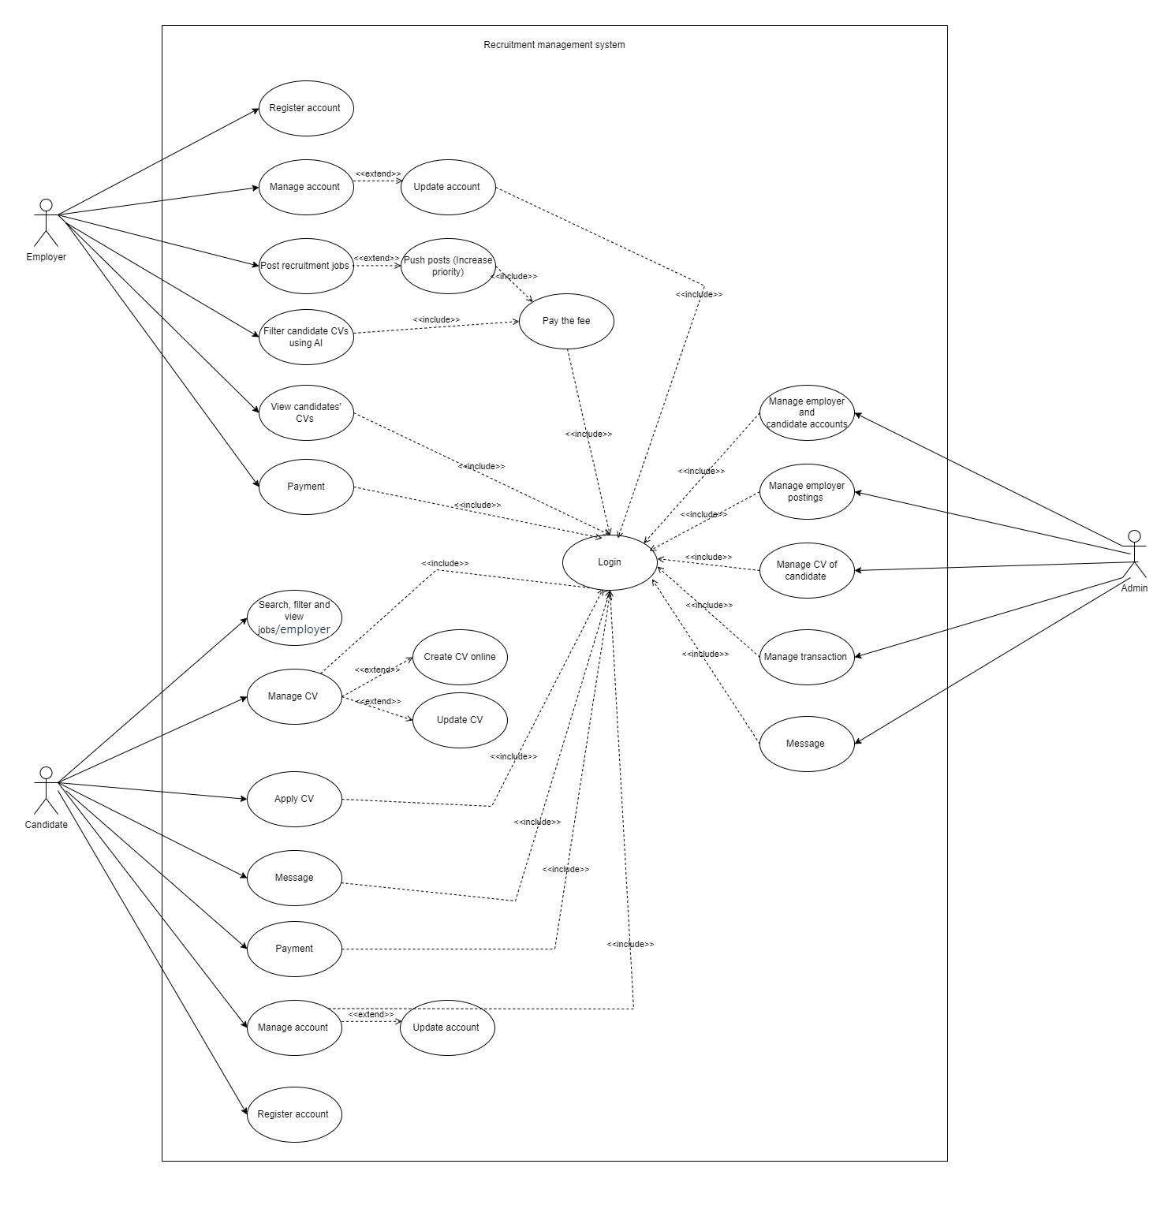

*Use case diagram*

##### Constraints

Finally, a set of constraints on the system and its implementation were collected.

These are presented in the following table.

|  |  |
| --- | --- |
| **ID** | **Constraint** |
| CON-1 | A minimum of 100 simultaneous users must be supported. |
| CON-2 | The system must be accessed through a web browser (Chrome V3.0+, Firefox V4+, IE8+) in different platforms: Windows, OSX, and Linux. |
| CON-3 | The project must be completed with 5 weeks. |
| CON-4 | The project is developed by 4 members and the estimated project budget is 4,000 USD. |
| CON-5 | For Front-End:   * Programming language: Javascript * FrameWork: ReactJs * Library: Bootstrap * Operating System: Multiplatform * Web Browser: Chorme, FireFox, Microsoft Edge |
| CON-6 | For Back-End:   * Programming language: Java * FrameWork: Spring bot * Library: SpringMVC, Spring Security, Spring JPA * Operating System: Windows server 2016 |
| CON-7 | Tool Develop:   * Code Editor: Visual Studio Code, IntelliJ IDEA * Library: NodeJs |
| CON-8 | Database server:   * Database: MySQL * Operating System: Windows server 2016 |

##### Quality attributes

* QA01: Usability
  + Usability refers to the ease with which an end user can use the system. For recruitment management systems, usability includes the following elements:
    - Friendly, intuitive and easy-to-use interface: Admin, Candidates and employers can access and navigate functions easily and quickly.
    - Admin can easily access the dashboard to manage candidate and employer accounts, and manage posts.
    - The process of creating a CV, applying a CV to candidates, posting recruitment posts, and approving CVs for employers to easily access and implement.
    - Provide instructions, support and online chat to support users
    - Concurrency and fast response times.

Scenario 01: Admins can easily view and manipulate functions on the dashboard

|  |  |
| --- | --- |
| **Quality attribute: Usability** | **ID**: QA01 |
| **Stimulus** | Admin views the dashboard. |
| **Source(s) of the Stimulus** | Admin |
| **Relevant Environment** | Runtime |
| **Artifact Stimulated** | Website |
| **Response** | The system displays the dashboard accurately, functions are easy and smooth to operate |
| **Response Measure(s)** | System should response within 5 seconds |

Scenario 2: Candidates creates a new CV easy and convenient

|  |  |
| --- | --- |
| **Quality attribute: Usability** | **ID**: QA02 |
| **Stimulus** | Candidates creates a new CV |
| **Source(s) of the Stimulus** | Candidates |
| **Relevant Environment** | Runtime |
| **Artifact Stimulated** | Website |
| **Response** | System should provide an easy-to-use form for CV creation with tooltips and validations. |
| **Response Measure(s)** | Candidates can easily complete their CV quickly without difficulty or confusion |

Scenario 3: Candidates search for jobs and employers quickly and accurately.

|  |  |
| --- | --- |
| **Quality attribute: Usability** | **ID**: QA03 |
| **Stimulus** | Candidates search for jobs and employers |
| **Source(s) of the Stimulus** | Candidates |
| **Relevant Environment** | Runtime |
| **Artifact Stimulated** | Website |
| **Response** | The system must display search results that exactly match the candidates' criteria. |
| **Response Measure(s)** | Results should appear within 3 seconds and be relevant at least 95% of the time. |

* QA02: Security
  + Security ensures that the system and the data within it are protected from threats and attacks. Security is of paramount importance in a recruitment website as it deals with sensitive personal and professional information of both candidates and employers. For recruitment management systems, security includes the following elements:
    - Authentication and authorization: Ensure that only authenticated users with appropriate access rights can access parts of the system. Admin, candidates, and recruiters need different access rights. Avoid exposure of sensitive personal data and impersonation.
    - Protection against attacks: The system needs to have measures to prevent attacks such as SQL Injection, Cross-Site Scripting (XSS), and Cross-Site Request Forgery (CSRF).
    - Security in the payment process and transactions of candidates and employers.

Scenario 1: Unauthorized user attempts to access admin panel

|  |  |
| --- | --- |
| **Quality attribute: Usability** | **ID**: QA04 |
| **Stimulus** | An unauthorized user attempts to access admin panel |
| **Source(s) of the Stimulus** | Unauthorized user |
| **Relevant Environment** | Runtime |
| **Artifact Stimulated** | Website |
| **Response** | System should prevent access and log the attempt. |
| **Response Measure(s)** | Prevent unauthorized access from unauthorized accounts  Unauthorized access attempts should be logged 100% of the time and no unauthorized user should gain access. |

Scenario 2: Encrypt sensitive information when Candidates submits sensitive information

|  |  |
| --- | --- |
| **Quality attribute: Usability** | **ID**: QA05 |
| **Stimulus** | An candidates submits sensitive information (e.g., personal details). |
| **Source(s) of the Stimulus** | Candidates |
| **Relevant Environment** | Data submission process |
| **Artifact Stimulated** | Website |
| **Response** | System should encrypt the data during transmission and storage. |
| **Response Measure(s)** | Data should be encrypted during transmission and storage 100% of the time. |

Scenario 3: Employer uploads a job posting (Prevent attacks from opposing forces)

|  |  |
| --- | --- |
| **Quality attribute: Usability** | **ID**: QA06 |
| **Stimulus** | Employer uploads a job posting |
| **Source(s) of the Stimulus** | Employer |
| **Relevant Environment** | Runtime |
| **Artifact Stimulated** | Website |
| **Response** | System should validate the input to prevent SQL injection. |
| **Response Measure(s)** | Input should be validated 100% of the time and any SQL injection attempts should be blocked and logged. |

Scenario 4: Secure payment methods and transaction processes

|  |  |
| --- | --- |
| **Quality attribute: Usability** | **ID**: QA07 |
| **Stimulus** | Employer and Candidates payment |
| **Source(s) of the Stimulus** | Employer and Candidates |
| **Relevant Environment** | Runtime |
| **Artifact Stimulated** | Website |
| **Response** | System should process the payment securely and confirm the transaction. |
| **Response Measure(s)** | Payment should be processed within 10 seconds, and a confirmation receipt should be sent to the applicant's email immediately after successful payment. |

* QA03: Modifiability
  + Modifiability is chosen to address the evolving nature of recruitment processes and the need for the platform to adapt to changing requirements.
  + As the recruitment landscape evolves, there might be changes in job categories, assessment criteria, or additional features needed. The system should be easily modifiable to accommodate these changes without causing significant disruptions.
    - Modular design: The system should be designed into independent modules, so that when it is necessary to change or upgrade a module, it does not affect other parts of the system.
    - Flexible architecture, reasonable source code management, easy to modify

Scenario 1: Admin requests a new feature to generate custom reports

|  |  |
| --- | --- |
| **Quality attribute: Usability** | **ID**: QA09 |
| **Stimulus** | Admin requests a new feature to generate custom reports. |
| **Source(s) of the Stimulus** | Admin |
| **Relevant Environment** | Development environment |
| **Artifact Stimulated** | Codebase |
| **Response** | System should allow developers to add the feature without significant changes to the existing codebase. |
| **Response Measure(s)** | The new feature should be integrated within 2 weeks with less than 5% of existing code being modified. |

Scenario 2: Candidates interface needs a redesign

|  |  |
| --- | --- |
| **Quality attribute: Usability** | **ID**: QA10 |
| **Stimulus** | Candidates interface needs a redesign. |
| **Source(s) of the Stimulus** | Design team |
| **Relevant Environment** | Development environment |
| **Artifact Stimulated** | Frontend code |
| **Response** | System should support modular updates to the user interface |
| **Response Measure(s)** | Redesign should be implemented within 4 weeks, affecting only the frontend modules. |

Scenario 3: New compliance regulation requires changes to data handling processes

|  |  |
| --- | --- |
| **Quality attribute: Usability** | **ID**: QA09 |
| **Stimulus** | A new compliance regulation requires changes to data handling processes. |
| **Source(s) of the Stimulus** | Regulatory body |
| **Relevant Environment** | Development environment |
| **Artifact Stimulated** | Data handling modules |
| **Response** | System should allow for updates to data handling processes with minimal disruption. |
| **Response Measure(s)** | Compliance updates should be completed within 3 weeks, with less than 10% of the data handling code needing modification. |

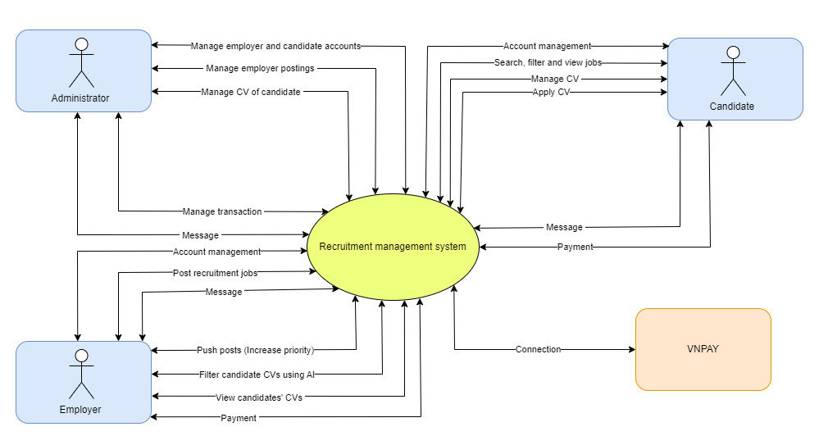

*System context diagram*

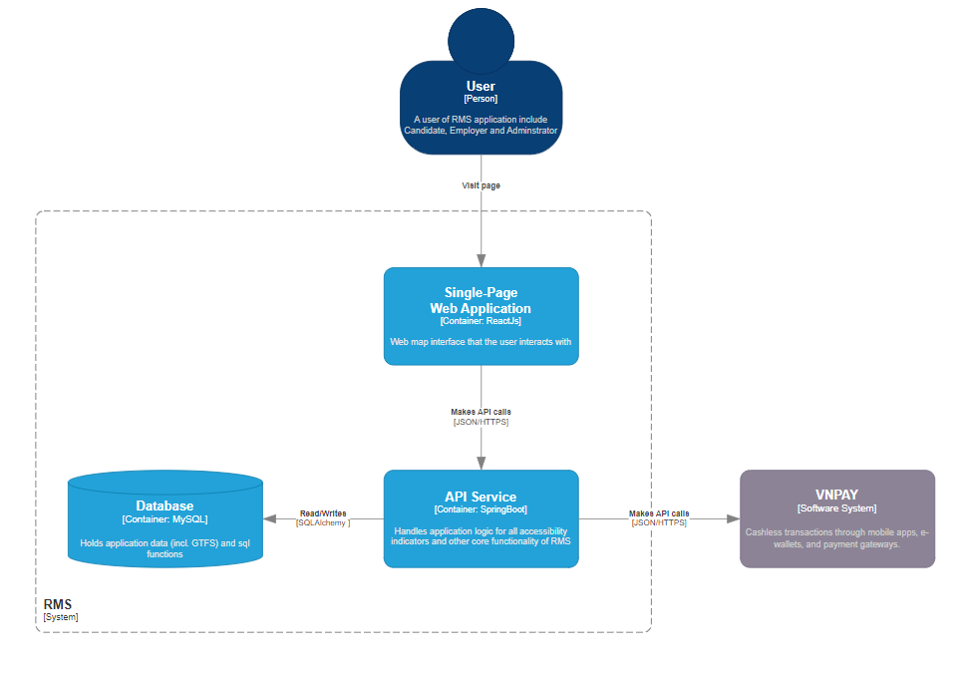

*Container diagram*

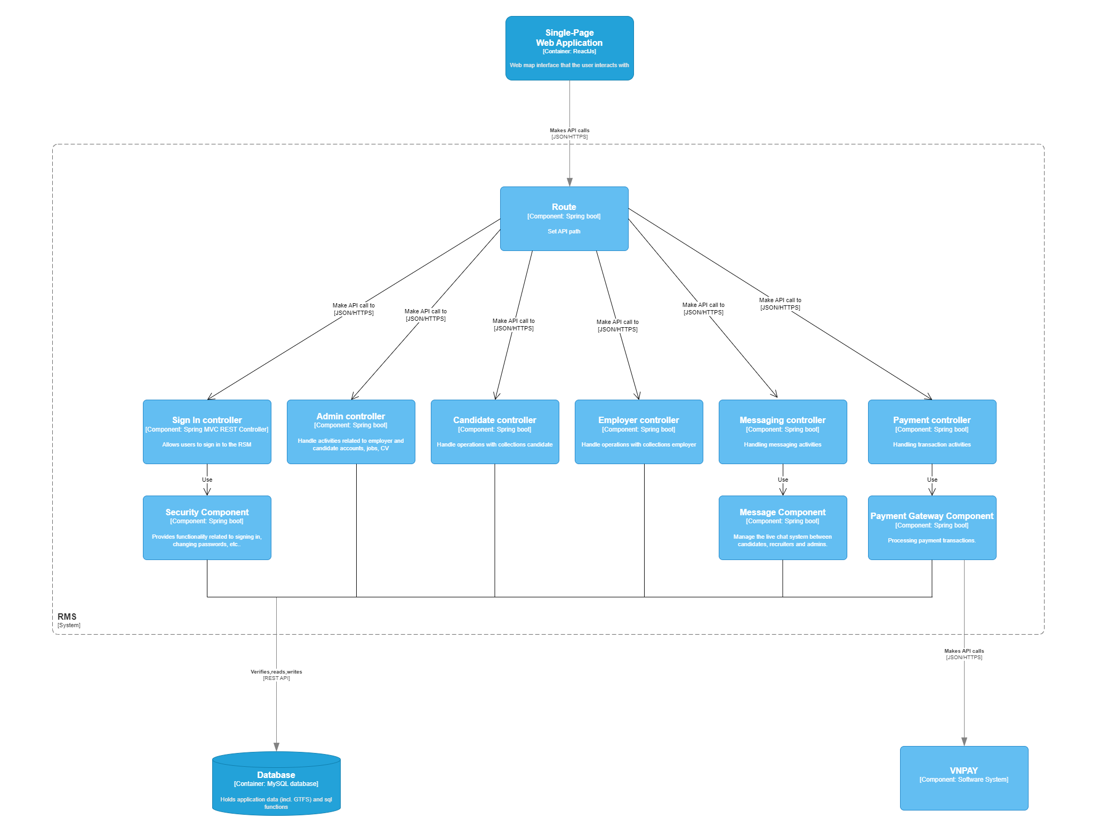

*Component Diagram*

