AZURE CLOUD COMPUTING
Virtual Machine and Linux Administration Assignment
Practical implementation report
Student: Anhar Taha Al-Rujaee
Platform: Microsoft Azure
Operating System: Ubuntu Server 24.04 LTS
VM: AnharAlRujaee-VM
Region: South Africa North
Date of practical evidence: 7 November 2026

Executive Summary
This report presents the setup and practical administration of an Ubuntu virtual machine in Microsoft Azure. The work covers Apache web hosting, MySQL database administration, Samba file-sharing configuration, and Azure File Share integration.

Evidence and Results

1. Introduction
This report documents a practical assignment in Microsoft Azure and Linux administration. The work involved deploying an Ubuntu virtual machine, publishing a website with Apache, creating a MySQL database, configuring Samba file sharing, and mounting an Azure File Share for file operations.

2. Azure Virtual Machine Setup
An Ubuntu Server 24.04 virtual machine named AnharAlRujaee-VM was created in Microsoft Azure. The VM overview screenshot records the region as South Africa North and shows the VM in the Running state. A remote shell session was established from a Mac terminal using SSH. Public IP and subscription identifiers are intentionally omitted from this public report.

3. Task 1 – Apache Web Server and Website
Apache was installed using `sudo apt update` and `sudo apt install apache2 -y`. The service was enabled and started with `sudo systemctl enable --now apache2`, and its status was checked using `sudo systemctl status apache2`. A custom HTML welcome page was placed in `/var/www/html/index.html`. Initially, the website timed out because inbound HTTP traffic was not allowed by the Azure Network Security Group. An inbound rule allowing TCP port 80 was added (priority 310), after which the website became accessible through the VM public IP.

4. Task 2 – MySQL Database
MySQL Community Server 8.0.46 was installed and enabled. The service status showed `active (running)`. Using `sudo mysql`, the database `anhar_database` was created, followed by a `students` table with `id`, `name`, and `course` columns. A sample record (Anhar, Linux Administration) was inserted and retrieved using `SELECT * FROM students;`. The query returned one row successfully.

5. Task 3 – Samba File Sharing
Samba was installed and the service `smbd` was confirmed active and running. A shared directory was created at `/srv/samba/shared`, a `sambashare` group was created, and the Ubuntu user was added to that group. Directory ownership and permissions were configured, and a Samba password was set. The `[AnharShare]` share was configured in `/etc/samba/smb.conf` with browseable access, write access, group-based valid users, and file/directory creation masks. The configuration was validated with `testparm` according to the completed setup workflow. A separate connection test from another client was not captured and is not claimed in this report.

6. Task 4 – Azure File Share
A storage account named `nexuscrm` and a file share named `anhar-files` were created. The share was mounted on the Ubuntu VM at `/media/anhar-files`, and the mount was verified with `df -h`. A test file named `test.txt` was created using `tee`, its contents were displayed using `cat`, and it was deleted using `rm`. A final directory listing showed the share empty again. These operations demonstrate successful create, read, and delete access to the mounted Azure File Share.

7. Problems Encountered and Solutions
The published website initially returned a connection timeout. The cause was an Azure Network Security Group rule that did not allow inbound HTTP. An Allow-HTTP rule for TCP port 80 was added and the website then worked. Samba required installation, a dedicated shared directory, group permissions, a Samba user password, and a share definition in the configuration file. The Azure File Share mount was checked with `df -h` before performing file operations.

8. Additional Technical Training and Projects
The student reports technical learning in Python programming, PostgreSQL databases, and UI design through IT Bootcamp. Additional learning/development activities are associated with VIT Academy and We RHere IT Academy. Separately, the student designed and developed NexusCRM, a CRM desktop application using Python, PyQt6, and PostgreSQL. The NexusCRM screenshots are included in a separate supplementary folder and are not presented as evidence for the Azure tasks.

9. Conclusion
The four main practical tasks were completed: Apache web hosting, MySQL database creation and query execution, Samba share configuration, and Azure File Share mounting with create/read/delete operations. The assignment provided practical experience with Azure VM deployment, SSH, Linux services, network security rules, relational databases, and cloud file storage.

10. Submission Links
GitHub repository: https://github.com/AnharAlRujaee/Azure-Cloud-Computing-Virtual-Machine-VM-and-Linux-Administration
LinkedIn profile: https://www.linkedin.com/in/anhar-taha-al-rujaee-645668226/
LinkedIn post URL: To be added after publication.

Appendix A – Practical Screenshots

Azure VM overview

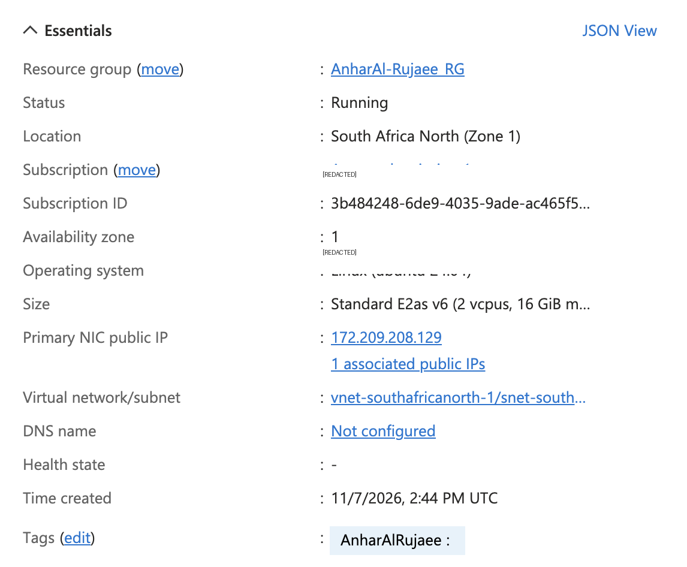
Figure: Azure VM overview.

SSH session and Ubuntu system information

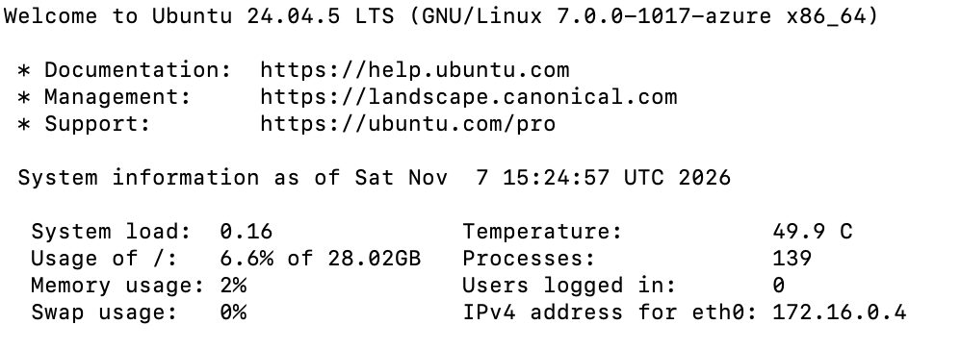
Figure: SSH session and Ubuntu system information.

Apache service status

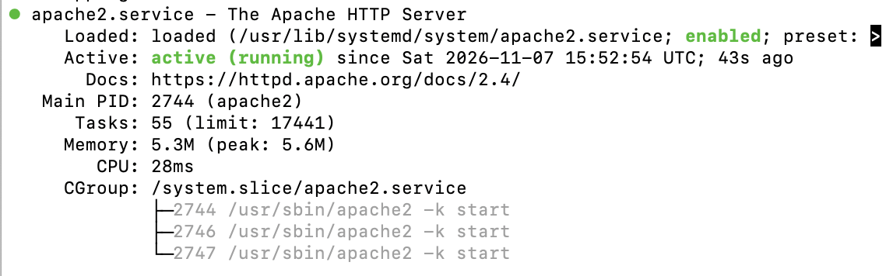
Figure: Apache service status.

Published Apache website

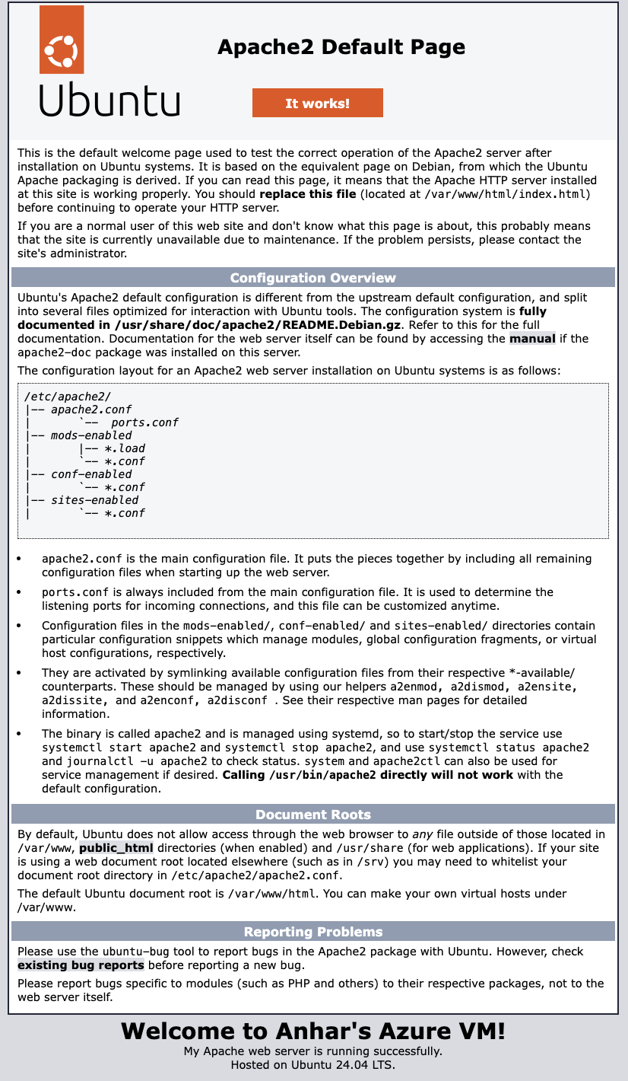
Figure: Published Apache website.

Azure inbound HTTP security rule

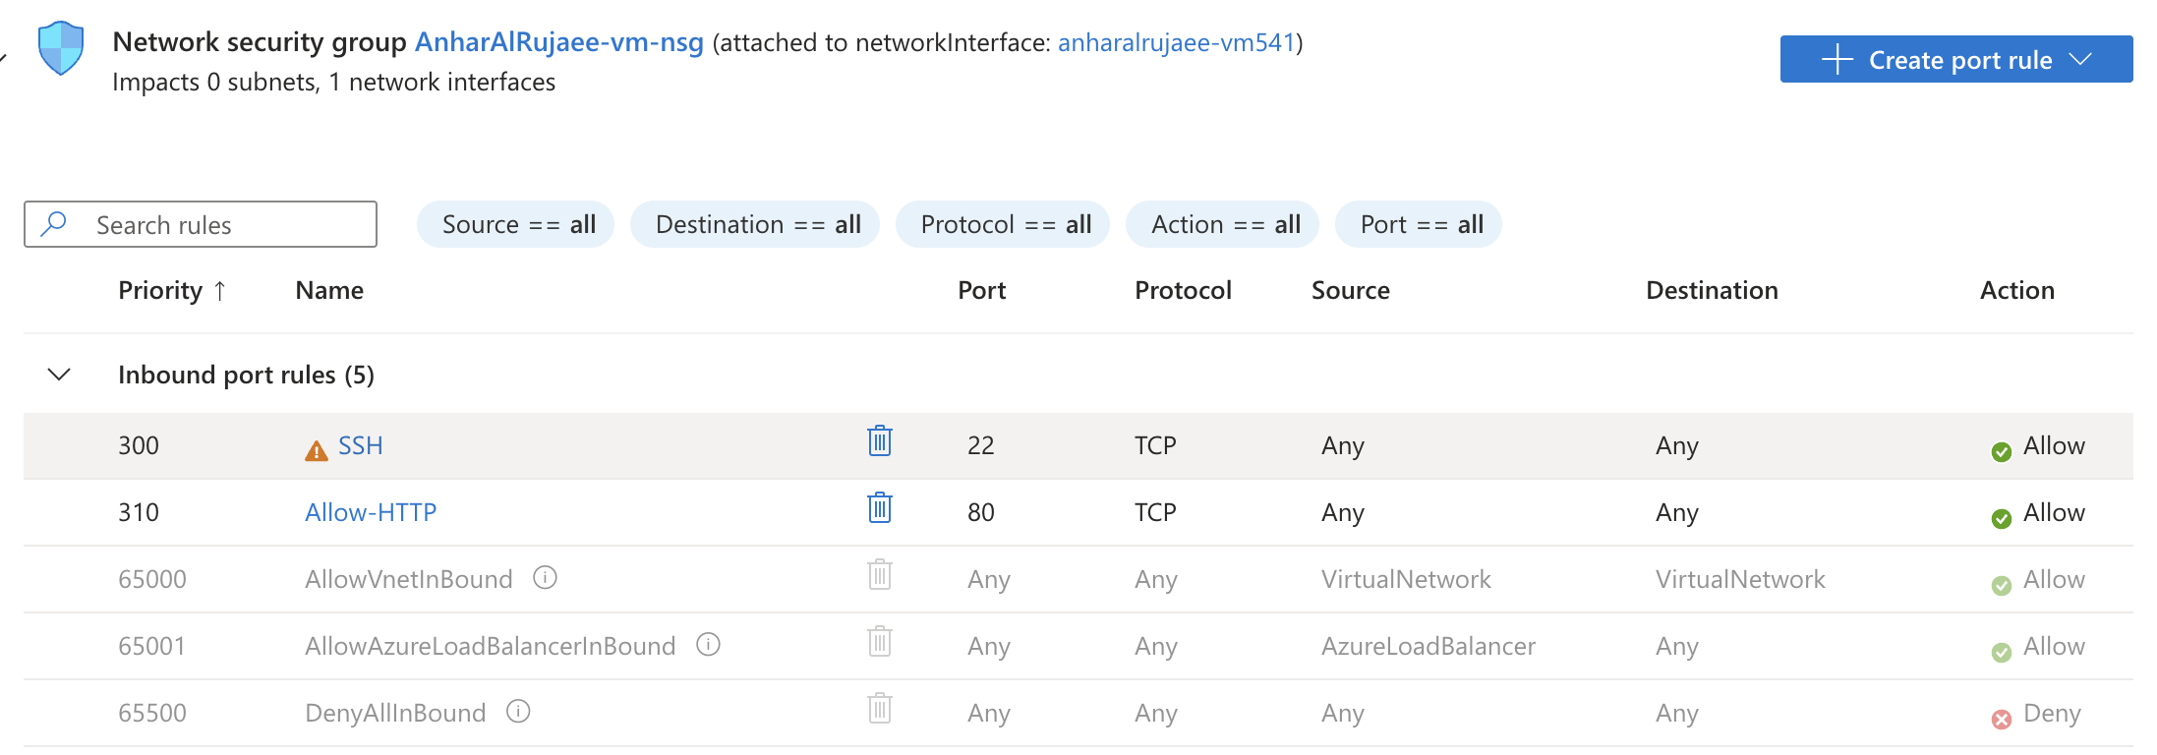
Figure: Azure inbound HTTP security rule.

MySQL service status

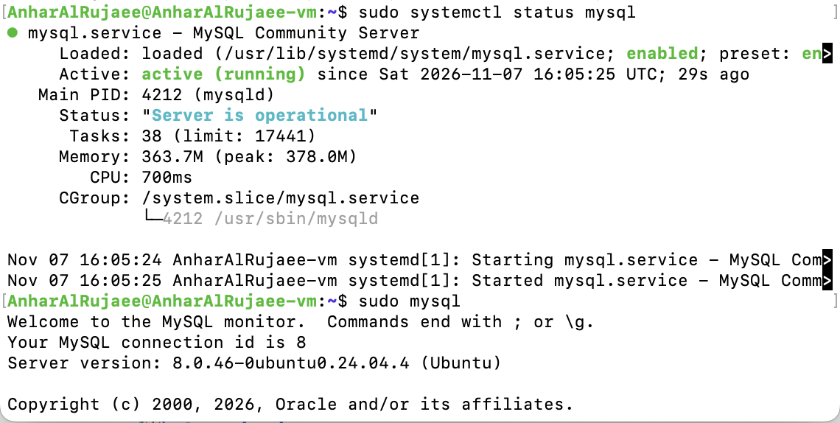
Figure: MySQL service status.

MySQL database, table and query result

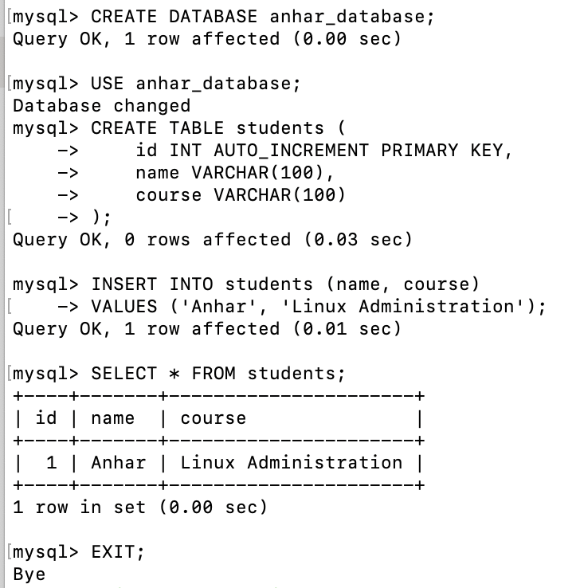
Figure: MySQL database, table and query result.

Samba service status

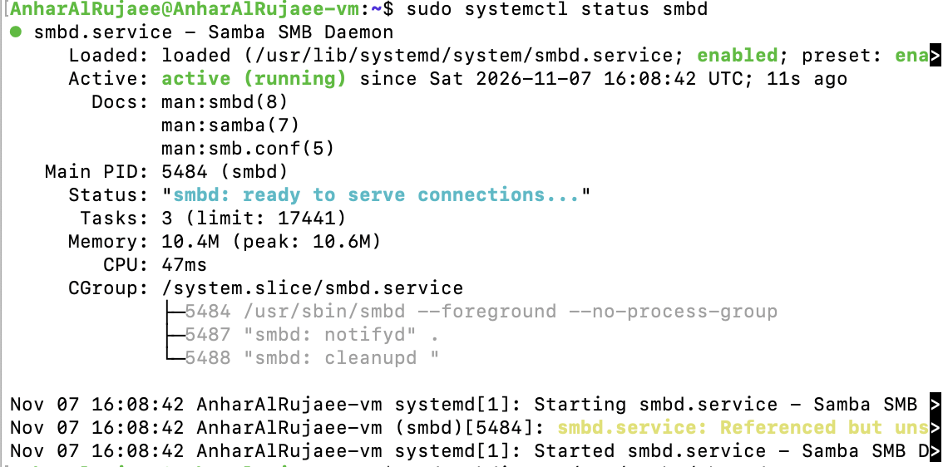
Figure: Samba service status.

Samba installation output

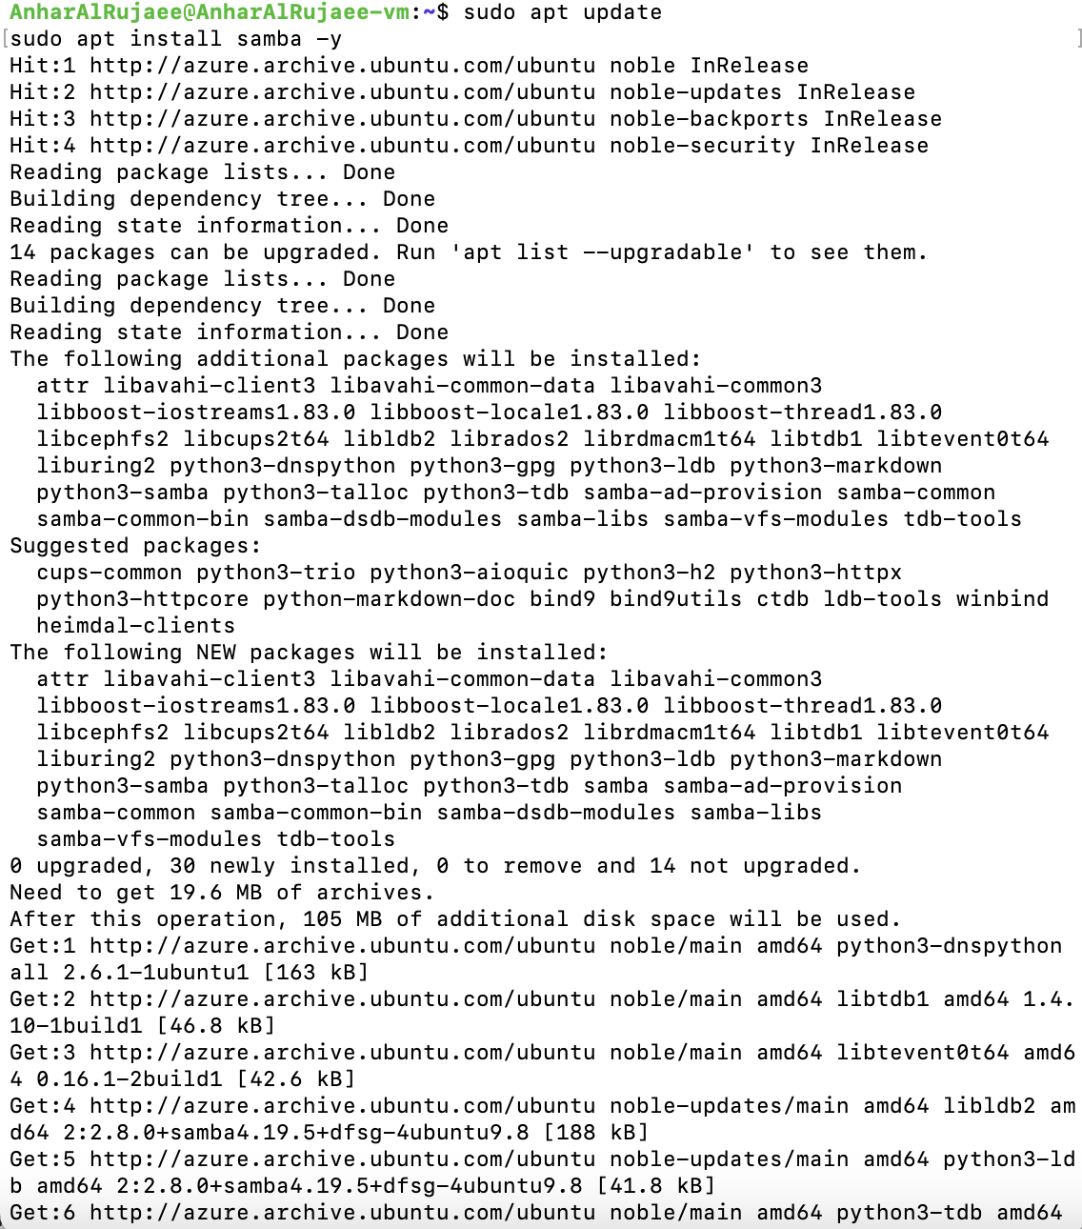
Figure: Samba installation output.

Azure File Share mount, create, read and delete

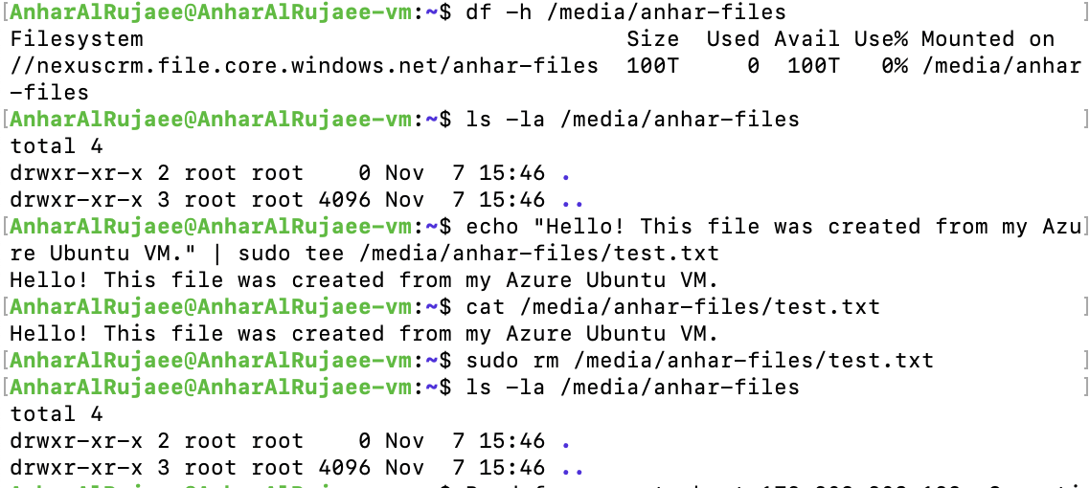
Figure: Azure File Share mount, create, read and delete.

Appendix B – Supplementary NexusCRM Project
The following images are a separate visual showcase of NexusCRM, a CRM application developed with Python, PyQt6, and PostgreSQL. They are supplementary portfolio material and are not part of the Azure assignment evidence.

01 NexusCRM Login
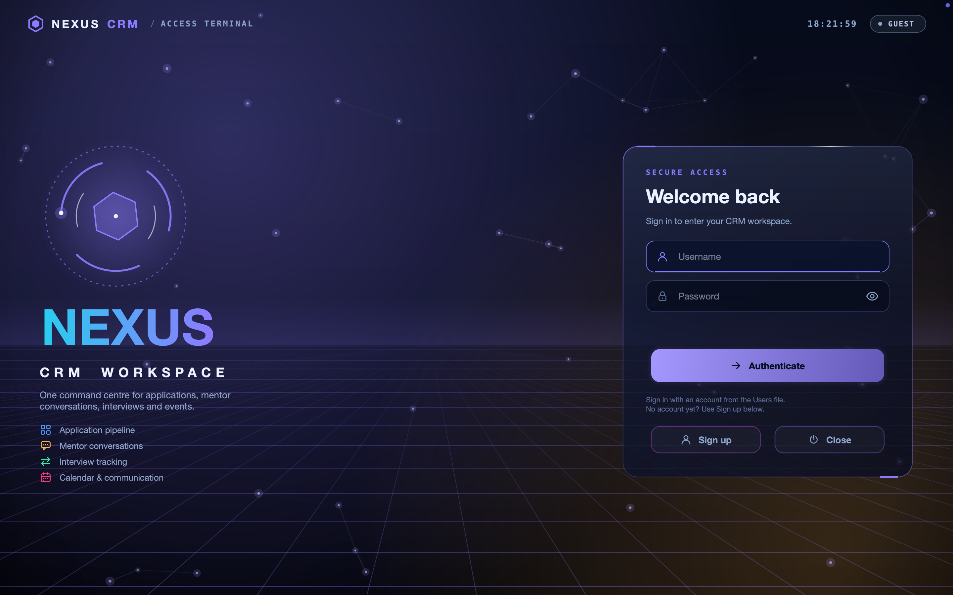

02 NexusCRM Admin Dashboard
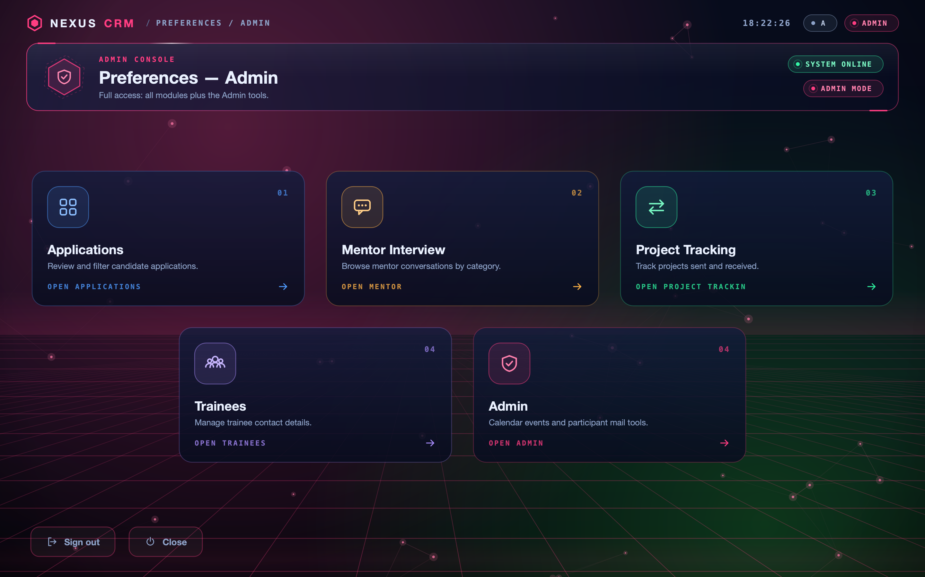

03 NexusCRM Database Overview
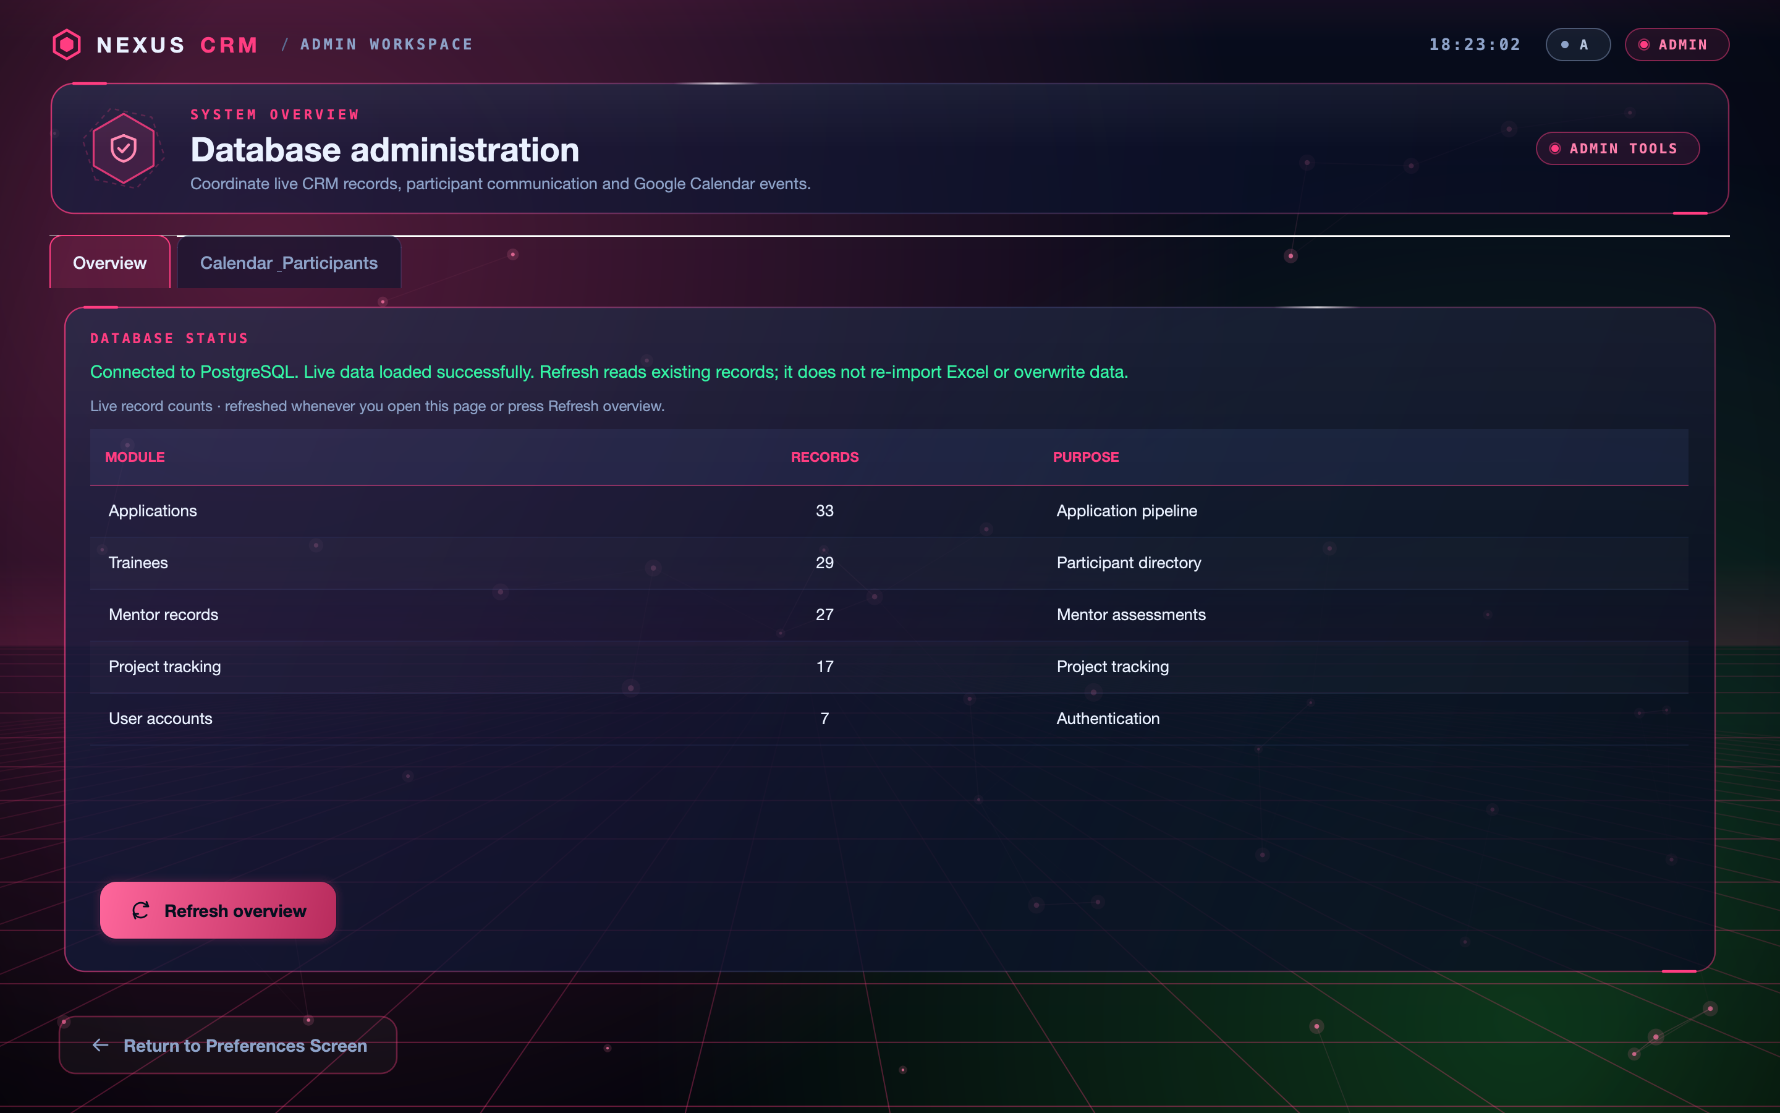

04 NexusCRM Application Pipeline
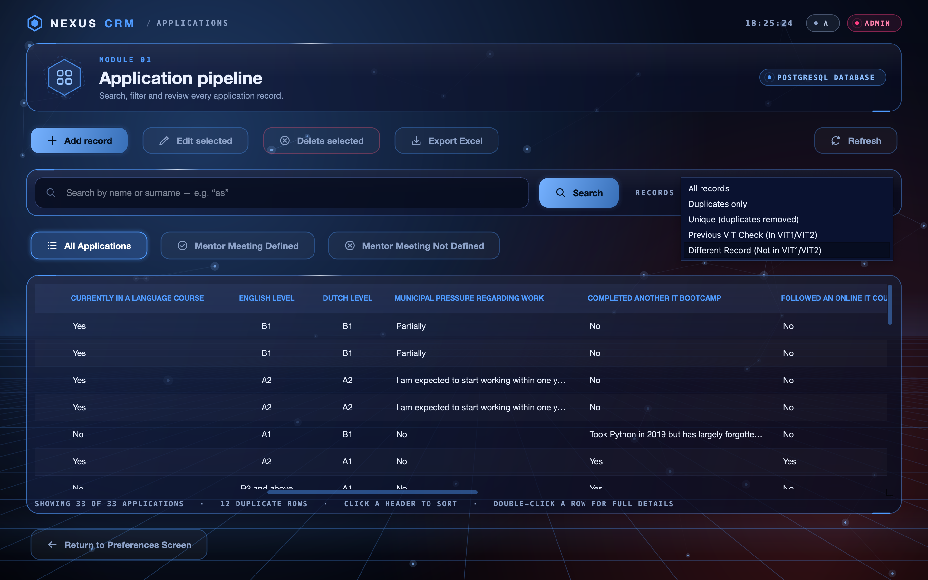

05 NexusCRM Code Development


