Jyothi Golasangi:

Group Number: 2

Mobile: 6300047854

**Requirement**:

* **Use Case**: Combine two datasets (e.g., products from two different CSV files) with the same structure.
* Example:
  + If you have a second products dataset (products_2.csv), you can use a **Union** transformation to combine both datasets into a single output.
* Use the **Union Activity** to merge two datasets.

**Architecture**:

**Outcomes**:

1. **Filter**:

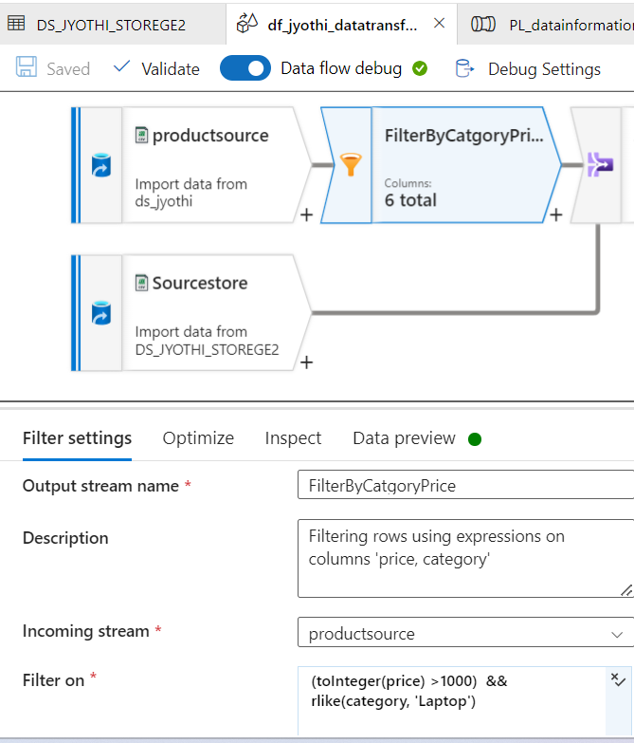

**RESULT-**

**2. Join:**

**RESULT-**

**3.Sort:**

**RESULT-**

**4. Derived Column:**

**RESULT-**

**5.Select:**

**RESULT**

**6.Aggregate:**

**RESULT-**

**Union**

**RESULT-**

**Overall Outcomes-**

**RESULT-**

Storage Account → Container → Part…...csv