Table of Contents

# Sandeel in Division 3.a and Subarea 4

## Sandeel in SA 6

### Catch data

Total catch weight by year for SA 6 is given in Table 9.6.1, and plotted in Figure 9.6.1 and Figure 9.6.2

Table 9.6.1: Sandeel. Total catch (tonnes) for the first and second half of the year as estimated by ICES

| **Year** | **1st half** | **2nd half** | **Total** |
| --- | --- | --- | --- |
| 1983 | 364 | 0 | **364** |
| 1984 | 735 | 55 | **791** |
| 1985 | 973 | 953 | **1927** |
| 1986 | 12020 | 1199 | **13219** |
| 1987 | 1091 | 72 | **1163** |
| 1988 | 2114 | 612 | **2726** |
| 1989 | 897 | 12 | **909** |
| 1990 | 485 | 14 | **499** |
| 1991 | 17 | 0 | **17** |
| 1992 | 4270 | 6 | **4277** |
| 1993 | 4393 | 97 | **4490** |
| 1994 | 3222 | 526 | **3748** |
| 1995 | 1829 | 1 | **1830** |
| 1996 | 1168 | 95 | **1263** |
| 1997 | 2194 | 179 | **2372** |
| 1998 | 939 | 1 | **941** |
| 1999 | 0 | 0 | **0** |
| 2000 | 0 | 0 | **0** |
| 2001 | 26 | 0 | **26** |
| 2002 | 493 | 0 | **493** |
| 2003 | 111 | 0 | **111** |
| 2004 | 571 | 2 | **573** |
| 2005 | 259 | 0 | **259** |
| 2006 | 160 | 0 | **161** |
| 2007 | 0 | 0 | **0** |
| 2008 | 0 | 0 | **0** |
| 2009 | 0 | 0 | **0** |
| 2010 | 0 | 0 | **0** |
| 2011 | 489 | 0 | **489** |
| 2012 | 213 | 0 | **214** |
| 2013 | 72 | 0 | **72** |
| 2014 | 65 | 0 | **65** |
| 2015 | 197 | 0 | **198** |
| 2016 | 123 | 0 | **123** |
| 2017 | 0 | 0 | **0** |
| 2018 | 0 | 0 | **0** |
| **arith. mean** | **1097** | **106** | **1203** |

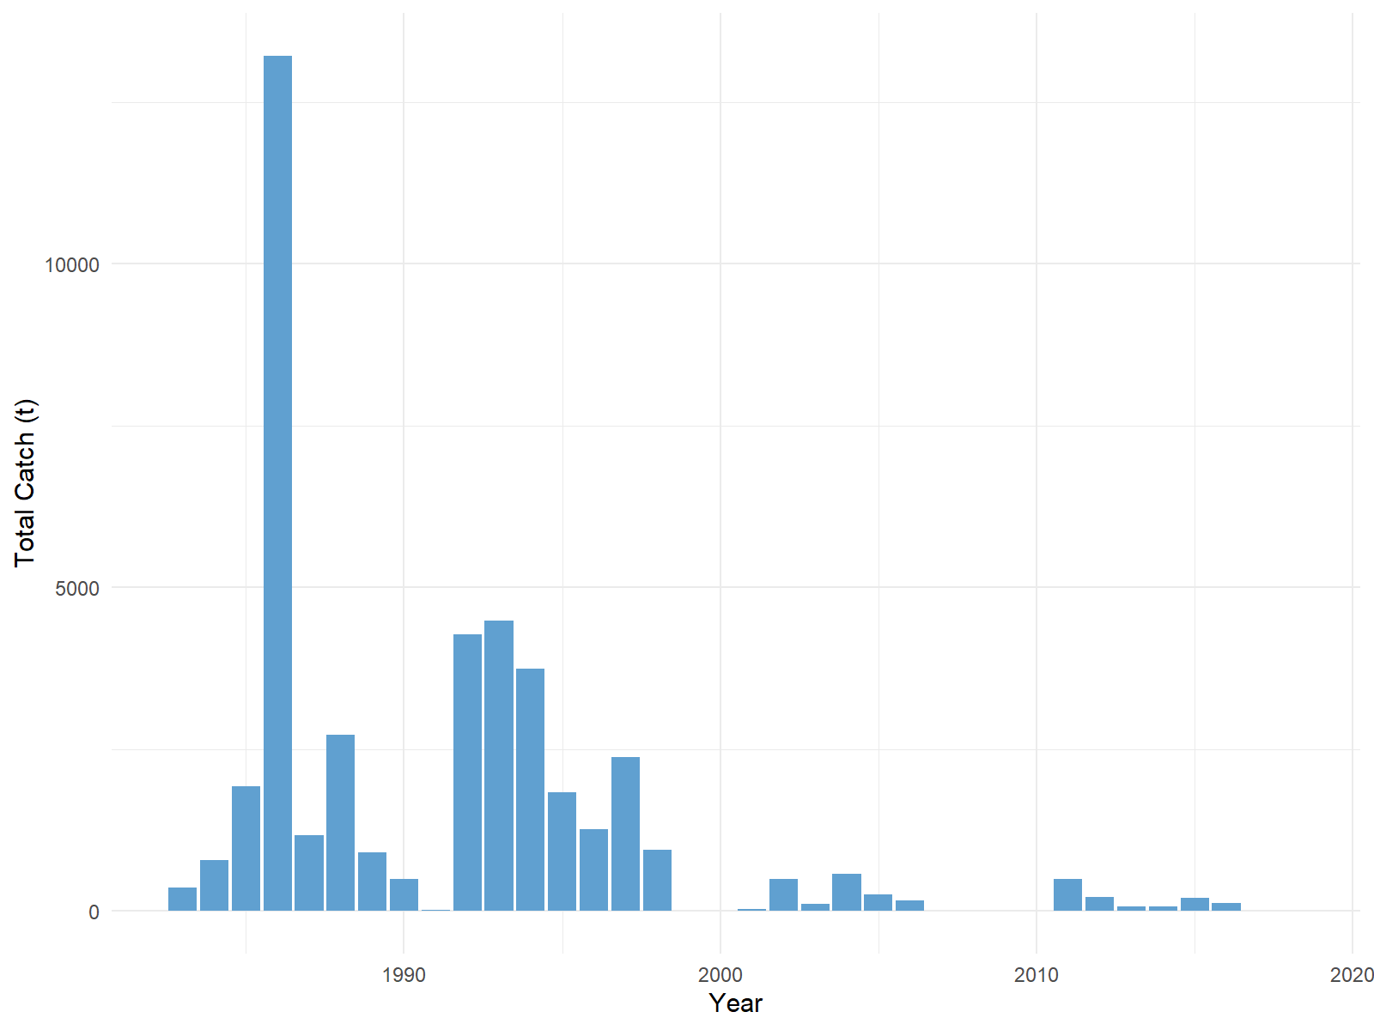

Figure 9.6.1: Sandeel. Total catch (tonnes) by year as estimated by ICES.

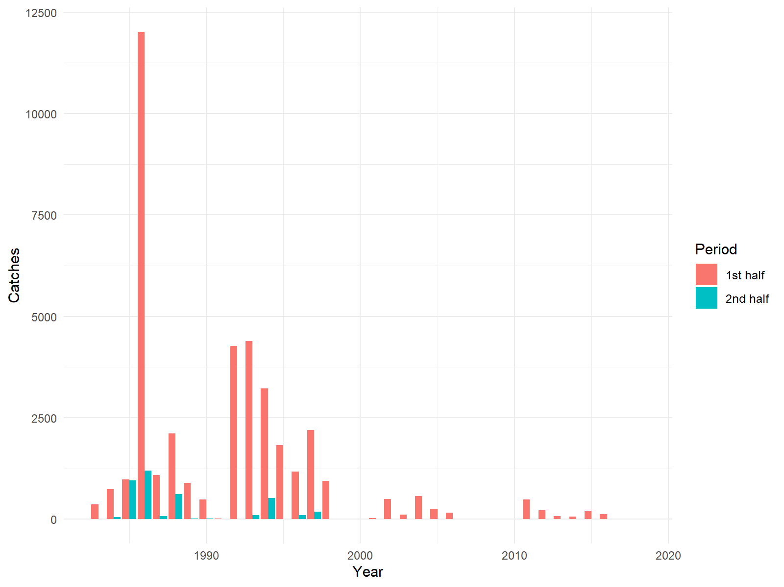

Figure 9.6.2: Sandeel. Total catch (tonnes) by year for the first and second half of the year as estimated by ICES.