CprE 381: Computer Organization and Assembly Level Programming, Spring 2019

Report – Project Part 2

Lab Partners ____Anh To________________________________

____Shuang Li______________________________

Section /Lab Time _______C_______________

Canvas Group ID ________3___________________

Refer to the highlighted language in the project 2 instruction for the context of the following questions.

- [Part (a.1.a)] Create a spreadsheet detailing the list of M instructions to be supported in this part alongside their binary opcodes and funct fields, if applicable. Create a separate column for each binary bit. Inside this spreadsheet, create a new column for the N control signals needed by your datapath implementation. [You can attach the spreadsheet as a separate file.]

- [Part (a.1.b)] Create a testbench to test this module individually, and show that your output matches the expected control signals from problem 1(a). [Please attach waveforms and explanations.]

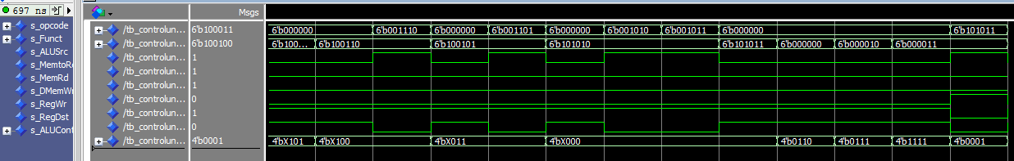
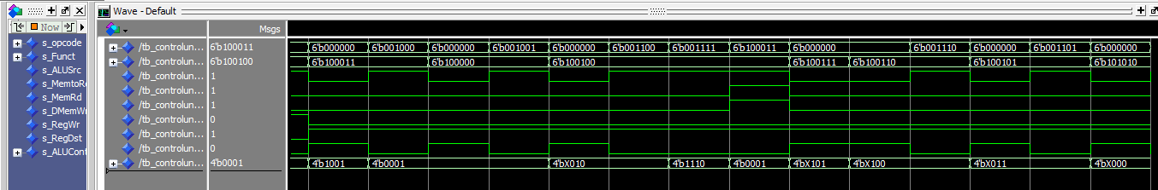
Testbench takes opcode and function codes that represent an instruction needed to be implemented listed in part A. ALUSrc, MemRd, RegWre, and other outputs matches the expected outputs for each instructions from the excel sheet.

- [Part (a.2)] In your writeup, describe what challenges (if any) you faced in implementing this module.

Some challenges we ran into include implementing the lui instructions, and setting the RegWrite signal to X when instruction has not been decoded.
We designed the lui instruction to use sign extender to extend the input to a 32bit number, then shift left logical 16 bit to get [imm + 16 0’s], then write it to rt.
At first, our RegWrite signal was set to be 1 at all time except for when it is a sw instruction. That messed up the comparison system that compares our execution result with the MARS result because there were always 2 extra Write to register actions at the beginning of the program and at the end of the program. So we added 2 other situations where the RegWrite would be 0: when opcode is XXXXXX(not decoded) and when opcode is 0x001100 (syscall).

- [Part (a.3)] Create a test application that makes use of every arithmetic/logical/shift instruction, and attach waveforms.

[Complete test and waveform attached in the zip.]
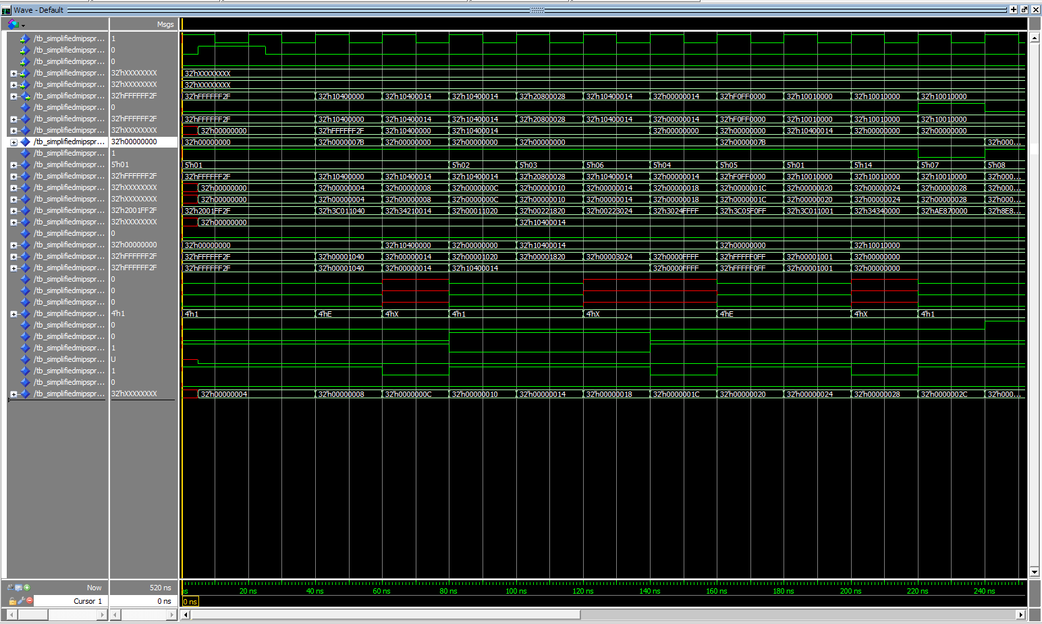
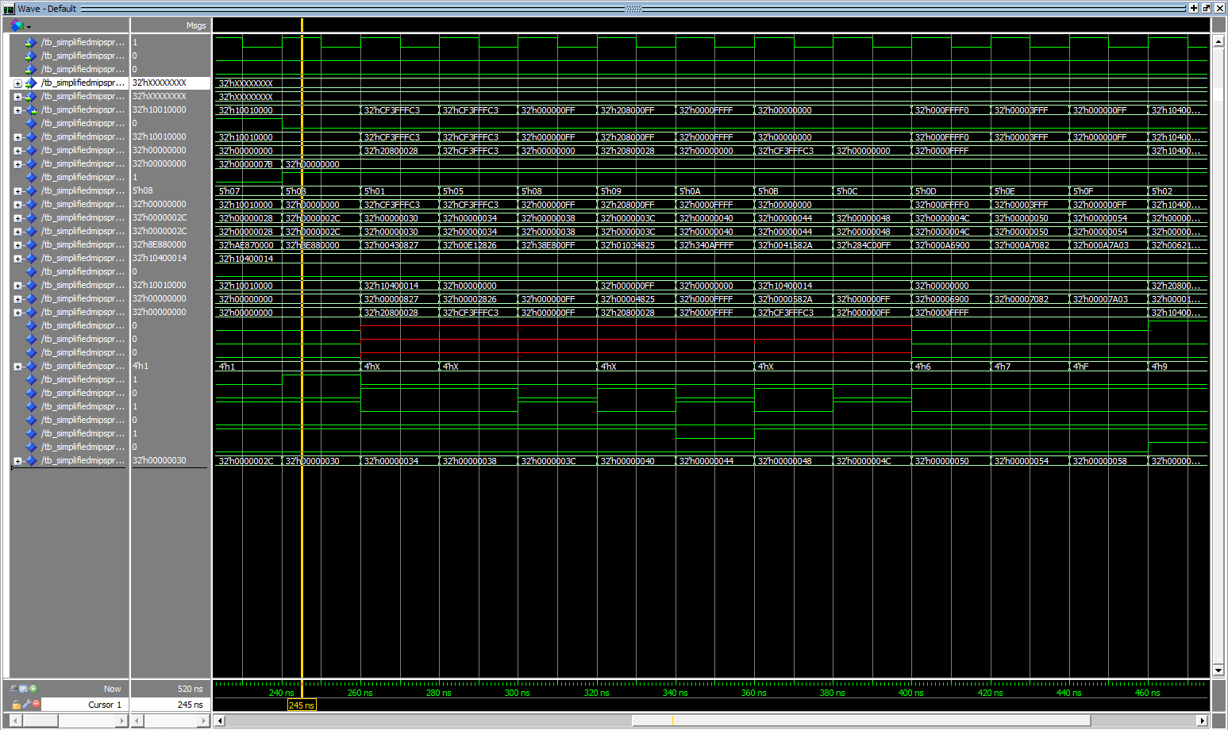
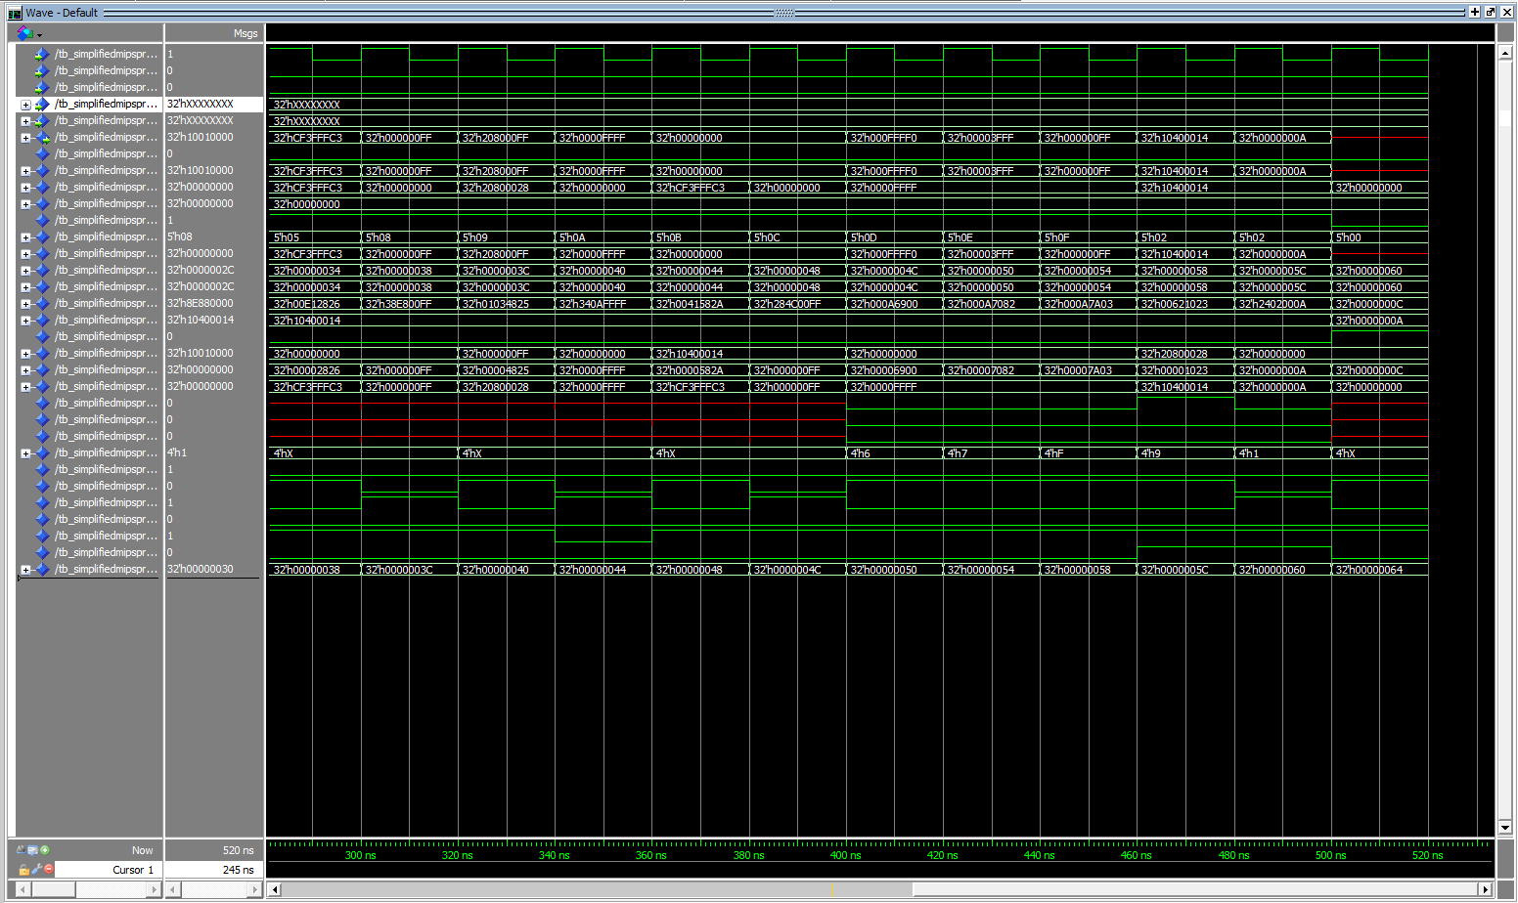

- [Part (b.5.a)] Describe these possibilities as a function of the different control flow-related instructions from Part (a.1.a).

- [Part (b.5.b)] Draw a schematic for the instruction fetch logic and any other datapath modifications needed for control flow instructions. What additional control signals are needed?

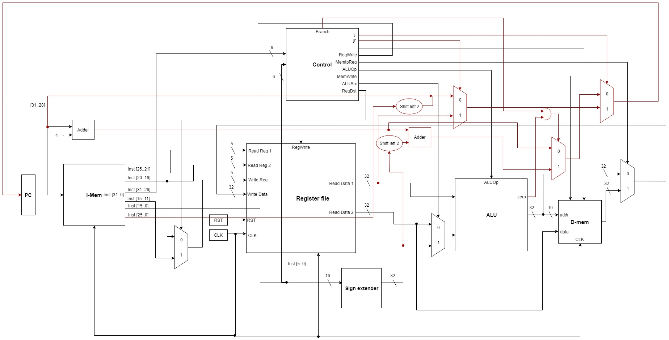
Additional controls needed are: j, jr, and branch as shown above.

- [Part (b.5.c)] Attach waveforms, and describe how the execution of the control flow possibilities corresponds to the Modelsim waveforms in your writeup.

- [Part (b.6)] In your writeup, show the Modelsim output for each of the following tests, and provide a discussion of result correctness. It may be helpful to also annotate the waveforms directly.

  - [Part (b.6.a)] Modify your application from Part (a.4) to include tests for each control flow instruction in addition to the data-handling instructions. Confirm your processor is completely functional.

  - [Part (b.6.b)] Create and test an application that sorts an array with N elements using the BubbleSort algorithm

- [Part (b.8)] Report the maximum frequency your processor can run at and determine what your critical path is. What components would you focus on to improve the frequency?

- [Feedback] You must complete this section for your lab to be graded. This will be turned in INDIVIDUALLY in a separate assignment called “Proj 1 Feedback”. Write down the first response you think of; I expect it to take roughly 5 minutes (do not take more than 10 minutes).

1. How many hours did you spend on this lab?

Task | During lab time | Outside of lab time
Reading lab
Pencil/paper design
VHDL design
Assembly coding
Simulation
Debugging
Report writing
Other:
Total

- What fraction of the above time did you spend working with your partner (either in a lab or remotely)?

- If you could change one thing about the lab experience, what would it be? Why?

- What was the most interesting part of the lab?

