CprE 381: Computer Organization and Assembly-Level Programming, Spring 2019

Project Part 1 Report

Lab Partners ______________________________________________

______________________________________________

______________________________________________

Section /Lab Time _________________________

Refer to the highlighted language in the project 1 instruction for the context of the following questions.

- [Part 0] With your project group members, create a list of best practices / tips for designing, compiling, and testing VHDL modules based on your experiences so far with these labs, both working individually and as a group.

- [Part 1 (a)] Describe the difference between logical (srl) and arithmetic (sra) shifts. Why does MIPS not have a sla instruction?

- [Part 1 (b)] In your writeup, briefly describe how your VHDL code implements both the arithmetic and logical shifting operations.

- [Part 1 (c)] In your writeup, explain how the right barrel shifter from part b) can be enhanced to also support left shifting operations.

- [Part 1 (d)] Describe how the execution of the different shifting operations corresponds to the Modelsim waveforms in your writeup. Waveforms.

- [Part 2 (a)] Draw a simplified schematic for this 32-bit ALU. Consider the following questions: how is Overflow calculated? How is Zero calculated? How is slt implemented?

- [Part 2 (c)] Describe how the execution of the different operations corresponds to the Modelsim waveforms in your writeup .Waveforms.
Testing Shifter with ALUOP(3) set to 0 and ALUOP(0) set to one to perfrom srl using A(4-0) as number of bits to shift for B
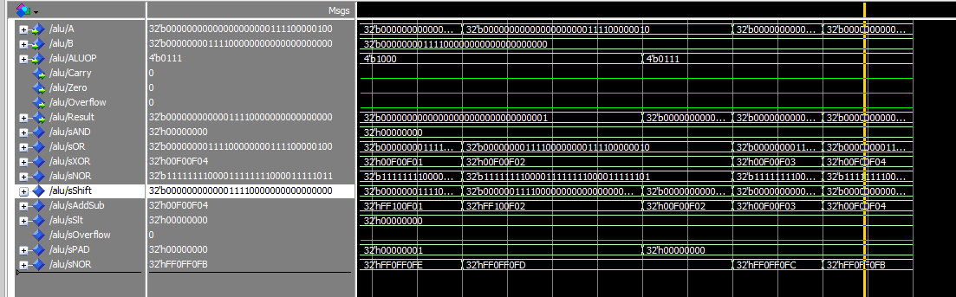
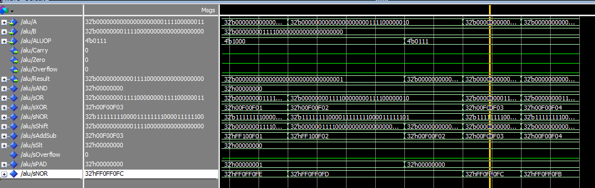

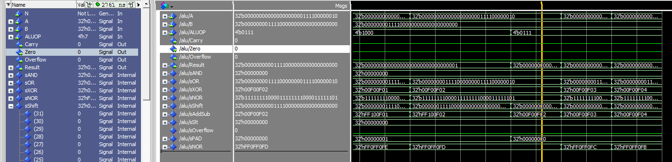
Testing Shifter with ALUOP(3)=1 and ALUOP(0)=1 to test sra
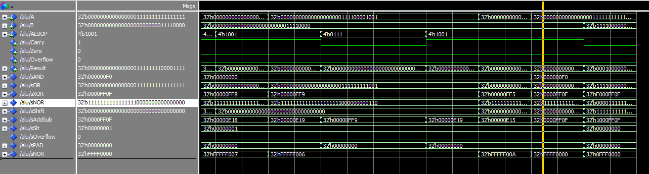
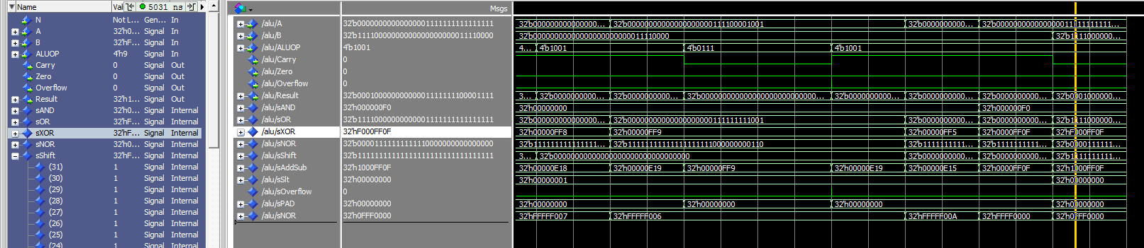
Testing Shifter with ALUOP(3) and ALUOP(0) set to zero to test sll
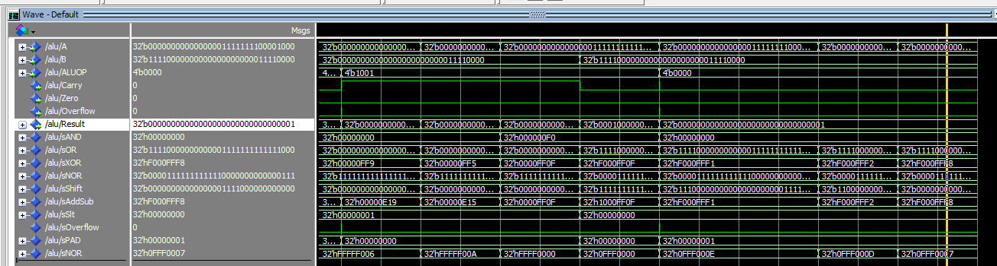
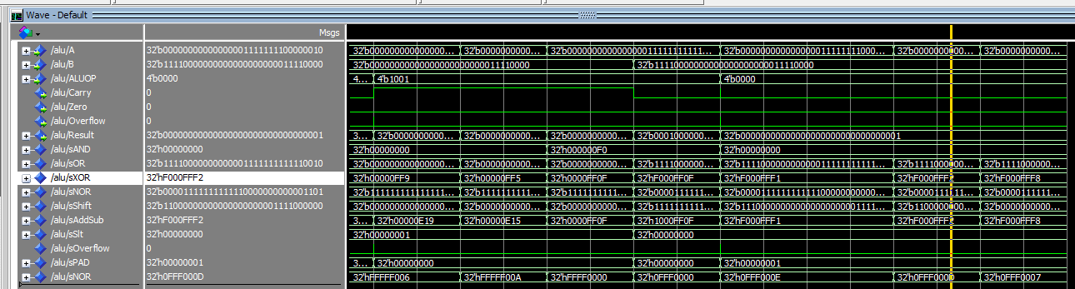
Testing AND functionality with ALUOP set to 2 or 0010
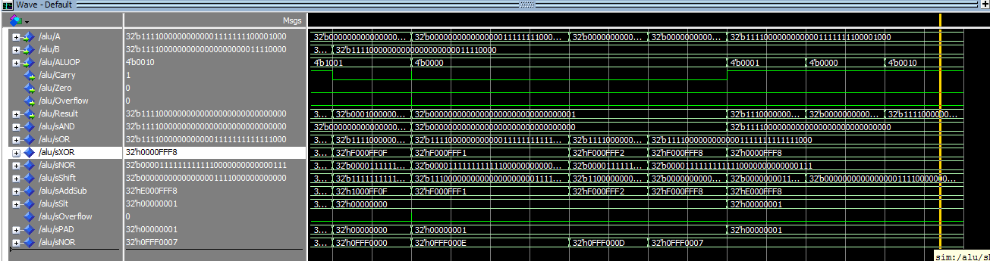
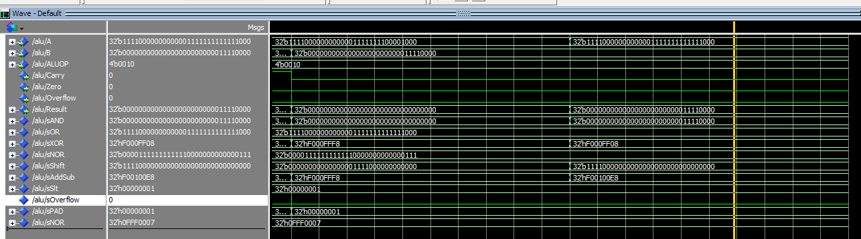
Testing OR functionality with ALUOP set to 3 or 0011
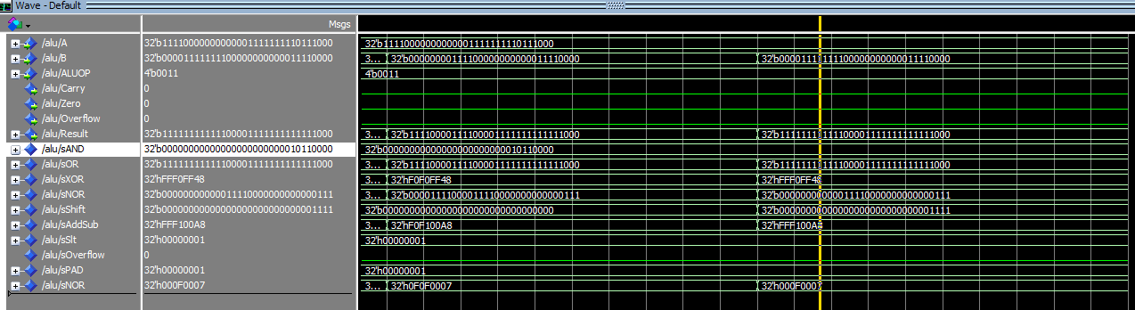
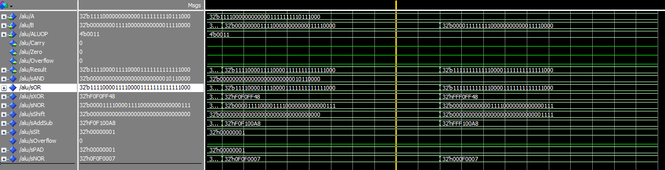
Testing XOR functionality with ALUOP set to 4 or 0100

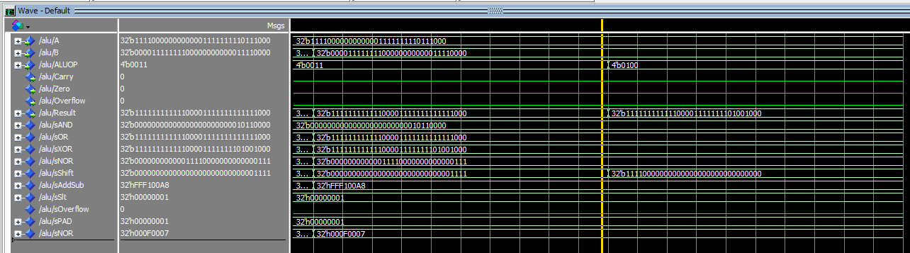
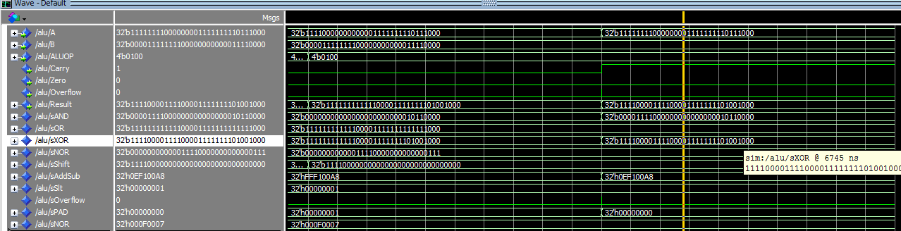
Testing NOR functionality with ALUOP set to 5 or 0101
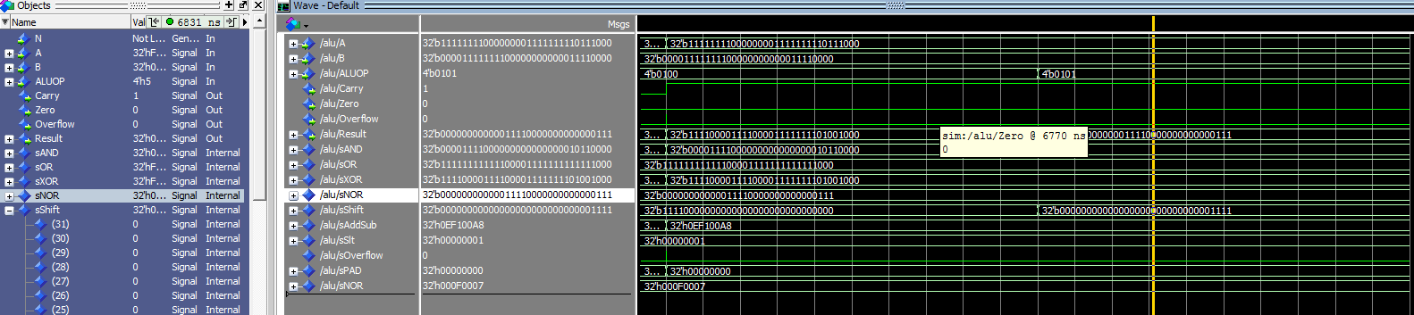
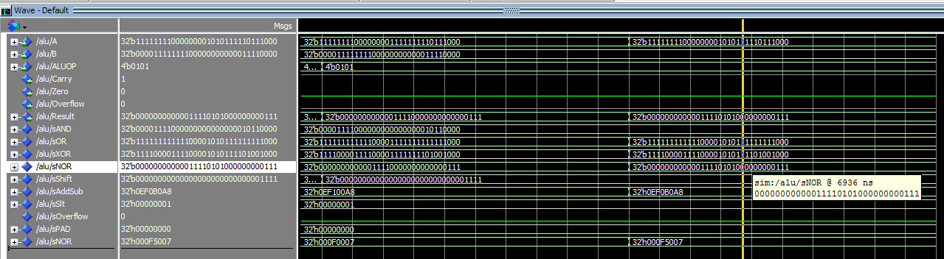

Testing subtractor with ALUOP(3)=1 to turn on subtractor and ALUOP(0)=1 to get result = add/sub signal
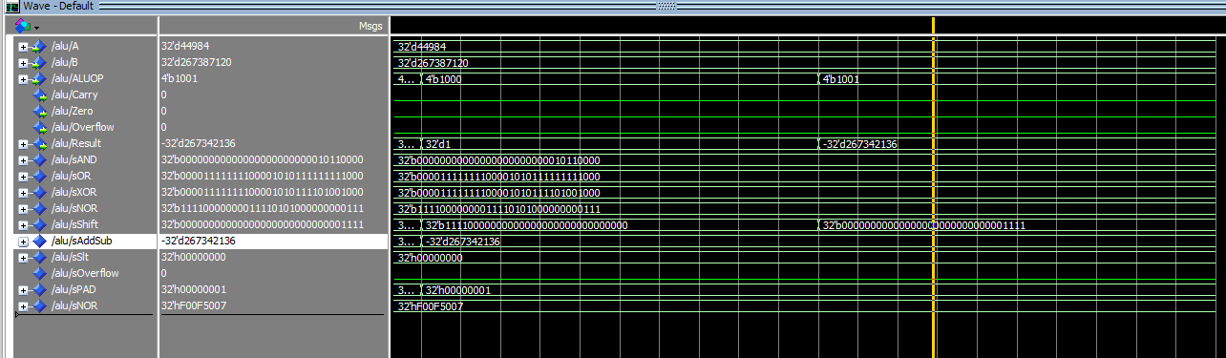
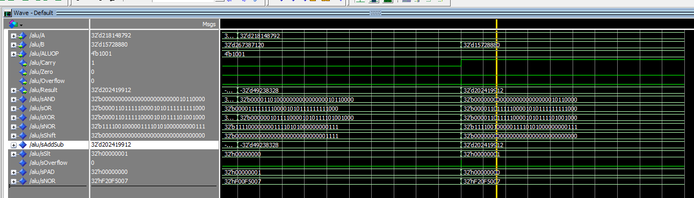
Testing adder with ALUOP(3)=0 and ALUOP(0) remains at zero
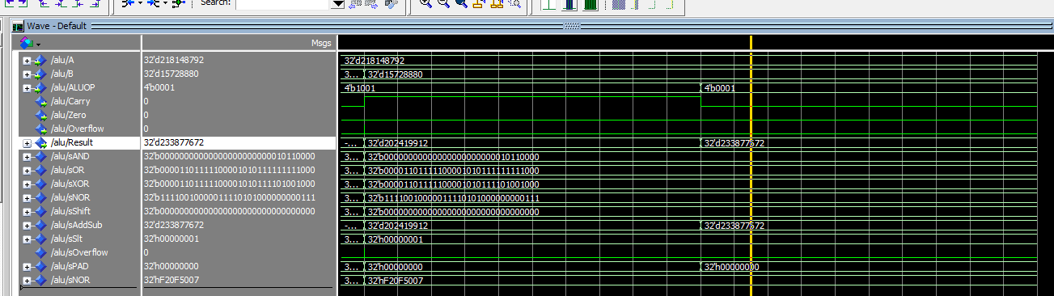
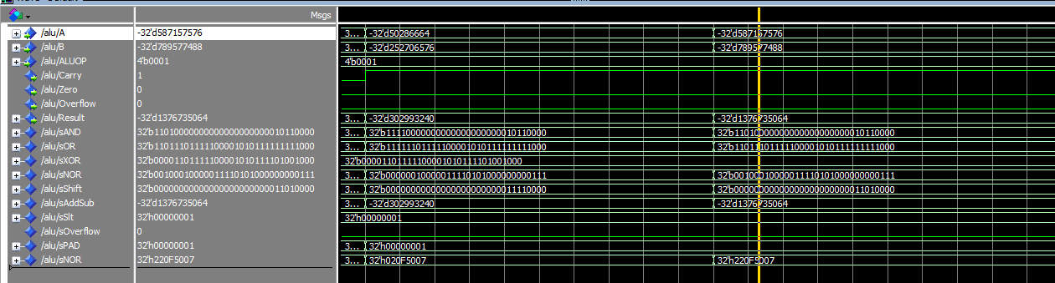
Test slt by setting ALUOP to 6 or 0110
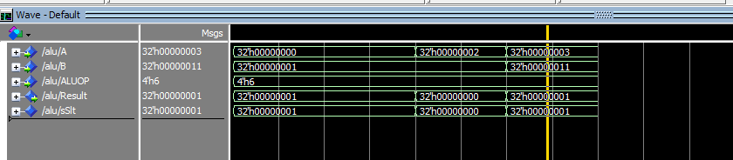

- [Part 3(b)] justify why your test plan is comprehensive. Include waveforms that demonstrate your test programs functioning.

- [Feedback] You must complete this section for your lab to be graded. This will be turned in INDIVIDUALLY in a separate assignment called “Proj 1 Feedback”. Write down the first response you think of; I expect it to take roughly 5 minutes (do not take more than 10 minutes).

1. How many hours did you spend on this lab?

Task | During lab time | Outside of lab time
Reading lab
Pencil/paper design
VHDL design
Assembly coding
Simulation
Debugging
Report writing
Other:
Total

- What fraction of the above time did you spend working with your partner (either in a lab or remotely)?

- If you could change one thing about the lab experience, what would it be? Why?

- What was the most interesting part of the lab?

