**Державний вищий навчальний заклад  
Ужгородський національний університет  
Факультет інформаційних технологій**

**ЛАБОРАТОРНА РОБОТА № 20**

**Тема**:  Побудова анімаційних зображень.

Виконав студент 1 курсу

ІПЗ

Кушнірук Артем

Ужгород – 2018

**Мета**:

Вивчення і застосування методів побудови рухомих графічних об'єктів.

**Завдання до роботи:**

У Windows-додатку, складеному в лабораторній роботі №19, на головній формі додати кнопку «Рух об’єкта», при натисненні на яку здійснити переміщення одного з графічних елементів малюнку за траєкторією: від поточного місця до правого нижнього кута вікна.

Код:

using System;

using System.Collections.Generic;

using System.ComponentModel;

using System.Data;

using System.Drawing;

using System.Linq;

using System.Text;

using System.Threading.Tasks;

using System.Windows.Forms;

namespace Lab19

{

public partial class Form1 : Form

{

Parametrs Param = new Parametrs(1200, 700);

public Form1()

{

InitializeComponent();

button4.Visible = false;

radioButton1.Select();

timer1.Interval = 15;

}

public class Parametrs

{

public Pen newPen = null;

public Color StandartColor = Color.White;

public Bitmap bmp = null;

public Graphics graph = null;

public int boxWidth;

public int boxHeight;

public Parametrs(int Width, int Height)

{

boxWidth = Width;

boxHeight = Height;

bmp = new Bitmap(Width, Height);

graph = Graphics.FromImage(bmp);

}

public void SetPenCollor(string color)

{

switch (color)

{

case "Black":

newPen = new Pen(Color.Black, 3);

break;

case "Blue":

color = "Blue";

newPen = new Pen(Color.Blue, 3);

break;

case "Green":

color = "Green";

newPen = new Pen(Color.Green, 3);

break;

}

}

}

private void button3_Click(object sender, EventArgs e)

{

Application.Exit();

}

int pp = 0;

private void button1_Click(object sender, EventArgs e)

{

Draw(pp++, 0);

}

private void Draw(int WayX, int WayY)

{

Bitmap bmp = Param.bmp;

Graphics graph = Param.graph;

graph.Clear(Color.White);

//антена

Point point1 = new Point(225+WayX, 25+WayY);

Point point2 = new Point(225+WayX, 70+WayY);

Point point7 = new Point(220+WayX, 20+WayY);

Point point8 = new Point(230+WayX, 30+WayY);

Point point9 = new Point(220+WayX, 30+WayY);

Point point10 = new Point(230+WayX, 20+WayY);

//голова

int x4 = 150;

int y4 = 70;

int width4 = 150;

int height4 = 130;

//ліве око

Point point11 = new Point(270+WayX, 110+WayY);

Point point12 = new Point(250+WayX, 110+WayY);

Point point15 = new Point(270+WayX, 130+WayY);

Point point16 = new Point(250+WayX, 130+WayY);

//праве око

Point point13 = new Point(180+WayX, 110+WayY);

Point point14 = new Point(200+WayX, 110+WayY);

Point point17 = new Point(180+WayX, 130+WayY);

Point point18 = new Point(200+WayX, 130+WayY);

//рот

Point point19 = new Point(200+WayX, 170+WayY);

Point point20 = new Point(250+WayX, 160+WayY);

Point point21 = new Point(200+WayX, 160+WayY);

Point point22 = new Point(250+WayX, 170+WayY);

Point[] curvePoints =

{

point1,

point2

};

Point[] curve2Points =

{

point7,

point8,

point10,

point9,

};

Point[] curve3Points =

{

point13,

point14,

point18,

point17,

};

Point[] curve4Points =

{

point11,

point12,

point16,

point15,

};

Point[] curve5Points =

{

point19,

point21,

point20,

point22,

};

//круги

int x = 125;

int y = 200;

int width = 200;

int height = 200;

int x1 = 155;

int y1 = 250;

int width1 = 100;

int height1 = 100;

Rectangle rect = new Rectangle(200+WayX, 200+WayY, 140, 169);

float startAngle = 59.0F;

float sweepAngle = 199.0F;

//очі

int x2 = 258;

int y2 = 118;

int width2 = 5;

int height2 = 5;

int x3 = 188;

int y3 = 118;

int width3 = 5;

int height3 = 5;

Param.graph.DrawArc(Param.newPen, rect, startAngle, sweepAngle);

Param.graph.DrawEllipse(Param.newPen, x + WayX, y + WayY, width, height);

Param.graph.DrawEllipse(Param.newPen, x1+WayX, y1+WayY, width1, height1);

Param.graph.DrawEllipse(Param.newPen, x2+WayX, y2+WayY, width2, height2);

Param.graph.DrawEllipse(Param.newPen, x3+ WayX, y3+WayY, width3, height3);

Param.graph.DrawEllipse(Param.newPen, x4+WayX, y4+WayY, width4, height4);

Param.graph.DrawPolygon(Param.newPen, curvePoints);

Param.graph.DrawPolygon(Param.newPen, curve2Points);

Param.graph.DrawPolygon(Param.newPen, curve3Points);

Param.graph.DrawPolygon(Param.newPen, curve4Points);

Param.graph.DrawPolygon(Param.newPen, curve5Points);

Param.graph.DrawString("Це робот R2-D2", new Font("Times New Roman", 20), new SolidBrush(Color.Black), 0, 0);

pictureBox1.Image = bmp;

}

private void radioButton1_CheckedChanged(object sender, EventArgs e)

{

Param.SetPenCollor("Black");

}

private void radioButton2_CheckedChanged(object sender, EventArgs e)

{

Param.SetPenCollor("Blue");

}

private void radioButton3_CheckedChanged(object sender, EventArgs e)

{

Param.SetPenCollor("Green");

}

private void button2_Click(object sender, EventArgs e)

{

pictureBox1.Image = null;

}

private void button4_Click(object sender, EventArgs e)

{

timer1.Enabled = true;

}

int x, y = 0;

private void checkBox1_CheckedChanged_1(object sender, EventArgs e)

{

if (checkBox1.CheckState == CheckState.Checked)

{

button4.Visible = true;

}

else

{

button4.Visible = false;

}

}

private void timer1_Tick(object sender, EventArgs e)

{

if (x < Param.boxWidth)

{

if (x <= 250)

{

Draw(x, x);

x++;

}

else

{

x = 0;

timer1.Stop();

}

}

else

{

x = 0;

timer1.Stop();

}

}

}

}

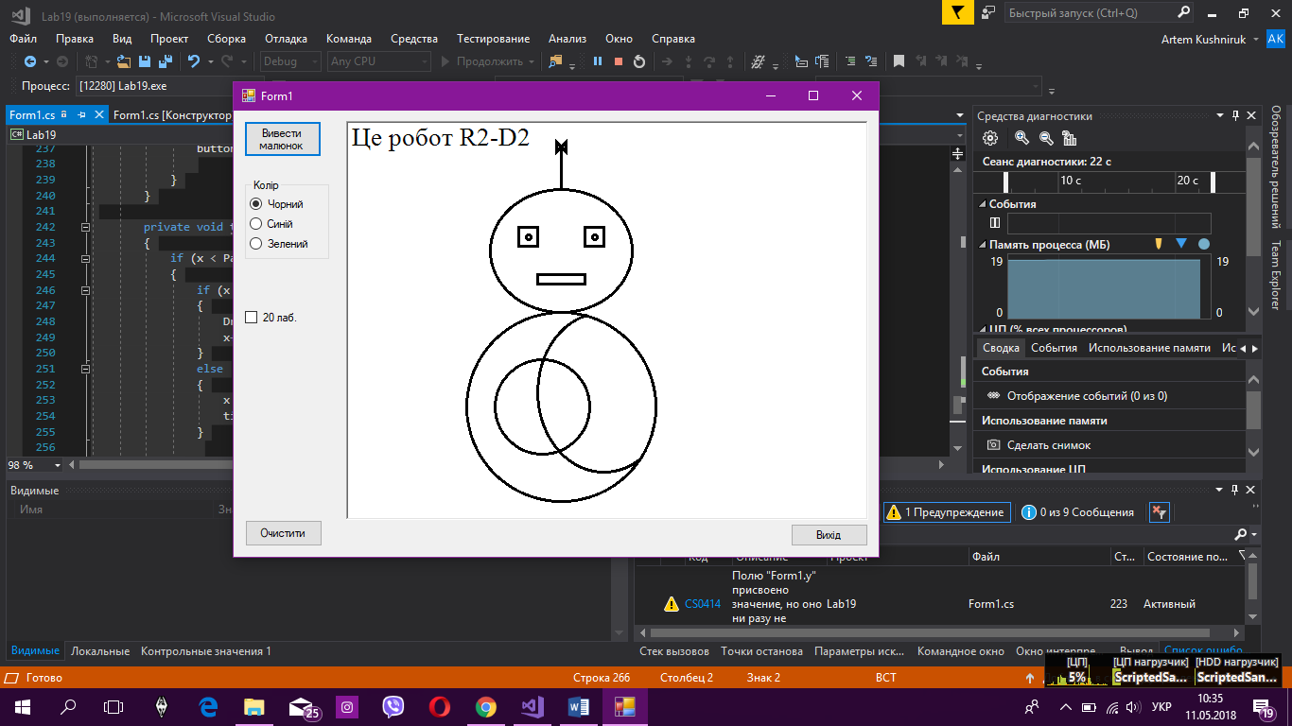

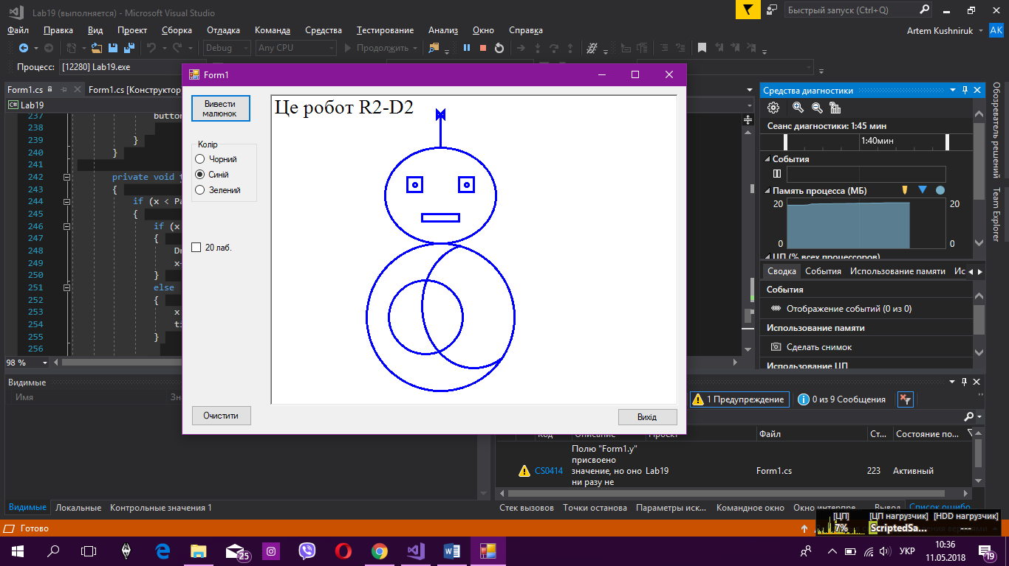

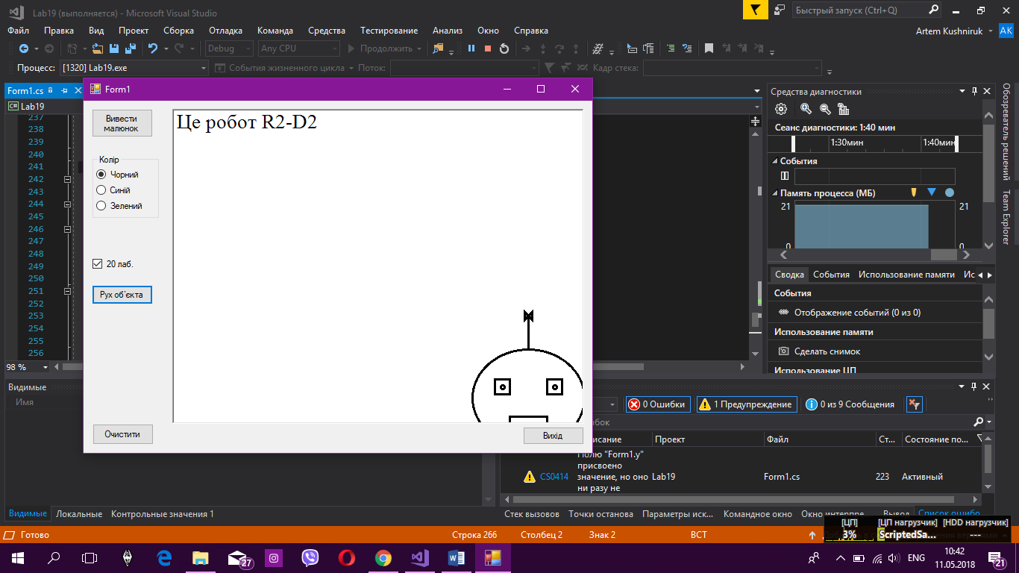

Висновок: на цій лабараторній роботі я навчився переміщати об’єкти по формі.