



**<<BIRD SERVICE PLATFORM>>**

**Software Requirement Specification**

– HoChiMinh, November 2023 –

**Table of Contents**

Record of Changes 4

Definition and Acronyms 5

I. Introduction 6

1. Product Background 6

2. Business Opportunity 6

3. Software Product Vision 6

4. Major Features 7

5. Limitations and Exclusions 7

II. Overall Description 8

1. Product Overview 8

2. Business Process 9

III. User Requirements 10

1. Actors 10

2. Use Cases 10

2.1 Diagram 10

2.2 Descriptions 11

3. Business Rules 14

IV. Functional Requirements 15

1. System Functional Overview 15

1.1 Screen Flow 15

1.2 Screen Descriptions 15

1.3 Screen Authorization 15

1.4 Non-Screen Functions 16

2. Data Requirements 16

2.1 Logical Data Model 16

2.2 Data Dictionary 17

2.3 Reports 19

2.4 State transition diagram 20

3. <<Feature Name 1>> 20

3.1 <<Function Name 1>> 20

3.2 <<Function Name 2>> 21

4. <<Feature Name 2>> 21

V. Non-Functional Requirements 22

1. External Interface Requirements 22

1.1 User Interfaces 22

1.2 Software Interfaces 22

1.3 Hardware Interfaces 23

1.4 Communications Interfaces 24

2. Quality Attributes 24

2.1 Usability 24

2.2 Performance 24

2.3 Security 25

2.4 Safety 25

# 2.5 Availability 25

2.6 Reliability 26

2.7 Design Contrainsts 26

2.8 [Others as relevant] 26

# Record of Changes

|  |  |  |  |
| --- | --- | --- | --- |
| Date | A* M, D | In charge | Change Description |
|  |  |  |  |
|  |  |  |  |
|  |  |  |  |
|  |  |  |  |
|  |  |  |  |
|  |  |  |  |
|  |  |  |  |
|  |  |  |  |
|  |  |  |  |
|  |  |  |  |
|  |  |  |  |
|  |  |  |  |
|  |  |  |  |

*A - Added M - Modified D - Deleted

# Definition and Acronyms

*[Fill all the definitions, acronyms,… used within the document] in the table format as below]*

|  |  |
| --- | --- |
| **Acronym** | **Definition** |
| PWM | Psychology website |
| AWS | Amazon Web Services |
| BA | Business Analysis |
| BR | Business Rule |
| ERD | Entity Relationship Diagram |
| GUI | Graphical User Interface |
| PM | Project Manager |
| SDD | Software Design Description |
| SPMP | Software Project Management Plan |
| SRS | Software Requirement Specification |
| UAT | User Acceptance Test |
| UC | Use Case |
| API | Application Program Interface |

# I.Introduction

## 1.Product Background

Are you a bird lover looking for the best resources and assistance in your bird-keeping journey? Look no further; our Bird Service Platform is designed to provide you with a comprehensive range of benefits and support to enhance your experience as a bird enthusiast. With our Bird Service, you gain access to a diverse selection of bird species from around the world. Bird Service streamlines the process for you. We provide a centralized platform where you can easily search for birds, access detailed information about each species, and connect with reputable bird sellers. When it comes to the well-being of your feathered friends, we prioritize their health and safety. We work closely with trusted breeders and sellers who adhere to ethical practices, ensuring that you receive healthy and well-cared-for birds. Additionally, our Bird Service fosters a vibrant community of bird enthusiasts. Through our online forums and chat groups, you can connect with like-minded individuals, share experiences, and exchange valuable knowledge and advice.

## 2.Business Opporturnity

**Business Opportunity: Bird Service Platform**

Many bird owners and service providers in the pet bird industry have expressed a need for a comprehensive platform that connects bird owners seeking various pet bird services with qualified service providers. This platform would facilitate the management of bird-related services, such as bird care, cage repair, and more, streamlining the entire process from order placement to service completion.

Opportunity Rationale:

Efficiency and Convenience for Bird Owners: The platform will allow bird owners to easily order a range of services for their feathered companions. This online system will save them time and ensure they receive the specific services they desire, enhancing overall satisfaction.

Monetization Opportunities: The platform can generate revenue through service fees, subscription plans for service providers, and premium features.

Scalability: As the platform gains popularity, it can expand to serve a broader geographical area and potentially branch out into other pet-related services, increasing its market reach and revenue potential.

Responsible Pet Ownership: Promoting ethical and responsible pet ownership within the bird community is a valuable aspect of this opportunity. The platform can encourage education and conservation efforts related to birds.

## 3. Software product vision

The vision of this software product is to create efficient and convenient system connections and service management for both bird owners and service providers. Here are some important elements of this vision:

For bird owners and bird service providers, this product is a software system that meets their diverse needs. The system connects bird owners with bird service providers and facilitates the implementation of services.

-Service providers can manage bird services on the platform, from receiving orders until they are completed. They are able to manage service processes more effectively than ever before.

-Customers can easily set up services through the platform, view a history of previous services, and provide feedback and reports on the services they have used.

-The system also manages accounts and general categories easily, helping to ensure accuracy and ease in managing information related to birds, services and account access.

-Finally, the dashboard provides product and reporting lists to assist platform management and service providers in tracking performance, earnings, and related activities. This vision aims to create an easy, efficient and smart environment for both bird owners and bird service providers.

## 4.Major Features

The Bird Service Platform is developed with a range of essential features to meet the needs of different user groups: Guest, Customer, Provider, and Admin. More details about the key features are as follows:

### 4.1. Connecting Bird Owners and Service Providers:

* **FE-01 Booking Bird Services:** Customers can easily book specific services such as healthcare, cage repair, cleaning, and more through a user-friendly interface.

* **FE-02 Finding Service Providers:** Customers can search and compare service providers based on location, community ratings, and pricing, allowing them to choose the most suitable services for their birds.

* **FE-03 Rating and Reviewing:** Customers have the ability to rate and provide reviews about their service experience after completing an order, enabling community-based feedback on the quality of service providers.

### 4.2. Order Management for Service Providers:

* **FE-04 Order Management:** Service providers can view and manage the entire process from order reception to completion. They can accept, reject, or easily schedule tasks while keeping track of the progress.

* **FE-05 Order Status:** The system allows service providers to monitor the work progress and provide notifications to customers about timeframes and expected dates, ensuring transparency and trust.

* **FE-06 Smart Scheduling:** The system supports intelligent scheduling, optimizing time and resources for service providers to deliver services efficiently.

### 4.3. Customer-Centric Features:

* **FE-07 View Service History:** Customers can track their booking history and usage, including information about received services, dates and times, and current status.

* **FE-08 Feedback and Reporting:** The system enables customers to easily provide feedback on their experiences and report any issues encountered during service usage.

### 4.4. System Management:

* **FE-09 Account Management:** Admin has the authority to manage access accounts, including creating, deactivating, or deleting customer and service provider accounts to ensure data security and easy account management.

* **FE-10 Category Management:** Admin can manage the categories of services and products offered on the platform, allowing for flexible addition, editing, or removal of service types.

* **FE-11 Security and Privacy:** The system ensures the security of personal information and critical data of users while complying with privacy regulations.

**4.5. Dashboard and Analytics:**

* **FE-12 Provider Dashboard:** A user-friendly interface for service providers allows them to monitor order statuses, track revenue statistics, and efficiently manage their service listings.

* **FE-13 Admin Dashboard:** Admin can monitor and review the overall platform activities, providing comprehensive reports and statistical data to support platform management and service providers in monitoring and improving performance.

These features collectively create a comprehensive platform, facilitating smart and efficient connections between bird owners and service providers, enhancing the bird service experience for all stakeholders involved.

## 5. Limitations and exclusions

Limitations and exclusions of bird care, cage repair, and other bird-related services may include the following terms and situations:

1. Restrictions on service types: Some services may be limited to care or cage repair for specific bird species or in specific situations. For example, a service may not provide care for rare bird species or a cage repair service that only applies to small-sized cages.

2. Area limitations: The service may limit the cage area or not take care of cages with too large an area. This may depend on the service's resources and facilities.

3. Exclusion of liability for pre-existing health problems: The Service may exclude liability for pre-existing health problems of birds before they are delivered to the service. This may apply to other medical conditions or health problems the bird may have.

4. Bird damage exclusion: The Service may not be liable for damage caused by the actions or interference of birds in the care or repair of the cage.

5. Service Term and Termination: The Service may establish specific deadlines for cage care or repair and reserves the right to terminate service if these terms are not followed.

6. Commitment to information security: The service may propose a commitment to protect information related to customers and other personal information provided during the service process.

7. Exclusion of liability for loss or accident: The services may exclude liability for loss or accident which may occur during the transport of birds to or from the service.

**Reference source:**

[**https://longchimcham.com/**](https://longchimcham.com/)

[**https://www.chotot.com/mua-ban-chim**](https://www.chotot.com/mua-ban-chim)

[**https://www.chotot.com/tags/mua-ban-phu-kien-thuc-an-dich-vu/long-chim**](https://www.chotot.com/tags/mua-ban-phu-kien-thuc-an-dich-vu/long-chim)

[**Bird's Boarding Services - Pet Boarding and Pet Sitting, Birds Sitting Services, Birds Boarding Services**](https://birdsboardingservices.com/)

[Bird Vet - Bird Friendly Hospital and Staff.-Bird Vet Melbourne (bird-vet.com)](https://www.bird-vet.com/)

# II. Overall Description

## 1. Product Overview

**Contents part 1:**

-High level overview: The pet bird service booking application is a software system that connects bird owners who need pet bird services and service providers. This system allows users to set up various pet bird services, such as caring for, fixing cages, training, and selling birds.

-Use the environment: The goods service alert setting application is designed for use in web and mobile environments. It is accessible on any device with an internet connection.

**User**

-Users of the bird service booking application include:

* Bird owners need to alert service birds
* Service alert provider
* Administrator system
* Forced, assumed and known dependencies

**Known requirements, assumptions, and dependencies for applications that set row service alert groups:**

* System will be used in web and mobile environments.
* The system will support the following types of pet bird services: care, cage repair, training and selling birds.
* The system will be used by bird owners and service alert providers.

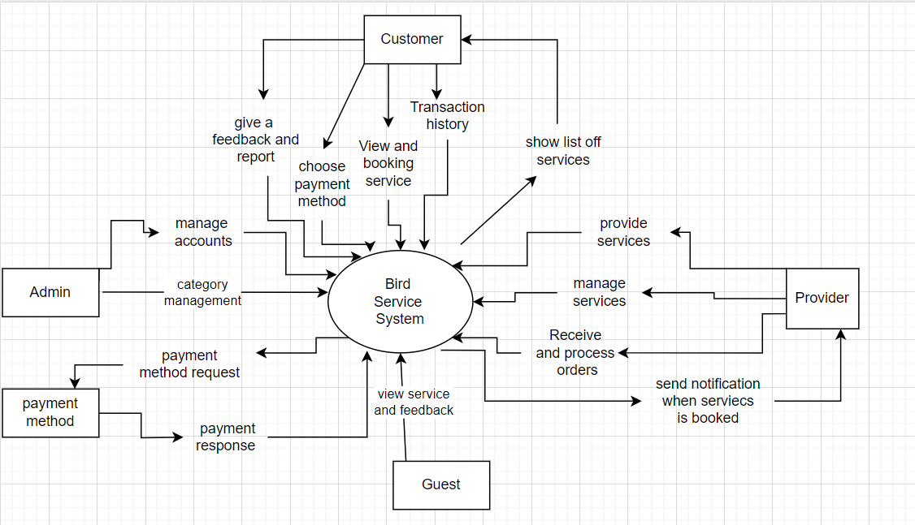

## 2. Business Process

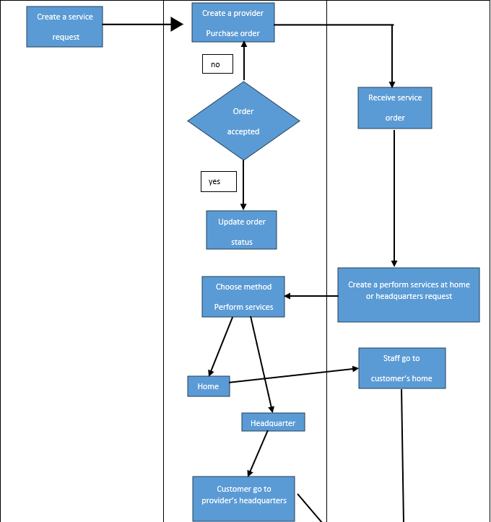

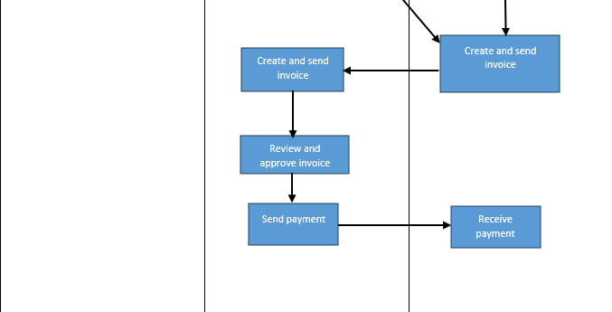

|  |  |  |
| --- | --- | --- |
| **#** | **Process Step** | **Description** |
| 1 | Create a bird service request | User choose service and submit |
| 2 | Create a provider purchase order | Send order to provider |
| 3 | Receive service order | provider receive order request |
| 4 | Update status order | If the provider accept the order, update the order status and ask user  to choose a method to perform service. |
| 5 | Service perform | If user choose to perform service at home:provider send staff to user home and complete the order  If user choose to perform service at headquarters: user can send order to the headquarter to complete the order |
| 6 | Create and send invoice | After the user selects the service, the provider assesses the service and prints the invoice and sends it to the user. |
| 7 | User review and approve invoice | User receive and verification invoice through email |
| 8 | User send payment | User confirmed and sent payment back to the provider |
| 9 | Provider receive payment | Supplier receives invoices and maintains related documents. |

# III. User Requirements

## 1. Actors

|  |  |  |
| --- | --- | --- |
| **#** | **Actor** | **Description** |
| 1 | Provider | The Service Provider is an individual or a company that offers bird-related services, such as bird watching tours, bird photography workshops, bird breeding consultations, or bird care services. They are registered on the Bird Service Platform and provide their expertise and services to the platform users. |
| 2 | Customer | The Platform User is an individual or organization that utilizes the Bird Service Platform to access bird-related services. They can be bird enthusiasts, researchers, photographers, or anyone interested in avian activities. Platform users can search for available services, make bookings, communicate with service providers, and provide feedback on the services received |
| 3 | Administrator | The Administrator is responsible for managing and maintaining the Bird Service Platform. They oversee the registration process for service providers, ensure the quality and accuracy of the services listed on the platform, handle user inquiries and complaints, and perform administrative tasks related to the smooth functioning of the platform. |
| 4 | Guest | A Guest refers to a user who is visiting the Bird Service Platform without being authenticated or logged in. Guests typically have limited access to certain features and functionalities compared to Authen Users. They can browse through available services, view general information, and get a glimpse of what the platform offers. However, guests may not be able to make bookings, communicate with service providers, or access personalized features until they create an account or log in as an Authen User |
| 5 | Authen User | An Authen User refers to an authenticated user on the Bird Service Platform. This means that they have successfully gone through the authentication process and have provided valid credentials to access the platform. Authen Users have the ability to log in to their accounts, access personalized features, and utilize the full functionality of the platform. |

## 2. Use Cases

### 2.1 Diagram

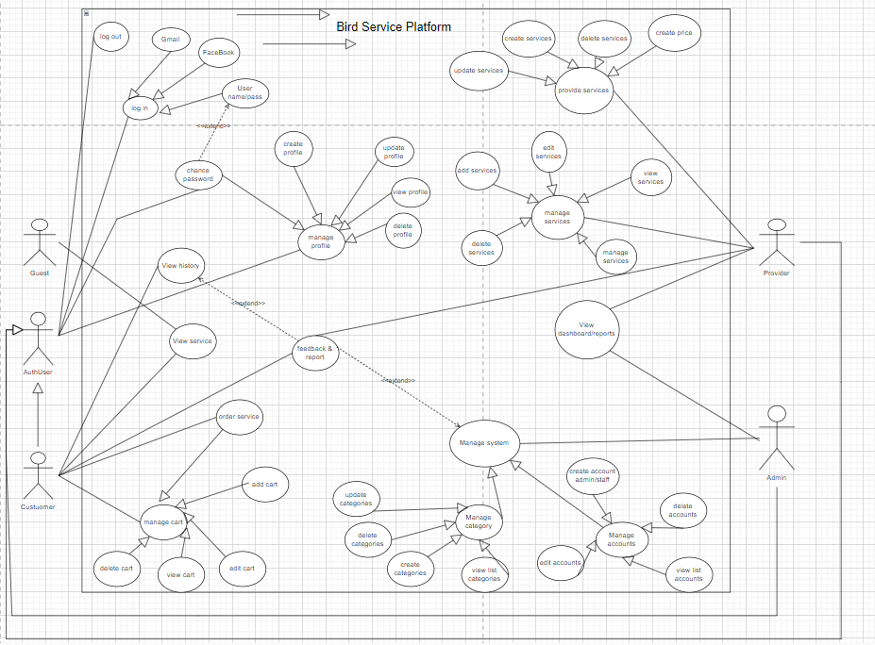

### 2.2 Descriptions

|  |  |  |  |
| --- | --- | --- | --- |
| **ID** | **Use Case** | **Actors** | **Use Case Description** |
| UC-01 | **Add carts** | Customer | This function allows customers to add products they want to purchase to their virtual shopping cart on the website. This is a crucial feature for any e-commerce platform as it enables customers to manage their desired purchases before making a final decision. |
| UC-02 | Edit cart | Customer | This function allows customers to manage their virtual shopping cart on the website. Customers can modify the quantity of a product, remove a product, or even clear the entire cart. This feature provides customers with flexibility and control over their potential purchases, enhancing their shopping experience. |
| UC-03 | **View Cart** | Customer | This function allows customers to view the contents of their virtual shopping cart on the website. Customers can see a list of products they have added to the cart, along with the quantity of each product, the price of each product, and the total price of the cart. |
| UC-04 | Delete Cart | Customer | This function allows customers to delete their virtual shopping cart on the website. Customers can choose to remove all products from their cart at once, effectively deleting the cart. |
| UC-05 | View History Usage | Customer | This function allows customers to view their past usage history on the website. The usage history could include actions such as products viewed, added to cart, purchased, etc. |
| UC-06 | **View dashboard & reports** | Admin, Provider | This function allows admins and providers to view the dashboard and reports on the website. The dashboard and reports could include information such as sales statistics, user activity, product popularity |
| UC-07 | **login** | Admin, Provider, Customer | This function allows Admins, Providers, and Customers to log into their accounts on the website using their registered username and password. |
| UC-08 | **logout** | Admin, Provider, Customer | This function allows Admins, Providers, and Customers to log out of their accounts on the website. |
| UC-09 | **Feedback & Reports** | Customer, Admin, Provider | Customers leave their comments after using the service so that admins and providers can improve their services and systems. |
| UC- 10 | **Order** | Customer | Customer ordering service and manager shopping cart on platform |
| UC-  11 | **Update services** | Provider | This use case involves the process of updating software to the latest available version. |
| UC-  12 | **Create services** | provider | This use case involves a service provider creating and offering a new service within the Bird Service Platform. |
| UC-  13 | **Delete services** | provider | This use case involves a service provider removing or discontinuing a service from the Bird Service Platform. |
| UC-  14 | **View services** | provider | This use case involves a user accessing and browsing services available on the Bird Service Platform. |
| UC-  15 | **Edit services** | provider | This use case involves a service provider modifying or updating details of a service listed on the Bird Service Platform. |
| UC-  UC-16 | **View categories** | Admin | This use case involves a service provider establishing or modifying the pricing structure for a service listed on the Bird Service Platform. |
| UC-17 | **Update categories** | Admin | This use case Admin want to update categories |
| UC-18 | **Delete categories** | Admin | This use case Amin want to delete categories |
| UC-19 | **Create Categories** | Admin | This use case Amin want to create new categories |
| UC-20 | **Create categories** | Admin | This use case Admin want to create new categories |
| UC-21 | **Create account** | Admin | This use case Admin want to create new account |
| UC-22 | Edit accounts | Admin | This use case Amin want to edit account |
| UC-23 | View list accounts | Admin | This use case Amin want to view account |
| UC-24 | Delete accounts | Admin | This use case Amin want to remove account |

|  |  |  |  |
| --- | --- | --- | --- |
| ID and Name: | **UC-01 - Add Carts** | | |
| Created By: | Nguyen Vo Anh Kiet | Date Created: | 2/10/2023 |
| Primary Actor: | Customer | Secondary Actors: | None |
| Description: | This function allows customers to add products they want to purchase to their virtual shopping cart on the website. This is a crucial feature for any e-commerce platform as it enables customers to manage their desired purchases before making a final decision. | | |
| Trigger: | The customer clicks on the “Add to Cart” button on the product detail page. This button is typically located next to the product image and price, providing an intuitive and user-friendly shopping experience. | | |
| Preconditions: | The customer has viewed the product details. This includes information such as the product image, price, description, and reviews. The customer must also be logged into their account on the website. | | |
| Postconditions: | The product is added to the customer’s shopping cart. The shopping cart icon, usually located at the top right corner of the website, is updated to reflect the new item count. | | |
| Normal Flow: | 1. The customer views the product details. 2. The customer selects the desired quantity and clicks on the “Add to Cart” button. 3. The system confirms the action and adds the product to the cart. This is usually accompanied by a brief animation or a pop-up message. 4. The system displays a success notification and updates the quantity of products in the shopping cart. The customer can choose to continue shopping or proceed to checkout. | | |
| Alternative Flows: | If the product is out of stock, the system will notify the customer and not add the product to the cart. The “Add to Cart” button may be replaced with an “Out of Stock” message. | | |
| Exceptions: | 1. **Product Availability Error**: If the product is no longer available or out of stock when the customer tries to add it to the cart, the system will display an error message. 2. **Quantity Error**: If the customer tries to add a quantity of the product that exceeds the available stock, the system will display an error message. 3. **Session Timeout**: If the customer’s session times out due to inactivity while they’re adding a product to the cart, the system will display a message asking them to log in again. 4. **Website Maintenance or Downtime**: If the website is down for maintenance or experiencing technical issues, the customer might not be able to add products to their cart. The system will display a message informing the customer of the issue and the estimated time of resolution. 5. **Network Issues**: If the customer’s internet connection is unstable or slow, it might take longer to add the product to the cart, or the request might even time out. The system will display a message asking the customer to check their internet connection. 6. **Unexpected Errors**: For any unexpected errors or exceptions not covered above, the system will display a generic error message and may provide an error code for further troubleshooting or support. | | |
| Priority: | High | | |
| Business Rules: | BR-01, BR-02, BR-11, BR-12, BR-46 | | |
| Other Information: | None | | |

|  |  |  |  |
| --- | --- | --- | --- |
| ID and Name: | **UC-02 - Edit Carts** | | |
| Created By: | Nguyen Vo Anh Kiet | Date Created: | 2/10/2023 |
| Primary Actor: | Customer | Secondary Actors: | none |
| Description: | This function allows customers to manage their virtual shopping cart on the website. Customers can modify the quantity of a product, remove a product, or even clear the entire cart. This feature provides customers with flexibility and control over their potential purchases, enhancing their shopping experience. | | |
| Trigger: | The customer navigates to their shopping cart, either by clicking on the cart icon usually located at the top right corner of the website or by selecting the option from a dropdown menu. Once in the cart, the customer can choose to edit the contents. | | |
| Preconditions: | The customer’s shopping cart contains at least one product. The customer must also be logged into their account on the website. | | |
| Postconditions: | The changes made by the customer are saved, and the shopping cart is updated to reflect these changes. The total price of the cart is recalculated if necessary. | | |
| Normal Flow: | 1. The customer navigates to their shopping cart. 2. The customer changes the quantity of a product using a dropdown menu or input field next to the product. Alternatively, the customer can remove a product by clicking on a “Remove” button or icon next to the product. 3. The system validates the changes. If the new quantity exceeds the available stock, the system notifies the customer and does not proceed with the update. 4. If the changes are valid, the system updates the cart, recalculates the total price, and displays a success message. The updated cart is displayed to the customer. | | |
| Alternative Flows: | If the customer wants to remove all products from the cart, they can click on a “Clear Cart” button. The system will ask for confirmation before clearing the cart. | | |
| Exceptions: | 1. **Product Information Error**: If there’s an error retrieving the information of a product in the cart (for example, the product has been removed from the database), the system will display an error message. 2. **Quantity Error**: If the customer tries to change the quantity of a product in the cart that exceeds the available stock, the system will display an error message. 3. **Session Timeout**: If the customer’s session times out due to inactivity while they’re editing the cart, the system will display a message asking them to log in again. 4. **Website Maintenance or Downtime**: If the website is down for maintenance or experiencing technical issues, the customer might not be able to edit their cart. The system will display a message informing the customer of the issue and the estimated time of resolution. 5. **Network Issues**: If the customer’s internet connection is unstable or slow, it might take longer to update the cart, or the request might even time out. The system will display a message asking the customer to check their internet connection. 6. **Unexpected Errors**: For any unexpected errors or exceptions not covered above, the system will display a generic error message and may provide an error code for further troubleshooting or support. | | |
| Priority: | High | | |
| Business Rules: | BR-01, BR-02, BR-11, BR-12, BR-13, BR-51 | | |
| Other Information: | None | | |

|  |  |  |  |
| --- | --- | --- | --- |
| ID and Name: | **UC-03 - View Carts** | | |
| Created By: | Nguyen Vo Anh Kiet | Date Created: | 2/10/2023 |
| Primary Actor: | Customer | Secondary Actor: | None |
| Description: | This function allows customers to view the contents of their virtual shopping cart on the website. Customers can see a list of products they have added to the cart, along with the quantity of each product, the price of each product, and the total price of the cart. | | |
| Trigger: | The customer clicks on the cart icon, usually located at the top right corner of the website, or selects the option from a dropdown menu. | | |
| Preconditions: | The customer has added at least one product to their shopping cart. The customer must also be logged into their account on the website. | | |
| Postconditions: | The customer views the contents of their shopping cart, including the list of products, the quantity of each product, and the total price of the cart. | | |
| Normal Flow: | 1. The customer navigates to their shopping cart. 2. The system displays the contents of the cart, including a list of products, the quantity of each product, the price of each product, and the total price of the cart. | | |
| Alternative Flows: | none | | |
| Exceptions: | 1. **Product Information Error**: If there’s an error retrieving the information of a product in the cart (for example, the product has been removed from the database), the system will display an error message to the customer. 2. **Session Timeout**: If the customer’s session times out due to inactivity while they’re viewing the cart, the system will display a message asking them to log in again. 3. **Cart Synchronization Error**: If the customer is shopping on multiple devices and makes changes to their cart on one device, there might be a delay in synchronizing the cart contents across all devices. The system will display a message informing the customer to refresh their cart. 4. **Website Maintenance or Downtime**: If the website is down for maintenance or experiencing technical issues, the customer might not be able to view their cart. The system will display a message informing the customer of the issue and the estimated time of resolution. 5. **Browser Compatibility Issues**: If the customer is using an outdated or unsupported browser, some features of the cart might not work properly. The system will display a message suggesting the customer to update their browser or switch to a supported one. 6. **Network Issues**: If the customer’s internet connection is unstable or slow, it might take longer to load the cart, or the request might even time out. The system will display a message asking the customer to check their internet connection. 7. **Unexpected Errors**: For any unexpected errors or exceptions not covered above, the system will display a generic error message and may provide an error code for further troubleshooting or support. | | |
| Priority: | High | | |
| Business Rules: | BR-01, BR-02, BR-11, BR-12, BR-13, BR-51 | | |
| Other Information: | None | | |

|  |  |  |  |
| --- | --- | --- | --- |
| ID and Name: | **UC-04 - Delete Carts** | | |
| Created By: | Nguyen Vo Anh Kiet | Date Created: | 2/10/2023 |
| Primary Actor: | Customer | Secondary Actors: | None |
| Description: | This function allows customers to delete their virtual shopping cart on the website. Customers can choose to remove all products from their cart at once, effectively deleting the cart. | | |
| Trigger: | The customer clicks on the “Delete Cart” or “Clear Cart” button on the cart page. | | |
| Preconditions: | The customer’s shopping cart contains at least one product. The customer must also be logged into their account on the website. | | |
| Postconditions: | The customer’s shopping cart is empty. The total price of the cart is recalculated to zero. | | |
| Normal Flow: | 1. The customer navigates to their shopping cart. 2. The customer clicks on the “Delete Cart” or “Clear Cart” button. 3. The system asks for confirmation to ensure that the customer wants to delete the cart. 4. If the customer confirms, the system removes all products from the cart and displays a success message. | | |
| Alternative Flows: | If the customer decides not to delete the cart during the confirmation step, the system cancels the deletion process and keeps the cart intact. | | |
| Exceptions: | 1. If an error occurs while deleting the cart, such as a server error or a lost internet connection, the system will display an error message to the customer. 2. If the customer’s session times out due to inactivity while they’re deleting the cart, the system will display a message asking them to log in again. | | |
| Priority: | Medium | | |
| Business Rules: | BR-01, BR-09, BR-14 | | |
| Other Information: | None | | |

|  |  |  |  |
| --- | --- | --- | --- |
| ID and Name: | **UC-05 - View History Usage** | | |
| Created By: | Nguyen Vo Anh Kiet | Date Created: | 2/10/2023 |
| Primary Actor: | Customer | Secondary Actors: | None |
| Description: | This function allows customers to view their past usage history on the website. The usage history could include actions such as products viewed, added to cart, purchased | | |
| Trigger: | The customer navigates to their account settings and selects the “View History Usage” option. | | |
| Preconditions: | The customer must be logged into their account on the website. | | |
| Postconditions: | The customer views their past usage history. | | |
| Normal Flow: | 1. The customer navigates to their account settings. 2. The customer selects the “View History Usage” option. 3. The system retrieves and displays the customer’s usage history. | | |
| Alternative Flows: | If the customer has not performed any actions on the website, the system will display a message indicating that there is no usage history to display | | |
| Exceptions: | 1. If an error occurs while retrieving the usage history, such as a server error or a lost internet connection, the system will display an error message to the customer. 2. If the customer’s session times out due to inactivity while they’re viewing the usage history, the system will display a message asking them to log in again. | | |
| Priority: | Medium | | |
| Business Rules: | BR-01, BR-33 | | |
| Other Information: | None | | |

|  |  |  |  |
| --- | --- | --- | --- |
| ID and Name: | **UC-06 - View DashBoard&Reports** | | |
| Created By: | Phan Tan Phu | Date Created: | 2/10/2023 |
| Primary Actor: | Admin, Provider | Secondary Actors: | None |
| Description: | This function allows admins and providers to view the dashboard and reports on the website. The dashboard and reports could include information such as sales statistics, user activity, product popularity | | |
| Trigger: | The admin or provider navigates to the dashboard page on the website. | | |
| Preconditions: | The admin or provider must be logged into their account on the website. | | |
| Postconditions: | The admin or provider views the dashboard and reports. | | |
| Normal Flow: | 1. The admin or provider navigates to the dashboard page. 2. The system retrieves and displays the dashboard and reports, including sales statistics, user activity, product popularity, etc. | | |
| Alternative Flows: | 1. If the admin or provider selects a specific report from a list or dropdown menu, the system will display that report. 2. If the admin or provider applies filters or sorts the data in the reports, the system will update the display accordingly. | | |
| Exceptions: | 1. If an error occurs while retrieving the dashboard or reports, such as a server error or a lost internet connection, the system will display an error message to the admin or provider. 2. If the admin’s or provider’s session times out due to inactivity while they’re viewing the dashboard or reports, the system will display a message asking them to log in again. | | |
| Priority: | High | | |
| Business Rules: | BR-01, BR-33, BR-36 | | |
| Other Information: | None | | |

|  |  |  |  |
| --- | --- | --- | --- |
| ID and Name: | **UC-07 - Login** | | |
| Created By: | Phan Tan Phu | Date Created: | 2/10/2023 |
| Primary Actor: | Admin, Provider, Customer | Secondary Actors: | None |
| Description: | This function allows Admins, Providers, and Customers to log into their accounts on the website using their registered username and password | | |
| Trigger: | The actor selects the “Login” option on the website. | | |
| Preconditions: | The actor has a registered account on the website. | | |
| Postconditions: | The actor is logged into their account and can access features and information relevant to their role. | | |
| Normal Flow: | 1. The actor selects the “Login” option. 2. The actor enters their registered username and password. 3. The system validates the entered credentials. 4. If the credentials are valid, the system logs the actor into their account and redirects them to the homepage or dashboard. | | |
| Alternative Flows: | If the actor enters invalid credentials, the system displays an error message and prompts the actor to try again. | | |
| Exceptions: | 1. If the actor’s account is locked due to too many failed login attempts, the system will display a message informing them of the account lock and the process to unlock it. 2. If there’s a system error or network issue during the login process, the system will display an error message. | | |
| Priority: | High | | |
| Business Rules: | BR-01,  BR-06,BR-32 | | |
| Other Information: | None | | |

|  |  |  |  |
| --- | --- | --- | --- |
| ID and Name: | **UC-08 -Logout** | | |
| Created By: | Phan Tan Phu | Date Created: | 2/10/2023 |
| Primary Actor: | Admin, Provider, Customer | Secondary Actors: | None |
| Description: | This function allows Admins, Providers, and Customers to log out of their accounts on the website. | | |
| Trigger: | The actor selects the “Logout” option on the website. | | |
| Preconditions: | The actor is currently logged into their account on the website. | | |
| Postconditions: | The actor is logged out of their account and can no longer access features and information that require login. | | |
| Normal Flow: | 1. The actor selects the “Logout” option. 2. The system logs the actor out of their account and redirects them to the homepage. | | |
| Alternative Flows: | None | | |
| Exceptions: | If there’s a system error or network issue during the logout process, the system will display an error message. | | |
| Priority: | High | | |
| Business Rules: | BR-01, BR-33 | | |
| Other Information: | None | | |

|  |  |  |  |
| --- | --- | --- | --- |
| ID and Name: | UC-09 Feedback & Reports | | |
| Created By: | Phan Tan Phu | Date Created: | 2/10/2023 |
| Primary Actors: | Customer, Admin, Provider | Secondary Actor: | none |
| Description: | This function allows Customers to provide feedback and report issues or concerns about the services they have ordered. Feedback could include ratings, reviews, reports of service quality issues, and general comments about the service experience. Admins and Providers can view these feedbacks and reports, and respond to them if necessary. | | |
| Trigger: | The customer selects the “Feedback & Report” option on the website after receiving a service. | | |
| Preconditions: | The customer must be logged into their account on the website and must have ordered a service. | | |
| Postconditions: | The customer’s feedback or report is submitted and will be reviewed by the website’s support team and the service provider. | | |
| Normal Flow: | 1. The customer navigates to the “Feedback & Report” page. 2. The customer enters their feedback or report in the provided text field. They can also choose to categorize their feedback or report for better clarity. 3. The system submits the feedback or report and displays a success message to the customer. | | |
| Alternative Flows: | 1. If the customer chooses to rate the service, they can do so using a star rating system. The system will update the service provider’s overall rating based on this input. 2. If the customer reports a service quality issue, the system will notify the service provider and the website’s support team for further action. | | |
| Exceptions: | 1 If an error occurs while submitting the feedback or report, such as a server error or a lost internet connection, the system will display an error message to the customer.  2 If the customer’s session times out due to inactivity while they’re submitting the feedback or report, the system will display a message asking them to log in again. | | |
| Priority: | High | | |
| Business Rules: | **BR-01, BR-10, BR-14, BR-17, BR-53, BR-54** | | |
| Other Information: | none | | |
| Assumptions: | * Customers will provide truthful, constructive feedback to improve services. * Admins and providers will value and respond appropriately to feedback. | | |

|  |  |  |  |
| --- | --- | --- | --- |
| ID and Name: | **UC-10 Order Services** | | |
| Created By: | Phan Tan Phu | Date created | 2/10/2023 |
| Primary Actors: | Customer | Secondary Actor | None |
| Description: | In this use case, customer decide to order bird-service after view the service | | |
| Trigger: | The customer decides to order bird service | | |
| Preconditions: | The customer must have an account  The customer must login into  The bird service must be available | | |
| Postconditions: | The order is successfully placed.  The customer receives an order confirmation email.  The system updates the order status. | | |
| Normal Flow: | The customer explores the list of available bird-related services.  After identifying the desired service, the customer initiates the order process.  The system prompts the customer to review and confirm the order details.  The customer provides any necessary information such as delivery details.  The customer selects the preferred payment method.  The customer confirms the order.  The system generates an order confirmation. | | |
| Alternative Flows: | Step 3a: If the customer wishes to modify the order details, they can do so before confirming.  Step 4a: If the customer wants to change the delivery address, they can edit the information. | | |
| Exceptions: | Step 5a: If there are issues with the payment method, the system alerts the customer to choose an alternative. | | |
| Priority: | Medium | | |
| Business Rules: | **BR-01, BR-02, BR-06, BR-07, BR-11, BR-12, BR-14, BR-16, BR-21** | | |
| Other Information: | The system sends an email confirmation to the customer.  The order history is stored in the customer's account. | | |
| Assumptions: | Customers have a valid account on the platform.  Bird services are correctly categorized and available for purchase. | | |

|  |  |  |  |
| --- | --- | --- | --- |
| ID and Name: | **UC 11 - Update services** | | |
| Created By: | Nguyễn Khương | Date Created: | 2/10/23 |
| Actors: | Provider | | |
| Description: | This use case involves a service provider modifying or updating the details of a service listed on the Bird Service Platform. | | |
| Trigger: | Periodic automatic: Automatic updates are triggered at predetermined intervals to ensure information is always fresh and accurate.  User updates: Service providers can manually update information by logging into their account.  Event-related changes: Specific events, such as changes in service availability or price adjustments, can trigger updates. | | |
| Preconditions: | Service provider and platform admin have valid accounts and appropriate permissions on the Bird Service Platform.  The service to be updated already exists on the platform. | | |
| Postconditions: | The updated service details are reflected on the Bird Service Platform according to the modifications made by the service provider.  Users can view the updated service information. | | |
| Normal Flow: | Login:Service provider logs into the Bird Service Platform using their credentials.  Access Service Management:Navigates to the service management or administration section of the platform.  Select Service to Update:Identifies the specific service to be updated.  Edit Service Details:Modifies necessary details about the service (e.g., description, pricing, availability, media).  Adjust Pricing and Availability:Updates pricing, adjusts availability schedules, and makes any necessary changes.  Review Changes:Ensures accuracy and completeness of updated service information.  Submit Updates:Confirms and submits the changes made to update the service details.  View Updated Service:Verifies that the changes are accurately reflected in the service listing.  Confirmation and User Visibility:Confirms that the updated service details are visible and accessible to platform users. | | |
| Alternative Flows: | Cancel Updates: The service provider can opt to discard any changes made before submitting the updated service. | | |
| Exceptions: | Invalid Information: If any required information is missing or invalid, the platform prompts the service provider to provide the correct information before submission.  Technical Issues: If the platform experiences technical problems during the updating process, the service provider may need to retry the action or report the issue to the platform admin for resolution. | | |
| Priority: | High | | |
| Business Rules: | BR-08, BR-09, BR-10-> BR-15, BR-16, BR-17, BR-26, BR-45 | | |
| Other Information: | None | | |
| Assumptions: | User Authorization: Service providers have authorized access to update only their own listed services, ensuring data integrity and ownership.  Real-Time Updates: Changes made by service providers are immediately reflected for users, providing current service information.  Error Handling: The platform has measures to handle errors or invalid data input during the update process, ensuring data accuracy.  Consistency: Updated service details maintain consistency across all platform interfaces for a seamless user experience.  Security Measures: The update process occurs in a secure environment to prevent unauthorized changes or data collected. | | |

|  |  |  |  |
| --- | --- | --- | --- |
| ID and Name: | **UC 12 -Create  services** | | |
| Created By: | Nguyễn Khương | Date Created: | 2/10/23 |
| Actors: | Provider | | |
| Description: | This use case involves a service provider creating  and offering a new within the Bird Service Platform. | | |
| Trigger: | Create new jobs: Service providers can create new services by logging in to their account and using the interface management service.  Request browser from admin: There can be a browser that requires approval from the admin before a new service is published on the platform.  Event-based creation: New services can be automatically created based on event tools, like supplier bookings or schedules.  Update from exception source: Data from an external source or via API can trigger automatic creation of new services. | | |
| Preconditions: | User is registered and logged in to the Bird Service Platform. | | |
| Postconditions: | A new bird service is created and can be viewed and booked by other users on the platform. | | |
| Normal Flow: | 1. User navigates to the “Create Service” page. 2. User inputs necessary information about the bird service they wish to create, such as service name, description, bird species involved, location, and pricing. 3. User submits the form. 4. System validates the input data. 5. If the data is valid, System creates a new bird service with the provided information and assigns a unique ID to it. 6. System displays a confirmation message to the User. | | |
| Alternative Flows: | Edit Service Details:  The service provider can edit the service details after submission if changes are needed. | | |
| Exceptions: | Invalid Information: If any required information is missing or invalid, the platform prompts the service provider to provide the correct information before submission.  Technical Issues: If the platform experiences technical problems during the updating process, the service provider may need to retry the action or report the issue to the platform admin for resolution. | | |
| Priority: | High | | |
| Business Rules: | BR-05, BR-06, BR-12, BR-26-> BR-45 | | |
| Other Information: | None | | |
| Assumptions: | Access Rights: Service providers have the right to access and create new services, ensuring information is regulated by the service provider themselves.  Interactive Interface: The interface provides an easy and efficient way to create new services, helping service providers easily enter information.  Accurate and Complete: It is assumed that service providers enter detailed and accurate information when creating new services.  Confirm and Publish: After creating a new service, it is assumed that the confirm and publish process will proceed smoothly.  Efficiency and Convenience: The interface provides an efficient experience, helping service providers create new services conveniently.  Easy Interaction: End users can easily find new services created on the platform. | | |

|  |  |  |  |
| --- | --- | --- | --- |
| ID and Name: | **UC 13 -  Delete services** | | |
| Created By: | Nguyễn Khương | Date Created: | 2/10/23 |
| Actors: | Provider | | |
| Description: | This use case involves the removal of a service from the Bird Service Platform by the service provider. | | |
| Trigger: | Confirmation from the service provider: The service provider confirms and requests deletion of the service in the management interface.  Delete because no longer active: The system automatically deletes the service if it is no longer active or has no scheduled use for a long period of time.  Confirmation from administrator: Administrator confirms and deletes the service as requested by the service provider. | | |
| Preconditions: | Service provider and platform admin have valid accounts and appropriate permissions on the Bird Service Platform.  The service to be deleted exists on the platform. | | |
| Postconditions: | The deleted service is removed from the Bird Service Platform's catalog and is no longer visible to users.  Bookings or appointments for the deleted service may be canceled, and any associated data might be archived or removed. | | |
| Normal Flow: | Login:The service provider logs into the Bird Service Platform using their credentials.  Access Service Management Interface:Upon login, the service provider navigates to the service management or administration section of the platform.  Select Service for Deletion:The service provider identifies the service they want to remove and selects it for deletion.  Confirmation of Deletion:The platform may prompt the service provider to confirm the deletion to prevent accidental removal of services.  Delete Service:The service provider confirms the deletion action. | | |
| Alternative Flows: | Edit Service Details:  If the service provider intends to update or modify the service instead of deleting it, they may opt to edit the service details. | | |
| Exceptions: | Authorization Issues:  If the service provider does not have the necessary permissions to delete the service, the platform denies the deletion action.  Technical Issues:  If technical issues arise during the deletion process, the service provider may need to report the issue to the platform admin for resolution. | | |
| Priority: | High | | |
| Business Rules: | BR-15, BR-16-> BR-36, BR-42, BR-43 | | |
| Other Information: | None | | |
| Assumptions: | Authorized Deletion: Service providers possess the necessary permissions to remove services, ensuring that only authorized personnel can delete services.  Data Removal: Assumption that when a service is deleted, associated data such as bookings or appointments are appropriately managed, possibly archived or removed from the platform.  Prevention of Accidental Deletion: The platform prompts for confirmation to prevent accidental deletion, ensuring deliberate action is taken before removing a service.  User Impact: It is assumed that users are informed or accommodated in case of service deletion, ensuring minimal disruption to their experience on the platform. | | |

|  |  |  |  |
| --- | --- | --- | --- |
| ID and Name: | **UC 14 - view services** | | |
| Created By: | Nguyễn Khương | Date Created: | 2/10/23 |
| Actors: | Provider | | |
| Description: | This use case involves users accessing and browsing services available on the Bird Service Platform. | | |
| Trigger: | User Login: User logs in to their account on the bird service platform.  Accessing the Services interface: Users access the home page or service management section on the platform.  Browse Services: Users browse the list of services or available categories.  View Service details: Users select a specific service and view details such as service description, price, availability at which locations, and multimedia content if available.  Check Availability: Users view the service provider's availability schedule, including days and times services are offered.  Schedule or Contact: If interested, users can schedule to use the service or contact the service provider for more information. | | |
| Preconditions: | Users have registered accounts or access to the Bird Service Platform.  The platform is operational and contains a catalog of services. | | |
| Postconditions: | Users have viewed details of the selected service.  Users may proceed to book the service, explore more services, or return to the platform's main interface. | | |
| Normal Flow: | Login:Users log into the Bird Service Platform using their credentials.  Accessing Service Catalog:  Upon login, users navigate to the service section or homepage of the platform.  Browsing Services:  Users view a list or categories of available services (e.g., bird care, grooming, veterinary services).  Viewing Service Details:  Users select a specific service and explore its details, including service description, pricing, location availability, service duration, and any media content provided by service providers.  Checking Availability:  Users review the service provider's availability schedule, which may include days and times the service is offered.  Booking or Contacting:  If interested, users might have the option to book the service or contact the service provider for more information. | | |
| Alternative Flows: | Search Functionality:  Users may use a search bar or filters to find specific services based on keywords, location, or service type. | | |
| Exceptions: | Technical Issues:If the platform experiences technical problems during the service view process, users might experience difficulties in accessing or viewing service details. | | |
| Priority: | High | | |
| Business Rules: | BR-04, BR-23, BR-26-> BR-34, BR-06, BR-10, BR-21, BR-22 BR-38, BR-41, BR-43, BR-44. | | |
| Other Information: | None | | |
| Assumptions: | Data Accuracy: It is assumed that the service information displayed is correct and accurate.  Access Rights: Users are assumed to have access to all services available to them for viewing.  Complete Information: It is assumed that detailed information about each service (description, price, hours of operation) is provided in full.  Availability: Services displayed are those that are active and available for users to use.  Interactive Interface: The interface assumes that viewing the service is easy and intuitive for the user.  Information Updates: It is assumed that service information is updated regularly to maintain accuracy and provide the most current information to users. | | |

|  |  |  |  |
| --- | --- | --- | --- |
| ID and Name: | **UC 15 - Edit services** | | |
| Created By: | Nguyễn Khương | Date Created: | 2/10/23 |
| Actors: | Provider | | |
| Description: | This use case involves the process by which a user (service provider or administrator) can modify or update the services offered on the bird service platform. | | |
| Trigger: | "Edit service" can be pressed on the service manager or when logged into a user account. | | |
| Preconditions: | The user must be logged into their account on the platform.  The user must have appropriate permissions to modify services.  Services that are to be edited must already exist in the platform's database. | | |
| Postconditions: | The modified service information is updated and reflected in the platform's database.  Users browsing or searching for services will see the updated information.  Notifications or updates may be sent to users who have previously engaged with the edited service. | | |
| Normal Flow: | Initiate Edit Services Process:The user navigates to the 'Manage Services' or 'Edit Services' section within their account dashboard.  Select Service to Edit:The system presents a list of existing services that the user has the authority to edit.  The user selects the service they want to modify from the list.  Modify Service Information:The system displays the details of the selected service, such as title, description, price, availability, images, and any other relevant information.  The user can update any of the service information fields as needed.  Changes can include editing the service description, adjusting pricing, updating service duration, uploading new images, or making changes to availability slots.  Save Changes:Once modifications are completed, the user confirms the changes.  The system validates the modified information for accuracy and completeness.  If all required"Edit service" can be pressed on the service manager or when logged into a user account. fields are properly updated, the user saves the changes. | | |
| Alternative Flows: | Invalid Information: If any entered information is invalid or incomplete, the system prompts the user to rectify the errors before saving the changes.  Cancellation: At any point before saving changes, the user can choose to cancel the editing process, returning to the service list or dashboard without saving any modifications. | | |
| Exceptions: | Technical Errors: If the system encounters technical issues during the editing process, the user may be notified to try again later or contact support for assistance. | | |
| Priority: | High | | |
| Business Rules: | BR-06, BR-07, BR-20-> BR-31,  BR-35, BR-36, BR-10 | | |
| Other Information: | None | | |
| Assumptions: | Login Requirements:  It is assumed that only logged in and authorized users can edit services on the platform. | | |

|  |  |  |  |
| --- | --- | --- | --- |
| ID and Name: | **UC 16 - Create price** | | |
| Created By: | Nguyễn Khương | Date Created: | 2/10/23 |
| Actors: | Provider | | |
| Description: | This use case involves the process by which a user (service provider or administrator) establishes or updates the pricing details for a specific service offered on the bird service platform. | | |
| Trigger: | Create prices when adding new services or changing the prices of existing services on the platform. | | |
| Preconditions: | The user must be logged into their account on the platform.  The user must have appropriate permissions to create or modify pricing information.  The service for which the pricing is being created must already exist in the platform's database. | | |
| Postconditions: | The newly created or updated pricing information for the service is stored and reflected in the platform's database.  Users browsing or looking for services will see the updated pricing information.  Notifications or updates may be sent to users interested in the service due to the pricing change. | | |
| Normal Flow: | Initiate Price Creation Process:The user navigates to the 'Manage Prices' or 'Create Price' section within their account dashboard.  Select Service for Pricing:The system presents a list of existing services that the user is authorized to set prices for.  The user selects the specific service they want to set or modify the price for.  Enter Price Details:The system displays the current pricing details (if available) or blank fields to input new pricing information, including cost, currency, any applicable taxes or fees, and billing frequency (if relevant).  The user enters or modifies the price information according to the service's requirements.  Save Price Information:  Once the user completes entering the price details, they confirm and save the new pricing information.  The system validates the entered data for accuracy and completeness.  If all required fields are properly filled, the user saves the new price. | | |
| Alternative Flows: | Invalid Information: If any entered information is invalid or incomplete, the system prompts the user to rectify the errors before saving the new price.  Cancellation: At any point before saving changes, the user can choose to cancel the price creation process, returning to the service list or dashboard without saving any modifications. | | |
| Exceptions: | Technical Errors: If the system encounters technical issues during the price creation process, the user may be notified to try again later or contact support for assistance. | | |
| Priority: | High | | |
| Business Rules: | BR-06, BR-11,BR-12, BR-13, BR-14,BR-15 BR-19-> BR-21, BR-26-> BR-33, BR-36, BR-38->BR-44 | | |
| Other Information: | None | | |
| Assumptions: | The price data entered is valid and complete, the user has the right to create or edit prices. | | |

|  |  |  |  |
| --- | --- | --- | --- |
| ID and Name | **UC-17 - View Categories** | | |
| Created By | Trung Hieu | Created | 02/10/2023 |
| Primary Actor: | Admin | Secondary Actors | Provider |
| Description: | The administrator views the list of categories in the system | | |
| Trigger: | Admin check the | | |
| Preconditions: | The administrator is logged into the system | | |
| Postconditions: | List of categories is displayed to the administrator | | |
| Normal Flow: | 1. Administrator selects "View Categories" option 2. System retrieves list of all categories 3. System displays the list of categories showing name, description, status, etc. | | |
| Alternative Flows: | None | | |
| Exceptions: | A system error prevents retrieval of category list | | |
| Priority: | Medium | | |
| Business Rules: | BR-36,BR-37 | | |
| Other Information: | Categories can be filtered and sorted to aid searchability | | |
| Assumption | Admin is trained on category structure and organization | | |

|  |  |  |  |
| --- | --- | --- | --- |
| ID and Name | **UC-18 - Update Categories** | | |
| Created By | Trung Hieu | Created | 02/10/2023 |
| Primary Actor: | Admin | Secondary Actors | Provider |
| Description: | The administrator updates details of an existing category | | |
| Trigger: | Admin need to update categories | | |
| Preconditions: | A category exists in the system  The administrator has access to edit categories | | |
| Postconditions: | The category is updated with new details | | |
| Normal Flow: | 1. Administrator views list of categories 2. Administrator selects a category and chooses "Edit" 3. Administrator modifies category details as needed 4. System validates updated category information 5. System updates category with new details | | |
| Alternative Flows: | None | | |
| Exceptions: | * Category does not exist * Insufficient access rights * System error prevents update * Updated data fails validation | | |
| Priority: | Medium | | |
| Business Rules: | * BR-38 - Only admins can edit categories * BR-39- Category changes must maintain naming conventions * BR-40 - Category hierarchy impacts change propagation | | |
| Other Information: | Changes are logged showing who made edits and when | | |
| Assumption | Admin makes category changes intentionally | | |

|  |  |  |  |
| --- | --- | --- | --- |
| ID and Name | **UC-19 - Delete Category** | | |
| Created By | Trung Hieu | Created | 02/10/2023 |
| Primary Actor: | Admin | Secondary Actors | Provider |
| Description: | Administrator deletes an existing category from the system | | |
| Trigger: | Admin need to update categories | | |
| Preconditions: | * Category exists in the system * Administrator has access to delete categories * Category is not linked to any active services | | |
| Postconditions: | Category is deleted from the system | | |
| Normal Flow: | * Administrator views list of categories * Administrator selects a category and chooses "Delete" * System prompts administrator to confirm deletion * Administrator confirms deletion * System deletes category from database | | |
| Alternative Flows: | * Administrator cancels deletion during confirmation prompt | | |
| Exceptions: | * Category does not exist * Category is linked to active services * Insufficient access rights * System error prevents deletion | | |
| Priority: | Medium | | |
| Business Rules: | * BR-41 - Only admins can edit categories * BR-42 - Category changes must maintain naming conventions * BR-43 - Category hierarchy impacts change propagation | | |
| Other Information: | Changes are logged showing who made edits and when | | |
| Assumption | Admin makes category changes intentionally | | |

|  |  |  |  |
| --- | --- | --- | --- |
| ID and Name | **UC-20 - Create Categories** | | |
| Created By | Trung Hieu | Created | 02/10/2023 |
| Primary Actor: | Admin | Secondary Actors | Provider |
| Description: | Administrator creates a new category in the system | | |
| Trigger: | Admin need to Add new categories | | |
| Preconditions: | Administrator is logged into the system | | |
| Postconditions: | New category is created and saved in the system | | |
| Normal Flow: | Administrator selects "Create New Category" option  Administrator enters details of new category - name, description, status, etc.  System validates the category information  System creates new category record and saves it | | |
| Alternative Flows: | None | | |
| Exceptions: | Entered information fails validation  System error prevents category creation | | |
| Priority: | Medium | | |
| Business Rules: | * BR-42 - Only admins can create categories * BR-43 - New categories require admin approval * BR-44 - Categories must follow naming conventions | | |
| Other Information: | New categories should be added to navigation menus | | |
| Assumption | Admin understands implications of adding new categories | | |

|  |  |  |  |
| --- | --- | --- | --- |
| ID and Name | **UC-21 -Create accounts** | | |
| Created By | Gia Han | Created | 02/10/2023 |
| Primary Actor: | Admin | Secondary Actors | None |
| Description: | The process of creating user accounts in the system by the Admin. | | |
| Trigger: | The Admin initiates the account creation process. | | |
| Preconditions: | Admin  has accessed the account creation function. | | |
| Postconditions: | A new user account is successfully created in the system. | | |
| Normal Flow: | 1. The Admin accesses the account creation functionality. 2. The system presents a form for entering the account details, including username, email, and password. 3. The Admin fills in the required fields in the form. 4. The Admin submits the form to create the account. 5. The system validates the entered information. 6. If the information is valid, the system creates a new account and associates it with the provided details. 7. The system generates a unique identifier (ID) for the account. 8. The system saves the account information in the database. 9. The system confirms the successful creation of the account. 10. The Admin receives a notification or confirmation message indicating that the account has been created. | | |
| Alternative Flows: | * Select the login method using the Admin account. The system switches to the Admin login screen * The user enters the Admin account and selects the login command | | |
| Exceptions: | 1. If the entered information is incomplete or invalid:  * The system displays an error message indicating the missing or incorrect fields. * The Admin corrects the errors and resubmits the form. * The process continues from step 5 of the normal flow. | | |
| Priority: | Medium | | |
| Business Rules: | BR-36,BR-46,BR-47 | | |
| Other Information: | None | | |
| Assumption | If there is not an account administrator, login fails | | |

|  |  |  |  |
| --- | --- | --- | --- |
| ID and Name | **UC-22 -Edit accounts** | | |
| Created By | Gia Han | Created | 02/10/2023 |
| Primary Actor: | Admin | Secondary Actors | None |
| Description: | Admin can edit the accounts of other users in the system | | |
| Trigger: | The admin selects the option to edit accounts from the edit screen | | |
| Preconditions: | The admin is logged in and has the permission to edit accounts | | |
| Postconditions: | The admin successfully edits the accounts of the selected users and the changes are saved in the database | | |
| Normal Flow: | 1. The system displays a list of all the users in the system with their account details. 2. The admin selects one or more users from the list and clicks on the edit button. 3. The system shows a form with the editable fields of the selected users, such as username, password, email, role, etc. 4. The admin modifies the values of the fields as desired and clicks on the save button. 5. The system validates the input and updates the database with the new values. 6. The system displays a confirmation message to the admin and returns to the list of users | | |
| Alternative Flows: | * At step 2, the admin can click on the cancel button to abort the operation and return to the main menu. * At step 4, the admin can click on the reset button to restore the original values of the fields. * At step 5, if the input is invalid, such as an empty or duplicate username, the system displays an error message and asks the admin to correct the input | | |
| Exceptions: | None | | |
| Priority: | High | | |
| Business Rules: | BR-36,BR-32,BR-33.BR-35 | | |
| Other Information: | None | | |
| Assumption | The system has a secure login mechanism and a role-based access control system. | | |

|  |  |  |  |
| --- | --- | --- | --- |
| ID and Name | **UC-23 -View list accounts** | | |
| Created By | Gia Han | Created | 02/10/2023 |
| Primary Actor: | Admin | Secondary Actors | None |
| Description: | Admin can view the list of all the accounts in the system | | |
| Trigger: | The admin selects the option to view accounts from the main menu. | | |
| Preconditions: | The admin is logged in and has the permission to view accounts. | | |
| Postconditions: | The admin views the list of accounts and can perform other actions on them | | |
| Normal Flow: | 1. The system displays a list of all the users in the system with their account details, such as username, email, role, status, etc. 2. The admin can sort, filter, or search the list by any of the criteria. 3. The admin can select one or more users from the list and perform actions such as edit, delete, activate, deactivate, etc. 4. The admin can return to the main menu or log out. | | |
| Alternative Flows: | * At step 3, if the admin selects an action that requires confirmation, such as delete, the system prompts the admin to confirm or cancel the action. * At step 3, if the admin selects an action that is not allowed, such as deleting their own account, the system displays an error message and prevents the action. | | |
| Exceptions: | None | | |
| Priority: | High | | |
| Business Rules: | BR-36,BR-47,BR-48.BR-49,BR-50 | | |
| Other Information: | None | | |
| Assumption | The system has a secure login mechanism and a role-based access control system. | | |

|  |  |  |  |
| --- | --- | --- | --- |
| ID and Name | **UC-24 -Delete accounts** | | |
| Created By | Gia Han | Created | 02/10/2023 |
| Primary Actor: | Admin | Secondary Actors | None |
| Description: | Admin can delete the accounts of other users in the system. | | |
| Trigger: | The admin selects the option to delete accounts from the main menu | | |
| Preconditions: | The admin is logged in and has the permission to delete accounts. | | |
| Postconditions: | The account has been deleted from the system and no longer exists in the account list. | | |
| Normal Flow: | 1. The system displays a list of all the users in the system with their account details, such as username, email, role, status, etc. 2. The admin selects one or more users from the list and clicks on the delete button. 3. The system prompts the admin to confirm or cancel the deletion. 4. The admin confirms the deletion. 5. The system removes the selected users from the database and displays a confirmation message to the admin. 6. The system returns to the list of users. | | |
| Alternative Flows: | * At step 2, the admin can click on the cancel button to abort the operation and return to the main menu. * At step 4, the admin can cancel the deletion and return to the list of users. * At step 5, if the admin tries to delete their own account, the system displays an error message and prevents the deletion. | | |
| Exceptions: | None | | |
| Priority: | High | | |
| Business Rules: | BR-36, BR-47,BR-49 | | |
| Other Information: | None | | |
| Assumption | The system has a secure login mechanism and a role-based access control system. | | |

# 3. Business Rules

|  |  |
| --- | --- |
| ID | Rule Definition |
| BR-01 | Customers must log in to add products to the cart. This ensures that the cart items can be saved and retrieved across different browsing sessions. |
| BR-02 | Products can only be added to the cart if they are in stock. This prevents customers from purchasing items that are not available. |
| BR-03 | Ordinary users can view the services of bird service providers and can contact and order those services. |
| BR-04 | Service providers can post their services on the website and can use other features such as order |
| BR-05 | Users and service providers must comply with animal protection and legal trade regulations when using the website |
| BR-06 | Users and service providers must provide accurate personal and contact information when registering an account. |
| BR-07 | Users and service providers must agree to the terms and conditions of using the website when registering an account. |
| BR-08 | Users and service providers can change their personal information and password in the account settings section. |
| BR-09 | Users and service providers can delete their account at any time but will lose all data related to that account. |
| BR-10 | Users and service providers can send feedback and suggestions to the website through the contact section or email |
| BR-11 | Users and service providers can choose one of the following payment methods: credit card, PayPal, ZaloPay, Momo, or cash on delivery. |
| BR-12 | Users and service providers must provide accurate and valid payment information when using online payment methods such as credit card, PayPal, ZaloPay, or Momo. |
| BR-13 | Users and service providers must comply with the regulations and policies of the online payment service providers when using those payment methods. You can view the regulations and policies of the online payment service providers on the following websites: [Stripe], [PayPal], [ZaloPay], [Momo]. |
| BR-14 | Users and service providers can request a refund in case the product or service is not as described, damaged, or not delivered. Users and service providers must contact each other to agree on the conditions and deadline for the refund. The website will not be responsible for any disputes related to the refund. |
| BR-15 | Users who are bird owners must verify their accounts by confirming their email address or phone number when registering or after registering. Users cannot use features such as ordering, reviewing, refunding, etc. if they have not verified their accounts. |
| BR-16 | Users who are bird owners must confirm their satisfaction with the service they received by marking the order as completed on the website. Users can request a refund if the service does not meet the requirements within 7 days from the date of receiving the service. |
| BR-17 | Users who are bird owners can rate the quality of service of the service provider by sending reviews and star ratings on the website. Users must comply with the rules for review content, such as not using vulgar language, not violating privacy rights, not advertising for third parties, etc. |
| BR-18 | Users who are bird owners can publicize information about their birds on the website, such as name, species, age, preferences, photos, videos, etc. Users must ensure that the public information does not violate the intellectual property rights or privacy rights of any third party. |
| BR-19 | Service providers must register an account type 2 to be able to post their services on the website. Service providers must provide accurate personal and contact information, as well as information about the services they provide, such as type of service, price, time, location, images, videos, etc. |
| BR-20 | Service providers must comply with the regulations and quality standards for bird services on the website. Service providers must not use illegal, dangerous or harmful methods for birds or customers. Service providers must have qualifications, certificates, or experience related to the services they provide |
| BR-21 | Service providers must deliver on time and ensure the quality of service for customers. Service providers must communicate politely and professionally with customers. Service providers must resolve customer complaints and disputes reasonably and promptly. |
| BR-22 | Service providers can receive payment from customers through the payment methods supported by the website, such as credit card, PayPal, ZaloPay, Momo, or cash on delivery. |
| BR-23 | Service providers can use other features of the website to manage orders, reviews, promotions, etc. Service providers must comply with the rules and conditions for using those features. |
| BR-24 | After the service provider marks the request as completed, the system notifies the bird owner about the completion status through email or app notification. |
| BR-25 | If the bird owner does not confirm completion within a specified timeframe (e.g., 7 days), the system automatically marks the request as completed, considering it as accepted by the bird owner. |
| BR-26 | Categories must follow a standardized naming convention to ensure consistency and ease of navigation for users. |
| BR-27 | Categories can be organized into a hierarchical structure, allowing subcategories to be nested under parent categories. This hierarchy aids in logical grouping of similar services. |
| BR-28 | Each category must have a brief description explaining the types of services it encompasses. Descriptions help users understand the category's scope before exploring services. |
| BR-29 | Admins can set categories as visible or hidden. Hidden categories are not displayed to users but can still be used to organize services in the system. |
| BR-30 | Admins can upload representative images for categories to enhance visual appeal and help users quickly identify the category's content. |
| BR-31 | Newly registered accounts, especially service provider accounts, must go through a verification process to ensure their authenticity. This process can include document verification or phone number confirmation. |
| BR-32 | After a specific number of failed login attempts, user accounts must be temporarily locked to prevent unauthorized access. Locked accounts can be unlocked through an email-based account recovery process. |
| BR-33 | The system must maintain detailed logs of user activities, including login attempts, password changes, and account modifications. These logs aid in security audits and tracking user interactions. |
| BR-34 | User accounts found violating terms of service or engaging in malicious activities can be suspended temporarily or permanently based on the severity of the violation. Suspended accounts cannot access the platform until the suspension is lifted after a review process. |
| BR-35 | Users who forget their passwords must have a secure account recovery process, such as email-based password reset or two-factor authentication, to regain access to their accounts. |
| BR36 | Admins must have proper access permissions |
| BR-37 | Categories have standardized naming conventions |
| BR-38 | BR-01 - Only admins can edit categories |
| BR-39 | Category changes must maintain naming conventions |
| BR-40 | Category hierarchy impacts change propagation |
| BR-41 | Only admins can delete categories |
| BR-42 | Deleted categories must have no linked services |
| BR-43 | Deleted categories can be hidden vs fully removed |
| BR-43 | Only admins can create categories |
| BR-44 | New categories require admin approval |
| BR-45 | Categories must follow naming conventions |
| BR-46 | Customers can update the number of products in the cart or remove products from the cart before proceeding to checkout. This helps customers manage the items they want to buy flexibly. |
| BR-47 | Account management: Administrators can access all accounts accessing the system, including customer and supplier accounts. They can add, edit or delete system access accounts as needed |
| BR-48 | Catalog system management: Administrators have general access to the common catalog system and can add, edit or delete items in this catalog |
| BR-49 | Service bird management: Administrators can access all managed services on the platform and can add, edit, or delete these services |
| BR-50 | Dashboard & Reporting Management: Administrators can access service listing dashboards and reports for provider and platform manager activity. They can add, edit or delete this report |
| BR-51 | Customers can view the contents of their cart at any time and can modify the quantity or remove items before proceeding to checkout. This allows customers to review their potential purchases and make adjustments as needed. |
| BR-52 | Customers can view the contents of their cart at any time before proceeding to checkout. This allows customers to review their potential purchases and make adjustments as needed. The system must accurately calculate and display the total price of the cart based on the quantity and price of each product. |

# IV. Functional Requirements

## 1. System Functional Overview

*[Provide functionality overview of software system: screen flow, screen descriptions, system user roles, screen authorization, non-screen functions, ERD]*

### 1.1 Screen Flow

*[This part shows the system screens and the relationship among screens. You can draw the Screens Flow for the system in the form of diagram as below]*

<<Sample: S

Customer screen flow:

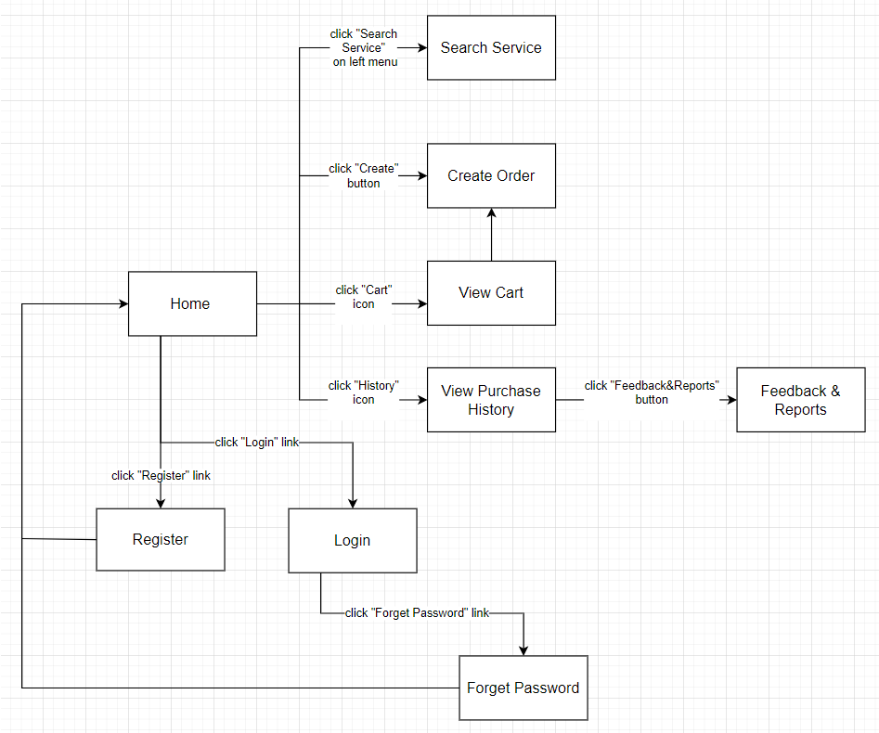

Provider-screen-flow:

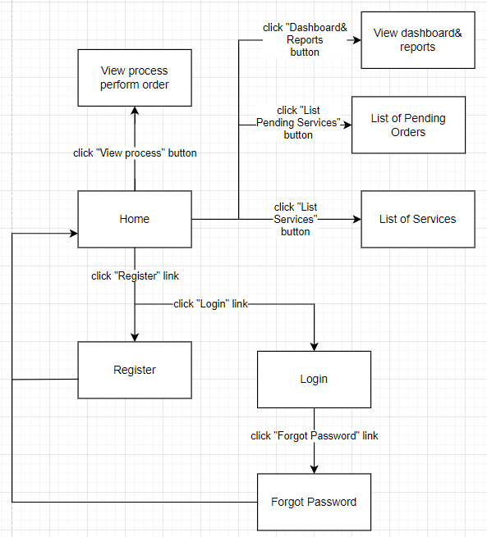

Admin-screen-flow:

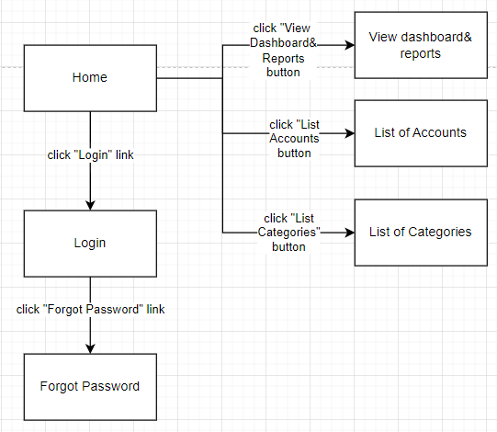

>>

### 1.2 Screen Descriptions

|  |  |  |  |
| --- | --- | --- | --- |
| **#Customer** | **Screen** | **Feature** | **Description** |
| FR-01 | Login | Login | Customers log in to their accounts and can reset their password if they forget it. If they don’t have account, they can register |
| FR-02 | View Cart | Manage Cart | Customers view the list of services added to the cart so they can edit or order services |
| FR-03 | View Purchase History | View Purchase History | Customers view the list of services performed and from there can leave feedback & reports |
| FR-04 | Search Service | Search | Customers search the service they want to order |
| FR-05 | Create Order | Order Service | Customers choose the service to order and complete the forms related to ordering the service |

|  |  |  |  |
| --- | --- | --- | --- |
| **#Admin** | **Screen** | **Feature** | **Description** |
| FR-01 | Login | Login | Administrators log in to their accounts and can reset their password if they forget it. |
| FR-06 | List of Categories | Manager categories | Administrators view the list of service categories, add categories, edit categories, and remove categories |
| FR-07 | View dashboard & reports | Manager dashboard & reports | Administrators view the dashboard with statistics and reports on service activities. |
| FR-08 | List of accounts | Manager accounts | Administrators view the list of user accounts, Add account, remove user accounts, update user account |

|  |  |  |  |
| --- | --- | --- | --- |
| **#Provider** | **Screen** | **Feature** | **Description** |
| FR-09 | Login | Login | Providers log in to their accounts and can reset their password if they forget it. If they don’t have account, they can register |
| FR-10 | List of Service | Manage Service | Providers view the list of services; they can edit and add service |
| FR-11 | View process, perform order | View process, perform order | Providers can view the details of a service request, including customer information, service details, etc. |
| FR-12 | List Pending Order | List Pending Order | Providers can indicate their order by setting it in their list. |
| FR-07 | View Dashboard and Reports | View Dashboard and Reports | Providers can view a dashboard showing key metrics and data about their services and earnings. They can also generate and view reports on their service history, customers, earnings, ratings, etc. |

>>

### 1.3 Screen Authorization

*[Provide the system roles authorization to the system features (down to screens, and event to the screen activities if applicable) in the table form as below – replace Role1, Role2,… with the specific system user role names]*

<<Sample:

| **Screen** | **Customer** | **Admin** | **Provider** |
| --- | --- | --- | --- |
| Home | X | X | X |
| Create Order | X |  |  |
| Search Service | X |  |  |
| View Cart | X |  |  |
| View Purchase History | X |  |  |
| Login | X | X | X |
| Register | X |  | X |
| Forget Password | X | X | X |
| View dashboard&reports |  | X | X |
| List of Accounts |  | X |  |
| List of Categories |  | X |  |
| List of Services |  |  | X |
| List of Pending Orders |  |  | X |
| View process perform order |  |  | X |

In which:

* Role Customer: use service
* Role Admin: system management
* Role Provider: provide and perform service

>>

### 1.4 Non-Screen Functions

*[Provide the descriptions for the non-screen system functions, i.e batch/cron job, service, API, etc.]*

<<Sample:

|  |  |  |  |
| --- | --- | --- | --- |
| **No.** | **System Function** | **Feature** | **Description** |
| FR-13 | User Management | User Authentication | Authenticates user login credentials and manages user sessions. |
| FR-14 | Service  Management | Service Indexing | Indexes service information for search and retrieval. |
| FR-15 | Order Management | Order Workflow | Manages order statuses and state transitions. |
| FR-16 | Notification reminder | Orders Reminders | Sends appointment notifications via email and SMS. |
| FR-17 | Payment gateways to | Payment Processing gateways to | Integrates with payment processing transactions. |
| FR-18 | Reporting performance | Usage Metrics | Generates usage and reports. |
| FR-19 | Data Management | Backup databases | Performs daily backups of files. |

>>

## 2. Data Requirements

### 2.1 Logical Data Model

*[A data model is a visual representation of the data objects and collections the system will process and the relationships between them. Include a data model for the business operations being addressed by the system, or a logical representation for the data that the system itself will manipulate. Data models are most commonly created as an entity-relationship diagram.]*

<<Sample:

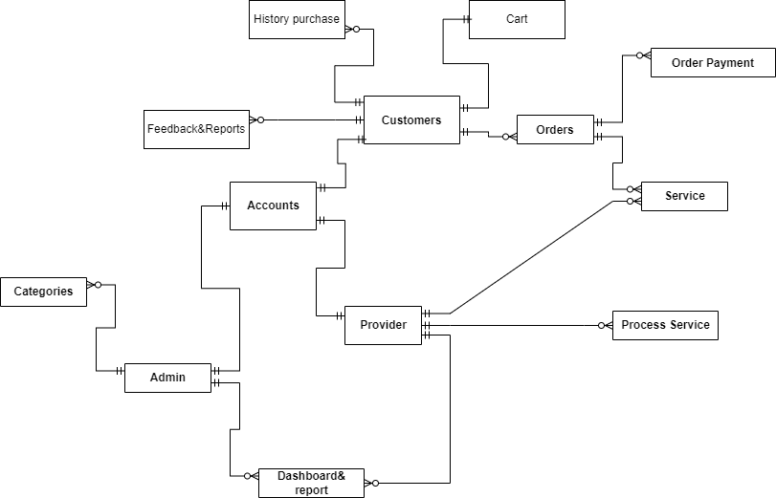

>>

### 2.2 Data Dictionary

*[The data dictionary defines the composition of data structures and the meaning, data type, length, format, and allowed values for the data elements that make up those structures. In many cases, you're better off storing the data dictionary as a separate artifact, rather than embedding it in the middle of an SRS. That also increases its reusability potential in other projects.]*

<<Sample:

|  |  |  |  |  |
| --- | --- | --- | --- | --- |
| **Data Element** | **Description** | **Composition or Data Type** | **Length** | **Values** |
| User ID | A unique identifier for each user. | Integer |  |  |
| User Role | User's role within the system (e.g., Rider, Admin). | String |  | Predefined roles. |
| Date of Birth | User's date of birth. | Date |  | Valid date. |
| Gender | User's gender. | String |  | Male, Female, Other. |
| Bird ID | A unique identifier for each Bird. | Integer |  | Unique, auto-generated. |
| Bird Model | Model or type of Bird (e.g., electric scooter, e-bike). | String |  | Predefined models. |
| Manufacturing Date | Date when the Bird was manufactured. | date, MM/DD/YYYY |  | Valid date. |
| Ride ID | A unique identifier for each ride. | Integer |  | Unique, auto-generated. |
| Start Location | Starting location of the ride (GPS coordinates). | Geographic coordinates (Latitude and Longitude). |  |  |
| End Location | Ending location of the ride (GPS coordinates). | Geographic coordinates (Latitude and Longitude). |  |  |
| Payment Status | he status of the payment (e.g., Pending, Successful, Failed). | String |  | Predefined statuses. |
| Payment Currency | The currency used for the payment. | String |  | Valid currency codes (e.g., USD, EUR). |
| Issue Description | Issue Description | Text |  | Free text input. |
| Issue Severity | The severity level of the reported issue (e.g., Critical, Minor). | String |  | Predefined severity levels. |
| order cutoff time | the time of day before which all meal orders for that date must be placed | time, HH:MM | 5 |  |
| order date | the date on which a patron placed a meal order | date, MM/DD/YYYY | 10 |  |
| ordered Bird item | Data Dictionary for Ordered Bird Items in the Bird Service Platform |  |  |  |
| patron | a Process Impact employee who is authorized to order a meal | patron name  + employee ID  + patron phone number  + patron location  + patron email |  |  |
| patron email | email address of the employee who booked the bird | alphanumeric | 50 |  |
| patron location | number of people placing birds | alphanumeric | 50 | hyphens and commas permitted |
| patron name | the name of the person who booked the bird service | alphabetic | 30 |  |
| patron phone number | Phone number of the employee who booked the bird service | AAA-EEE-NNNN xXXXX for area code (A), exchange (E), number (N), and extension (X) | 18 |  |
| payment amount | total price of an order in dollars and cents, calculated per BR-12 | numeric, dollars and cents | dddd.cc |  |
| payment method | how the Patron pays for the service he has ordered | alphabetic | 16 | payroll deduction, cash, credit card, debit card |
| quantity ordered | the number of bookers the Patron is placing in a bird service order | integer | 4 | default = 1; maximum = quantity presently in inventory |
| transaction number | unique sequence number that COS assigns to each payment transaction | integer | 12 |  |

>>

### 2.3 Reports

*[If your application will generate any reports, identify them here and describe their characteristics. If a report must conform to a specific predefined layout you can specify that here as a constraint, perhaps with an example. Otherwise, focus on the logical descriptions of the report content, sort sequence, totaling levels, and so forth, deferring the detailed report layout to the design stage.]*

<<Sample:

|  |  |  |
| --- | --- | --- |
| **#** | **Report Name** | **Description** |
| RPT-01 | Ordered Service History | Customers can view their history of ordered services for reordering or reference. |
| RPT-02 | Service Provider Performance | Help provider track their order performance |
| RPT-03 | Revenue by Service Category | Allow admin view the revenue generated across different service category |
| RPT-04 | Customer Lifetime Value | Provide administrators insights into customer lifetime value to inform marketing and promotions. |
| RPT-05 | Customer Satisfaction Survey Responses | Allow administrators to view customer satisfaction survey responses to identify areas for improvement. |

|  |  |
| --- | --- |
| Report ID: | RPT-01 |
| Report Title: | Ordered Service History |
| Report Purpose: | Allow customers to view their history of ordered services for reordering or reference. |
| Priority: | Medium |
| Report Users: | Customers |
| Data Sources: | Database of customer order history |
| Frequency and Disposition; | GeneratedIt is generated on-demand when a customer requests a view of order history. Data is static once displayed.  The report can be displayed on the web, mobile, or printed if permitted by the device. |
| Latency: | The report must display within 5 seconds of request. |
| Visual Layout: | Landscape orientation |
| Header and Footer: | The header displays the report title, date range, and customer name. The footer shows the page number if printed. |
| Report Body: | Columns:   * Order Number * Service Date * Service Category * Service Name * Provider Name * Price * Status (Completed, Refunded, etc.)   Rows:   * One row per service order in the date range. * Sort: reverse chronological order. |
| End-of-Report Indicator: | "End of Report" is displayed after the last row. |
| Interactivity: | Allow customers to click each row to view service order details. |
| Security Access Restrictions: | Customers can only view their order history. |

|  |  |
| --- | --- |
| Report ID: | RPT-02 |
| Report Title: | Service Provider Performance |
| Report Purpose: | Allow service providers to track their key performance metrics over time. |
| Priority: | Medium |
| Report Users: | Service Providers |
| Data Sources: | Databases storing provider profiles, services, orders, reviews, etc. |
| Frequency and Disposition | Generated weekly. Archived for 1 year. |
| Latency: | Available within 1 day of the week ending |
| Visual Layout: | Landscape orientation |
| Header and footer: | The header shows the report name, date range, and provider name. The footer shows the page number if printed. |
| Report Body: | * Number of Services Listed * Number of Orders Received * Average Order Value * Number of Reviews Received * Average Review Rating * Revenue from Orders * Revenue Change % (Week over Week) | |
| End-of-Report Indicator: | "End of Report" is displayed after the last row. |
| Interactivity: | Allow the provider to click each row to view service order details. |
| Security Access Restrictions: | Providers can only view their performance reports. |

|  |  |
| --- | --- |
| Report ID: | RPT-03 |
| Report Title: | Revenue by Service Category |
| Report Purpose: | Provide administrators with an overview of revenue generated across different service categories. |
| Priority: | High |
| Report Users: | Administrators |
| Data Sources: | Databases containing order details and payment information. |
| Frequency and Disposition | Generated weekly. Archived for 1 year. |
| Latency: | Available within 1 day of the week ending. |
| Visual Layout: | Bar chart showing revenue by service category. |
| Header and footer: | The header shows the report name and date range.  The footer shows the page number if printed. |
| Report Body: | * X-axis shows service categories (Cleaning, Repair, Delivery, etc.) * Y axis shows revenue amount in dollars * One colored bar per service category * Each bar is labeled with the service category name and revenue dollar amount * Bars are shown in descending order of revenue amount * The report shows top 10 categories by revenue |
| End-of-Report Indicator: | "End of Report" is displayed after the last row. |
| Interactivity: | Allow the provider to click each row to view service order details. |
| Security Access Restrictions: | Providers can only view their performance reports. |

|  |  |
| --- | --- |
| Report ID: | RPT-04 |
| Report Title: | Customer Lifetime Value |
| Report Purpose: | Provide administrators insights into customer lifetime value to inform marketing and promotions.. |
| Priority: | Medium |
| Report Users: | Administrators |
| Data Sources: | Databases with customer profiles, order history, promotions redeemed, etc. |
| Frequency and Disposition | Generated monthly. Archived for 2 years. |
| Latency: | Available within 3 days of month ending. |
| Visual Layout: | Table report. |
| Header and Footer: | Header shows report name, date range, metrics descriptions. Footer shows pagination. |
| Report Body: | * Customer Name * Total Revenue * Number of Orders * Average Order Value * Total Promotions Redeemed * Calculated Customer Lifetime Value Rows sorted by lifetime value high to low. End-of-Report Indicator: "End of Report" displayed after last row. Interactivity: Allow admin to click each row to see customer profile and order history details. Security Access Restrictions: Only administrators can access this report. |
| End-of-Report Indicator: | "End of Report" displayed after last row. |
| Interactivity: | Allow admin to click each row to see customer profile and order history details. |
| Security Access Restrictions: | Only administrators can access this report. |

|  |  |
| --- | --- |
| Report ID: | RPT-05 |
| Report Title: | Customer Satisfaction Survey Responses |
| Report Purpose: | Allow administrators to view customer satisfaction survey responses to identify areas for improvement. |
| Priority: | Medium |
| Report Users: | Administrators |
| Data Sources: | Database storing customer satisfaction survey responses. |
| Frequency and Disposition |  |
| Latency: | Available within 5 days of month ending. |
| Visual Layout: | Table report. |
| Header and Footer: | Header shows report name, date range. Footer shows pagination. |
| Report Body: | * Date of Survey Response * Customer Name * Question Text * Customer Response * Verbatim Customer Comments Rows grouped by question, sorted chronologically. |
| End-of-Report Indicator: | "End of Report" displayed after last row. |
| Interactivity: | Allow admin to click each row to view full survey response. |
| Security Access Restrictions: | Only administrators can access this report. |

>>

### 2.4 State transition diagram

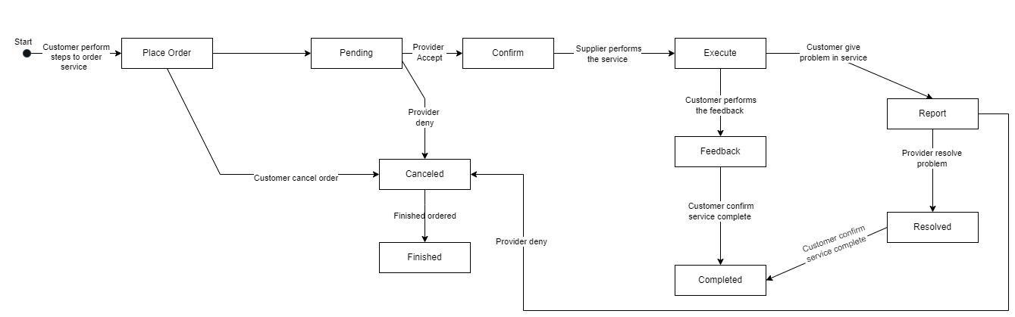

>>

## 3. <<Feature Name 1>>

*]*

### 3.2 Search Service

**Function trigger:**

* Navigation path: when a user navigates to a specific page or URL in the application. For example, you could have a function that is triggered when a user navigates to the product catalog page.
* Timing frequency: at regular intervals, such as every minute, hour, or day. For example, you could have a function that is triggered to generate a daily report of sales.
* HTTP requests: when an HTTP request is made to a specific URL. This is useful for creating APIs or webhooks.

**Function description:**

* Actors/roles: Customers
* Purpose: To display a list of services to customers
* Interface: Input: Name Service. Output: A list of services.
* Data processing: The function retrieves a list of services from the database and formats the data for display.

**Screen layout:**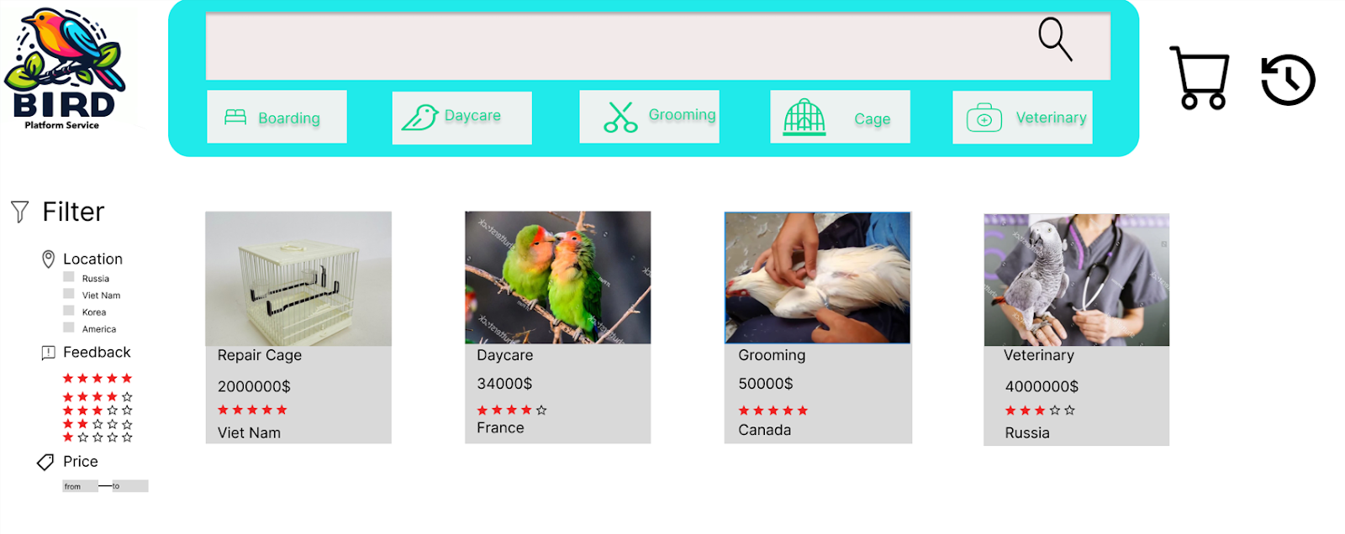=

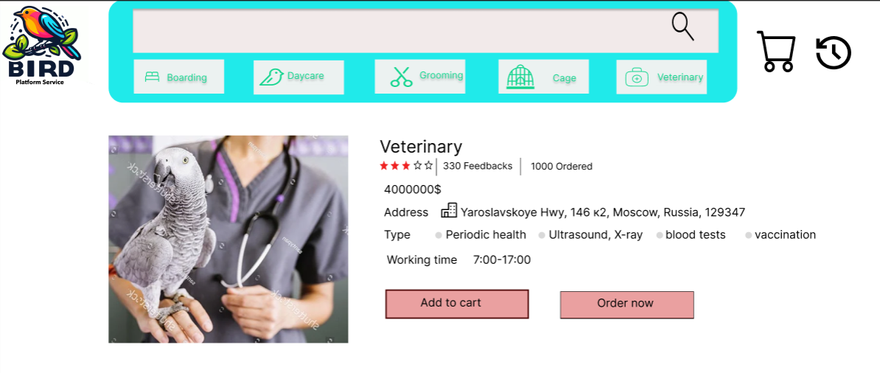

**Function details:**

* Data:
* Input data: Customer search query
* Output data: List of services that match the search query

* Validation:

* Check if the search query is empty

* Check if the search query is valid (e.g., does not contain special characters)

* Business logic:

1. Receive the customer's search query
2. Validate the search query
3. Search the service database for services that match the search query
4. Return the list of matching services to the customer

* Functionality:
* Normal cases:
* If the customer enters a valid search query that is in the service database, the system will return a list of matching services to the customer.
* If the customer enters a valid search query that is not in the service database, the system will return a message "No matching service found".
* Abnormal cases:
* If the customer enters an empty search query, the system will return a message "Search query cannot be empty".
* If the customer enters an invalid search query, the system will return a message "Invalid search query".

## 4. Order Service

**Function trigger:**

* Navigation path: The customer navigates to the veterinary service payment page.
* Timing frequency: None.

**Function description:**

* Actors/roles: Customer.
* Purpose: To pay for veterinary services.
* Interface:
  + Input:
* Service information (type of service, time, location, etc.).
* Payment information (customer name, credit card number, etc.).
* Output:
* Payment success or failure notification.
* Data processing:
  + The function receives service and payment information from the customer.
  + The function checks the validity of the information.
  + The function sends payment information to the payment system.
  + The function receives payment notification from the payment system.

**Screen layout:**

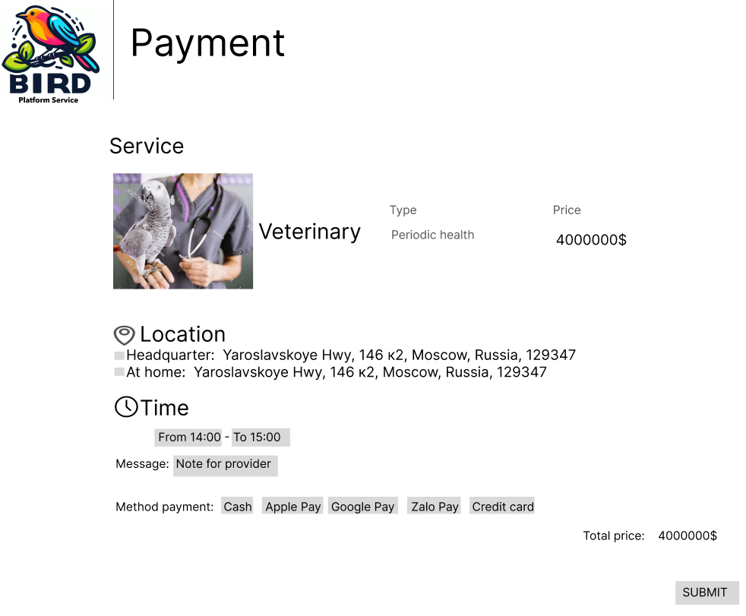

**Function details:**

* Data:
* Input data:
* Service information (type of service, time, location, etc.)
* Payment information (customer name, credit card number, expiration date, CVV, etc.)
* Output data:
* Payment success or failure notification

* Validation:
* The function checks the validity of the service information, such as the type of service, time, and location.
* The function checks the validity of the payment information, such as the customer name, credit card number, expiration date, and CVV.

* Business logic:
* The function sends the payment information to the payment system.
* The function receives the payment notification from the payment system.

* Functionality:

* Normal cases:
* If the service information is valid and the payment information is valid, the function will send the payment information to the payment system.
* The payment system will process the payment and send a payment notification to the function.
* The function will display the payment success or failure notification to the customer.
* Abnormal cases:
* If the service information is invalid, the function will display an error message to the customer.
* If the payment information is invalid, the function will display an error message to the customer.

# V. Non-Functional Requirements

## 1. External Interface Requirements

Bird Services software aims to connect users with needs related to ornamental birds and surrounding services with professional service providers. Main functions include:

Service Search: Users can search for services such as bird cage repair, bird care, bird consultation, and other services based on location, service type, and user reviews.

Make Appointments: Users can make appointments with service providers online easily through the application.

Service Confirmation: Service providers can view requests from users, confirm appointments, and update service status.

Secure Payment: The system provides secure and convenient payments for both users and service providers through online payment methods

### 1.1 User Interfaces

UI-1: The user interface will be designed with a friendly design, using bright colours and bird images to create a familiar and attractive online space for users.

UI-2: Users can search for services through a centralised search bar, with automatic suggestions when entering keywords. Search results will appear as an easy-to-read list with basic information about the service and provider.

UI-3: The service detail page will include high-quality images, detailed service descriptions, reviews from previous users, and transaction history. Users can select options such as "Schedule Appointment" or "Contact Provider" directly from this page.

UI-4: Users' appointment schedules and orders will be displayed in an interface similar to an agenda, allowing them to easily manage and track the status of booked services.

UI-5: User profile will include avatar, personal information, and transaction history. Users can change personal information and view previous transaction history from this interface.

UI-6: The application's home page will display featured services, special offers and the latest news related to pet birds, helping users easily update the latest information.

UI-7: Integrated online chat feature allows users to directly contact the supplier or support department to ask questions or receive quick support.

UI-8: The payment interface is designed to be simple and secure, supporting many payment methods including credit cards, e-wallets and cash on delivery (COD) to meet the diverse needs of customers. user.

UI-9: Notifications and reminders will be displayed as push notifications directly on the user's screen, including appointment confirmations, comments from other users, and special offers from providers' service level.

### 1.2 Software Interfaces

SI-1: Integration with Location Services

SI-1.1: The system will use GPS data to accurately determine the user's location and provide location-based service recommendations.

SI-1.2: When a user selects a service, the system uses geolocation technology to alert both the user and the service provider when they are in a specified vicinity, ensuring Ensure timely service delivery.

SI-1.3: The system integrates a mapping API to provide real-time directions to the service provider's location for users, enhancing convenience and ease of access.

SI-2: Notification and communication with users

SI-2.1: The system will implement push notifications to notify users of service confirmations, appointment reminders, and provider availability.

SI-2.2: Users will have the option to receive email notifications regarding appointment confirmations, appointment cancellations, and service reviews.

SI-2.3: The system will enable two-way SMS communication between users and service providers, allowing for quick queries and updates on appointments.

SI-2.4: Automated email surveys will be sent to users upon completion of services, gathering feedback to improve the overall user experience.

SI-2.5: The system will support an in-app chat function, allowing real-time communication between users and service providers for instant queries and problem resolution.

SI-3: Payments and transactions

SI-3.1: The system will securely process online payments through a variety of methods, including credit/debit cards, digital wallets and online banking, ensuring code Optimise and comply with payment card industry data security standards (PCI DSS).

SI-3.2: Users have the option to securely store multiple payment methods within the app for seamless and convenient transactions.

SI-3.3: The system shall generate electronic invoices for each transaction, providing users and service providers with detailed records of services provided and payments received.

SI-3.4: Users can review transaction history, including date, service, amount, and payment method in the app for transparent financial tracking.

SI-4: Feedback and rating system

SI-4.1: After each service completion, the system will prompt users to evaluate and give feedback on service quality and service providers.

SI-4.2: Service providers will have access to a dashboard that displays average ratings, individual service ratings, and user comments, helping them evaluate their performance and take action. improvements.

SI-4.3: The system will use machine learning algorithms to analyse user feedback and identify trends, supporting service providers to enhance their services based on user preferences and comments use.

SI-5: Data analysis and reporting

SI-5.1: The system will collect and analyse user behavioural data, such as service preferences, frequency of use, and location patterns, to generate insights for service recommendations, personalized service and marketing strategy.

SI-5.2: Service providers will have access to performance reports, including appointment trends, user demographics, and service popularity, allowing for Data-driven decisions for business growth and service improvement.

SI-5.3: The system will generate periodic summary reports for administrators, detailing key metrics such as user engagement, revenue generation, and user satisfaction, supporting planning Strategic planning and decision making for the overall development of the platform.

### 1.3 Hardware Interfaces

HI-1: ***Server Configuration***

*Application Server*

CPU : Intel Xeon 8 Core 2.40 GHz

Memory Space : 128 GB RAM 1333 MHz

Storage Space : 2 TB

Operating System : MS Windows Server 2012 R2

Software : Microsoft IIS 8.x, .NET Framework 4.5

*Database Server*

CPU : Intel Xeon 12 Core 2.40 GHz

Memory Space : 256 GB RAM 1333 MHz

Storage Space : 3 TB

Operating System : MS Windows Server 2012 R2

Software : Microsoft SQL Server 2000

HI-2: ***Client Configuration***

*PC Device*

CPU : Intel Core 2 Dual 2.00 GHz

Memory Space : 4 GB RAM 1333MHz

Storage Space : HDD: 500GB, 2.5" SATA x 2, RAID 1

Operating System : Windows Win7/Win8/Win10

Operator Display : 18.5-inch widescreen, 16:9 format

1280 x 720 pixel, 1024 x 768 pixel

*POS Device*

CPU : Intel® Celeron® Processor G1820TE (2.2GHz, Dual Core)

Memory Space : 2GB (Max. 4GB), DDR3 SO-DIMM slot x 2 (1 open)

Storage Space : HDD: 500GB, 2.5" SATA x 2, RAID 1

Operating System : Windows Embedded POS Ready 7

Operator Display : 15" XGA TFT colour LCD with resistive touch screen   (TeamTouch), Integrated

1024 x 768 pixel

Proximity Sensor

Option: Integrated Camera/Mic

*Mobility Device*

CPU : Quad-Core 1.2 GHz

Memory Space : 1.5 GB

Storage Space : 8 GB

Operating System : Android 8.0

Wifi Standard : 5GHz Wi-fi

Operator Display : 7.0 inches

1280 x 800 Pixels

HI-3: ***Network***

LAN Network : Speed ≥ 1 Gbps

WAN Network : Speed ≥ 2Mbps/10 Users operate together

### 1.4 Communications Interfaces

CI-1: The system shall send email or text message confirmations to Users for appointment bookings and service details.

CI-2: Automated reminders via email or text message for upcoming appointments and services.

CI-3: Real-time chat support feature between Users and Service Providers.

CI-4: Automatic post-service satisfaction surveys sent via email or text message.

CI-5: Integration for Users to share reviews and ratings on social media platforms.

CI-6: In-app notifications for real-time updates on service provider availability, appointment confirmations, and cancellations.

CI-7: Push notifications to alert users about exclusive offers, discounts, and new services.

CI-8: Email newsletters containing updates on seasonal promotions, tips, and relevant bird care information.

CI-9: SMS notifications for urgent service updates, such as last-minute appointment openings or changes in service schedules.

CI-10: Integration with third-party calendar applications, allowing users to sync their appointments seamlessly.

CI-11: API integration with payment gateways for secure and convenient online transactions.

CI-12: Integration with mapping services for real-time directions to service provider locations.

CI-13: Secure file upload feature for users to share relevant documents or images related to their service requests.

CI-14: Integration with social media platforms for easy sharing of user experiences and service provider recommendations.

CI-15: Automated birthday greetings and special offers sent via email or text message to loyal customers.

## 2. Quality Attributes

### 2.1 Usability

* USAB-1: The system shall provide context-sensitive help and tooltips for key functions and input fields.
* USAB-2: Forms and input fields shall be clearly labeled and arranged in a logical order to support efficient data entry.
* USAB-3: The platform shall incorporate responsive design to optimize the user experience across desktop, tablet, and mobile devices. Pages should resize and adapt to different viewport sizes.
* USAB-4: Primary navigation and functions should be accessible within three clicks from any page within the system.
* USAB-5: The system shall provide search capabilities to allow users to quickly find services, providers, and other information.

### 2.2 Performance

* PERF-1: Pages for public users shall load within 5 seconds for 95% of page loads over a 5Mbps network connection.
* PERF-2: Authenticated user pages shall load within 8 seconds for 90% of page loads over a 5Mbps network connection.
* PERF-3: Search results shall populate within 2 seconds for queries returning less than 100 results.
* PERF-4: The system shall support up to 100 concurrent authenticated users with acceptable response times.
* PERF-5: System administrators shall be able to run reports on demand for data sets up to 10,000 rows within 1 minute.

### 2.3 Security

* SEC-1: The system shall use TLS 1.2 or higher for all connections and transmissions of confidential data.
* SEC-2: Passwords shall be stored as salted hashes rather than plain text.
* SEC-3: User sessions shall timeout after 15 minutes of inactivity, requiring re-authentication.
* SEC-4: User inputs shall be sanitized and validated to prevent injection attacks.
* SEC-5: All confidential data shall be encrypted at rest within the system databases.

>>

### 2.4 Safety

*[Specify requirements that are concerned with possible loss, damage, or harm that could result from use of the product. Define any safeguards or actions that must be taken, as well as potentially dangerous actions that must be prevented. Identify any safety certifications, policies, or regulations to which the product must conform.]*

SAF-1: Customer and role management: The admin needs to have the ability to manage customers and roles within the system. This includes creating, deleting, and updating customer accounts, as well as assigning and revoking access rights for other roles.

SAF-2: Authorization security: The admin should have access to critical management functions and sensitive information. Ensure that only authorised individuals can access and perform these changes

SAF-3: System monitoring and logging: The admin needs the ability to monitor system activities, detect suspicious behaviour, and log events for analysis and issue resolution.

SAF-4: Authentication and authorization: Ensure that only registered and authenticated service providers can access and utilise their respective functions. Provide appropriate access rights based on the role and scope of operation for each provider.

SAF-5: Customer data security: Providers need to safeguard customer information that they have access to. This includes implementing strong security measures such as data encryption and adhering to privacy protection rules.

SAF-6: Privacy protection: Safeguarding customer's personal information is a top priority. Ensure that customer data is secure and only used as per the customer's consent.

SAF-7: Access control management: Ensure that customers can only access and interact with information and functions that are relevant to their role and permissions. Prevent unauthorised access to customer accounts and personal information.

### 2.5 Availability *[Availability is a measure of the planned up time during which the system’s services are available for use and fully operational. Formally, availability equals the ratio of up time to the sum of up time and down time. Still more formally, availability equals the mean time between failures (MTBF) for the system divided by the sum of the MTBF and the mean time to repair (MTTR) the system after a failure is encountered. Scheduled maintenance periods also affect availability. Availability is closely related to reliability and is strongly affected by the maintainability subcategory of modifiability. ]*

AVL-1: MTBF and MTTR: Bird Services Platform is designed with a distributed architecture and uses server redundancy. This helps increase MTBF (mean time between x`failures) by reducing the likelihood of a single point failure. Additionally, if a failure occurs, the MTTR (mean time to resolve the problem) is also reduced by developing automated recovery measures or rapid recovery processes..

AVL-2: Backup and redundancy: Bird Services Platform uses backup systems and redundant computing to ensure critical data and system components are backed up periodically. Developing backup copies of databases, servers, and other components helps minimise failures and increase recovery from failures.

AVL-3: Monitoring and incident response: Bird Services Platform uses monitoring and alerting tools to monitor system activity. If a problem occurs, the system will automatically notify the technical team to quickly react and resolve the problem.

AVL-4: Regular maintenance management: Bird Services Platform has a regular maintenance schedule to perform maintenance tasks, software updates, and system checks. Maintenance measures are planned to minimise impact on usability.

AVL-5: Scalability: Bird Services Platform is built to be scalable, allowing the system to be upgraded when required to increase load handling capacity and number of users. The expansion system helps minimise overload and maintain higher availability.

### 2.6 Reliability

*[The probability of the software executing without failure for a specific period of time is known as reliability.]*

<<Sample:

REL-1: Uptime: The Bird platform service needs to operate continuously and have high uptime to ensure availability to users at all times.

REL-2: Recovery: The service needs to have recovery capabilities after incidents or failures to quickly return to normal operation.

REL-3:  Resilience: The Bird platform service must have the ability to withstand adverse conditions and increased pressure without causing significant service disruptions.

REL-4:    Backup and Data Recovery: Ensure that important data is regularly backed up and can be quickly restored in case of loss or corruption.

REL-5:   Security and Data Protection: Ensure the privacy and security of user data and have measures to protect against network attacks and security risks.

REL-6:     Infrastructure reliability: Ensure that the underlying infrastructure, including servers, networks, and related resources, is highly reliable to support the service.

REL-7:    Monitoring and Testing: Provides continuous monitoring and testing tools to monitor service performance and status, ensuring that issues can be detected and resolved promptly.

REL-8:    Human Error Mitigation: Design processes and systems to minimize errors caused by humans, such as providing pre-deployment validation procedures.

REL-9:   External Interfaces: Ensure reliable integration and interaction with external services and applications.

>>

### 2.7 Design Constraints

*[Describe constraints in the software development process]*

<<Sample:

DES-1: Programming Language and Technology: The Bird platform service may be limited in the use of a specific programming language or a particular type of technology.

DES-2: Supported Devices and Platforms There may be limitations on the specific devices or platforms supported

DES-3: Standards and Regulations: The project needs to comply with specific standards and regulations, such as security standards or privacy regulations.

DES-4: Resource Constraints: There may be constraints on resources such as memory, storage capacity, or bandwidth that the project can use.

DES-5: Time and Budget: The project may have to adhere to specific time constraints or budget limitations.

DES-6: Functional Scope: There may be limitations on the functional scope of the project, specifying specific features that the project is not allowed to develop or must implement.

DES-7: Geographical or Location Constraints: The project may have to comply with constraints related to geographical location or regulations regarding data storage in specific countries.

DES-8:  Documentation and Guidance: The project may require the provision of specific documentation or guidance for users or administrators.

>>

### 2.8 [Others as relevant]

*Create a separate section in the SRS for each additional product quality attribute to describe characteristics that will be important to either customers or developers. Possibilities include efficiency, installability, integrity, interoperability, modifiability, portability, reusability, robustness, scalability, and verifiability. Write these to be specific, quantitative, and verifiable. [Clarify the relative priorities for various attributes, such as security over performance.]*

2.8

**Modifiability**

* **MOD-1:** The system shall be designed to support the addition of new features and capabilities through configuration rather than code changes.
* **MOD-2:** Bird Services administrators shall be able to add, update, and remove service providers, service categories, user roles, and configured system settings through the admin interface without development effort.
* **MOD-3:** The core system components and services shall use modular design to enable replacing or expanding modules without impacting overall system stability.
* **MOD-4:** Third-party APIs and integrations shall be abstracted through loosely coupled interfaces to minimize the impacts of API provider changes.

### Portability

* **PORT-1:** Bird Services shall run on standard commercial off-the-shelf server hardware and operating systems, including Windows Server and Linux platforms.
* **PORT-2:** The system shall not depend on proprietary frameworks, languages, or DBMS systems, relying only on widely available open source technology stacks.
* **PORT-3:** Application components shall be platform-agnostic, enabling deployment on cloud infrastructure providers including AWS, Azure, and Google Cloud.
* **PORT-4:** The mobile application shall be deployable to both iOS and Android platforms while sharing the majority of the application code.