The plan is switching to KICAD due to it open-source capabilities
Vincent Nguyen have really good videos for setting up
https://www.youtube.com/watch?v=_ZjyeltLMAg
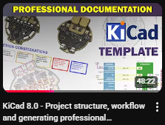
https://youtu.be/63R6Wnx44uY?si=8bjhTZ2d-c2DBhAj


