Shrinivas Kopparam Ramanath, Shijir Tsogoo

INFO 474

Assignment #3: Interactive Visualization Software

Goal of our Visualization

Everyone needs food to survive and many of us consider eating a quite enjoyable experience. However, nutritional value must be taken into account when we eat, else we either eat too little or eat too much and end up getting in a shape we’d rather not be in. In order to stay healthy, we must eat food with the nutrients that we require. The visualization that we will create will help people choose the food that they should eat in order to get to the shape that they want to be. An underweight person can look for foods high in fat and calories, someone looking to build lean muscle can look for food high in protein and low in fat, and a diabetic can look for food low in sugars while providing the other nutrients that he/she requires. For this project in particular, we decided to help people choose the breakfast cereal that best served their needs. We acquired data from the United States Department of Agriculture Agricultural Research Service National Nutrient Database found <http://ndb.nal.usda.gov/ndb/search>.

Visualization Setup

Since there were 346 different types of breakfast cereals, we chose to use a scatterplot to plot the data, with the two axis be based on different types of nutritional values that the user might want to take into account, such as (sugar, calories, protein, and carbohydrates). One type of interaction that we will add into the visualization are sliders to configure the upper and lower limits of the axis, and the data that we would want to appear on the graph. This is useful because it will help users better choose the right food for them. A diabetic for example then look for foods high in protein and low in fat, and use the slider to limit the food that appears to those that have for example under 10g of sugar. Another type on interaction that would be useful is to show the details of the food when the user hovers over the data point in the plot. A user, while looking for foods high in protein and low in fat could then hover over the data point to view the rest of the data associated with that food such as name, sugar, and calories. A third type of interaction that would be useful is allowing the user to configure the axis to plot with respect to different values (sugar vs calories or protein vs fat), as different people may have different requirements (one person might want to gain weight while another wants to keep their sugar low).

Storyboard

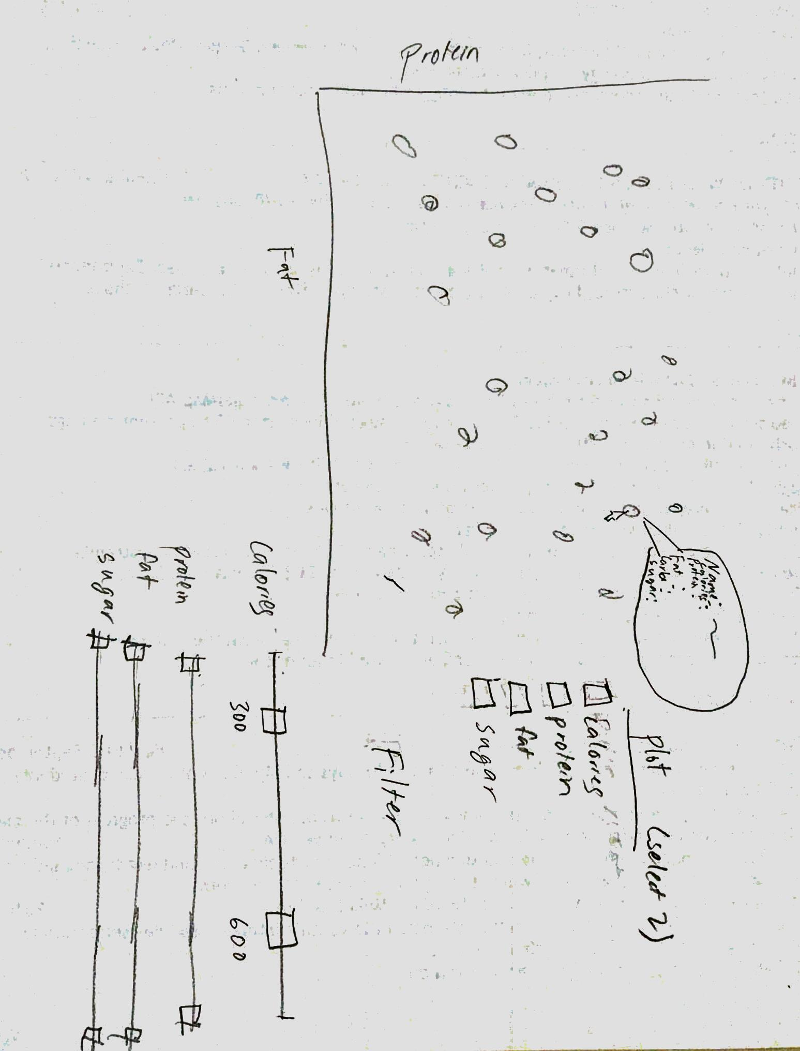

Development

We began by querying data from the USDA food database to find various kinds of information about breakfast cereals and stored it as a .json file. The information we found most valuable was sugar, fat, protein, carbohydrates, calories, and id(which we can use to lookup detailed information later on). The next step in the process was to get d3 to plot the data in a scatterplot. We used AngularJS to plot the graph as we thought that it would help us interact with the data better. The next step in the process was to add interaction to the plot to view detailed information about that particular food. This involved adding a tooltip, appending a div to the plot at the position of the data point. Our next interaction was to change the properties of the data as to which the food data points would be plotted against (for example carbs vs sugar or protein vs calories). We accomplished this in a rather hacky method which was redrawing the graphs rather than changing the data points that appeared. This turned out to be a problem as we were drawing additional graphs and destroying the old ones. In order to filter the data that appeared based on the multiple different variables that were being tracked, this would need to be switched to controlling the points that appeared on the graph using filter functions, and changing the properties with respect to which the data would be plotted to using variables. This was quite a challenge, and the part of the assignment we spent the most time on, as we were working towards getting our third interaction (filtering the data using multiple sliders) to work. Shijir was the main developer for the assignment while Shrinivas fetched the data, worked on implementing interactions, and wrote the report. A total of about 14 hours was spent on the process.