JOB NO :
DIVING OPERATION SERVICE REPORT

GENERAL DETAILS
VESSEL NAME |  |  |  | DATE
DIVE STATION |  |  |  | DRAFT
ANCHORAGE  LOCATION |  |  |  | FWD
 |  |  |  | AFT
SEA STATE | CALM | WINDY | CHOPPY | VISIBILITY
BERTHING | PORT | STBD TO QUAY | ANCHOR | CURRENT
CLASS SOCIETY |  |  | SURVEYOR

JOB ASSIGNM  Hull Cleaning: | ENT  Yes | No | Propeller Polishing: | Yes | No
Others: | Class IWS / CCTV |  | Visual Survey with Photos |  | Others / Repair
MARINE FOULING CONDITION

Type:
Acorn Barnacle | Tubeworm | Gooseneck | Algae
Slime | Mussels | Calcareous | Others
Severity: | Light | Moderate | Heavy

LOCATION | TYPE | % AREA |  |  |  | SEVERITY | LENGTH/  HEIGHT
 |  | BOW | MID |  | STERN
Port
Starboard
Flat Bottom
Rudder
Gratings(SC) |  | P |  | SB
Propeller
Bow Thruster (s)

POST CLEANING REMARKS

Hull Cleaning Performed: | Port Side | STBD Side | Flat Btm | Rudder
Sea Chest Gratings |  | Bilge Keel | Thruster(s)

Successful Completion of Cleaning YES NO

Post Cleaning Inspection YES NO

REMARKS:

PROPELLER

Diameter: |  | No. of Blades:
Type: | Single | Twin | Pitch

PRE & POST PROPELLER POLISHING CONDITION:-
Pressure Side (Rupert Scale Comparator Gauge)
Blade | 1(A) | 2(B) | 3(C) | 4(D) | 5(E) | 6(F)
Location
Remarks

Suction Side (Rupert Scale Comparator Scale Gauge)
Blade | 1(A) | 2(B) | 3(C) | 4(D) | 5(E) | 6(F)
Location
Remarks

PROPELLER

Blade Condition | Good | Fair | Poor
Bolting Assembly Intact | Yes | No | N.A.

DESCRIPTION
Pittings | Yes | No
Caviation / Erosion | Yes | No
Tears | Yes | No
Cracks | Yes | No
Previous Repairs | Yes | No
Any Oil Leak from Blade Seal | Yes | No | N.A

BOSS CONE

Condition | Good | Detective
Cement Covers | Intact | Missing | N.A.
Bolting Assembly | Intact | Missing | Covered

PROPELLER SHAFT

Any Oil Leaking From Shaft |  | Yes | No
Any Damage To Tailshaft Assembly |  | Yes | No
Any Entanglement On Shaft |  | Yes | No
If Yes, Has It Been Removed |  | Yes | No
Tailshaft Clearance Taken |  | Yes | No
Top Reading: | MM | Bottom Reading: | MM
Have The Plugs Been Re-Secured |  | Yes | No

PROPELLER SKETCH REMARKS SHEET
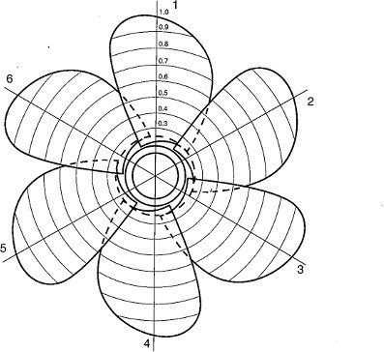

PROPELLER CONDITIONS REMARKS:

Blade 1(A) :
Blade 2(B) :
Blade 3 (C) :
Blade 4 (D) :
Blade 5 (E) :
Blade 6 (F) :

GENERAL HULL ASSESEMENT

PAINT CONDITION
Coatings | SPC | NON SPC
Condition | GOOD | FAIR | POOR

Paint Defects Description
a. Peeling b. Blisters c. Cracking d.Corrosion
e. Mechanical Damage f. Grounding damage Paint Defect remarks:

HULL PLATING BELOW WATERLINE

Port Vertical Side: | Any Damage | Yes | No
Starboard Vertical Side: | Any Damage | Yes | No
Port Flat Bottom: | Any Damage | Yes | No
Keel Plate: | Any Damage | Yes | No
Starboard Flat Bottom: | Any Damage | Yes | No

GENERAL HULL ASSESMENT

Condition of Weld Seams On Hull | Good | Satisfactory | Poor
Any visible Cracks | Yes / Indicated In Drawing |  | No

Hull Plating Below Waterline Damage Remarks Page
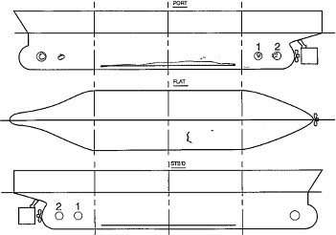

Remarks:

GENERAL HULL ASSESSMENT
BILGE KEEL
No. of Sections Each Side:
Any Anodes on Bilge Keel | Yes | No
Any Damage  Any Cracks on Weld Joint | Yes  Yes | No  No
Anodes % Remaining
Any Damage | Yes | No
Any Cracks on Weld Joint | Yes | No
Anodes % Remaining

Port Bilge Keel :

Port Bilge Keel :

Remarks:

ROPE GUARD COVER

Condition | Good | Defective
Type | Welded | Bolted | Access Hole Top | Bottom
Are Cutters Intact | Yes | No | N.A

Remarks:

GENERAL HULL ASSESMENT
STERN FRAME ARCH AREA
General Casting Condition | Good | Defective
Weld Seam to Rudder | Good | Defective
Weld Seam To Hull | Good | Defective
Weld Seam to Skeg  Remarks: | Good | Defective | N.A.

SEA CHEST GRATINGS
Number of sea chest | Port | Starboard

Type | Swing Door Hinge | Bolted | welded
Gratings | Intact | Defective
Condition | Good | Defective
Seizing wires | Intact | Non Intact
Remarks:

OVERBOARD DISCHARGE
Number of O/D | Port | Starboard
Condition of O/D | Good | Defective

CATHODIC PROTECTION SYSTEM

Sacrificial Anodes: | Located FWD | Mid | Aft | Rudder:
Percentage Remaining:
Port ICCP: | Located FWD | Aft | Any Damage: Yes | No:
Starboard ICCP: | Located FWD | Aft | Any Damage: Yes | No:

Remarks:

THRUSTERS

Bow Thrusters | Yes | N.A.
No. of Blades: |  | Blade Condition | Good | Defective
Any Visible Oil Leak | Yes | No
Grating Condition | Good | Defective | Bolted | Welded

Remarks:

RUDDER
Rudder Horn Any Visible Damage | Yes | No
Rudder Stock Any Visible Damage | Yes | No
Plate Condition | Good | Satisfactory | Poor | Damage
Any Visible Cracks Yes / indicated in drawing |  | No
Rudder Plugs Nos: |  | Intact | Not Intact
Rudder Pintle Clearance Taken | Yes | No | N.A

Top Reading: |  | Bottom Reading:
Forward 1 |  | Forward 1
2 |  | 2
Starboard 3 |  | Starboard 3
4 |  | 4
Aft 5 |  | Aft 5
6 |  | 6
Port 7 |  | Port 7
8 |  | 8

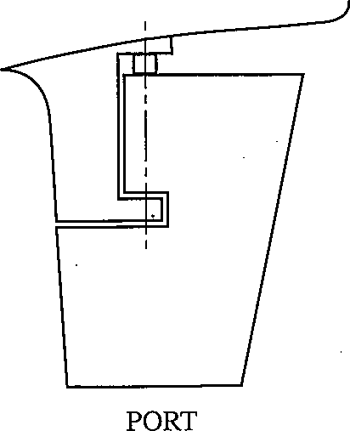 | 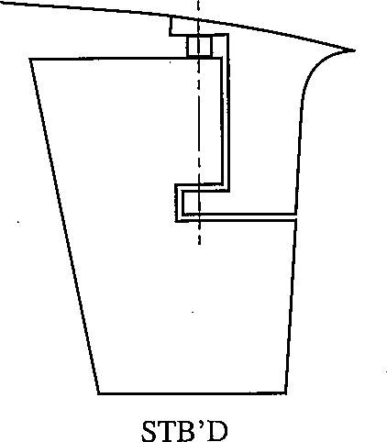

Remarks:

OPERATIONAL DETAILS

Workboat Time Along side: | Departed:

Total Hours Polishing / Cleaning / Inspection / Class Survey / Repairs:

Daytime | Night Time | Weekend | Holiday

Hours Not in Service
Net time of Polishing / Cleaning / Inspection / Class Survey / Repairs:

This is to certify that the Job Assignment has been satisfactorily completed as to the best of my ability.

Comments:

Master’s Endorsement
(Name / Signature / Vessel Stamp/Date)
Class Surveyor Acknowledgement
(Name / Stamp/Date)

Diving Supervisor Acknowledgement
(Name / Stamp/Date)

