**Hello Team!** **Consider the below two tables**:

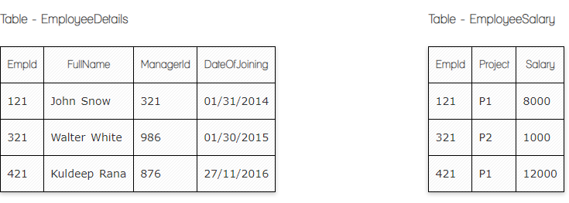

**Ques.1. Write a SQL query to fetch the count of employees working in project 'P1'.**

**Your Answer:**

**Select Count(EmpId)**

**from EmployeeSalary**

**Where Project= ‘P1’;**

**Ques.2. Write a SQL query to fetch employee names having salary greater than or equal to 5000 and less than or equal 10000.**

**Your Answer:**

**Select EmployeeDetails.FullName, EmployeeSalary.Salary**

**From EmployeeDetails**

**INNER JOIN EmployeeSalary ON EmployeeDetails.EmpId= EmployeeSalary.EmpId;**

**Where Salary Between 5000 and 10000;**

**Ques.3. Write a SQL query to fetch count of employees sorted by project's count in descending order.**

**Your Answer:**

**SELECT COUNT(EmpID)**

**From EmployeeSalary**

**Group By Project;**

**Order By Count(EmpId) DESC;**

**Ques.4. Write a query to fetch employee names and salary records. Return employee details even if the salary record is not present for the employee.**

**Your Answer:**

**Select EmployeeDetails.FullName, EmployeeSalary.Salary**

**From EmployeeDetails**

**RIGHT JOIN EmployeeSalary**

**ON EmployeeDetails.EmpId= EmployeeSalary.EmpId;**

**Ques.5. Write a SQL query to create an empty table with ‘Test’ name.**

**Your Answer:**

**Create Table Test(**

**TestId NULL,**

**TestName NULL,**

**)**

**Ques.6. Write a SQL query to delete an empty table with ‘Test’ name.**

**Your Answer:**

**Drop Table Test;**

**Ques.7. Write a SQL query to fetch all the Employees details from EmployeeDetails table who joined in Year 2016.**

**Your Answer:**

**Select * From EmployeeDetails**

**Where DateOfJoining Like ‘%2016’;**

**Ques.8. Write a SQL query to insert new record to the EmployeeDetails table with any data.**

**Your Answer:**

**INSERT INTO EmployeeDetails ( FullName, ManagerID, DateOfJoining)**

**Values(Ani, 535, “03/04/2024”);**

**Ques.9. Write a SQL query to update EmployeeSalery table with setting Salary to 2000 for Project P2.**

**Your Answer:**

**Update EmployeeSalary**

**Set Salary= “2000”**

**Where Project= “P2”**

**Ques.10. Write a SQL query to right join both tables and draw the results.**

**Your Answer:**

**Select * From EmployeeSalary**

**Right Join EmployeeDetails**

**On EmployeeSalary.EmpId= EmployeeDetails.EmpId**

**Now take these two tables:**

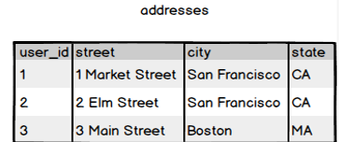

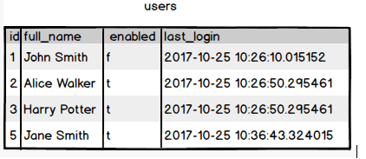

**Ques.11. Write a SQL query to fetch all users full_name from San Francisco.**

**Your Answer:**

**Select users.full_name From users**

**RIGHT JOIN addresses**

**ON users.Id= addresses.user_Id**

**Where address= ‘San Francisco’;**

**Ques.12. Write a SQL query to fetch all users full_name, last_login who are enabled**

**Your Answer:**

**Select full_name, last_login From users**

**Where enabled= ‘t’**

**Ques.13. Write a SQL query to fetch all users full_name who are not from Main street**

**Your Answer:**

**Select users.full_Name From users**

**INNER JOIN addresses**

**ON users.id= addresses.user_id**

**Where address NOT Like “%Main Street%”,**

**Ques.14. Write a SQL query to fetch all users full_name who are from Main street or San Francisco**

**Your Answer:**

**Select users.full_name, addresses.city, addresses.street**

**From users**

**Right Join addresses On users.id= addressed.user_id**

**Where city= “San Francisco” OR street= “Main street”;**

**Ques.15. Write a SQL query to fetch user full_name who is equal to user_id from Boston (find user_id value in sub_query)**

**Your Answer:**

**Select full_name From users**

**Right Join addresses On users.id = addresses.id**

**Where user_id in (Select user_id From addresses**

**Where address= ‘Boston’)**