Streaming Performance Analytics Project

Project Objective
This project analyzes OTT streaming data to understand how viewers actually engage with content and how data quality issues can distort business decisions if not handled correctly.
Instead of jumping straight to dashboards, the focus is on:
- Auditing raw data for quality issues
- Cleaning invalid records
- Calculating reliable engagement KPIs
- Identifying clear behavioral patterns across genre, device, subscription, and region
The goal is simple: turn messy viewing data into insights that a business can trust.
Datasets Used
TABLE 1: Content Table
Provides static metadata about content (movies/shows).
Key columns:
- Content ID
- Genre
- Language
- Content type (Movie / Series / Short)
- Duration (partially missing)

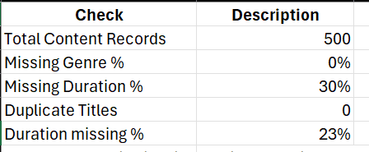

How this table is used:
- For content categorization and descriptive analysis only
- Duration-based KPIs are avoided due to missing values

TABLE 2: Performance Table
Represents individual viewing sessions.
Key columns:
- Watch time
- Completion rate
- Device type
- Subscription type
- Region
This is the main analytical dataset.

Step 1 – Data Quality Audit (Performance Data)
Before analysis, the raw performance data was audited.
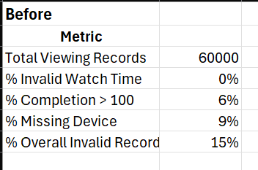
These issues would inflate engagement KPIs if left uncorrected.

Step 2 – Cleaning Decisions
Cleaning rules applied:
- Remove records with completion rate > 100%
- Rename records with missing device type as “Unknown”
- Retain all valid engagement behavior

After Cleaning
This cleaned dataset is used for all analysis below.
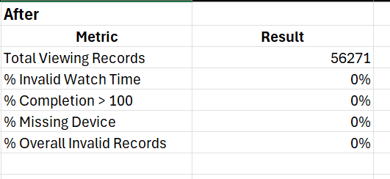

Step 3 – Core Engagement KPIs
These KPIs represent realistic platform-wide engagement after validation.
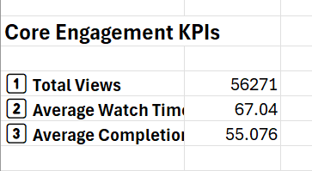

Step 4 – Genre-Level Insights
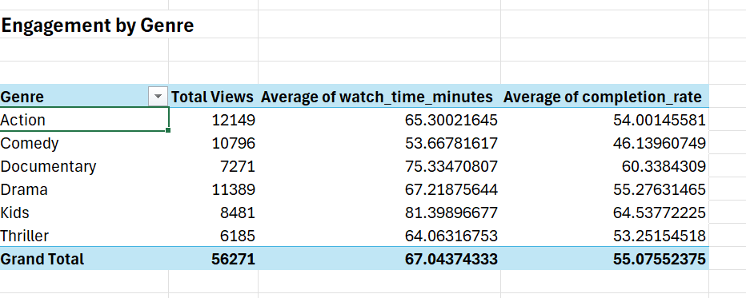

Key patterns observed:
- Action, Drama, and Comedy drive the most views, but Kids and Documentaries keep viewers engaged longer and finishing more often.
- Kids content: Strongest performer overall — high watch time and completion rate, even with fewer titles than Action/Drama.
- Documentaries: Smaller reach but excellent engagement metrics, suggesting loyal niche audiences.
- Comedy performs well in reach but weak in retention
Business takeaway:
High reach does not guarantee high engagement. Kids and Documentary content attract smaller but more loyal audiences.

Step 5 – Device-Level Insights
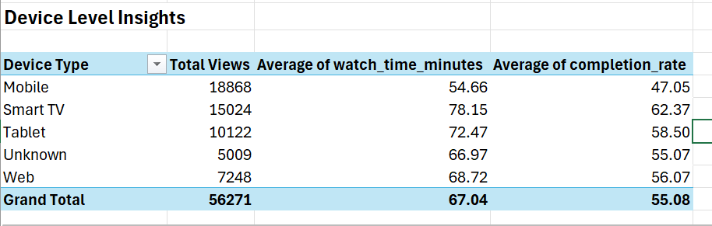
- Mobile: Largest source of views but weakest engagement
- Smart TV: Fewer views but highest watch time and completion
- Tablet: Balanced performer
Key insight:
Mobile brings scale, Smart TVs bring quality engagement.

Step 6 – Subscription-Level Insights

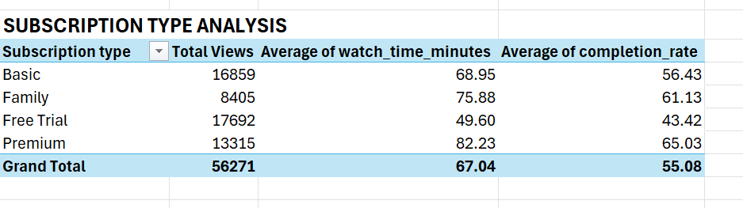

- Free Trial: Brings in the most views but lowest watch time and completion. Trial users sample content but don’t stick.
- Premium: Fewer views than Free Trial/Basic, but highest watch time and completion. Premium subscribers are the most loyal and invested.
- Family: Long viewing sessions, household usage pattern
Key insight:
Paid subscribers are more engaged, while trial users sample content without commitment.

Step 7 – Regional Insights
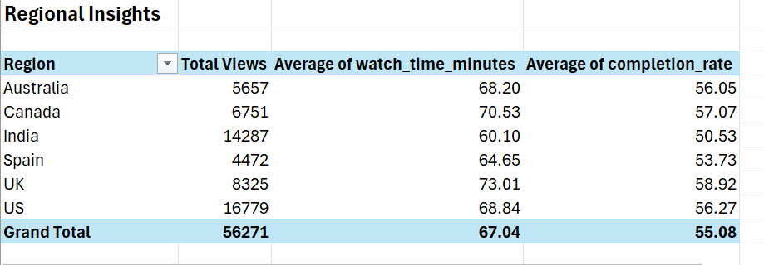

- US & India: They account for more than half of total views, but India lags in engagement
- UK: Smaller reach than US/India, but highest watch time and completion rate.
- Canada: Balanced reach and engagement
- Key insight:
High-volume regions are not always high-quality engagement markets.
Assumptions & Limitations
- Data is synthetically generated to mimic real-world OTT behavior
- Results demonstrate methodology and patterns, not real company metrics
- Analysis is session-based, not user-lifecycle based

Final Analysis (What the Data Ultimately Says)
After cleaning and validating the data, the analysis reveals clear and realistic engagement patterns that would be expected on a real OTT platform.
The most important finding is that reach and engagement are not the same thing. High-volume segments (such as Mobile devices, Free Trial users, and regions like India) contribute significantly to total views but show weaker engagement depth in terms of watch time and completion. In contrast, smaller segments (such as Kids and Documentary content, Smart TV usage, Premium subscriptions, and the UK region) consistently demonstrate stronger retention and viewing commitment.
This distinction is critical for decision-making. If the business focuses only on view counts, it risks over-investing in segments that generate scale but not loyalty. When engagement quality is considered alongside reach, a more balanced strategy emerges—one that supports both growth and long-term value.
Overall, the cleaned data tells a coherent story: paid users are more invested, large screens drive deeper sessions, certain content genres build loyal audiences, and some regions outperform others in engagement quality despite lower volume. These insights would not have been visible without first addressing data quality issues.

Final Conclusion
This project demonstrates an end-to-end analytics workflow that starts with imperfect data and ends with reliable, business-ready insights. By prioritizing data quality checks before KPI reporting, the analysis avoids misleading conclusions and produces a more accurate picture of user behavior.
The final outcome highlights how OTT platforms should differentiate between scale and quality when making content, product, and monetization decisions. The project emphasizes that clean data, clear logic, and simple explanations are often more valuable than complex models or dashboards.
End of Project

