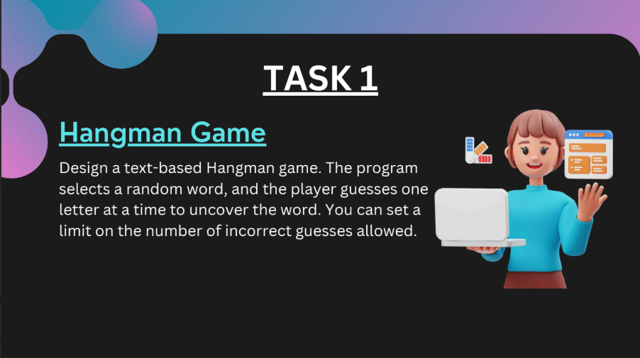

**Concept Overview:**

The Hangman game is a classic word-guessing game where:

* A random word is selected from a predefined list.
* The player tries to guess the word one letter at a time.
* If the guessed letter is in the word, it's revealed in its correct position(s).
* If the guess is incorrect, a penalty (e.g., a part of a hangman) is added.
* The player has a limited number of incorrect guesses before the game is lost.

**Key Elements of the Game:**

**1. Word Selection:**

The game randomly selects a word (like "python", "hangman").

**2. Display:**

The word is initially hidden (e.g., _ _ _ _ _ _ for "python").

Correct guesses reveal matching letters.

**3. User Input:**

The player inputs a letter guess each round.

**4. Logic Handling:**

Check if the guessed letter is in the word.

Track correct and incorrect guesses.

End game when:

The full word is guessed.

Maximum wrong guesses are reached.

**5. Optional Enhancements:**

* Show remaining guesses.
* Display guessed letters so far.
* Use simple ASCII art for visual hangman.

**Goal of the Task:**

To practice:

* String manipulation
* Loop and condition logic
* Random selection
* Input/output in Python

**CODE**

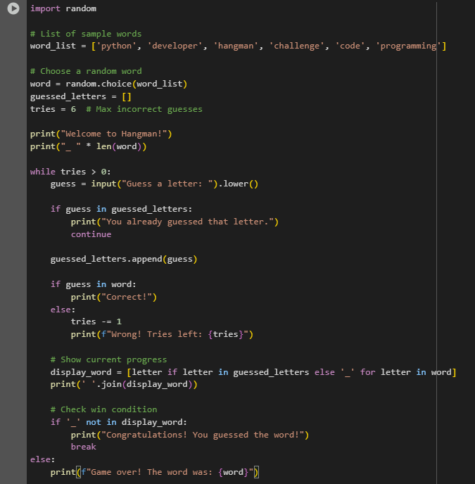

**OUTPUT**

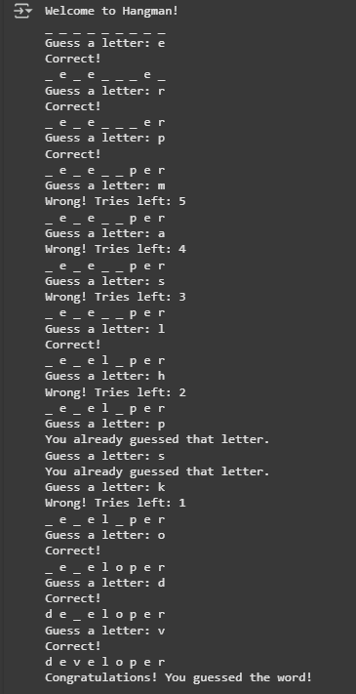\

**SUBMITTED BY :**

ANISHA GARG